

FINAL REPORT ON THE INTEREST PROGRAMME
Laboratory of Radiation Biology
The National University of Mongolia

Modeling of radiation damage to DNA and subcellular structures: emmision spectra and formation of biomolecular damage induced by medical radioisotopes

Participation period: March 05 - April 20 2026
PREPARED BY : TS.DELGERSAIKHAN
SUPERVISOR: DR M.BATMUNKH

2026
1.Abstract
Radiation biophysics at the cellular scale studies how ionizing radiation interacts with biological structures, resulting in molecular damage. In this study, a Monte Carlo-based multiscale modeling framework was applied to simulate the emission spectrum of I-125 radiation track structures, and the corresponding DNA damage induction. GEANT4 DNA, we modeled the physical processes such as photoelectric effect, Compton scattering, auger electron, elastic scattering, ionization, excitations to track where energy is deposited around DNA. The spatial pattern of DNA strand breaks is analyzed taking into account the atomic description of geometrical structure.

2.Introduction
Ionizing radiation interacts with biological systems across multiple spatial and temporal scales, producing molecular damage that ultimately influences cellular fate. At the nanometer scale, low-energy secondary electrons play a dominant role in initiating DNA lesions, including single strand breaks (SSB), double strand breaks (DSB), and clustered damage [1]. Auger electron emitters such as Iodine-125 are of particular radiobiological interest because their decay results in highly localized energy deposition around DNA when the radionuclide is incorporated into or near genetic materials.
I-125 undergoes electron-capture decay, followed by Auger electron cascade, generating dozens of low-energy electrons with sub-nanometer ranges. These electrons induce dense ionization clusters that significantly enhance the probability of DNA strand breaks [2]. To investigate these mechanisms at high spatial resolution, Monte Carlo track-structure simulations using GEANT4-DNA were employed. This work aims to simulate the nanoscale physical interactions of radiation from I-125 decay with biological medium, and quantify the strand breaks in a DNA target molecule.

3. Method
3.1 Simulation overview
This work aims to simulate the formation of the formation of radiation-induced DNA damage by modeling the fundamental interaction of I-125 decay products with biological medium (cellular water). GEANT4-DNA based Monte Carlo framework was used to simulate particle tracks, physics interactions, and local energy deposition leading to DNA strand damage.
3.2 Source and decay model
I-125 decay was implemented using the standard GEANT4 radioactive decay module, including auger electron, conversion electrons, and low-energy photons [3]. The resulting particle tracks were recorded for analysis (Fig 1).
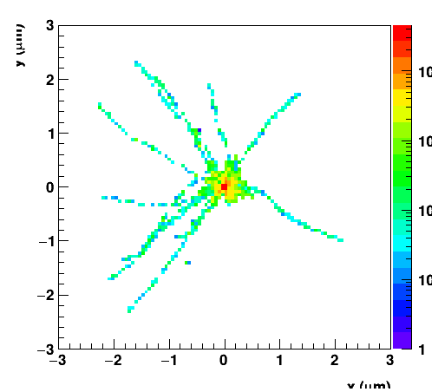
Figure1. The trajectory (track structure) of auger electrons and photons from I-125 atom decay. The local energy deposition is indicated as color-map and expressed in eV.
This figure shows the spatial distribution of electrons and photons emitted during I-125 decay, illustrating the dense local tracks characteristic of Auger electrons.
3.3 Geometry setup (DNA Model)
The DNA target was modeled as an elongated rectangular volume representing a simplified linear DNA segment was implemented to estimate strand-level energy deposition [4]. The geometry (Fig 2) included:
- Atomic radius and pitch consistent with B-from DNA
- Sugar- phosphate backbone region
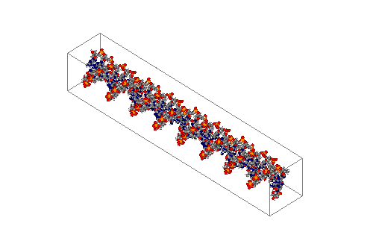
- Liquid water medium surrounding the DNA Energy depositions inside the van der Waals radius of DNA atoms were recorded and later used to evaluate SSB formation.

Figure2. Geometry of the atomic description of DNA short fragment used in the Geant4-DNA simulation of radiation transport.

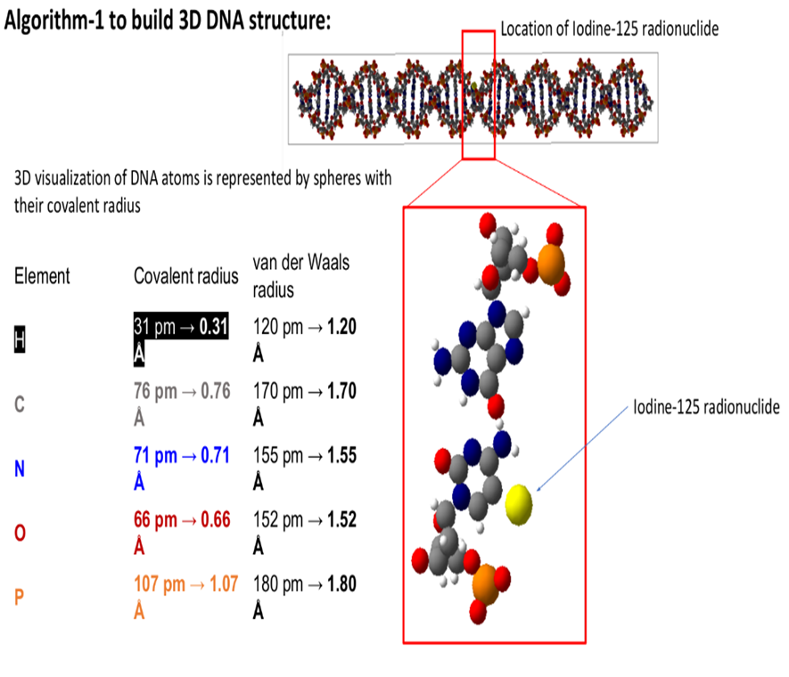
Fig3: Substitution of the 21st thymine base with an ¹²⁵I isotope. The substitution is feasible because the van der Waals radius of iodine is similar to that of the methyl group in thymine.
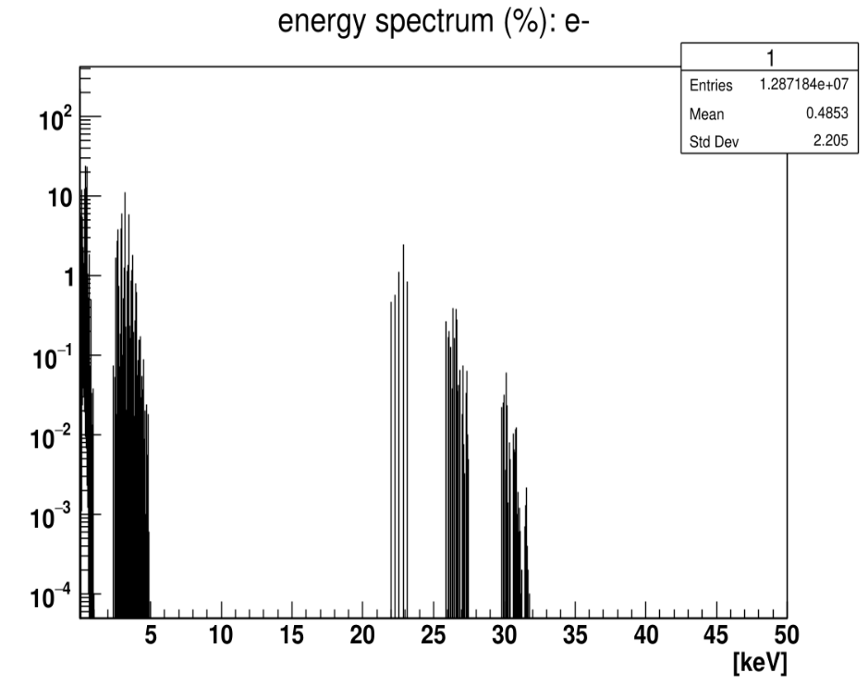
3.4 Energy spectrum of electrons emitted during the decay of ¹²⁵I

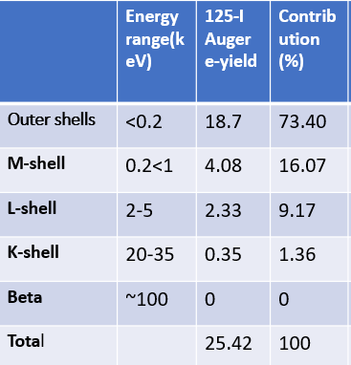
The emission of more than 25 electrons per single decay confirms that the ¹²⁵I isotope is capable of inducing intense ionization when positioned in close proximity to the DNA molecule.
Approximately 90% of the total electrons (originating from the outer and M-shells) possess energies below 1 keV. Since these electrons have a range of only a few nanometers in an aqueous medium, their energy is densely deposited within the DNA double helix, leading to severe damage such as double-strand breaks (DSBs)
3.5 Physics processes
Simulations were performed using GEANT4 DNA Physics [5], with the following low-energy interaction processes enabled:
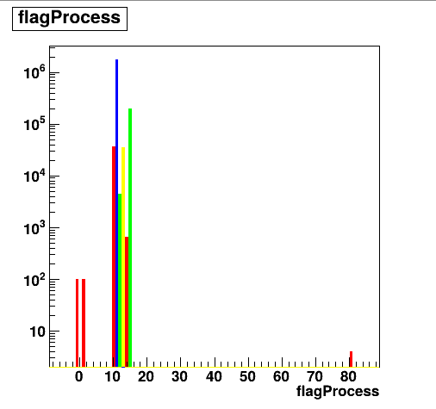
- 10-solvE- interactions of electrons with solvated water
- 11-elastE
- 12-excitE
- 13-ioniE
- 14-attE
- 15-vibE
- 81-photG
Figure4. Physics of Auger electrons produced by ¹²⁵I decay in liquid water.
Ionization and excitation processes dominate, reflecting the typical behavior of low-energy electrons in liquid water (Fig 4).
3.6 Data analysis
Physics process data and energy deposition values were exported to ROOT and processed in Excel (Fig 4-5). Percentage distributions were visualized using pie charts.
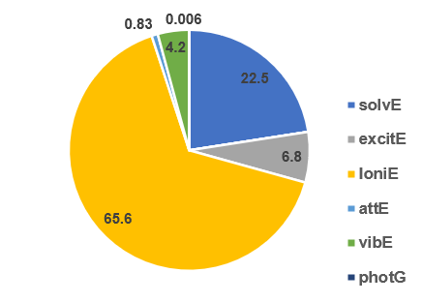
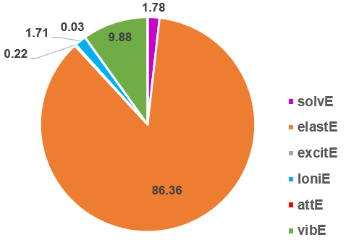
Figre5. Energy loss during physical interactions of ¹²⁵I Figure6. Absorbed energy and the
Auger electrons in an aqueous medium mechanism of energy deposition.
4.RESULTS
4.1 Distribution of physics process
The interaction statitics show that:
- Ionization is the dominant process (~65,6)
- Extitation contributes (6-10%)
- Elastic scattering accounts for (-86%)
- All other processes contribute <1%
This reflects the short-range, high-density interactions characteristic og auger electrons emitted by I-125.

4.2 Absorbed energy distribution
Energy deposition results indicate that:
- Ionization accounts for the largest fraction (65%)
- Electronic excitation contribute 4-10%
- SolvE and elastE contribute the remaining fraction
These results confirm that ionization events play the primary role in initiating DNA strand damage.
4.3 Single strand break (SBB)
Single strand breaks generated by I-125 decay electrons were quantified based on the local energy deposition in the DNA backbone. A threshold of 10.79 eV (minimum energy of water molecule ionization) was applied to identify strand breaking events (Fig 6).
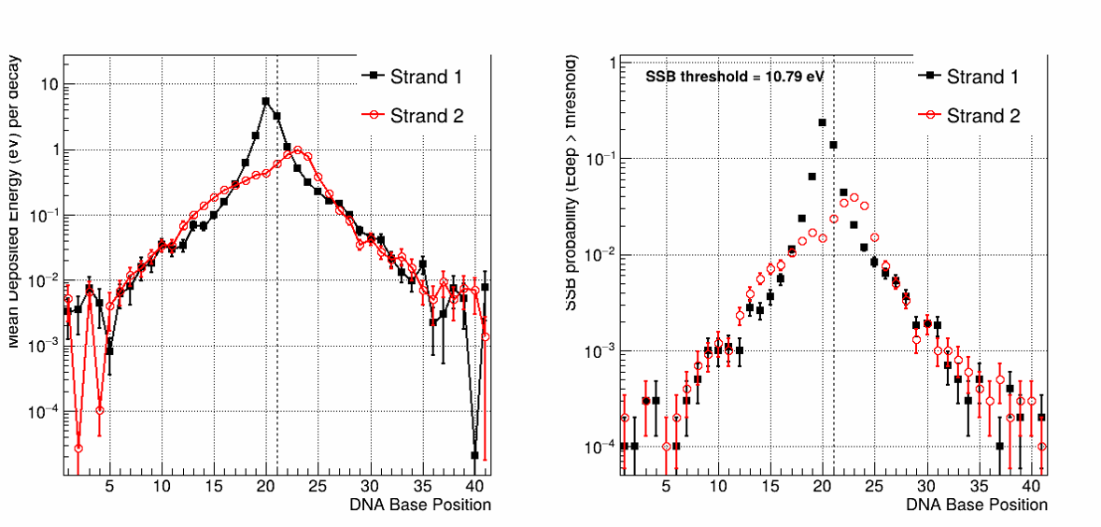 Figure 6. The spatial pattern of energy depositions (left) and single-strand breaks (rigth) along DNA strands from I-125 at DNA base position of 21.
5.Conclusion
In this study, the induction of DNA single strand breaks (SBB) caused by the decay of I-125 was quantified using GEANT4-DNA simulations. The results clearly show that I-125 produces a significant number of SBB due to the emission of low-energy Auger electrons, which deposit their energy within nanometer-scale distances. The spatially localized energy deposition leads to dense ionization clusters around the decay site, making I-125 highly effective at producing molecular-level DNA damage. We show that across all physics processes, elastic scattering are the most abundant (86%), though ionizations mediate the majority of the energy deposition (65%). We also find that the dominant contribution comes from auger electrons with smaller contributions coming from photons of I-125 decay. It was also observed that a completely different pattern of DNA single-strand breaks occurred at different base positions from the I-125 decay on the 5' and 3' ends of both strands.
6.Acknowledgments
I would like to express my sincere graditude to my supervisor for their continuous guidance, support, and valuable advice throughout this research. Their expentise and encouragement were instrumental in completing this work.
I am also sincerely grateful to the organizers of the INTEREST programm for providing an outstanding platform that enabled me to acquire highly valuable knowledge and experience.

7.References

- Baeyens, A. et al. (2023). Basic Concepts of Radiation Biology. In: Baatout, S. (eds) Radiobiology Textbook. Springer, Cham. https://doi.org/10.1007/978-3-031-18810-7_2
- Ekkehard Pomplun. Monte Carlo simulation of Auger electron cascades versus experimental data. Biomed. Phys. Eng. Express 2 (2016) 015014
- Bakr S, Kibédi T, Tee B, Bolst D, Vos M, Alotiby M, Desorgher L, Wright DH, Mantero A, Rosenfeld A, Ivanchenko V, Incerti S, Guatelli S. A benchmarking study of Geant4 for Auger electrons emitted by medical radioisotopes. Appl Radiat Isot. 2021 174:109777. doi: 10.1016/j.apradiso.2021.109777.
- Batmunkh, M., Bayarchimeg, L. &amp; Bugay, A.N. Mathematical Modeling of Radiation-Induced Effects in the Structures of the Central Nervous System under the Action of Accelerated Heavy Charged Particles. Phys. Part. Nuclei 56, 1030–1058 (2025). https://link.springer.com/article/10.1134/S1063779625700157
- Bernal, M. A., Bordage, M. C., Brown, J. M. C., Davídková, M., Delage, E., El Bitar, Z., … & Baldacchino, G. (2015). Track structure modeling in liquid water: A review of the Geant4-DNA project. Physica Medica, 31(8), 861–874.

