JOINT INSTITUTE FOR NUCLEAR RESEARCH
Flerov Laboratory of Nuclear Reactions

FINAL REPORT ON THE
INTERST PROGRAMME

Production and spectroscopic investigation of new neutron-rich isotopes near the neutron N=126 shell closure using the multinucleon transfer reactions

Supervisor:
Viacheslav Vedeneev,
Joint Institute for Nuclear Research, Dubna, Russia

Student:
Otabek Normukhamedov,
National University of Uzbekistan named after Mirzo Ulugbek

Participation period:
February 26 – April 14, Wave 10

Dubna 2024

Table of Contents

1.Abstract
2.Introduction
3.Experimental Setup
3.1.Target Assembly and Hot Catcher
3.2.MASHA Setup
3.3.Ion Source MASHA Setup
3.4.Detection and Control System
3.5.Experimental Technique
4.Result and Discussion
4.1 Reaction ⁴⁰Ar + ¹⁴⁸ Sm
4.2 Reaction ⁴⁰Ar + ¹⁶⁶Er
4.3 Reaction ⁴⁸Ca + ²⁴²Pu
5.Conclusions
6.Literature

1.Abstract
The MASHA mass spectrometer, developed at FLNR JINR, is engineered to precisely measure the masses of superheavy nuclei and investigate their decay processes, including α-decays and spontaneous fission. It employs a specialized mass separator to distinguish superheavy elements based on their masses. Recent experiments have successfully detected α-active isotopes of Hg and Rn generated in complete fusion reactions, such as ⁴⁰Ar + ¹⁴⁴Sm → 184 – xnHg + xn and ⁴⁰Ar + ¹⁶⁶Er → 206 – xnRn + xn. Furthermore, a calibration of the position-sensitive strip detector, situated at the focal plane of the separator, was conducted using test reactions.

2.Introduction
The study of super-heavy nuclei is one of the most important studies in nuclear physics. This involves precise measuring of energy, mass, α-decay schemes and spontaneous fission with using statistics analysis methods.
The Mass Analyser of Super Heavy Atoms (MASHA) had been built at one of the beamline from U-400M cyclotron that based in Flerov Laboratory of Nuclear Reactions (FLNR) at Joint Institute for Nuclear Research (JINR), Dubna, Russia.
The setup could be used for direct measuring the masses in a wide range up to A=450 a.m.u. with mass resolution M/ΔM=1700 of the heaviest elements with simultaneous detecting its α-decays and/or spontaneous fission. For this in the U-400M cyclotron a beam of Ar⁴⁰ or Ca⁴⁸ ions accelerated to 5-7 MeV/nucleon irradiating an external targets of Sm¹⁴⁸, Er¹⁶⁶ and Pu²⁴². The evaporation residue products stops in a hot catcher, from where they diffused into the ECR ion source, in which they were ionized to a charge state of +1. Then they got into the detector.
In experiments to study the chemical properties of superheavy elements, the element Copernicium (Cn, Z = 112) was found to have increased volatility compared to its chemical analogue mercury. At the MASHA facility the test experiments to measure the masses of radon and mercury isotopes were performed. Another important motivation for doing this work was studying the features of fusion reactions with target nuclei located near the magic number of neutrons N = 82.
The work is devoted to the calibration of a position-sensitive strip detector using the reactions Ar + Sm, Ar + Er and the reaction of multinucleon transfers calcium + plutonium - just for the synthesis of radons near a closed neutron shell N = 126

3. Experimental Setup
3.1 Target Assembly and Hot Catcher
The hot catcher is a part of the target assembly shown in Figure 2.2. Prior to hitting the target, the primary beam of heavy ions passes through the diagnostic system composed of a split type aperture of the electrostatic induction sensor and a Faraday cup. The split aperture is divided into four sectors each of which measures the fraction of the beam current that does not fall into the hole of the aperture. This system allows control of the beam position relative to the ion guide. The Faraday cup is fixed in place on the rotary vacuum tight feedthrough at a distance of 70 mm in front of the target. Behind the diagnostic system, there is a rotating target divided on 12 sectors assembled in cassettes and driven by electric engine. Nuclear reaction products escape from the target, pass through the separating foil, and are stopped in the graphite absorber. In the form of atoms, the products diffuse from the graphite absorber to the vacuum volume of the hot catcher and, moving over the pipeline, reach the ECR source.
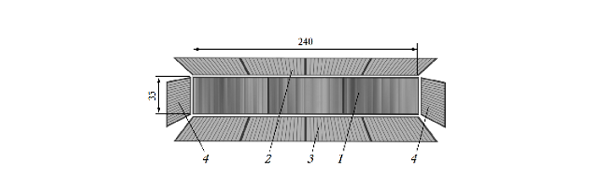
Figure 2.3: 1-frontal 192 strips; 2-top 64 strips; 3-bottom 64 strips; 4-side 16 strips
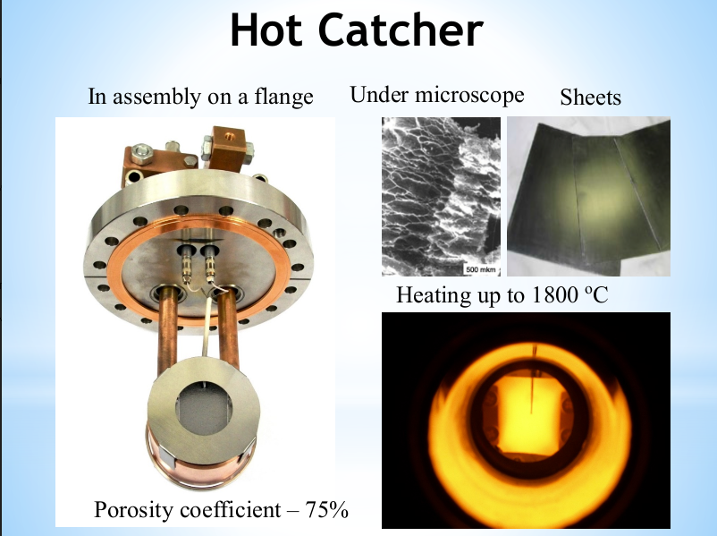
Figure 2.4: Hot catcher

3.2 MASHA Setup
The setup, the layout of which is shown in Figure 2.1, consists of the target assembly with a hot catcher; an ion source based on the electron cyclotron resonance phenomena (ECR); a magneto-optical analyzer (a mass spectrometer); a position sensitive strip detector at the focal plane.
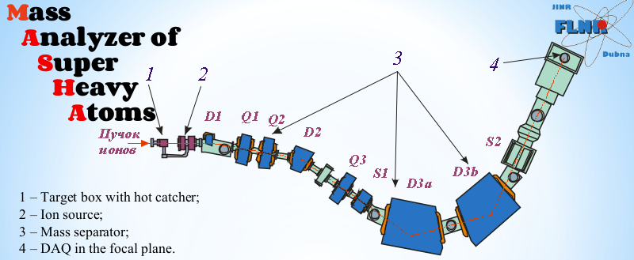
Figure 2.1: MASHA setup: (D1, D2, D3a, D3b) dipole magnets, (Q1, Q2, Q3) quadrupole lenses, and (S1, S2) sixtupole lenses. The detection system is in focal plane of the separator 4

3.3 Ion Source
An ion source based on the ECR (the ECR source) with a 2.45GHz frequency of its microwave oscillator is used for ionizing atoms of nuclear reaction products.
In the ECR, atoms are ionized to charge state Q = +1, accelerated with the aid of the three electrode system, and gathered into a beam, which is thereafter separated by the magneto-optical system of the mass spectrometer. The ECR source helps to obtain ion currents consisting of almost 100% of singly ionized atoms.
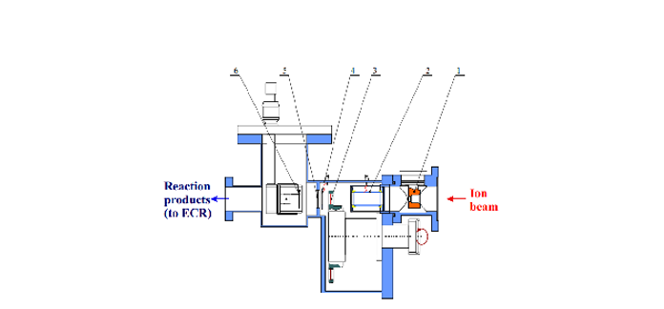
Figure 2.2: Target-hot catcher system. 1-diaphragm; 2-pick-up sensor; 3-target on the wheel; 4-electron emission beam monitor; 5-separatin foil; 6-hot catcher

3.4 Detection and Control System
To detect decays of nuclear reaction products, a well-type silicon detector is mounted in the focal plane of the mass spectrometer. The 192 strips make up the plane of the frontal detector component, which is positioned normal to the beam direction. Each of the side detectors is divided into 64 and 16 strips. The detectors have a conventional operating bias of 40V and a 25keV energy resolution for α-particles from a Ra²²⁶ source. The detector assembly’s stated design allows it to detect not less than 90% of particles emitted in a single nuclear decay at the detector’s frontal section. Each strip of the silicon detector’s signals is read out separately. The application displays one-dimensional energy spectra for each strip as well as two-dimensional spectra for each crystal’s energy dependency on strip number.

3.5 Experimental Technique
MASHA was constructed at one of the beam lines of U - 400M cyclotron in order to conduct online measurements of the physical properties of super-heavy elements. The target was bombarded by beam of ⁴⁸Ca with energy E_{beam}=7,3MeV/n.
Atoms diffuse from the graphite volume and, move along the vacuum pipe and reach the ECR ion source chamber where they are ionized. Faraday cup allows beam intensity control or target protection by periodically interrupting the beam. The separation efficiency and time were measured for Hg isotopes due to their similarity with element Z = 112 and Z = 114. A radioactive isotopes were obtained in the fusion reaction. A decay energy of the fusion products was measured as a function of the strip number.

4. Result and Discussion
In this chapter will be represented and analyzed the results of the nuclear reactions taken from MASHA.

4.1 Reaction ⁴⁰Ar + ¹⁴⁸ Sm

It is noticeable in Table 3.1, that the experimental and theoretical results are very close, and this indicates the accuracy of the mass analyzer MASHA. The magnetic system and detector have excellent resolution, distinguishing the various isotopes both in mass and energy.
Isotope | T ½, s | E _{experiment}, keV | E _{theory}, keV
Hg180 | 2.58 | 6119 | 6119
Hg181 | 10.83 | 5989 | 6006
Hg182 | 9.4 | 5862 | 5867
Hg183 | 30.9 | 5890 | 5904
Hg184 | 49.1 | 5527 | 5535
Hg185 | 82.8 | 5653 | 5653
Pt176 | 6.3 | 5731 | 5753

Table 3.1: comparison between experimental and theoretical table energy of the nuclei.

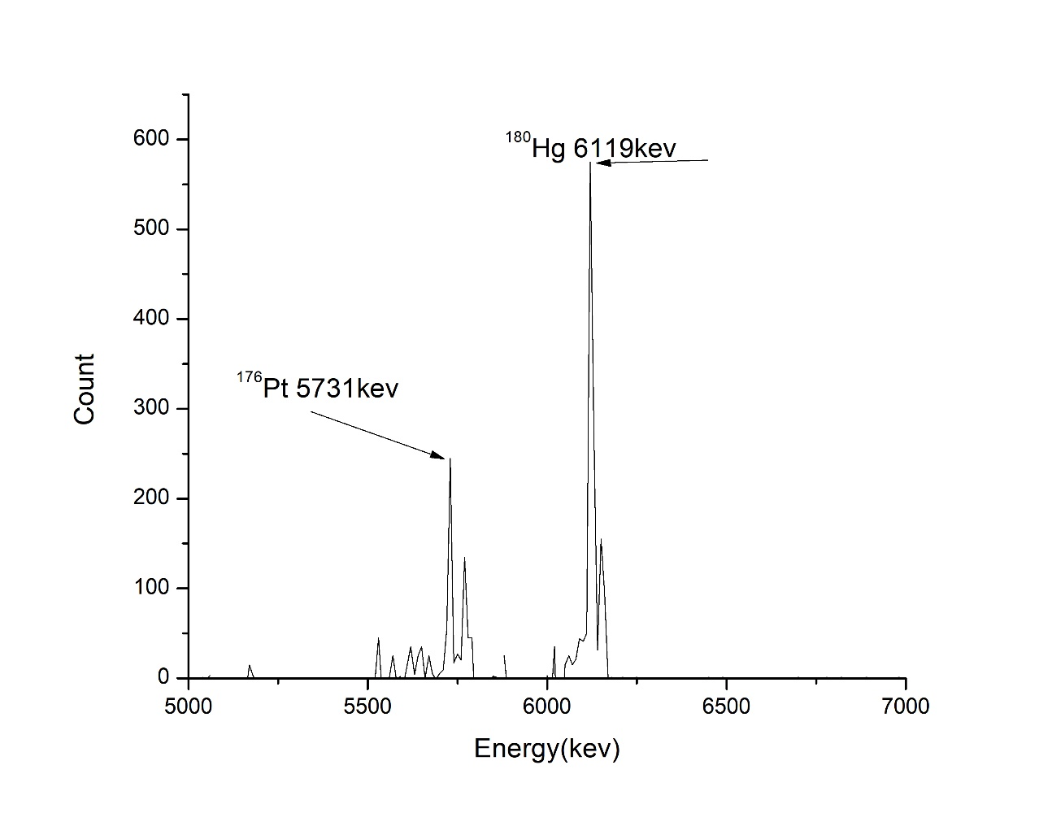
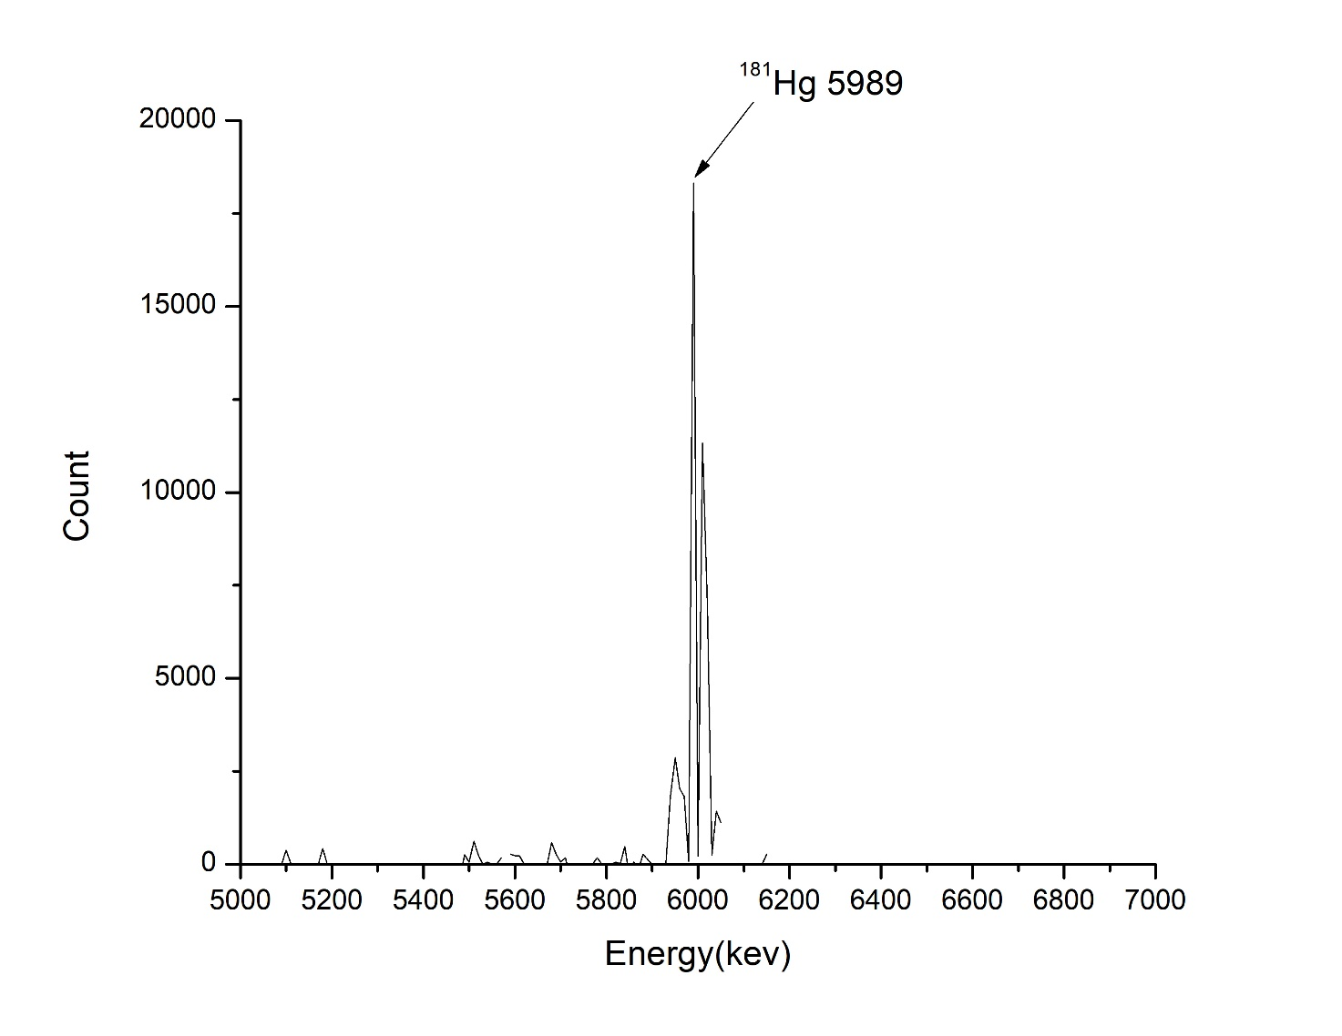
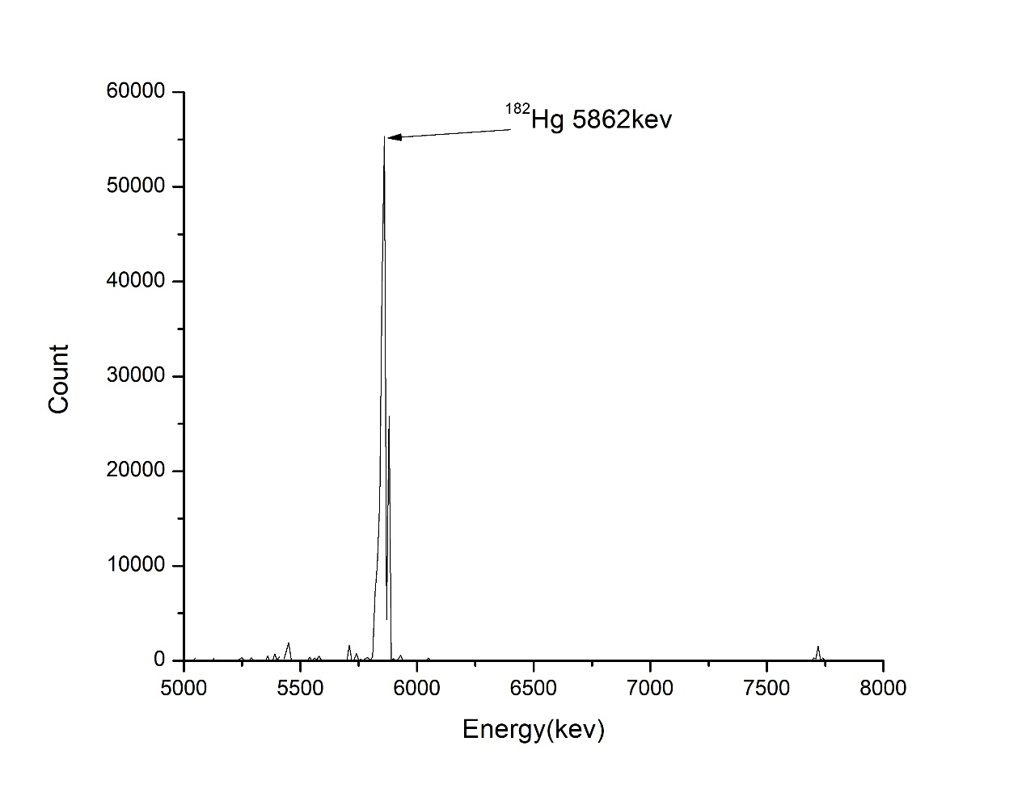
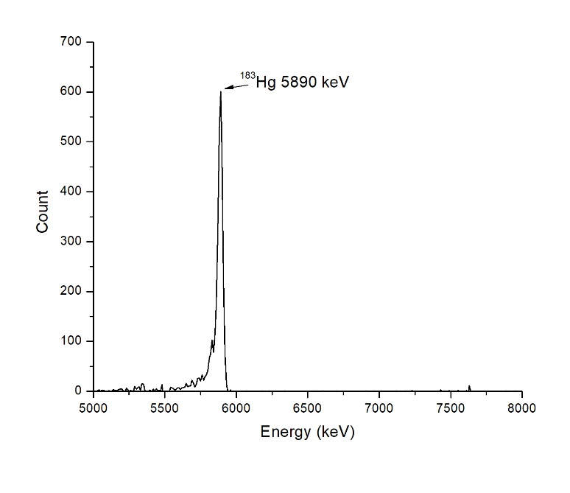

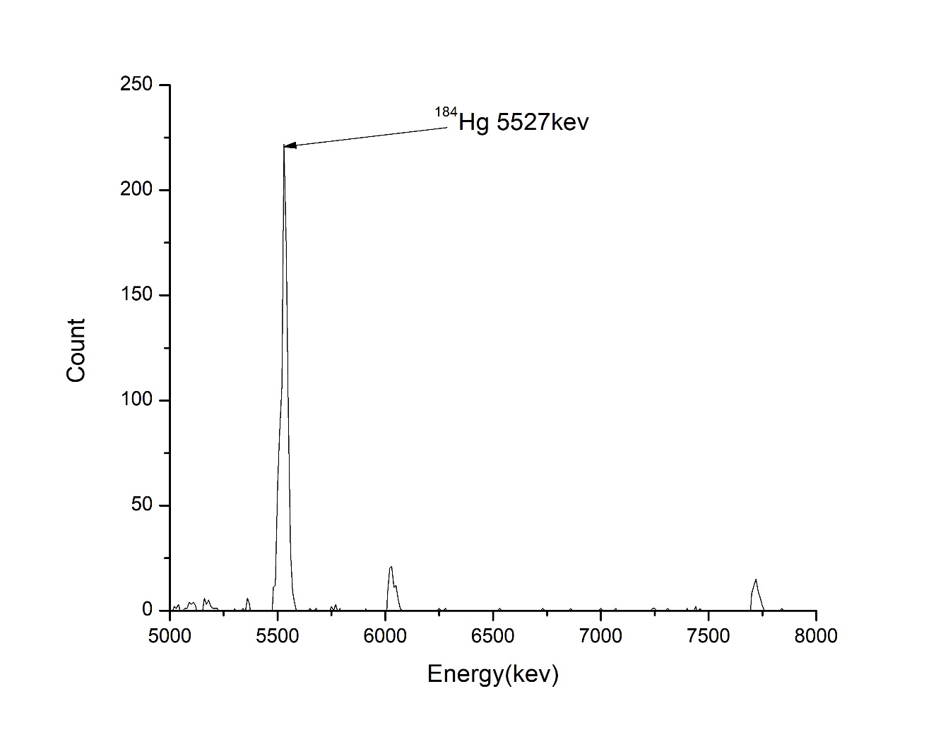
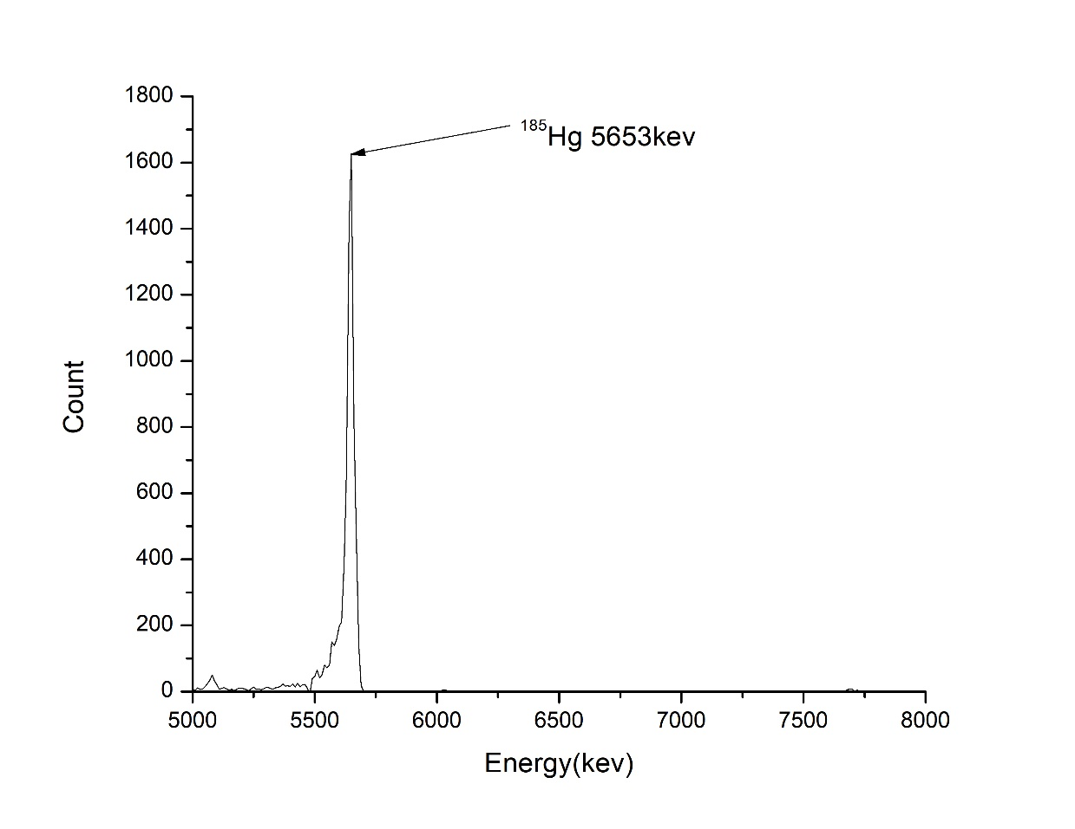

Figure 3.1
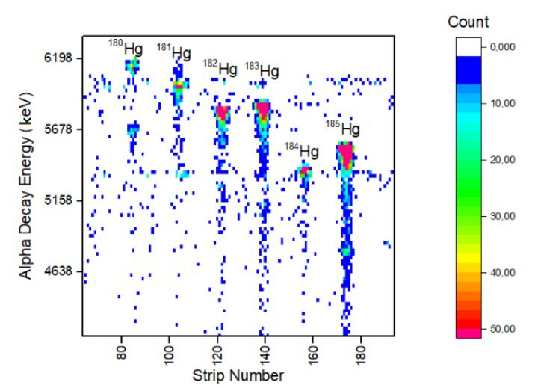
Heat map 3.3
4.2 Reaction ⁴⁰Ar+ ¹⁶⁶Er
In below the peaks are clearly shown whether they are Rn or Po nuclei. The decays which we can extract are:
Isotope | T ½, s | E _{exp}, keV | E _{theor}, keV
Rn201 | 7.1 | 6721 | 6725
Rn202 | 10 | 6631 | 6639
Rn203 | 28 | 6547 | 6549
Rn204 | 74.4 | 6400 | 6419
Rn205 | 170 | 6269 | 6262
Po197 | 25.8 | 6382 | 6383
Po198 | 106.2 | 6181 | 6182
Po199 | 250.2 | 5956 | 6059
Table 4.2: comparison between experimental and theoretical table energy of the nuclei.

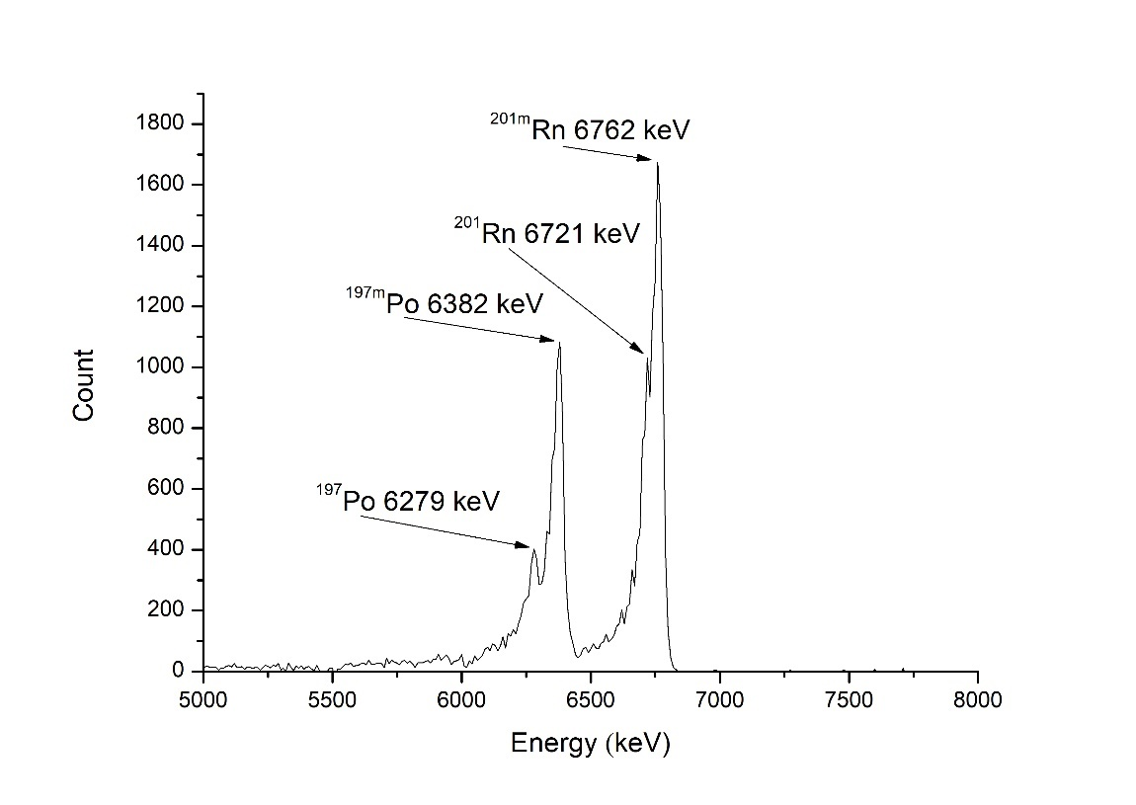
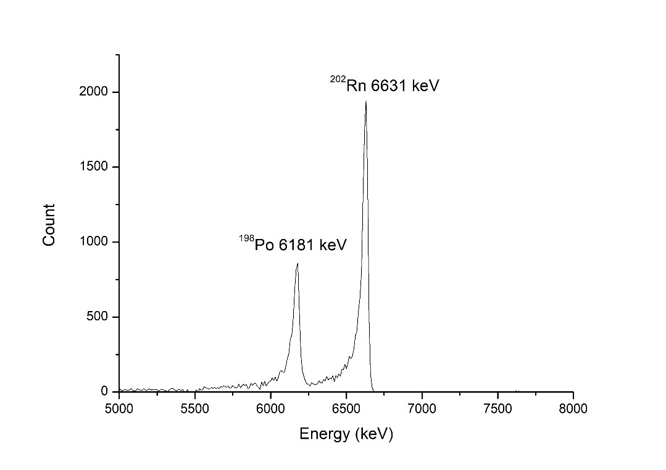
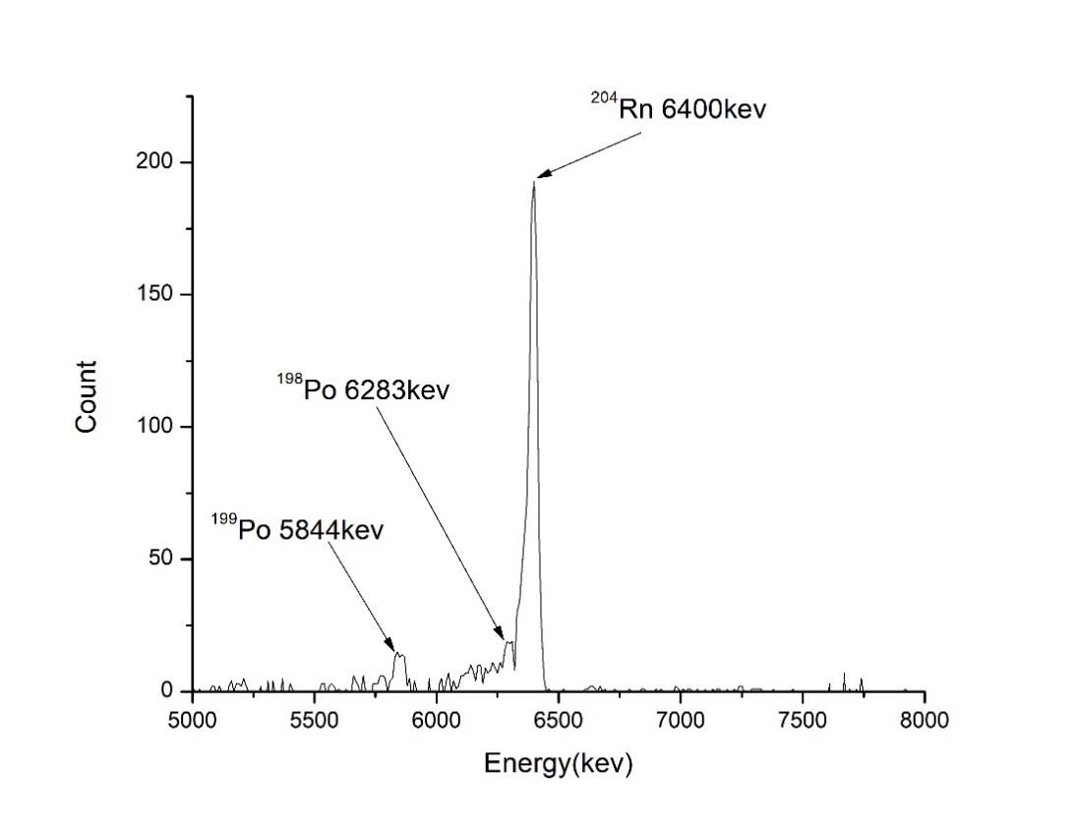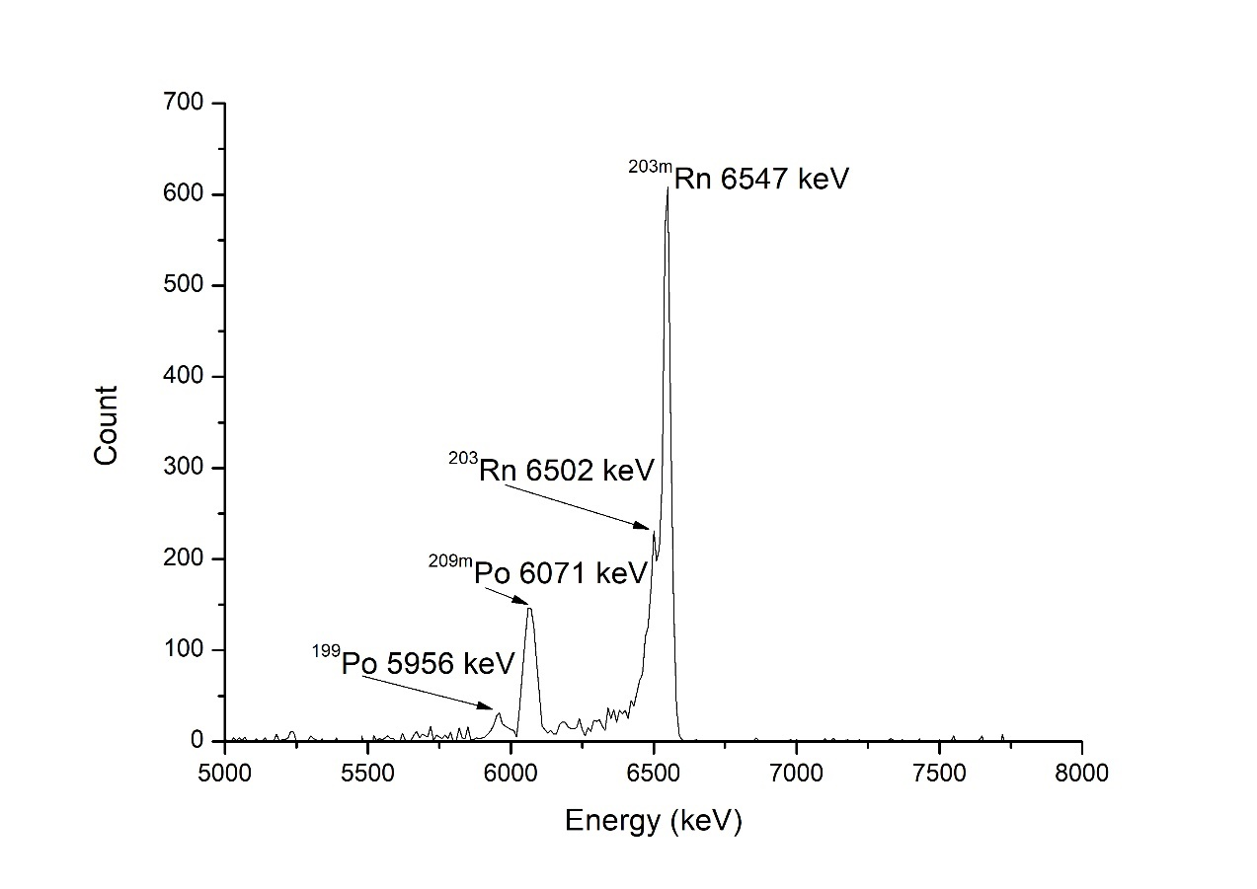
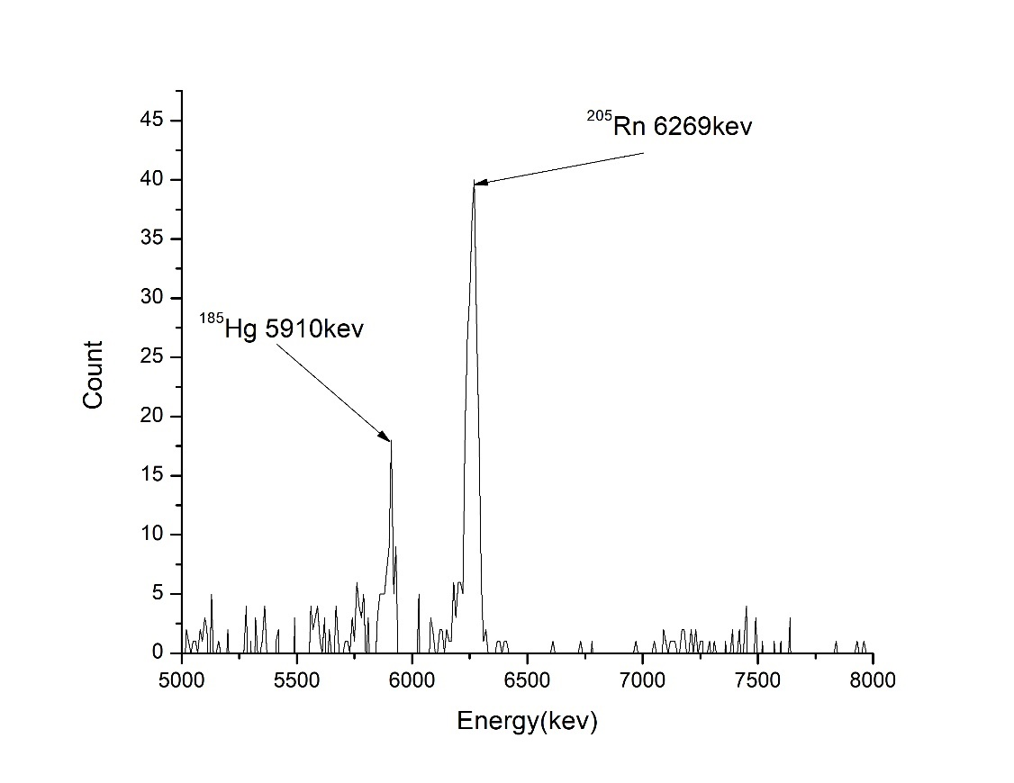
Figure 4.2

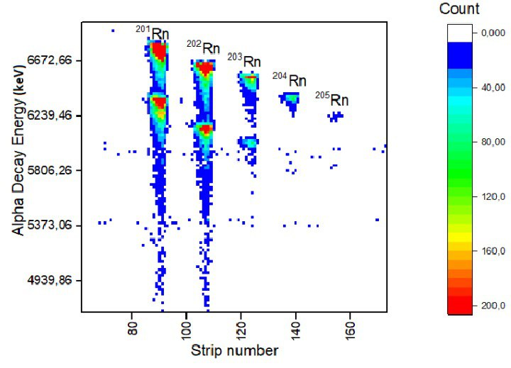Heat map 4.2

4.3 Reaction ⁴⁸Ca+²⁴²Pu

Isotope | T ½, s | E _{exp}, keV | E _{theor}, keV
Rn212 | 1434 | 6250 | 6264
Rn218 | 0.00035 | 7105 | 7129
Rn219 | 3.96 | 6788/6400 | 6819/6425
Rn222 | 36.17 | 6587 | 6559
Po218 | 138 days | 5282 | 5304
Po214 | 0.000163 | 7662 | 7686
Po215 | 0.0001781 | 7356 | 7386
Bi210 | 5 days | 4122 | 4100
Bi211 | 128.4 | 6603/6251 | 6622/6250
Table 4.3 comparison between experimental and theoretical table energy of the nuclei.

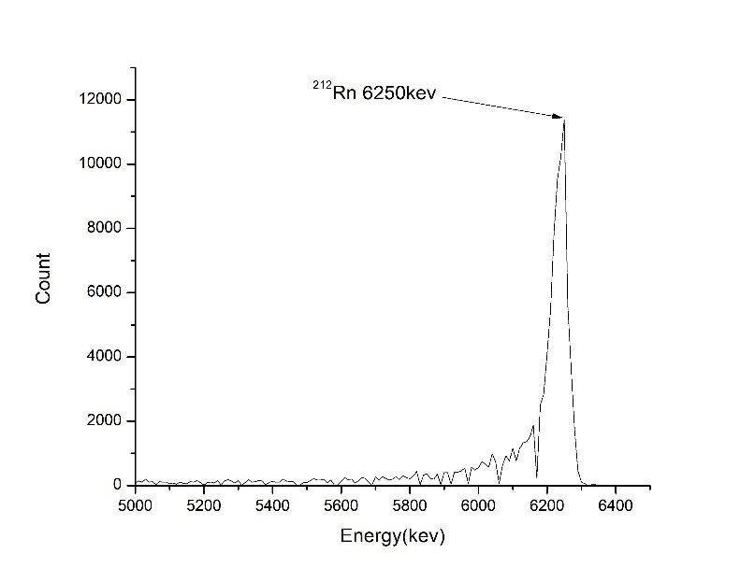
Figure 4.3

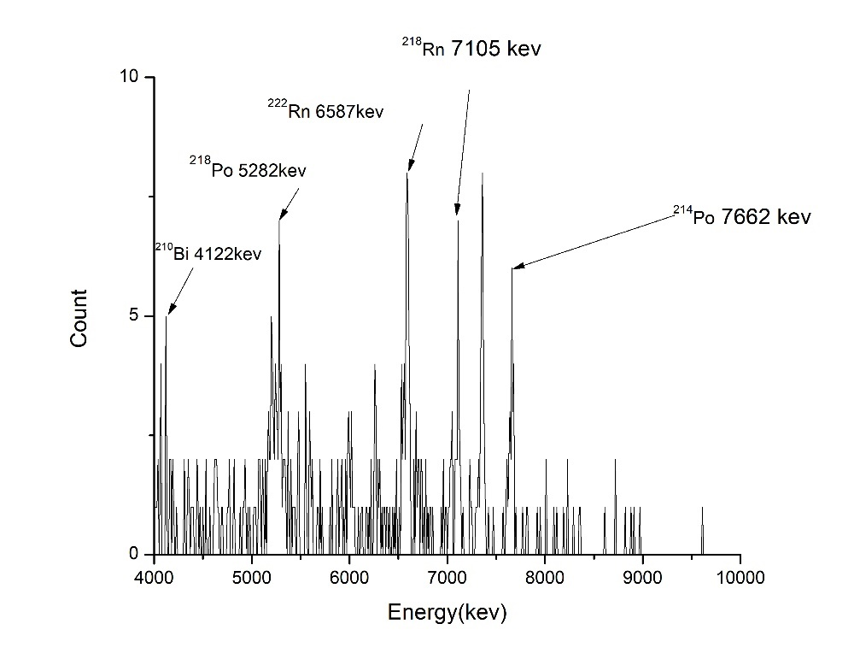
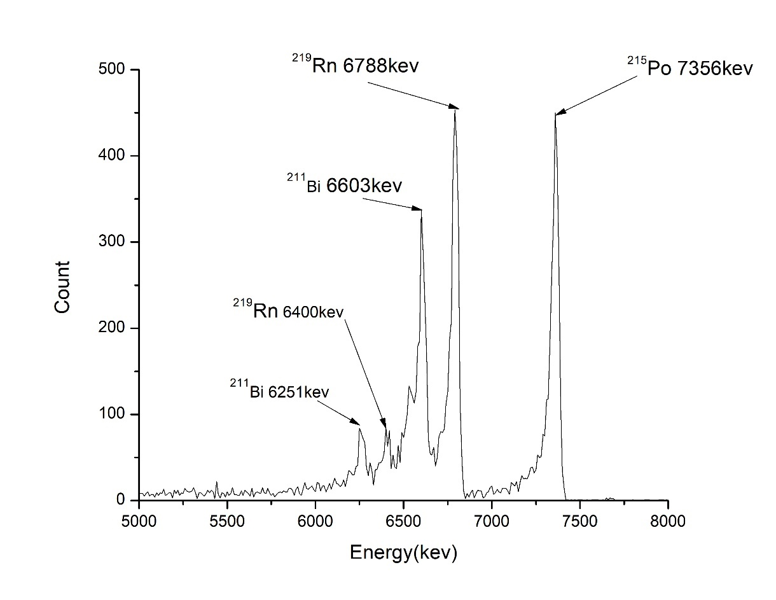

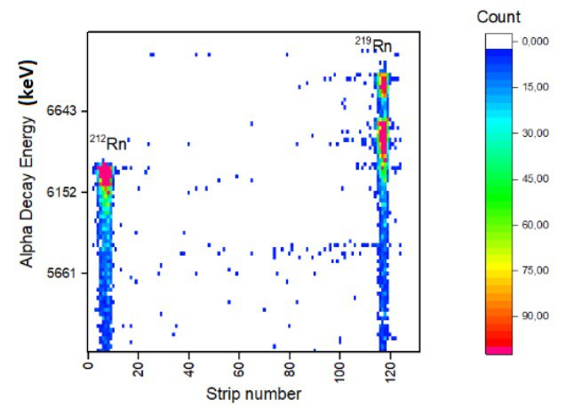

Heat map 4.3

Conclusions

The total synthesis reactions involving 40Ar+148Sm, 40Ar+166Er, and the multinucleon transfer reaction of 48Ca+242Pu, along with their resulting products, underwent analysis using OriginPro software. The silicon detector's response was validated by comparing the results with literature values, showcasing a relative deviation of no more than 3% for most nuclides. This validation facilitated the compilation of a two-dimensional matrix illustrating the relationship between α-energy and the position of the zone number for all reactions, highlighting the exceptional mass and energy separation capabilities of the multi-band detector. Through meticulous analysis, the confirmation of an "Island of Stability," hypothesized to harbor superheavy isotopes with notably extended half-lives, was achieved. Alpha decay energy spectra were captured at the focal plane using a silicon detection system, enabling the identification of mercury and radon nuclei. Comparison between experimental and theoretical results indicated a close agreement for mercury nuclei, while discernible disparities were observed for radon nuclei, suggesting further investigation is warranted.

Literature
- MATTHIAS SCHÄDEL//The Chemistry of Superheavy Elements // Kluwer Academic Publishers, 2003
- V. Yu. Vedeneev, A. M. Rodin and others: The current status of the MASHA setup, Hyperfine Interact (2017) 238: 19
- H W Gäggeler, Mendeleev's principle against Einstein's relativity: news from the chemistry of superheavy elements,Russian Chemical Reviews 78 (12) 1139 - 1144 (2009)
- R. Eichler and oth, Chemical characterization of element 112, NATURE| Vol 447| 3 May 2007
- В. Ю. Веденеев и др, СЕЧЕНИЯ ОБРАЗОВАНИЯ ИСПАРИТЕЛЬНЫХ ОСТАТКОВ РЕАКЦИЙ ПОЛНОГО СЛИЯНИЯ ¹⁴⁴Sm(⁴⁰Ar, xn)^{184 - X}Hg, ¹⁴⁸Sm(³⁶36Ar, xn)^{184 – X}Hg, ¹⁴⁴Nd(⁴⁰Ca, xn)^{184 - X}Hg, ИЗВЕСТИЯ РАН. СЕРИЯ ФИЗИЧЕСКАЯ, 2020, том 84, No 4, с. 611–615

