FINAL REPORT ON THE
INTEREST PROGRAMME
Optimization of the solid ISOL method for volatile reaction products of heavy ion beam reactions

Supervisor: Mr. Vedeneev Vyacheslav Yurievich,
Dubna, Russia

Student: Gurucharan S,
Institute of chemical technology, Bhubaneswar, India

Participation period: (13 February - 26 March 2023) Wave 8

Dubna,2023

ABSTRACT

In the 1940s, Physicists were able to produce new unstable heavy elements, it became an interest for researchers to produce more super heavy elements and study them. The MASHA mass-spectrometer was developed at the FLNR JINR in Dubna, Russia [1]. It combines the ISOL method which is the isotope separation on-line method that is used for the mass analysis of short-lived isotopes across a broad mass range and separates them from the primary ion beam in an online mode. The high resolving power of this instrument allows scientists to investigate the α-decays or spontaneous fission of these superheavy nuclei.

INTRODUCTION

The ISOL (Isotope Separation On-Line) method is a highly efficacious technique utilized in the process of segregating reaction products. Owing to burgeoning new nuclide synthesis, researchers have demonstrated an inclination towards devising novel approaches for ascertaining and distinguishing the freshly synthesized nuclides. In the ISOL method the super heavy isotopes from the original beam is separated so that we can study them and determine their masses. The ISOL system involves multiple steps, including production, thermalization, ionization, extraction, mass separation, cooling, charge-state breeding, and acceleration. Also, in this method we should check:

- The efficiency of the separation taking place as the production rate of the exotic nuclei will be very marginal. Therefore, any manipulation with the reaction products – e.g., ionization, purification, acceleration, transport to the detection system has to be very efficient, otherwise one can miss the “essential” nuclei.

- The selectivity of the separation method going to be implemented as in the nuclear reaction process the unwanted, more stable nuclei are being produced much more abundantly in general. Furthermore, ISOL systems often produce beams of isotopes from the target material itself or from other components of the target-ion source system. Thus, the separation process should distinguish between the wanted and unwanted species in an effective way.

- Most importantly, while handling short-lived exotic nuclei the time of separation has to be short, and the losses due to radioactive decay between the moment of production and the arrival at the experimental set-up should be kept to a minimum. Moreover, choosing the right material for the catcher is of prime importance. In ISOL we can have a solid, liquid, or gas catcher, and each of them has a certain application. In our application of carbon nanomaterial, the best choice of a catcher would be the solid one as it provides the efficiency and the speed required to fulfill the parameters. This method is done by MASHA setup[2].

MASHA

Mass Analyzer for Super Heavy Atoms (MASHA) is a set up that is used for the separation of the super heavy elements using a combination of the ISOL method and the classic magnetic mass analysis method.
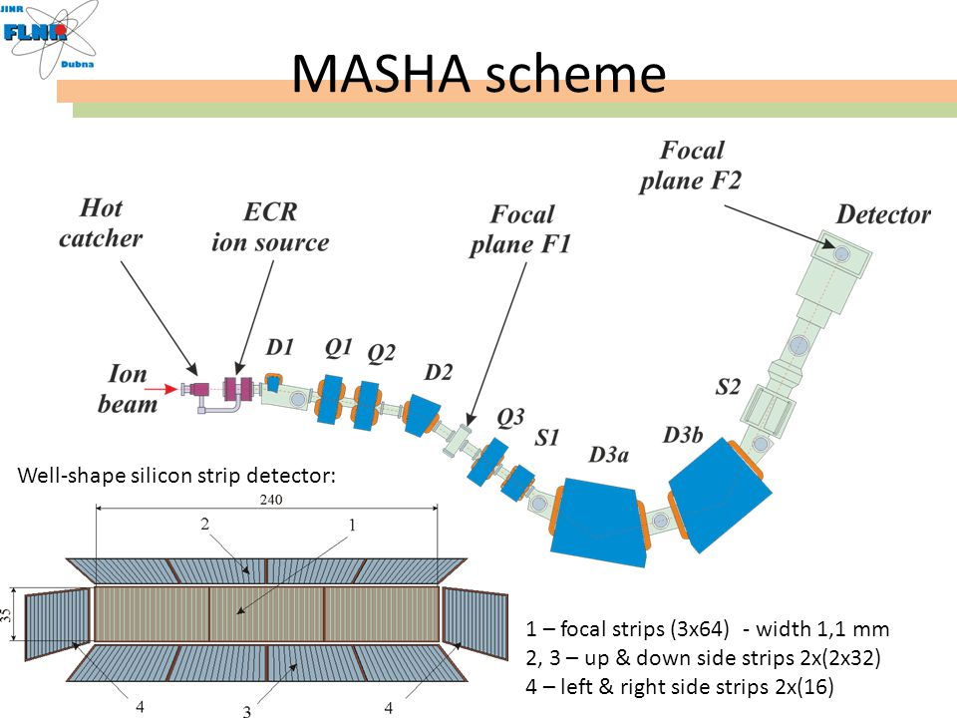

- Target box & hot catcher

The recoil nuclei, flying out of the target, are implanted into a heated catcher which has a temperature in the range~1800-2000k. The target itself is a rotating one, assembled into 6 cassettes, with 2 sectors each, as it has higher efficiency and heat distribution than the stationary target. The thickness of the target is determined by the range of the recoil nuclei in the working layer, which depends on the kinetic energy of the heavy atom produced from the fusion reaction.

The material used for the hot catcher is flexible thermally expandable graphite having a porous polygraphene structure, a density of 1 g/cm3 & 75% porosity, and shaped as a 30 mm diameter disk with a thickness of 0.6 mm. Also, the operating temperature is 1800~2000 K and the time taken for delivering the nuclides to the ion source (ECR) is 1.8±0.3s (This separation time is determined by using beam interruption method [3]).

- Ion source

The ECR ion source, operating at a frequency of 2.45 GHz, is utilized in the setup to ionize atoms of nuclear reaction products. The source is highly efficient, achieving nearly 100% singly ionized atoms, with noble gases achieving up to 90% ionization efficiency. The products of complete fusion reactions are introduced into the ECR source via a hot catcher. The diagnostic system for the primary beam of heavy ions includes an electrostatic induction sensor with a split-type aperture to regulate the beam position with respect to the ion guide[4]. After escaping from the target and passing through the separating foil, the nuclear reaction products are stopped by a heated graphite absorber at a temperature between 1500-2000 K. From there, the products diffuse into the vacuum volume of the hot catcher and ultimately reach the ECR source.

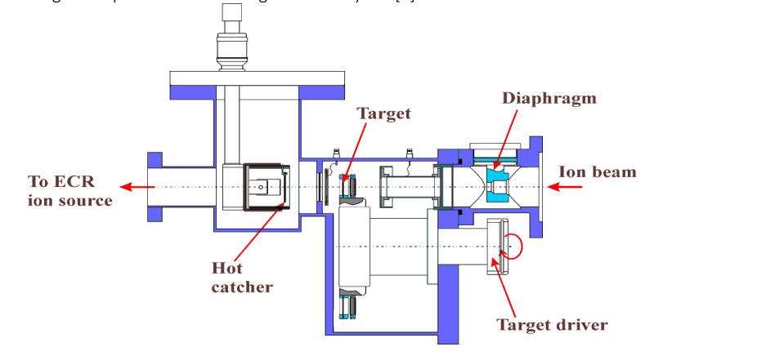
- The control & detection system:
The mass spectrometer employs a specialized detection and control system that comprises two types of detectors for measuring low direct currents and detecting nuclear reaction product decays. To measure low currents, a strip detector with 192 strips and a pitch of 1.25 mm is used, which is identical to the frontal part of a silicon detector. A multichannel electronic module has been developed for the strip detector. An apparatus that has been strategically placed within the focal plane of the mass spectrometer to discern nuclear reaction product degradation is a well-type silicon detector. The well-type silicon detector has 192 strips covering a 240 × 35 mm area. To increase detection efficiency, four side detectors are also installed. Both detectors have a dead layer thickness of less than 50 nm, and each strip's signals are read out independently using preamplifiers and shaping amplifiers. Two separate data acquisition programs are used for each detector

- The mass separator
The equipment used for separation in this configuration is a magnetic-optical analyser, which separates ions based on their magnetic rigidity within a permanent magnetic field. This method allows for the precise determination of the mass of super heavy atoms, with an accuracy of Δm = 0.25-0.30 e.m.
- DAQ in focal plane

Detectors are positioned in the focal plane of the magnetic analyzer to track the position and decay of the separated atom. The detector is designed with a well-type position sensitive strip construction and consists of focal, side, and lateral crystals, which enable the registration and determination of masses and decay energies for both evaporation residues and their daughter decay products with a higher geometric efficiency. However, the detection of atoms in the focal plane of the separator necessitates the elimination of alpha-particle background from the decay of target-like nuclei, particularly from the decay products of light isotopes of actinide elements (Th and U), which are generated in deep-inelastic collisions or quasi-fission. These nuclei have a mass range of 40-60 e.m.u. away from the mass of the superheavy atom and can be separated at the intermediate focal plane [5].

RESULTS

The experimental data was provided for three SHE decay reactions and the task given was to Draw the histograms using the reaction data and analyze the peaks of their alpha energy radiation and their daughter nuclei, then draw their heat maps.
$$\begin{aligned}& ^{40}Ar+ ^{148}Sm→ ^{188-xn}Hg+xn \\ \\ & ^{40}Ar+ ^{166}Er → ^{206-xn}Rn+xn \\ \\ & ^{48}Ca+ ^{242}Pu → ^{21x}Rn\end{aligned}$$

- Histograms for the fusion reaction $^{40}Ar+ ^{148}Sm→ ^{188-xn}Hg+xn$

  - Hg 180
The isotope of mercury in question possesses a half-life measuring 2.58 seconds, whereby almost half of its decay ensues by way of alpha emission that discharges noteworthy energy levels reaching up to approximately 6118 keV. The resulting daughter nucleus is platinum-176, which has a half-life of 6.35 seconds and undergoes alpha decay 40% of the time, reaching 5753 keV of energy.
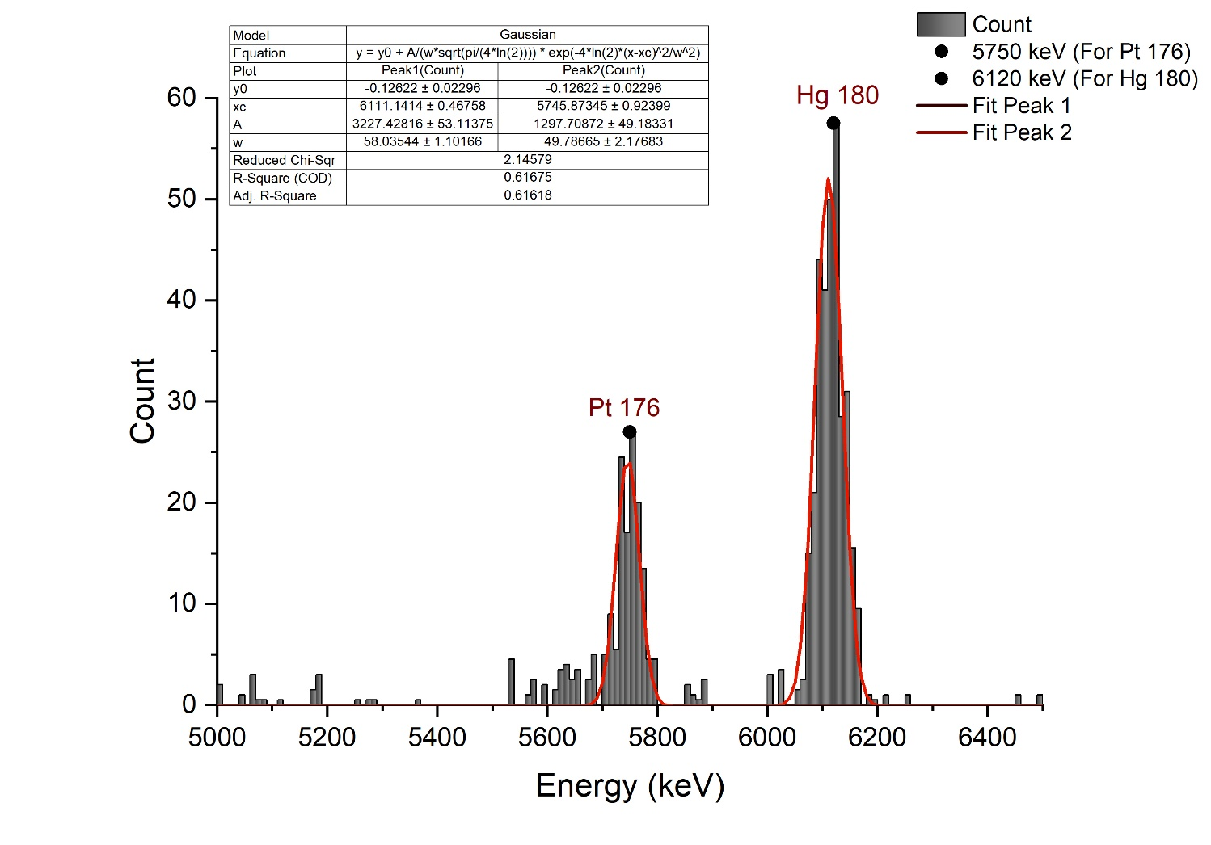
  - Hg 181
The specific isotope being discussed has a half-life of 3.5 seconds. Of its decay, 30% is attributed to alpha decay, which results in the release of 6006 keV of energy. This decay leads to the creation of a daughter nucleus, Pt-177, which has a half-life of 11 seconds. Additionally, Pt-177 undergoes alpha decay 5.6% of the time, releasing 5517 keV of energy.
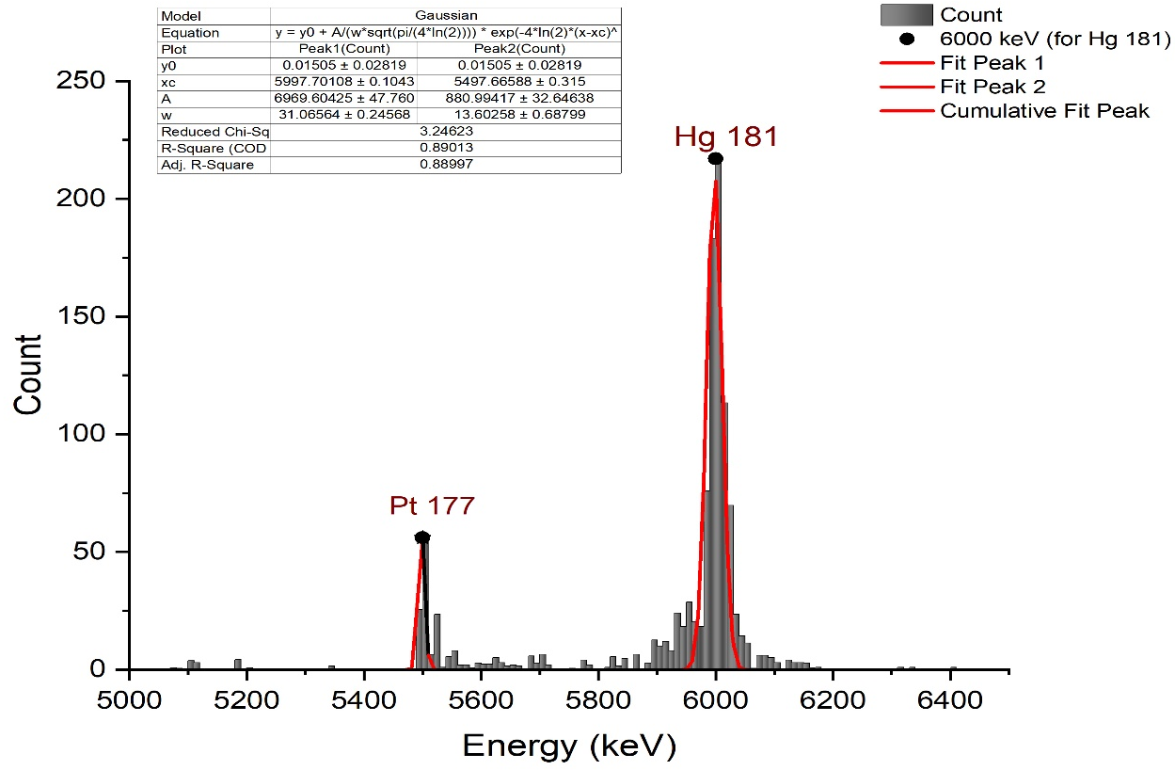
  - Hg 182
It has half-life time of 10.835 s, and it 15.2% decays by alpha of energy 5867 keV, giving a daughter Pt 178 that has half-life of 21.1 s and it 4.6% decays by alpha of energy 5446 keV.
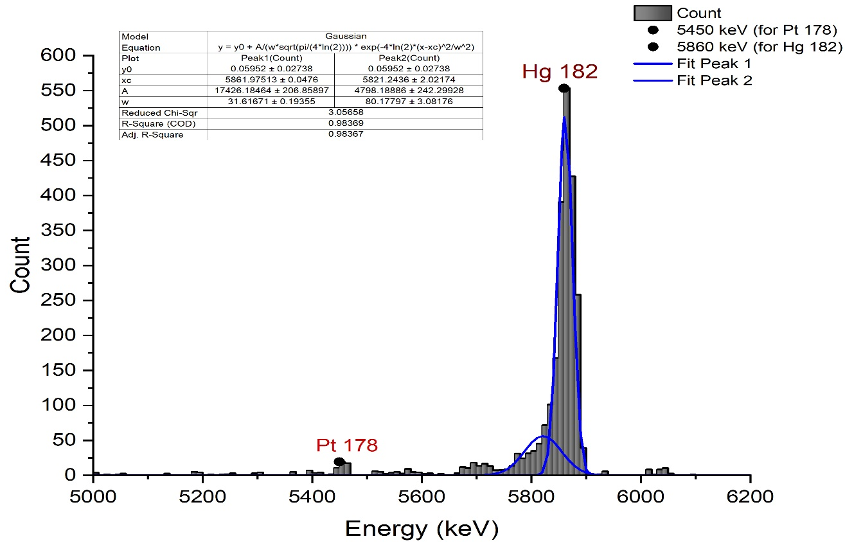
  - Hg 183
It has half-life of 9.4 s, and it decays by 11.7 % at energy 5904 keV α -Decay energy level, giving a daughter Pt 179 that has half-life of 21.1 s, and it decays by 0.24% at energy 5195 keV α -Decay energy level.
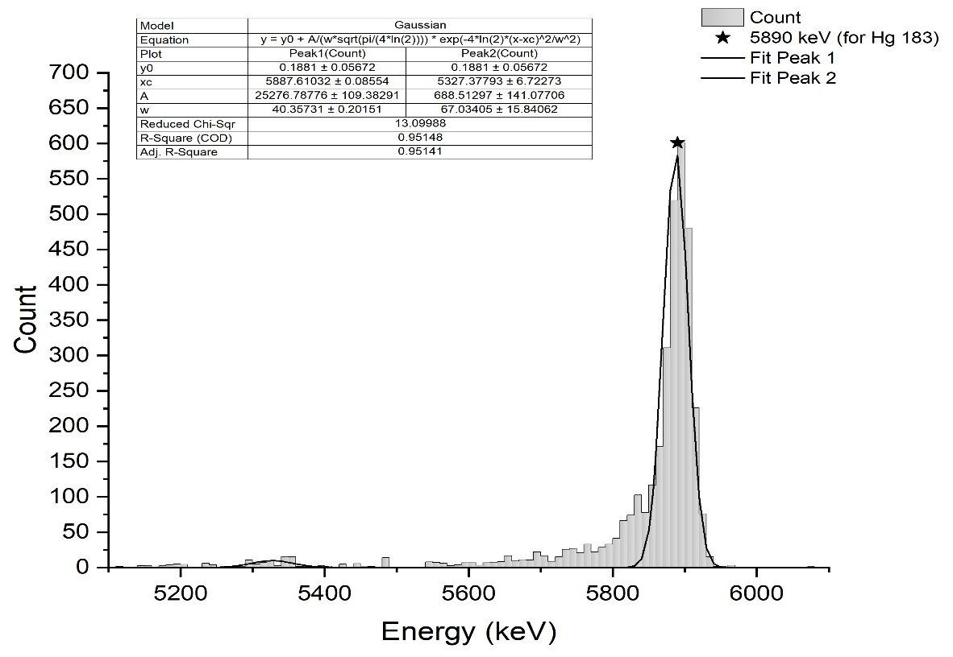
  - Hg 184
It has half-life of 30.9 s, and it decays by 1.26% at energy 5530 keV α -Decay energy level, giving a daughter Pt 180 that has half-life of 56 s, and it decays by 0.3% at energy 5140 keV α -Decay energy level.
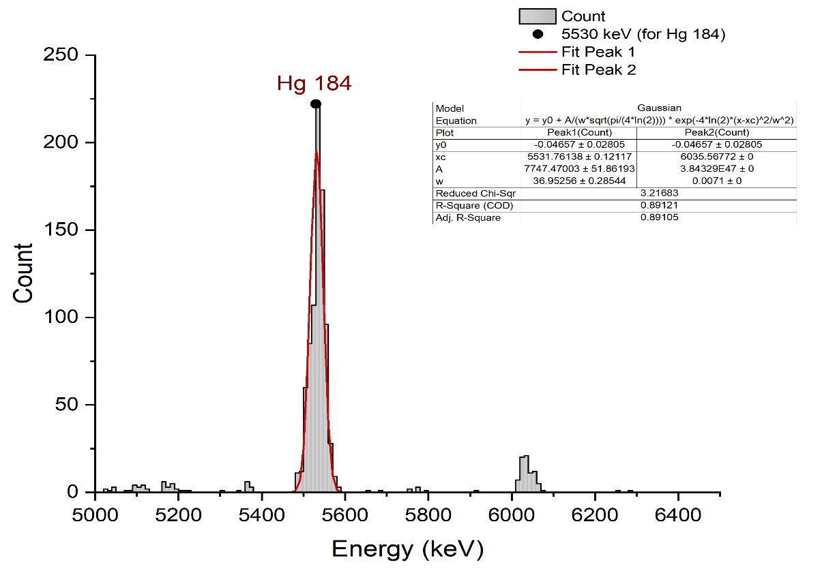
  - Hg 185
It has half-life of 49.1 s, and it decays by 16% at energy 5650 keV α -Decay energy level, giving a daughter Pt 181 that has half-life of 52 s, and it decays by 0.074% at energy 5080 keV α -Decay energy level.
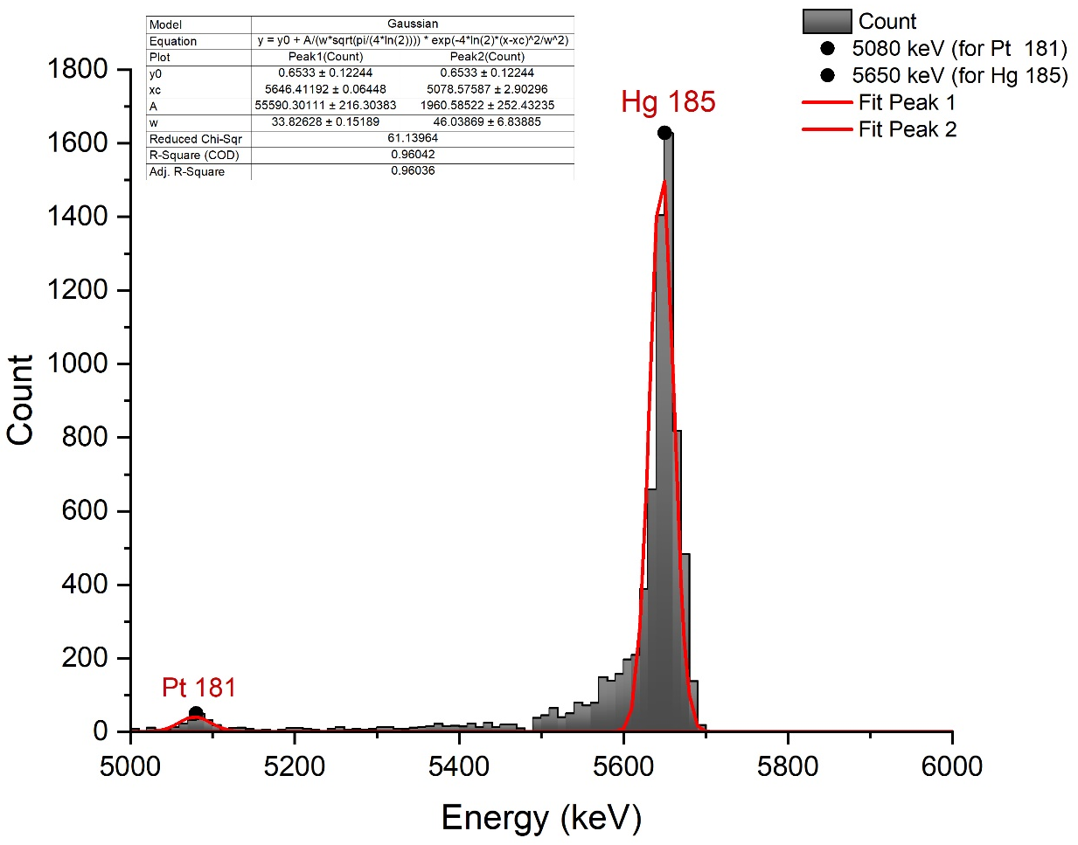

Heat contour graph map for all isotopes of mercury (180-185)
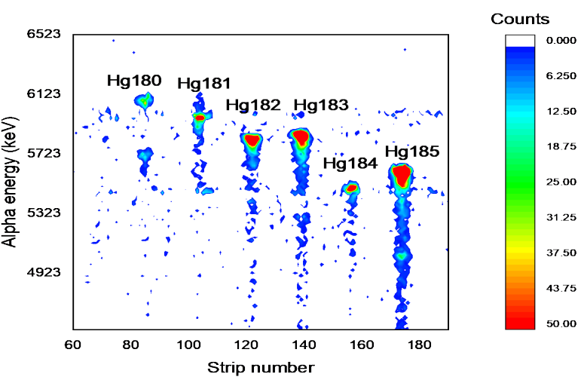
- Histograms for the fusion reaction $^{40}Ar+ ^{166}Er → ^{206-xn}Rn+xn$

  - Rn 201
The isotope has a half-life of 7.1 seconds, and 80% of it decays via alpha emission with an energy of 6725 keV, resulting in the creation of a daughter nucleus Po 197 that exhibits two distinct decay modes. The first mode, which is observed in 44% of cases, has a half-life of 53.6 seconds and emits alpha particles with an energy of 6281 keV. The second mode, which is observed in 84% of cases, has a half-life of 25.8 seconds and also undergoes alpha decay, but with an energy of 6383.4 keV.

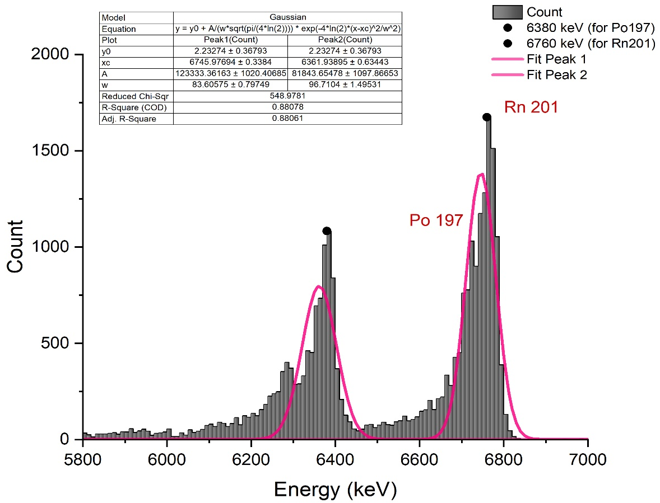

  - Rn 202
It exhibits a characteristic decay profile with a half-life of 10 seconds, whereby approximately 90% of the isotopic species undergoes alpha decay with an energy in the range of 6630 kiloelectronvolts. As a consequence of this nuclear phenomenon, there is an emergent daughter nucleus possessing atomic number 84 and mass number 198 - that is designated as Po-198 - which displays its own unique radioactive properties with a half-life estimated to be approximately1.77 minutes henceforth. The daughter Po 198, 57% decays via alpha emission with an energy of 6180 keV.

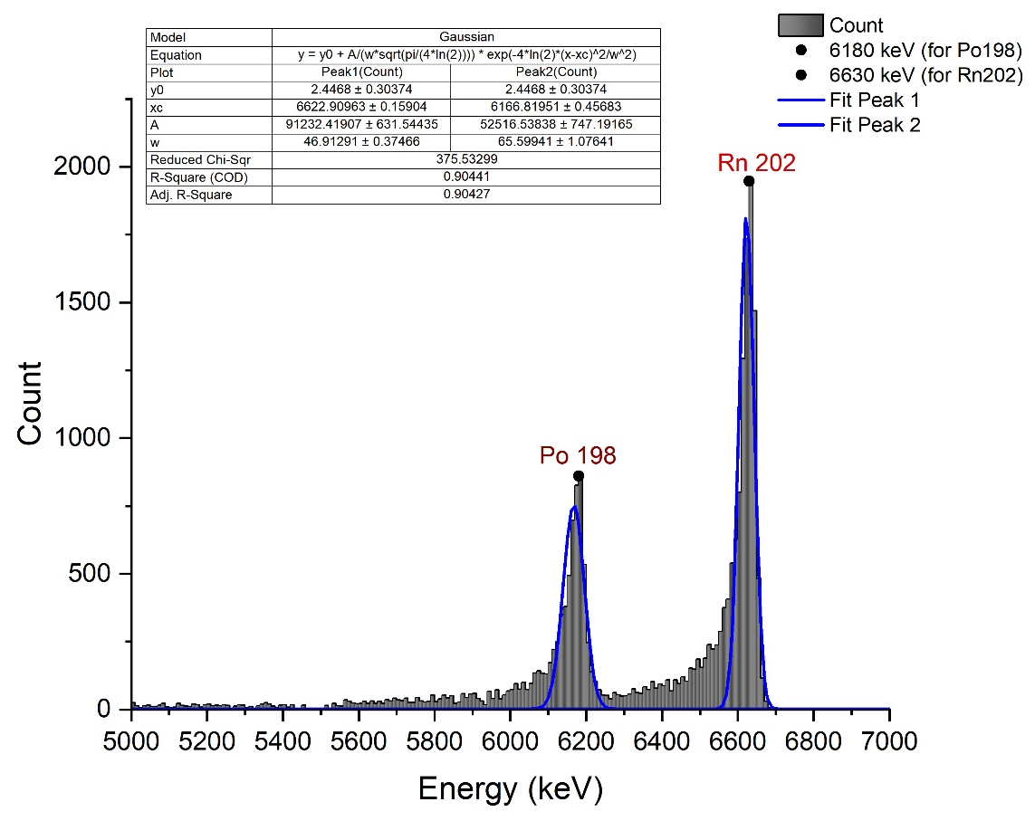
  - Rn 203
It has half-life of 45 s, and it decays by 66 % at energy 6550 keV α -Decay energy level, giving a daughter Po 199 that has a half-life of 5.48 m, and it decays by 12% at energy 5952 keV α -Decay energy level.

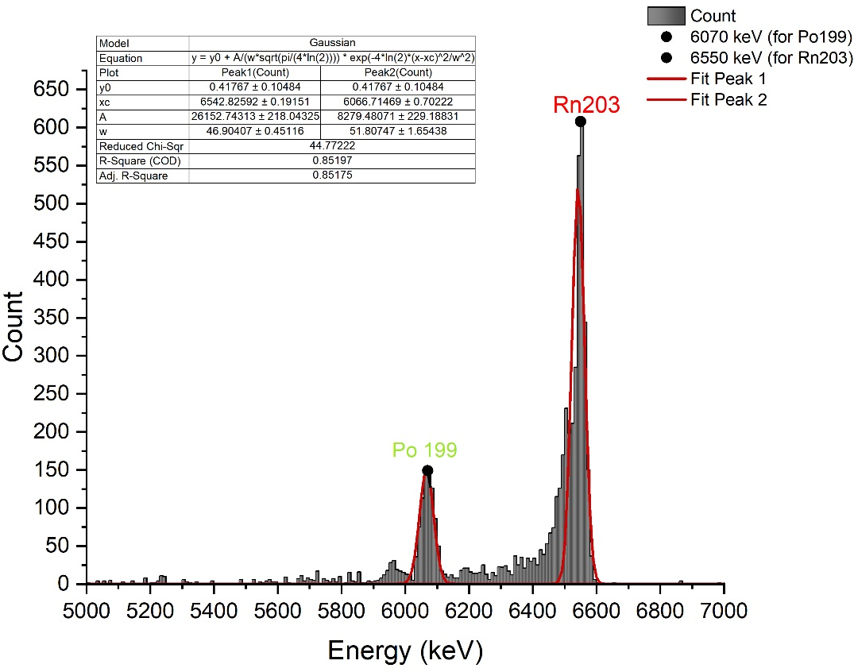
  - Rn 204
It has half-life of 1.24 m, and it decays by 73% at energy 6400 keV α -Decay energy level, giving a daughter Pt 181 that has half-life of 11.5 m, and it decays by 11% at energy 5860 keV α -Decay energy level.
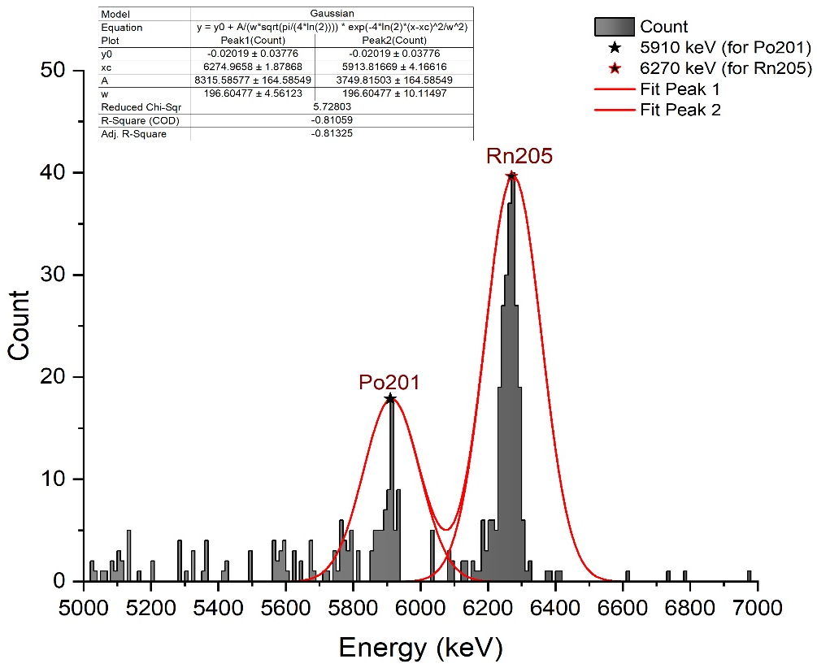
The following is the Heat contour graph map for all isotopes of Radon (201-205)
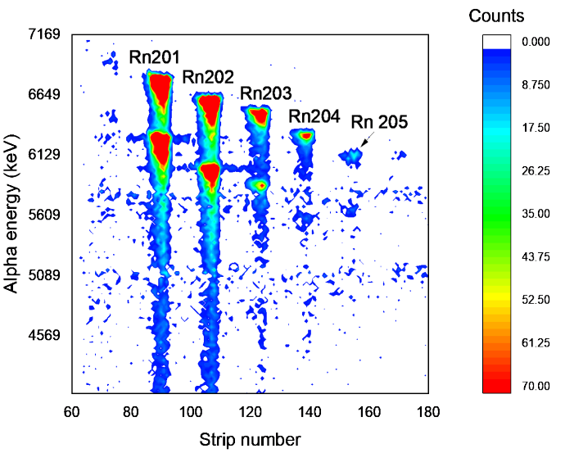
- Histograms for the fusion reaction $^{48}Ca+ ^{242}Pu → ^{21x}Rn$ –
The reaction produces various radon isotopes with mass numbers ranging from 211 to 219, which are detected in the strip detector area. Our graphs display data for only the 212, 218, and 219 radon isotopes, as the half-life of the 211, 213, 214, 215, 216, and 217 radon isotopes is very short (less than 35 ms)
  - Rn 212
This radon isotope has a half-life of 23.9 m, it decays by 100% at energy 6264 keV α -Decay energy level, giving a daughter Po 208 which has a half-life of 2.898 years, and it decays by 99.9% at energy 5114.9 keV α -Decay energy level.
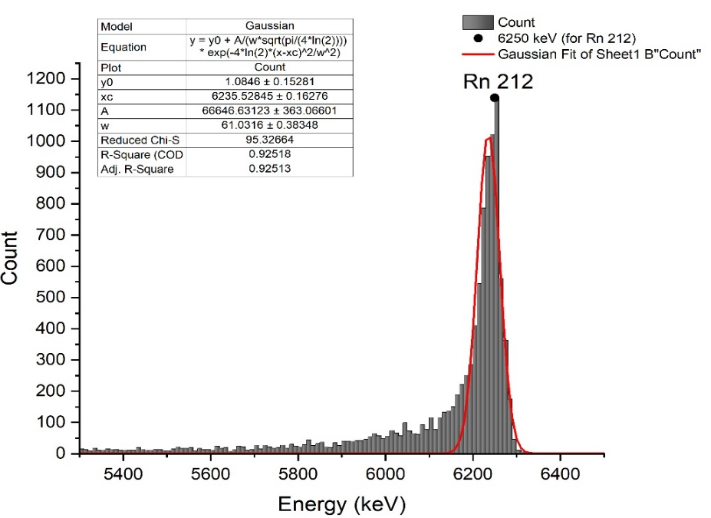
  - Rn 218
It has half-life of 35 ms, it decays by 100% at energy 7129.2 keV α -Decay energy level, giving a daughter Po 214 which has a half-life of 164.5 µs, and it decays by 100% at energy 7686.82 keV α -Decay energy level
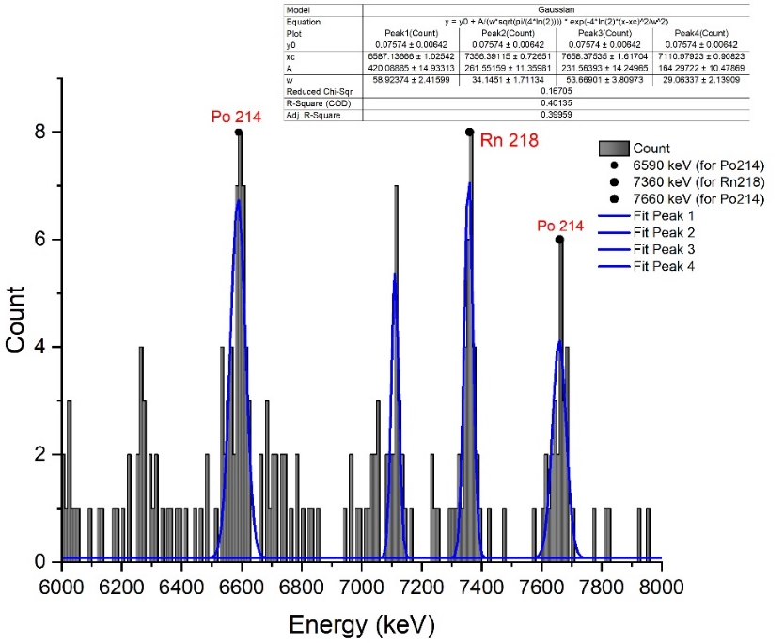
  - Rn 219
It has half-life of 3.96 s, it decays by 100% at energy 6819 keV α -Decay energy level, giving a daughter Po 215 which has a half-life of 1.781 ms, and it decays by 100% at energy 7386 keV α -Decay energy level.
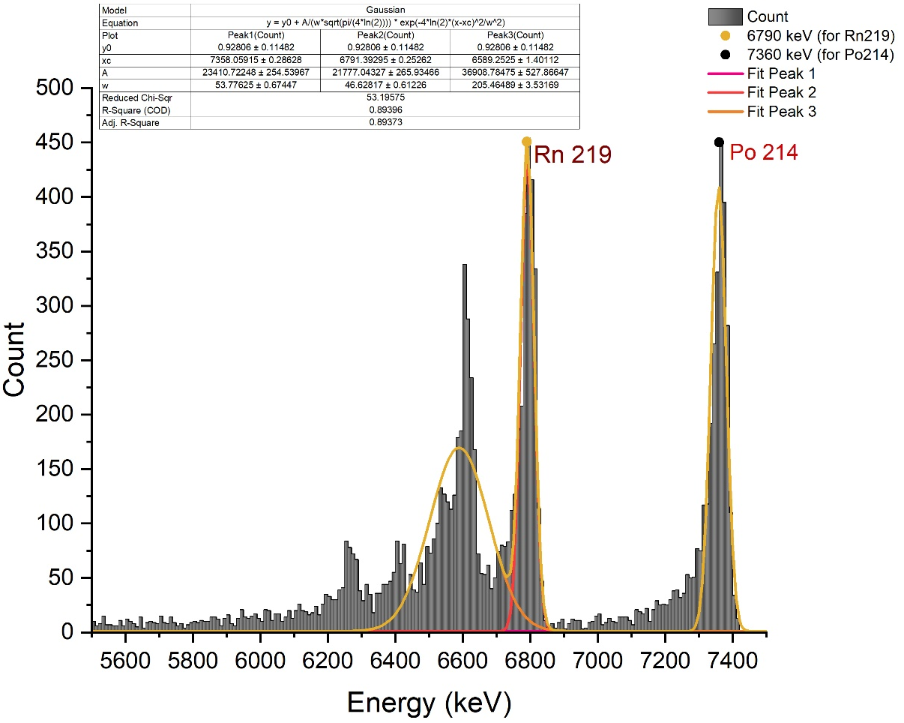
The following is the Heat contour graph map for all isotopes of Radon (212,218,219)
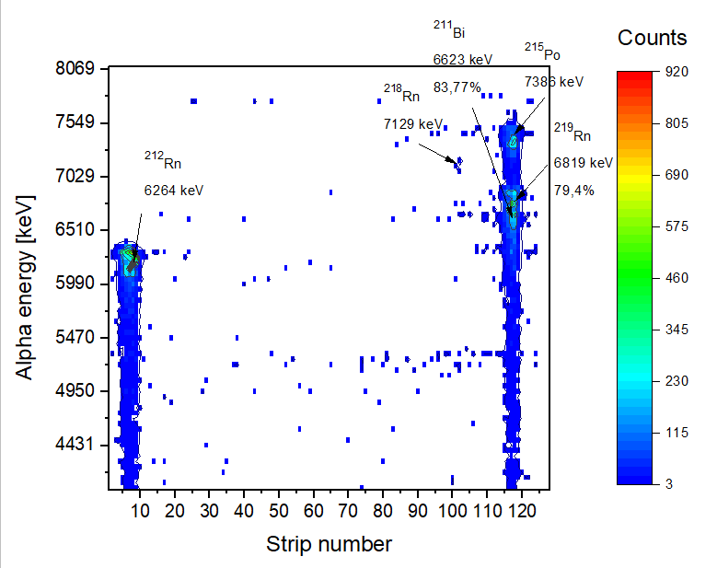

CONCLUSION

Enhancements to the MASHA Setup [6]:
Significant updates have been made to various components of the mass-spectrometer
MASHA, including the hot catcher, ECR ion source, vacuum chambers, hot transport system, and the addition of a strip detector for separation efficiency monitoring. The hot catcher now incorporates a poly-graphene heater along with thin graphene foil or carbon nanotube paper catcher to prevent heating and radiation damage. The ECR ion source has been coated with ceramic material to enable operation at high temperatures, and glass-enamel coating has been applied to detect non-volatile elements in close proximity to volatile ones.
Improvement in lon Source Configuration:
The walls of the source chamber, catcher, and transportation line have been coated with titanium nitride to enhance ionization efficiency and outgoing time. Optimizing the ECR ion source parameters, such as microwave generator power, frequency, and buffer gas pressure, is crucial for maximizing the effectiveness of the ion source.
Enhancement to Graphite Stopper:
To enhance the stability of separation efficiency in MASHA during experiments with high beam intensity, an additional graphene foil with a thickness of 0.6 mg/cm2 has been added 2.5 mm ahead of the main heater at the beam axis. The graphene foil is heated by the main heater through radiation and absorbs some of the heating load caused by the beam. It also acts as a separator for low-energy reaction products that stop inside the thin foil, while allowing the beam to pass through and deliver almost its entire energy to the graphite heater. This improvement prevents the high beam intensity from compromising the "Hot Catcher" and reducing its separation efficiency by over five times in just a few days.
Improvement in Control System:
A new modular WAGO-1/O-SYSTEM based control system has been developed, implemented, and tested for the upgraded MASHA setup. The ion source, hot catcher, and target box have been replaced with new ones based on the modular WAGO-VO-SYSTEM and integrated into a unified control system with the mass-separator. New software has been developed using LabVIEW for the control system and has undergone testing.
The study of superheavy elements plays a crucial role in advancing our understanding of nuclear reactions, as well as the potential existence of the "island of stability" - a predicted set of isotopes with significantly longer half-lives than currently known isotopes. The ISOL (Isotope Separation On-Line) method is an effective technique for obtaining high-quality beams of nuclei, which can be followed by post-acceleration. This method allows for the transport of the nuclei of interest from the production site, where background nuclear reactions are prevalent, to a well-shielded experimental setup where their properties can be investigated.
Furthermore, the ISOL method enables mass-analysis of newly produced nuclei through cooling. This transport process not only creates low-background conditions for experiments, but also purifies the beam and prepares it with the required energy, time, and ion optical properties. The MASHA setup utilizes these methods for atom separation and is continuously improved to enhance efficiency and gather more data about the atoms.
Ongoing experiments at the Masha facility focus on improving the ISOL method, construction, and materials. For instance, a spatially divided solid catcher has been implemented to eliminate heat load on the catcher material, thus enhancing separation efficiency stability. Additionally, the use of new nanomaterials such as graphene foil and carbon nanotube paper sheets has shown promising results in test experiments, exhibiting improved separation efficiency stability and reduced separation time. This opens up prospects for analyzing short-lived isotopes with greater accuracy

ACKNOWLEDGEMENT
I would like to express my sincere appreciation to the JINR Institute and the INTEREST team for organizing this online program and giving me the opportunity to participate in this project. I am especially grateful to Mr. Vedeneev Viacheslav Yurievich, who has been a kind and supportive project supervisor. Despite facing health challenges, he has displayed exceptional patience in explaining complex concepts and providing me with all the necessary project-related information. Additionally, I would like to extend my thanks and gratitude to my project colleague, Mr. Piyush who has been a great help & support in this project.

REFERENCES
[1] C. Moskowitz, "Superheavy Element 117 Points to Fabled "Island of Stability" on Periodic Table," Scientific American, 2014.
[2] P. V. Duppen, "Isotope Separation Online and Post Acceleration," Springer-Verlag Berlin Heidelberg, pp. 37-77, 2006.
[3] A.M. Rodin, A.V. Belozerov, E.V. Chernysheva et al., "Separation efficiency of MASHA facility for short-lived mercury isotopes," Hyperfine interact, vol. 227, pp. 209-221, 2014.
[4] V. Yu. Vedeneev1 · A. M. Rodin1 · L. Krupa1,3 · A. V. Belozerov1 ·..., "The current status of the MASHA setup," Springer International Publishing Switzerland, 2017.
[5] Heinz W Gӓggeler. Mendeleev’s principle against Einstein’s relativity: news from the chemistry of superheavy elements. Russian Chemical Reviews, 78(12):1139, 200
[6] V. Yu. Vedeneev1 · A. M. Rodin1 · L. Krupa1,3 · A. V. Belozerov1 ·..., "The current status of the MASHA setup," Springer International Publishing Switzerland , 2017.

