JOINT INSTITUTE FOR NUCLEAR RESEARCH
Dezhelepov Laboratory of Nuclear Problems

FINAL REPORT ON THE
INTEREST PROGRAMME

Radiation protection and the safety of Radiation Sources

Supervisor:
Dr. Said AbouElazm
Dzhelepov Laboratory of Nuclear Problems.
JINR ,Dubna-Russia

Student:
Sarah Salem Al-Bishi
Student at SCFHS

Participation period:
February 14– March 26,
Wave 8

Russia, Dubna, 2023

- Introduction
  - Radiation protection and dosimeters:
There are types of radiation the first type non-ionizing radiation ,it means radiation that does have sufficient energy that does not remove electrons from their orbit of atom such as : microwave, ultraviolet, light ,laser , infrared light and radiowaves . While the ionizing radiation that has sufficient energy to eject electrons from the orbit such as alpha particles, beta particles, neutrons, gamma ray and X-ray.
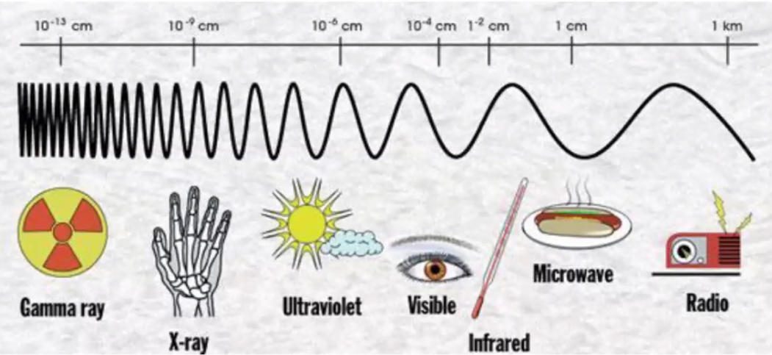

Figure1.1 Radiation spectrum for ionizing and non-ionizing radiation.

  - Dosimeters and the effective dose of radiation.
Radiation dosimeters is the measurement and calculation and assessment of ionizing radiation dose .
The amount of of radionuclide present it’s called activity the unit of activity is SI , unit is the (Bq) and the old unit is Curie (1 Ci = 3.7×10¹⁰ Bq ). There are number of factors that must be taken to calculating the quantity of radiation dose of person received including the strength of the source and the nature of the radiation and the biological sensitivity and the exposure factors such as shielding from the source , and distance and time .
The Radiation dose when using specifying dose of radiation will be effect on the human body . The most frequently used dose measurement are effective dose , equivalent dose and absorbed dose.
0-50 mSV | No visible effect
500 mSV | Reversible blood change
1 SV | Mild illness, fever
3 SV | Vomiting , hair loss
4.5 SV | Bone marrow destruction
6 SV | First and second degree burns
10 SV | Death in 3-5 days

Figure 1.2 table of effective of radiation dose.

1.3 Pixel Detector
It is an advantage detector like a digital camera . It consist of 3 parts (sensor-electronic chips -USB .
The size of sensor is 1.5x1.5cm and it has 256x256 pixels and it`s high resolution and used to record different type of radiation such as X-Ray , gamma, electron , neutron and charged particles.
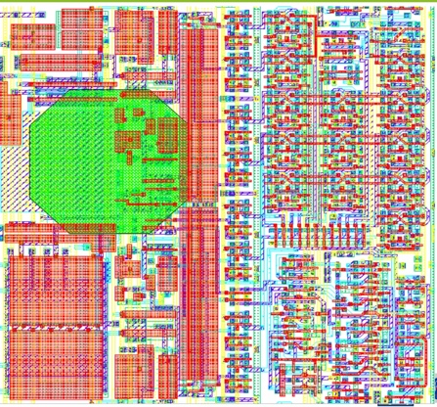
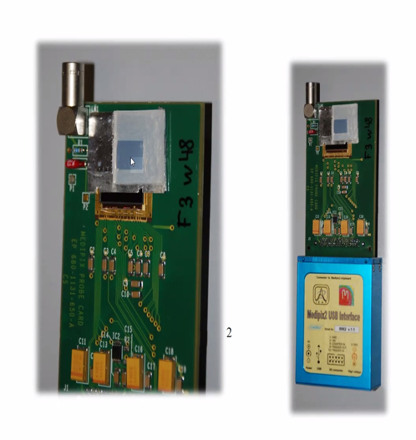
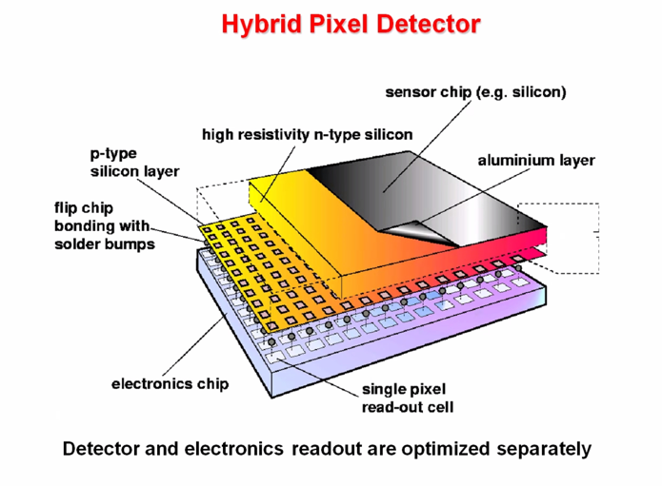
Figure1.3 schematic of pixel detector

Uses of pixel Detector in Medical Imaging , space dosimetry , education , high energy physics and Material analysis.
- Medical Imaging : the Medipix chips that implement on-pixel single photon counting. The technology has been applied in x-ray , mammography , CT scan and for beta, gamma ,autoradiography of biology sample with the Medipix . The image of x-ray it’s clear and more accurate image that help detectors give more accurate of radio-diagnostic image .
- Space dosimetry : CERN . Where the Medipix technologies were born , has a lot in common with space missions . They both deal with extreme environment . Timepix is being exploited for radiation monitoring in NASA`s Orion rocket and the international space station .
- Education : it`s especially designed for classroom use Timepix was put on the market can detected the ionizing radiation in real time
- High energy physics: the Medipix family roots extend deep into the tunnels of CERN . LHC and high energy physics originally developed for physics . They found their way to medical imaging and then came back for second run of the LHC. The chips are now being used in ATLAS experiment to provide real time information about radiation environment.
- Material analysis: Medipix2 and Medipix3 chips are both being used for commercial x-ray of material analysis .

  - Project goals.
To preform the radiation protection and measurement of the resolution by using BGo and NaI detector and use different radiation sources to calculate the resolution Co-60 and Cs-137 and find the attenuation coefficient with different thickness material Al and Cu . The experiment of measure the Alpha range in air by using source of radiation Plutonium-239 (Po-239).

Radiation dose | Type of radiation and half-life
Cesium-137 | Gamma ( half-life 30.1 years)  Beta ( half-life 5.27 years)
Cobalt-60 | Gamma (half-life 5.27 years)  Beta (half-life 138 days)
Plutonium-239 | Alpha (half-life 24.110 years)

Figure1.4 table of radiation source that we use it to measurement in this project.

2-Method.

The research project over period 14 February to 26 March 2023 have been cover of radiation protection and safety of radiation source by some types of detectors used in measure the level of energy by different source of radiation with different applied voltage and the detector to measure the resolution of detectors BGo and NaI .
and make plot and analysis by using Roots software .
Use SRIM to Experiment by equipment ( source Pu239 with energy 5.5 Mev – detector plastic -applied volt about 2000 V ) . Use pixel detector determine the range of Alpha particles with (Am-241) energy about 4 MeV in air using pixel detector .

3-Result .
3.1 Task 1
- Resolution of the BGo detector for every applied volt and make plot
- Relation between the applied volt and resolution of the detector.
Resolution (R) = (sigma/ mean)*2.35
Resolution % = (R) *100

- 12-Co60_BGo with applied volt 1200v
R=(sigma/mean)*2.35
R= (.590707/1.42853)*2.35=.97175
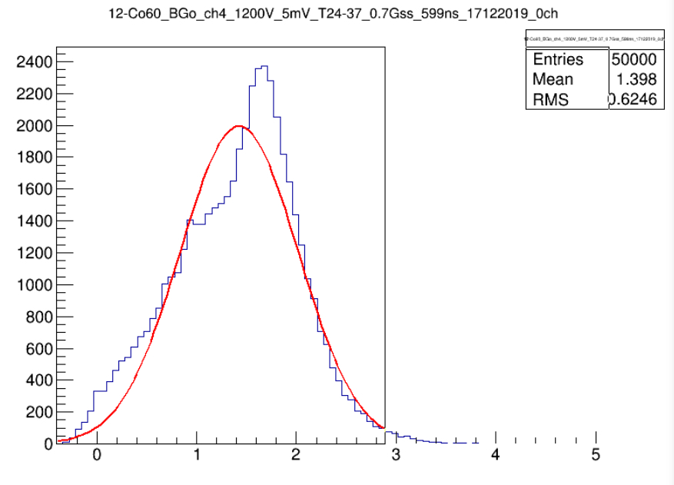
R%=.97175*100=97.17%

- 13-Co60_BGo with applied volt 1300
R=(sigma/mean)*2.35
R=(0.32072/1.41727)*2.35=0.53179
R%= 0.53179*100= 53.17%
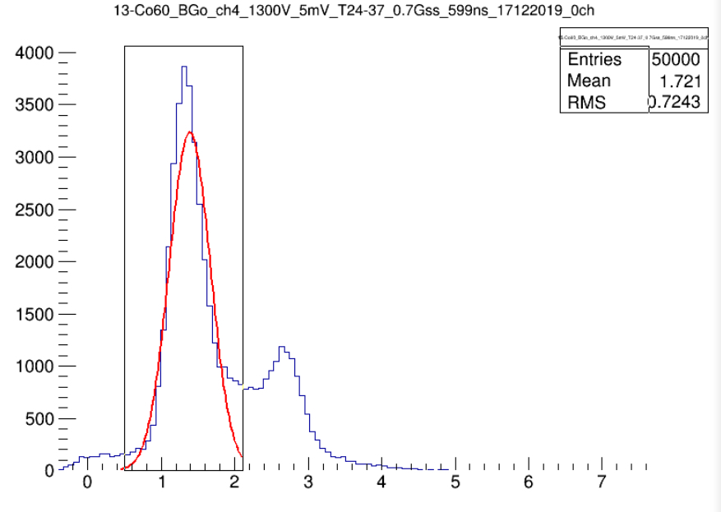

- 14-Co60_BGo with applied volt 1400
R=(sigma/mean)*2.35
R=(0.29499/1.92404)*2.35=0.36019
R%=0.36019*100=36.01%
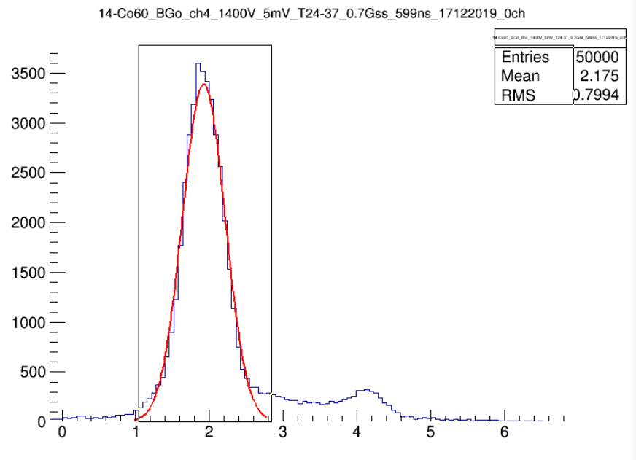

- 15-Co60_BGo with applied volt 1500
R=(sigma/mean)*2.35
R=(0.465/2.984)*2.35=0.36620
R%=0.36620*100=36.62%
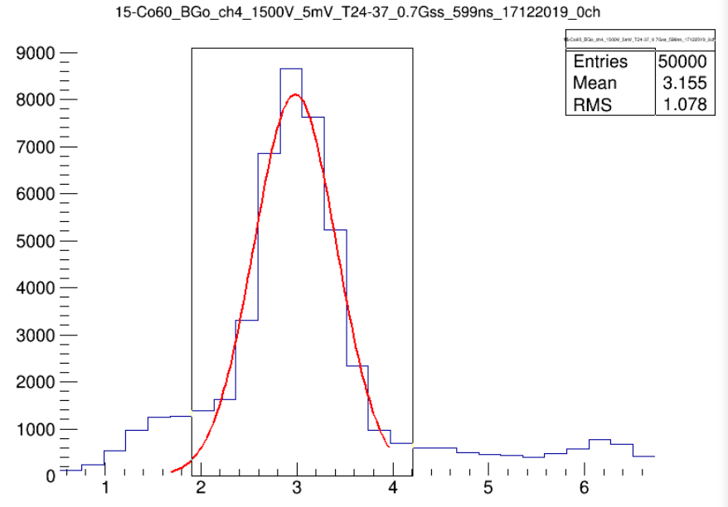

- 16-Co60_BGo with applied volt 1600
R=(sigma/mean)*2.35
R=(0.666/4.400)*2.35=0.355
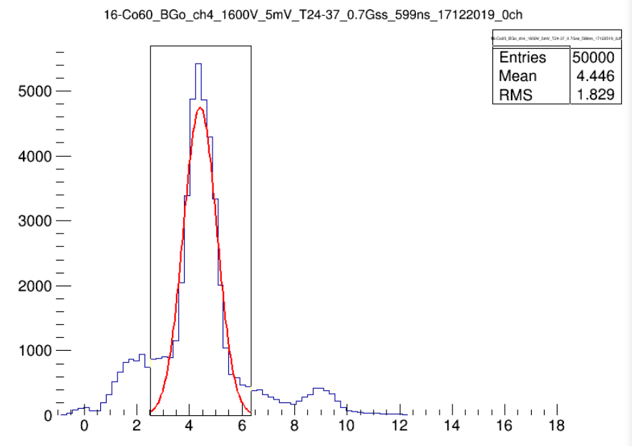
R%=0.355*100= 35.57%

- 17-Co60_BGo with applied volt 1700
R=(sigma/mean)*2.35
R=(0.848/6.083)*2.35=0.3276
R%=0.3276*100=32.76%
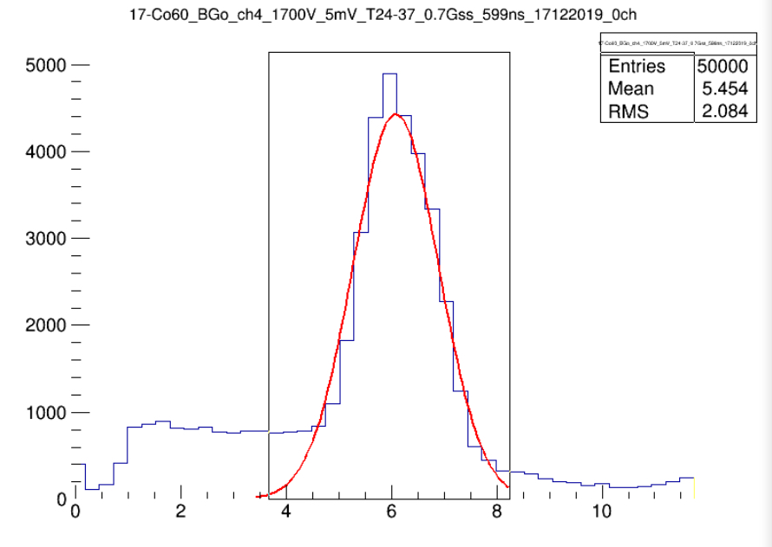

- 19-Co60_BGo with applied volt 1900
R=(sigma/mean)*2.35
R=(1.2326/10.6035)*2.35=0.2730
R%= 0.2730*100= 27.30%
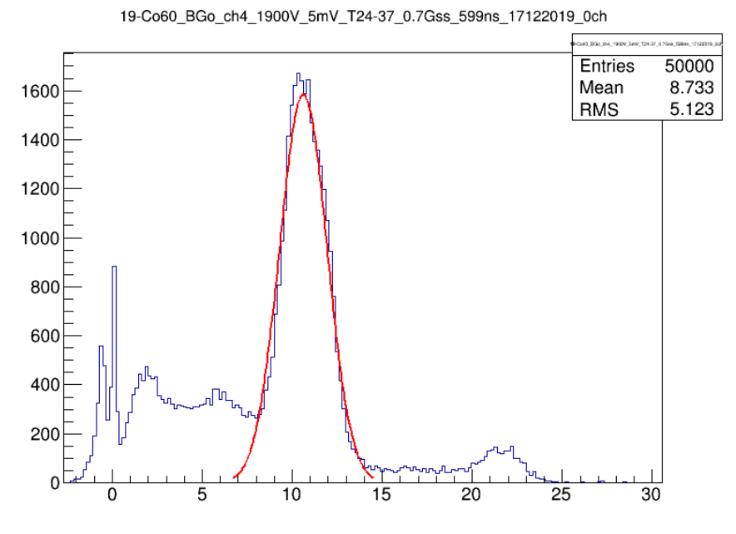

- 20-Co60_BGo with applied volt 2000
R=(sigma/mean)*2.35
R(1.684/13.548)*2.35=0.2921
R%=0.2921*100=29.21%
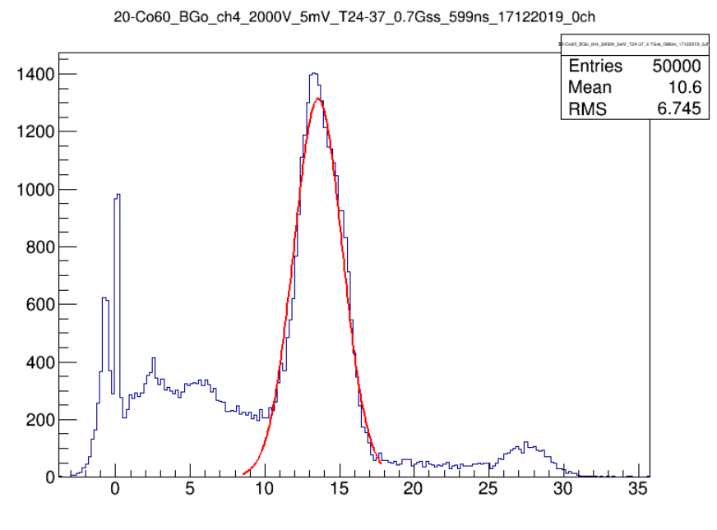

-Relation between the applied volt Vs resolution of detector

Applied voltage | Sigma | Mean | Resolution %
1200 | 0.0590707 | 1.42853 | 97.17%
1300 | 0.32072 | 1.41727 | 53.17%
1400 | 0.29499 | 1.92404 | 36.01%
1500 | 0.465 | 2.984 | 36.62%
1600 | 0.666 | 4.400 | 35.57%
1700 | 0.848 | 6.083 | 32.76%
1900 | 1.2326 | 10.6035 | 27.30%
2000 | 1.684 | 13.548 | 29.21%

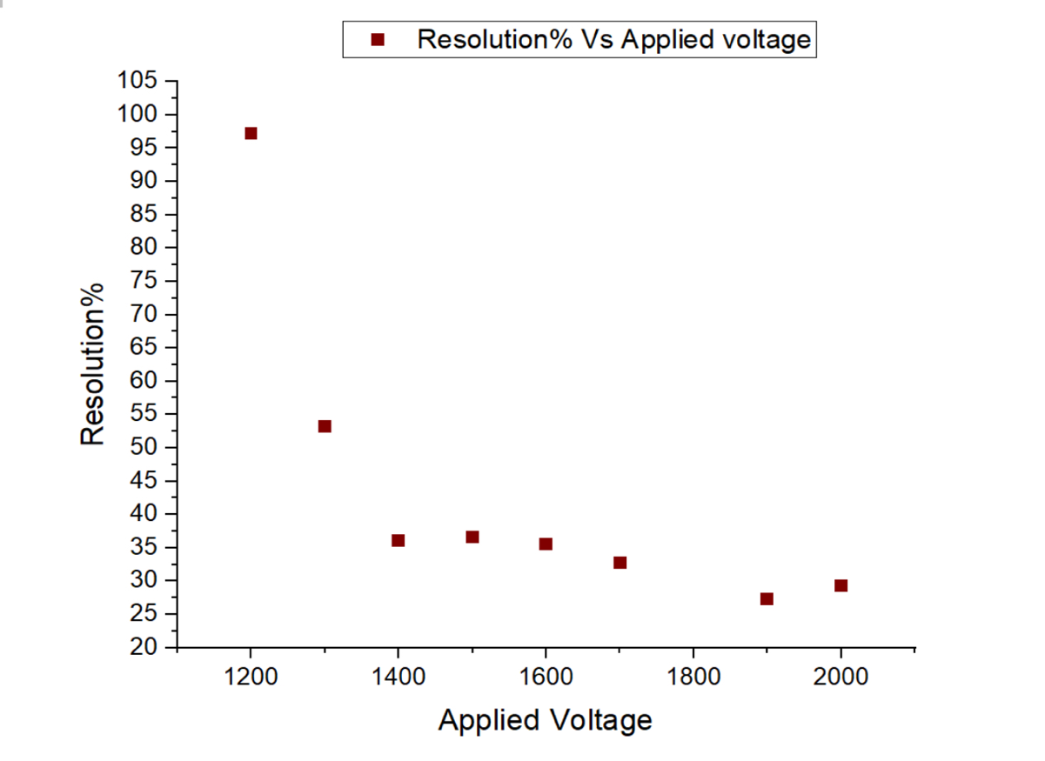

BGo detector calibration

- 28-PMT1_TI204-10mV-900V . Unknown source .
Means(channel number)=0.5814
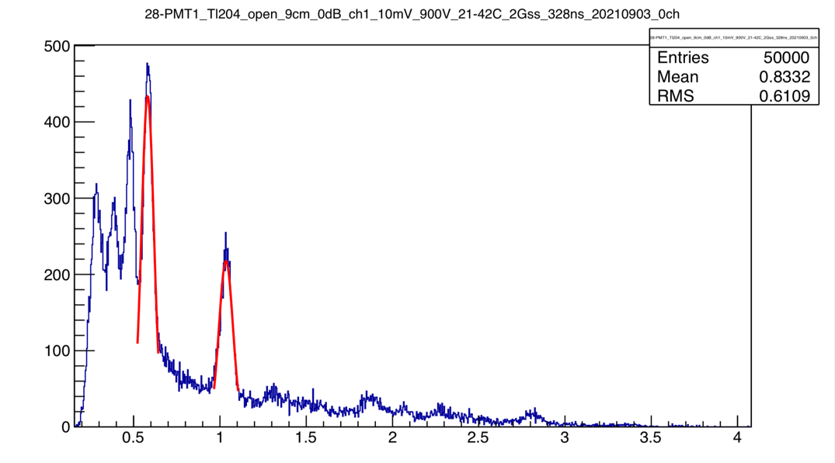

2)23-Co60+Cs137_side_BGo Ch4_2000v
-Cs137 energy spectrum = 6.4745
- Co60 energy spectrum ( 1170 and 1332)
1170+1332=2502
2502/2=1251 Kev
The energy of Cs137+Co60=1251KeV

Energy | Channel number(mean)
Cs (662) KeV | 6.4745
Co60 (1251)KeV | 12.2631
Co60*(2500)KeV | 24.3561

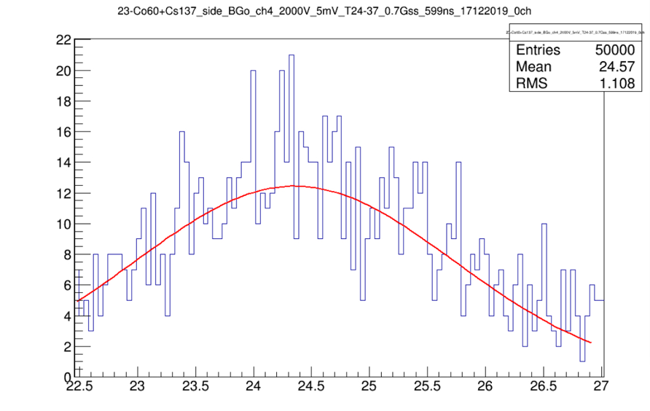
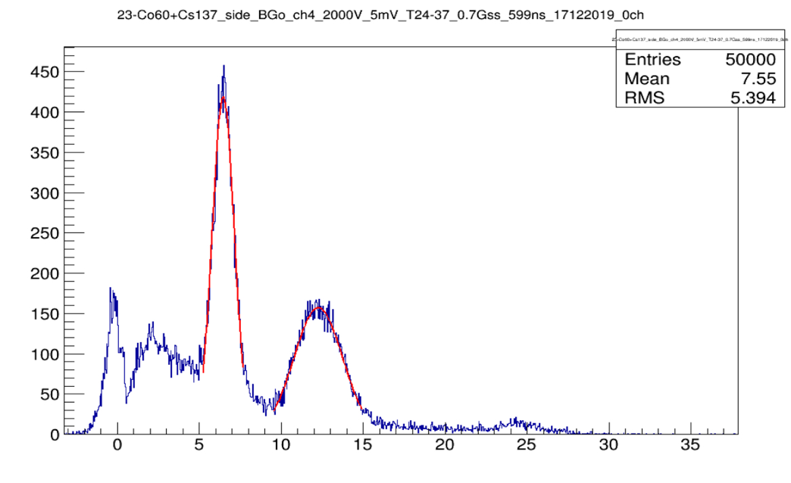
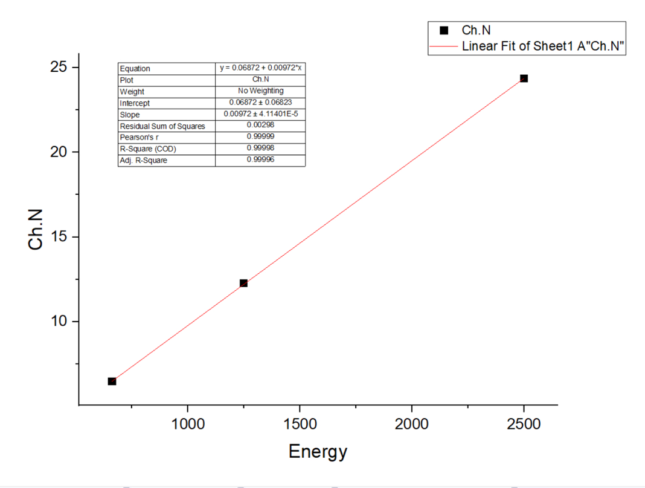

3.2 Task 2
1-Relation of resolution against Applied voltage for NaI detector.
R=sigma/mean*2.35
R%=(sigma/mean*2.35)*100

Applied voltage | Sigma | Mean | Resolution | Resolution(%)
900 | 0.5977 | 23.6737 | 0.0593 | 5.93%
1000 | 0.9656 | 40.654 | 0.0558 | 5.58%
1100 | 1.510 | 65.802 | 0.0539 | 5.39%
1200 | 2.056 | 98.723 | 0.0489 | 4.89%
1300 | 0.0163 | 1.105 | 0.0347 | 3.40%

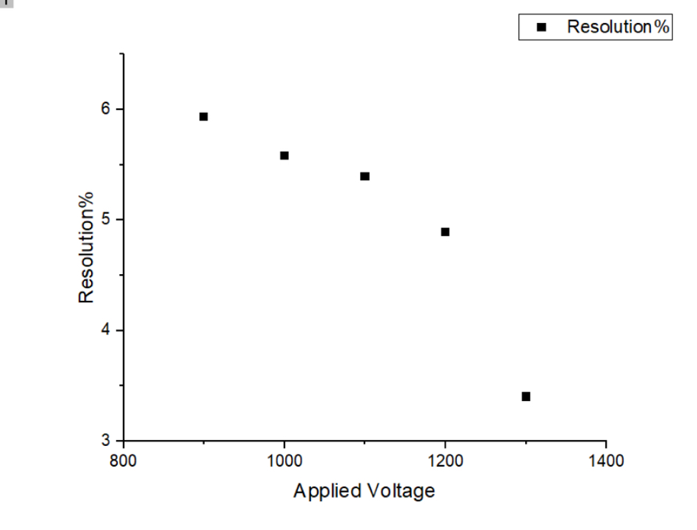

- 2-Co60_NaI_ch4_900v
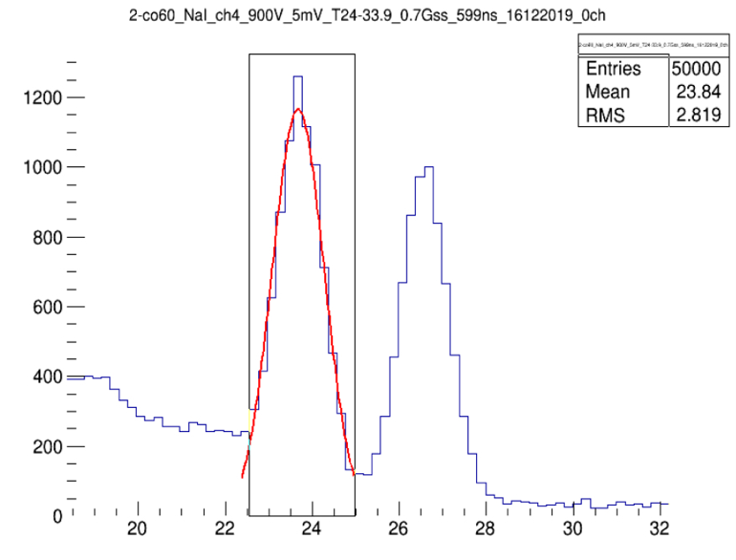

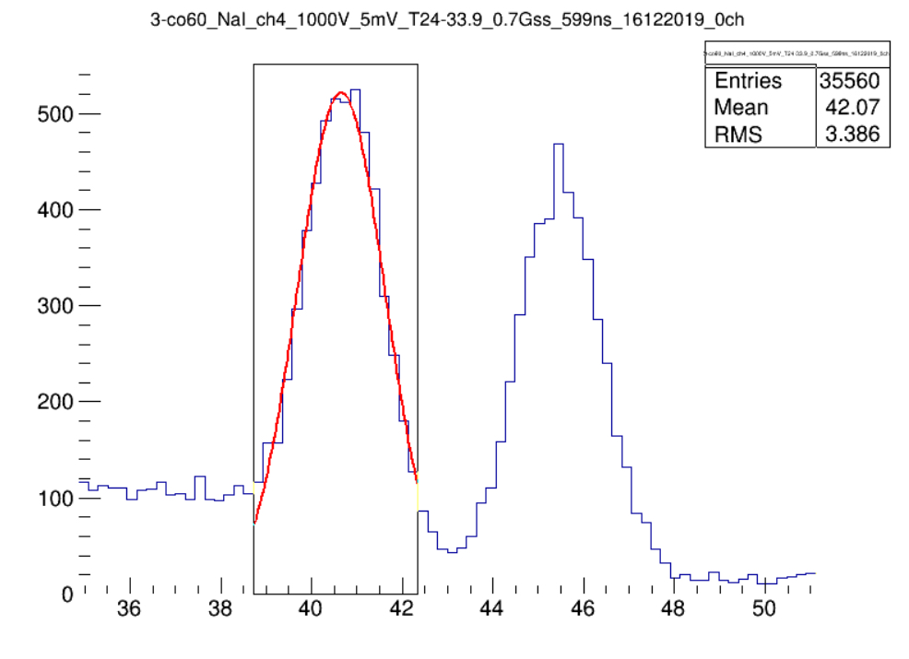
- 3-Co60_NaI_1000Kev
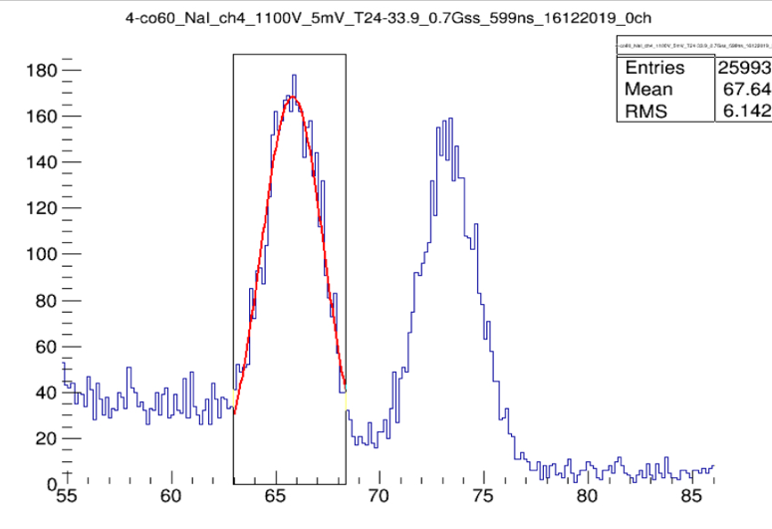
3)4-Co60_NaI_ch4_1100v

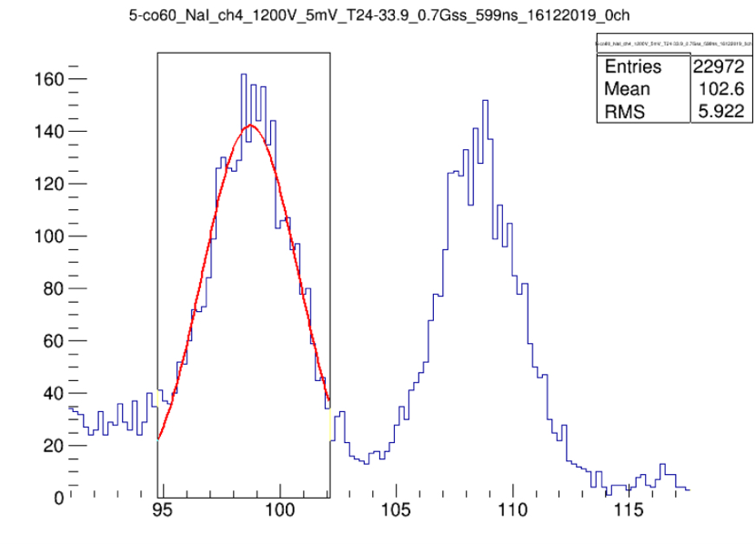
4)5-Co60_NaI_ch4_1200v

5)6-Co60_NaI_ch4_1300v

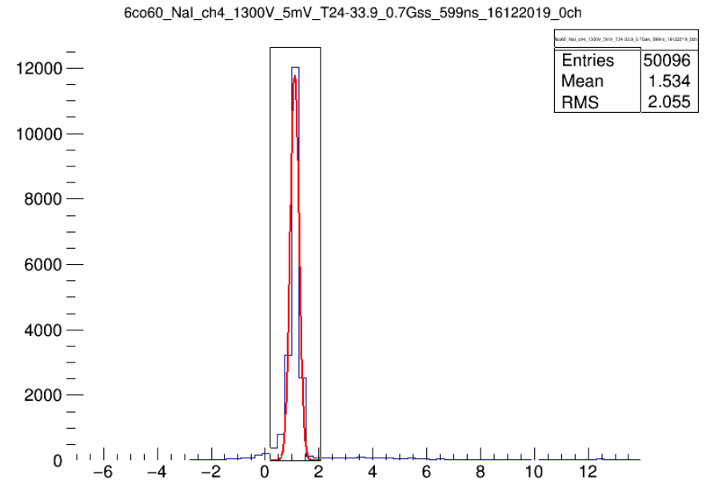

6) 9-Am241_NaI_ch4_800v
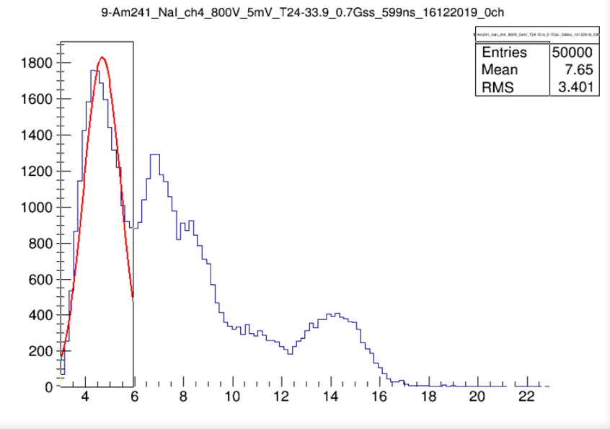
R=0.7609/4.688*2.35=0.3755*100=37.55%

7)Co60+Cs137_NaI_ch4_800v

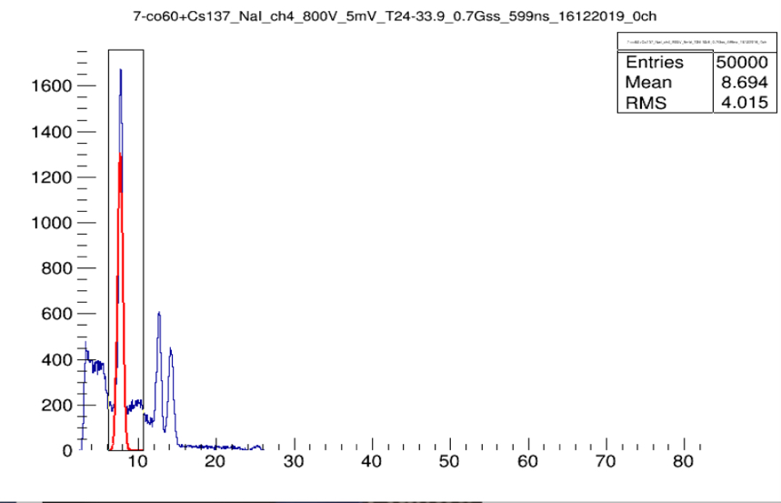
-Cs137 energy 667KeV

- Co60 energy 1251KeV
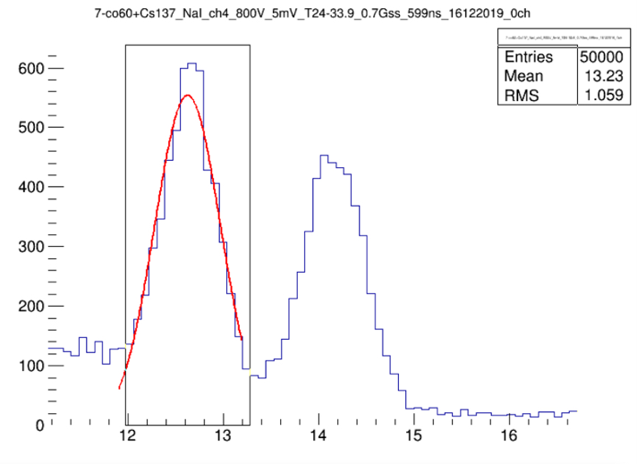

-Co60* energy 2500Kev.
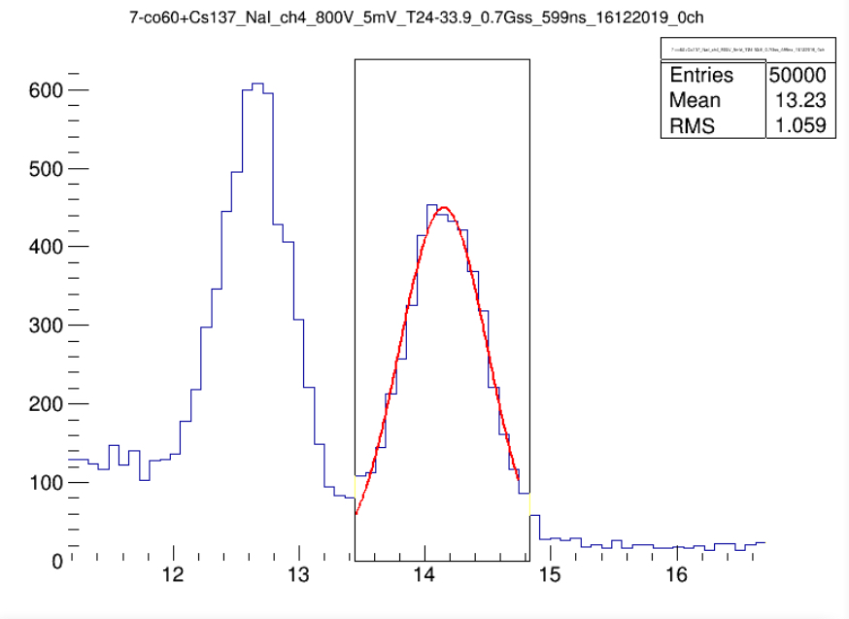

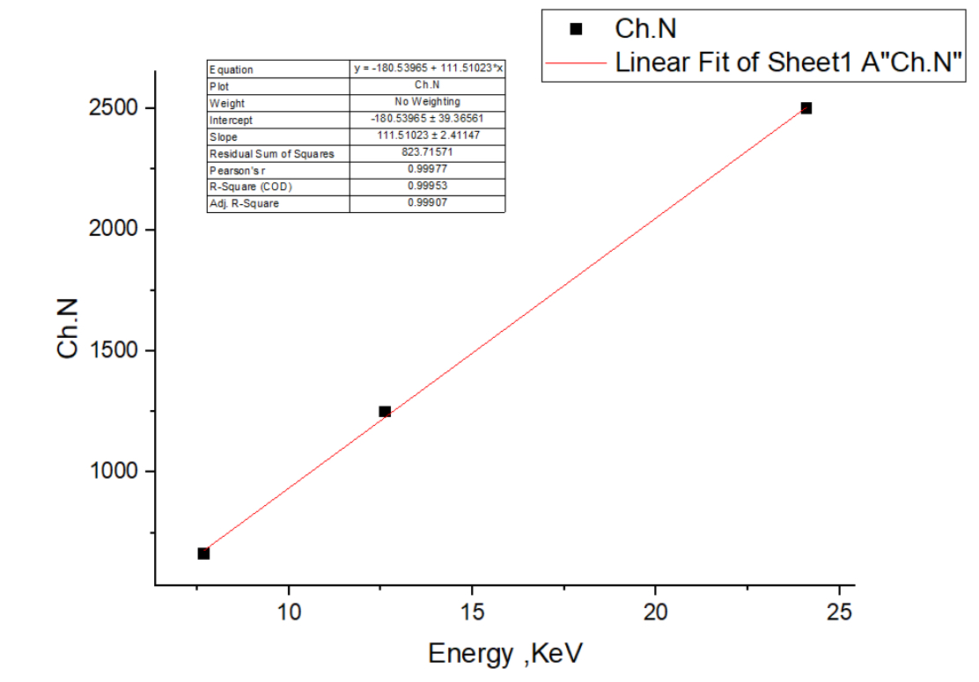

3.3 Task 3
Attenuation coefficient:
Describes the fraction of a beam that is absorbed or scattered per Unit thicknesses of the absorber.
𝐼 = 𝐼𝑜 ∗ e (−𝝁 ∗ 𝑥)
𝑰/ 𝑰𝒐 =𝒆 (−𝝁∗𝒙)
𝒙 = thickness in cm
𝝁 = absorb coefficient
𝐼 = intensity without shield
𝐼o= intensity with shield
- Attenuation coefficient for (Al)
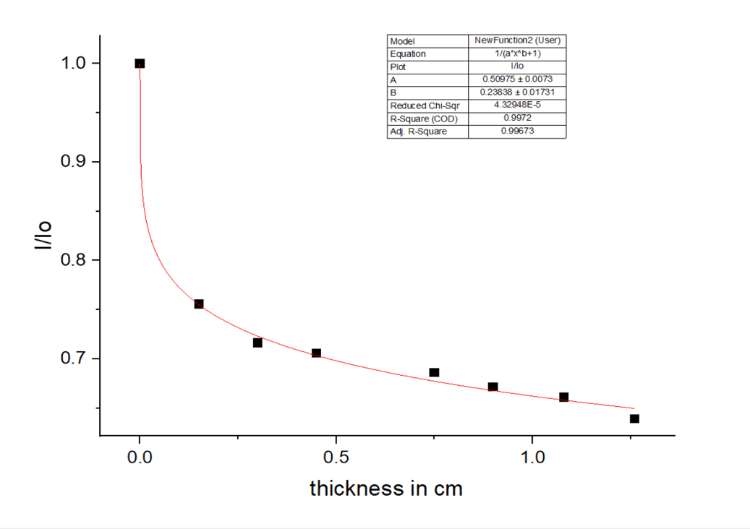
I/Io | Thickness in cm
1 | 0
0.75573 | 0.15
0.71623 | 0.3
0.70569 | 0.45
0.68596 | 0.75
0.67155 | 0.9
0.66103 | 1.08
0.6393 | 1.26

Linear Coefficient for Al by using BGo detector with Source of radiation Cs137(661keV) with different thickness
𝝁 (B-function) =0.23838 (+-) 0.01731

2-Attenuation Coefficient For Cu
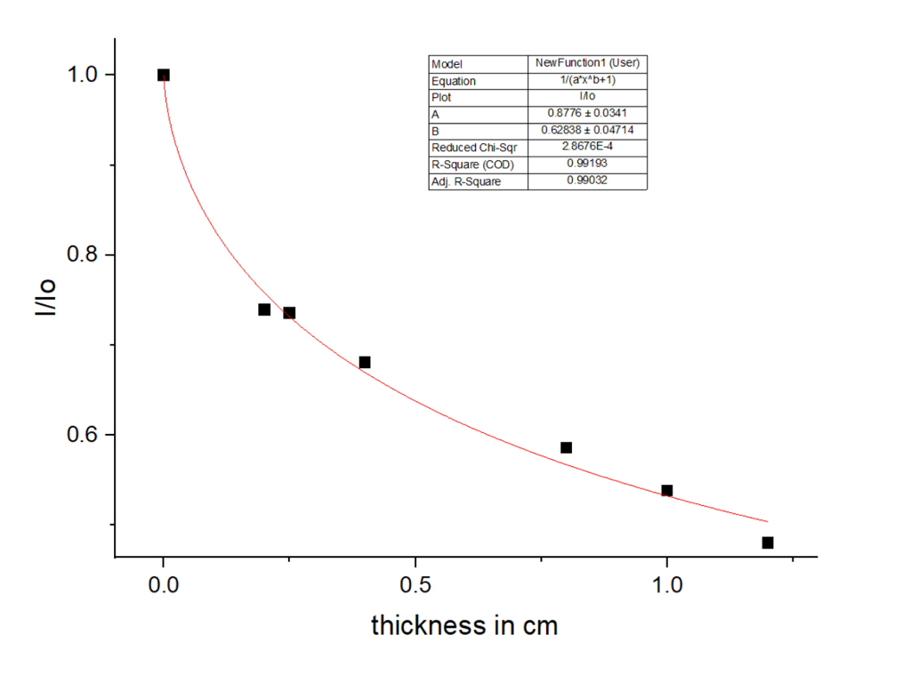
I/Io | Thickness in cm
1 | 0
0.73931 | 0.2
0.7357 | 0.25
0.68065 | 0.4
0.58611 | 0.8
0.53827 | 1
0.48042 | 1.2
Linear Coefficient for Cu by using BGo detector with Source of radiation Cs137(661keV) with different thickness
𝝁 (B-function) =0.62838 (+-) 0.04714

3.4 Task 4
1-Alpha range in air by experiment .
-experiment equipment.
1-source Pu239 , the energy (5.5) MeV.
2-Detector plastic .
3-Applied volt 2000 V.

Count/Sec | Distance/cm
440 | 0
390 | 0.5
360 | 1
340 | 1.5
320 | 2
300 | 2.5
280 | 3
260 | 3.5
260 | 3.8
260 | 4

The range alpha particle producing from measurement with plastic detector at applied voltage 2000 V with radiation source Pu-239 with energy about 5.5 MeV at range(R) 3.5 cm.
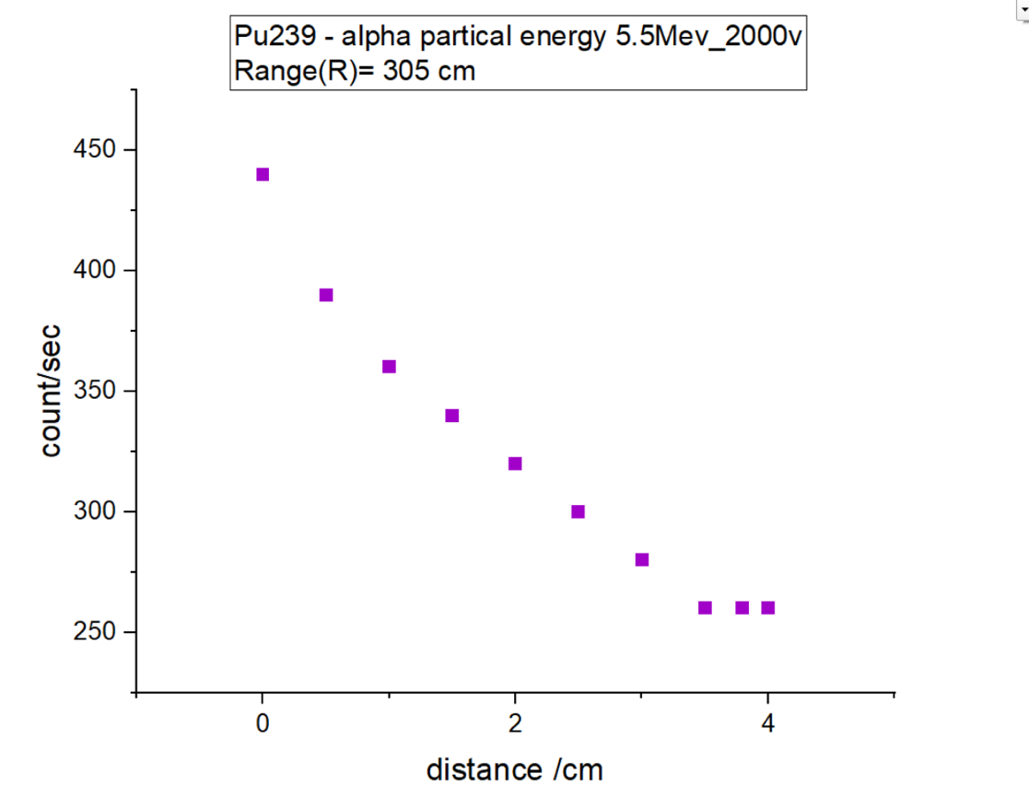

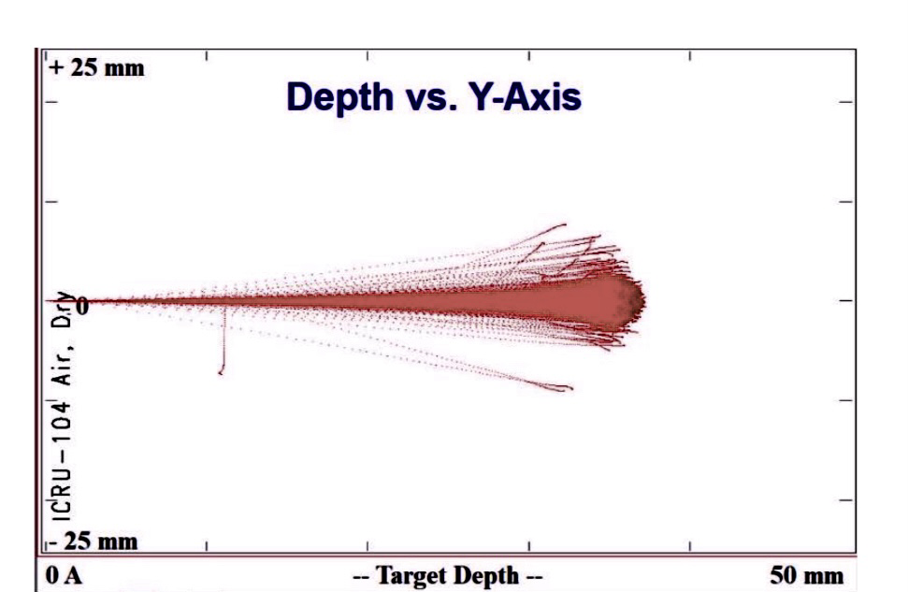

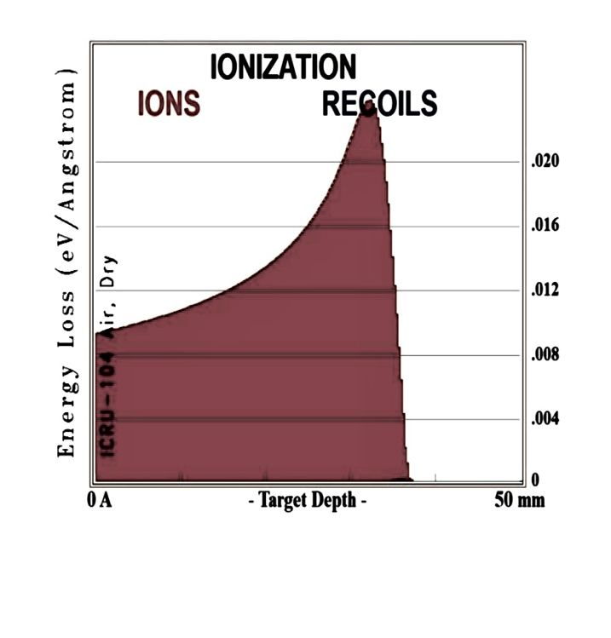
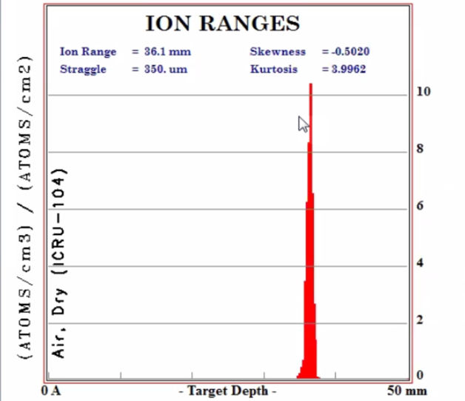
- Depth for Alpha radiation (He) Ion 4.003 amu and (H) Ion 1.008 amu at distance 3.5 cm in Dry air .
- Ionizing Radiation depth of alpha particle in air dry at 3.5 cm

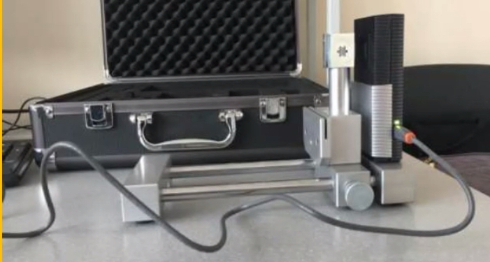
2-determine the range of Alpha particles with (Am-241) in air using pixel detector .

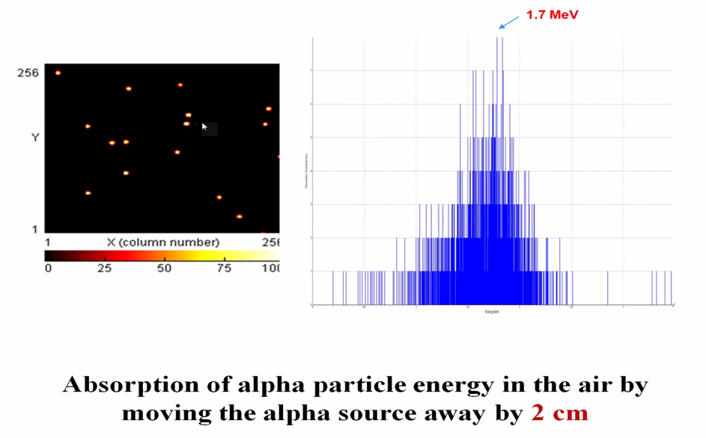
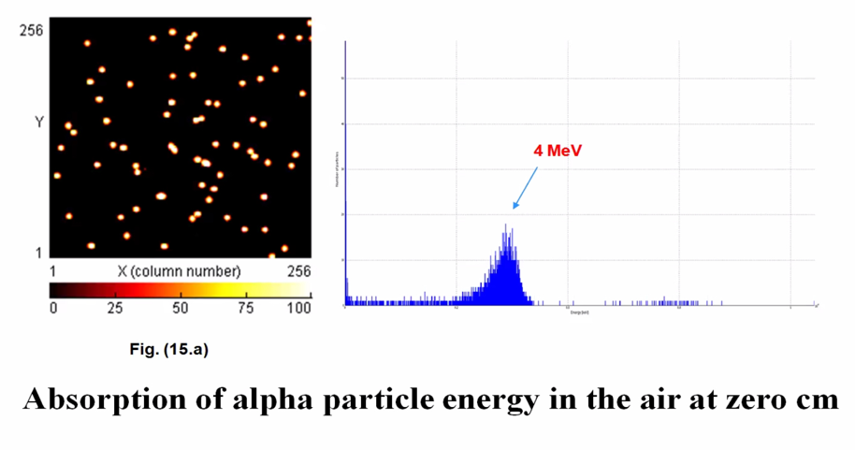
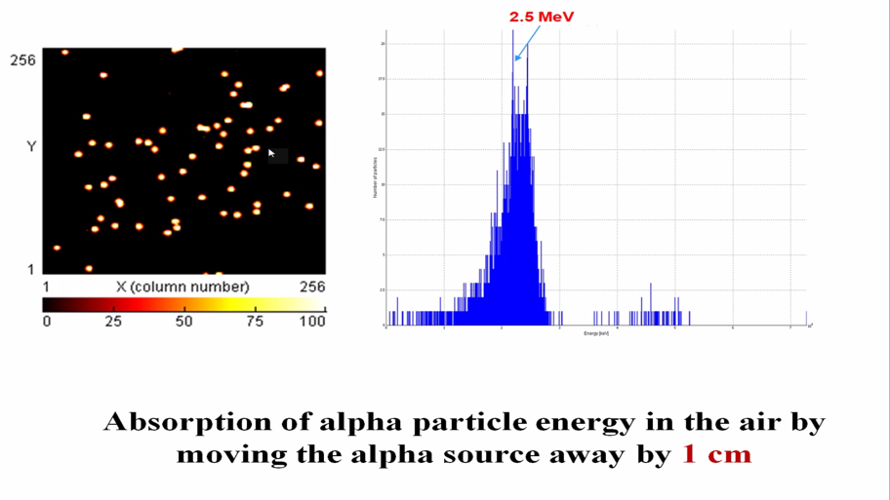
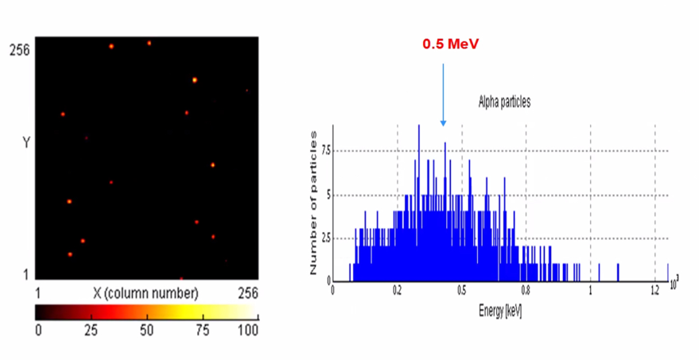
Absorbion of alpha particle energy in air by moving the Alpha source way by 2.5cm
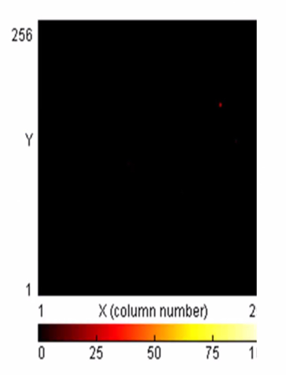

Maximum of alpha particle range is 3 cm – No Alpha particles are detected.

4- Conclusion.
The project covering in multitasks . First task was about resolution of the BGo detector with different applied voltage and the resolution were not good . Second task were about the relation of resolution against applied voltage for NaI detector and were good resolution are better than BGo the rang between 3.40% & 5.93% and use diffrent sources of radiation such as Co-60 , Cs-137 , Am-241and unknown source. Third task were about measured the attenuation coefficient for absorbed beam or scattered with different thickness material of Al and Cu then show it as linear attenuation coefficient when increase the thickness material the atomic number (count\sec) is increase. Fourth task measure the range of Alpha particles in dry air by using Plutonium-239 we found the depth of Alpha rang at 3.5 cm in 5 cm distance .

5-references
1. Cember, H., Introduction to Health Physics, 3rd Edition, McGraw-Hill, New York (2000).
2. Attix, F.H., Introduction to Radiological Physics and Radiation Dosimetry, Wiley, New York (1986).
3. Martin J.E., Physics for Radiation Protection, WILEY- VCH Verlag GmbH & Co. KGaA,
Weinheim (2013).

Acknowledgement.
There are no words to describe the extent of my gratitude to the scientist Dr. Said AbuoElazm. He was a collaborator with me. He guided me throughout the project stage. He was Great. He gave me the ability to challenge and challenge multiple tasks. There is no word I can say in his regard. Therefore, I thank him from my heart. I also thank the Joint Institute for Nuclear Research JINR for giving me The great opportunity to complete a research project with tasks, and I thank all the work team and those in charge of making these projects a success, I thank you from my heart.

