JOINT INSTITUTE FOR NUCLEAR RESEARCH
Frank laboratory of Neutron Physics

PROJECT REPORT ON THE
INTEREST PROGRAM

INTRODUCTORY COURSE "MD-SIMULATION RESEARCH (FROM ATOMIC FRAGMENTS TO MOLECULAR COMPOUND)"

Supervisor:
Prof. Kholmirzo Kholmurodov

Student:
Ibraheem Olayiwola Bisiriyu
University of Johannesburg, Johannesburg, Gauteng South Africa

Participation period:
Sept 27 – Nov 2 (wave 5)

Dubna 2021

Contents

1. Summary
2. Project goal
3. Introduction
4. Project goal
5. Methods
6. Results
7. Conclusion
8. Future work
9. Acknowledgement
10. Reference

1. Summary

Antimicrobial peptides that are short (containing around 50 amino acids), amphiphilic, and cationic are regarded to be a key part of the innate immune system, acting as a powerful defence mechanism against pathogenic microorganisms. The conformational change of a modelled antimicrobial peptide (GA-K4) in solvent was investigated using molecular dynamics (MD) simulations in this project. As a result, MD simulations were used to better understand the structure of the GA-K4 peptide and how its interaction mechanism might be predicted. The results demonstrate that in the aqueous phase, the peptide had an unstable secondary structure comprised of an uncoiled structure. Finally, it is proposed that the GA-K4 peptide is a membrane-active peptide, and that more research into the antimicrobial peptide's interaction with bacterial mimic membrane is required (POPG, POPC etc.).

2. Project goals

Using the knowledge and expertise learned from this course, the goal of this project was to investigate the conformation properties as well as the dynamical stability of an antimicrobial peptide in a water environment.

3. Introduction

Antibiotic resistance has increased dramatically in the last decade (Hancock, 1997). In fact, the World Health Organization (WHO) identified antibiotic resistance as a major threat to human health in a 2015 report (WHO, 2015). Antimicrobial peptides (AMPs) are naturally occurring antimicrobial peptides that provide a new option (dubbed "nature's antibiotics") for fighting germs (Boman, 1995). Antimicrobial peptide research has been going strong for decades. Up to this point, over 5,000 AMPs have been identified or synthesised (Zhao et al., 2013). Microbes, fungi, viruses, and bacteria, both gram-positive and gram-negative strains, are all susceptible to these AMPs (Jenssen et al., 2006; Pistolesi et al., 2007). Some multidrug-resistant microbial strains have been demonstrated to be susceptible to them (Ginsburg et al., 2008; Won et al., 2011; Kang et al., 2012). AMPs are being researched as possible medicinal agents with significant antibacterial activity and little harm to eukaryotic cells, and various antimicrobial peptides are being developed commercially (Cruciani et al., 1991; Won et al., 2011; Kang et al., 2012). AMPs have been shown to exhibit anti-cancer properties in multi-drug resistant cancer cells while causing minimal damage in non-tumor cells (Hoskin et al., 2008). Furthermore, investigations have indicated that when used with traditional chemotherapeutic drugs, AMP has synergistic benefits (Kang et al., 2012; Hui et al., 2002). The bacterial cytoplasmic membrane is thought to be the major target of antimicrobial peptides (Kim et al., 2003; Brogden et al., 2005; Jenssen et al., 2006). The most prevalent and important subclass of these AMPs is linear or random-coiled peptides, which have a tendency to form amphipathic α-helices when bound to bacterial membranes and contain a net positive charge (Pistolesi et al., 2007; Kang et al., 2012).

Many AMPs are thought to take a non-structured/extended conformation in water (Dathe et al., 1996), whereas others, such as -sheet peptides, achieve particular configurations due to the existence of intermolecular hydrogen bonds (Oishi et al., 1997). When peptides bind to the target bacterial cell, they undergo considerable structural changes in both circumstances. The role of secondary structure in AMP activity has been extensively researched in attempt to establish a structure-function link.

Brevinin-1 EMa, formerly known as Gaegurin 5, a short natural antimicrobial peptide (AMP) derived from the skin of the Korean frog Rana Rugosa, was found to be effective against bacteria (Park et al., 1994, Won et al., 2008). The peptide contains antibacterial and hemolytic properties, and distinct Brevinin-1 EMa derivatives, particularly GA-K4, have improved anti-cancer properties (Won et al., 2004; Kang et al., 2012). Brevinin-1 EMa and its derivatives have also been discovered to have microbicidal activity by dissolving bacterial membranes. Many researchers are renowned for selectively dissolving bacterial membranes to destroy microorganisms. Tossi et al., 2000, 2006) (Shai et al., 1999, Tossi et al., 2000). Kang et al. investigated whether synthesised GA-K4 peptide had a synergistic anti-cancer and cytotoxic impact when combined with doxorubicin, a DNA alkylating drug commonly used in combination chemotherapy. Doxorubicin and GA-K4 peptide in combination were found to be nine times more effective against kidney tumour cells and five times more effective against lung cancer cells.

De novo PSP (template-free modelling) can be used to predict unique protein folds in the absence of a suitable template. The most popular and effective ones (such as Rosetta (Bradley et al., 2005; Rohl et al., 2004) and QUARK (Xu et al., 2012)) are mainly based on assembling known structure fragments with possible energy functions from mining known protein structures. The predicted peptide models have a wide range of accuracies and could be used in a variety of applications (Zhang, 2009).

MD simulations have become a popular and widely used physics-based tool for exploring the conformational space of peptides and proteins, with the ability to fold tiny proteins back to their natural structures (Kholmurodov, 2009, 2013; McCammon et al., 1977). Because of the availability of user-friendly and dependable software to perform this type of calculation (e.g. Charmm, NAMD, Amber, Gromacs, Gromos, DL POLY, etc.) as well as to visualise and analyse the results (VMD, pymol, gOpenMol, nMoldyn, etc.), I have spent a lot of time studying the conformational dynamics of ab initio structure prediction of peptides using MD simulation.

4. Methods
4.1. Peptide Structure Prediction (PSP methods)

Because a peptide's function is invariably linked to its unique structural features (Bock et al., 2013), precise peptide structure prediction would greatly help with peptide-based medication design. Many attempts have been made to create peptide structure prediction methods, including evaluations of common PSP methods (Rosetta, I-TASSER) and the invention of unique PSP methods (PepLook, Pep-Fold). Because no X-ray crystallographic or NMR studies of the GA-K4 peptide (sequence:FLKWLFKWAKK) have been done, I used I-Tasser to predict the peptide structure. Swiss-PDB Viewer's molecular graphics software can be used to inspect and manipulate the model manually (Guex et al., 1997).

4.2. Evaluating stereochemical properties

Correct stereochemistry is the most basic need for a protein structure. Anomalies like phi/psi angle pairings in forbidden zones, steric collisions, and unfavourable bond lengths and angles are all checked by validation programmes. PROCHECK (Laskowski, 1993) and WHATCHECK (Hooft et al., 1996) are programmes that analyse these stereochemical properties of the residues in the model and provide an assessment of the structure's overall quality. The use of Ramachandran plots to examine bond geometry is critical in identifying unrealistic conformations inside the structure. Certain phi and psi angle conformations are prohibited in protein structures because they create steric hindrance, or atom collisions. In a Ramachandran plot, a good model will have 90% of its residues in the permitted regions (Laskowski 1993).

4.3. MD simulation and analysis

The MD simulation was run under periodic conditions on an Intel(R) Core(TM) i5 CPU 3.20 GHz using the GROMACS package v2020.04 on Ubuntu 20.04 Linux. Using the AMBER ff-03 force field (Duan et al., 2003) and the TIP3P water model, molecular dynamic simulation for the peptide in water phase was performed (Jorgensen et al., 1983). In less than 100 nanoseconds, the simulation converges. Charges were balanced with adequate amounts of sodium counter ions because the system needed to be neutral for computations. To set up the simulation system, the peptide was placed in a cubic box solvated with water. To restrict the length of all peptide bonds, the LINCS (Hess et al., 1997) algorithm was utilised. SETTLE was used to limit the geometry of water (Miyamoto et al., 1992). Initially, the technology was designed to save energy by employing the steepest descent approach. Position restraint was used in conjunction with NVT and NPT ensembles after the energy minimization process. The system is first simulated using a canonical ensemble (NVT), in which the number of molecules, volume, and temperature are all kept constant. At a constant temperature of 300 K and a time length of 100 ps, an NVT ensemble was used. The integration time step was 2 fs, and the solute atom positions were written to a file every 1 ps. After the temperature had stabilised, an isothermal–isobaric ensemble (NPT) was run. A steady pressure of 1.0 bar was used in the second phase, with a time period of 100 ps. After pressure stabilisation, the NPT ensemble was completed. The long-range electrostatic interaction was treated using the Particle-Mesh Ewald (PME) approach, while the van der Waals interactions were treated using the cut-off method, with a cut-off distance of 1.0 nm (Essmann et al., 1995). The DSSP algorithm was used to determine the composition of secondary structures (Kabsch et al., 1983). VMD (https://www.ks.uiuc.edu/Research/vmd/) was used to simulate the peptide-water system.

5. Results

Using the I-TASSER, Swiss-Pdbviewer programme, a three-dimensional structure of the antibacterial and anti-cancer active GA-K4 peptide was modelled (see Figure 1). -58.7 kJ/mol was the energy minimization. The DSSP software, which estimated the hydrogen bond energy of secondary structure from initial sequences, determined the peptide secondary structure element content. As a result, the -helix structural content was 86.4 percent and the uncoiled structure content was 13.6 percent, respectively. PROCHECK was used to confirm the structure of the GA-K4 peptide (Figure 2).

Steric constraints limit the torsion angles that the atoms of the peptide bond can take. Secondary structure is determined by the psi and phi torsion angles. As highlighted by Ramachandran, rotation around these dihedral angles is almost free compared to rotation around the omega dihedral angles, and is only restricted by steric repulsions affecting the methylene group at the α-position (Ramachandran et al., 1968). G. N. Ramachandran created the basis of the analytical conformations of peptide chains in 1963, before protein structures at atomic resolution were known, by employing simple hard sphere models for the atoms. Ramachandran maps are two-dimensional representations of the authorised regions of the, space. The highlighted locations in Figure 2 correspond to the amino acid's permissible local conformations.

A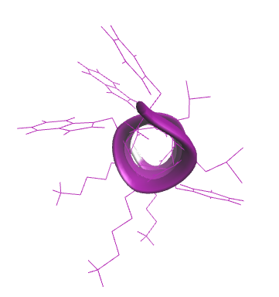 | B  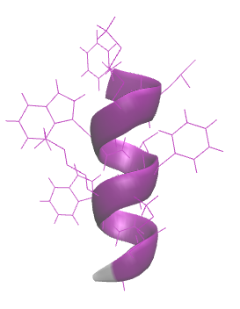
Figure 1. The snapshot of the three-dimensional structure of GA-K4 peptide by VMD. Helix (purple) and uncoiled (grey) structure of A) from above B) from side.

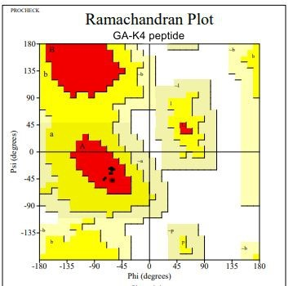
Figure 2. Ramachandran plot.The dotted black regions indicate the sterically allowed Φ and Ψ angles for all residues, excluding Gly and Pro.

The peptide was placed in a cubic box with pre-equilibrated water molecules, and the entire system was reduced using AMBER03 in TIP3P explicit water molecules. Figure 3 shows the results of the simulation after it was initialised with a 100 ps equilibration to stabilize the system.

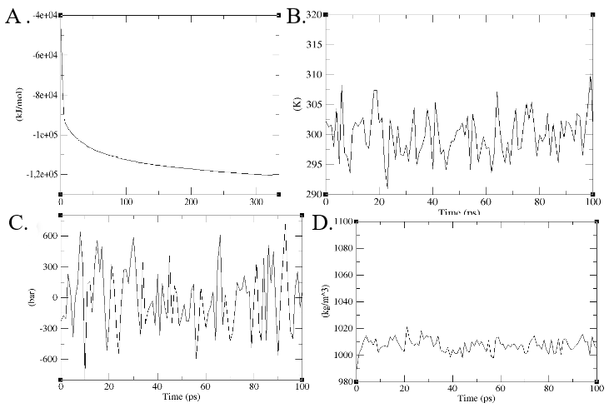
Figure 3. Energy minimization and equilibrium of GA-K4 in water phase

A  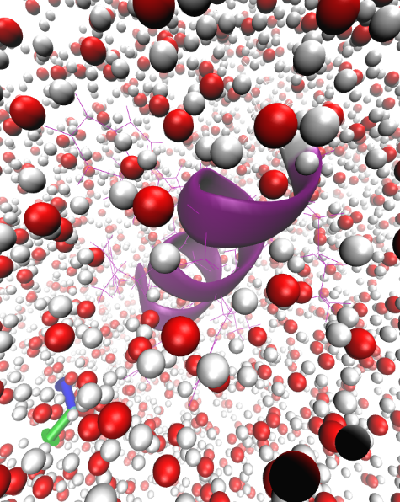 | B  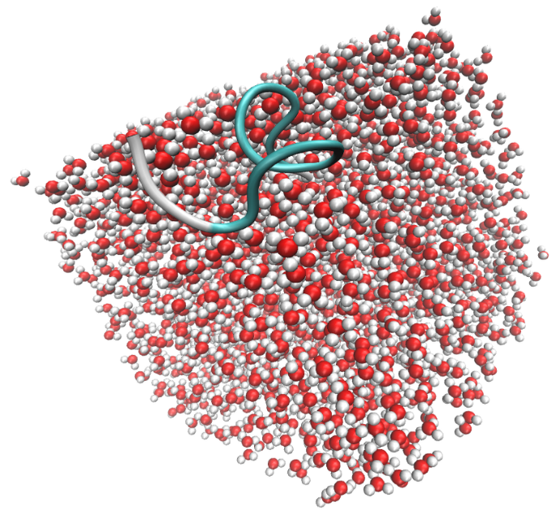
Figure 4. Snapshots at different times along the simulation of a system composed of water molecules and GA-K4 peptide. The water molecules were represented as bubbles with red (oxygen) and white (hydrogen) color, respectively. The GA-K4 peptide were presented A) helix structure (purple, cartoon), B) disordered structure (grey and tail, cartoon). The position of the peptide at initial stage (0 ns, A) and one of the positions of the peptide after a 100 ns simulation (B) were shown, respectively.

Figure 5 shows that RMSD for the peptide is stable during the simulation with the system.

A  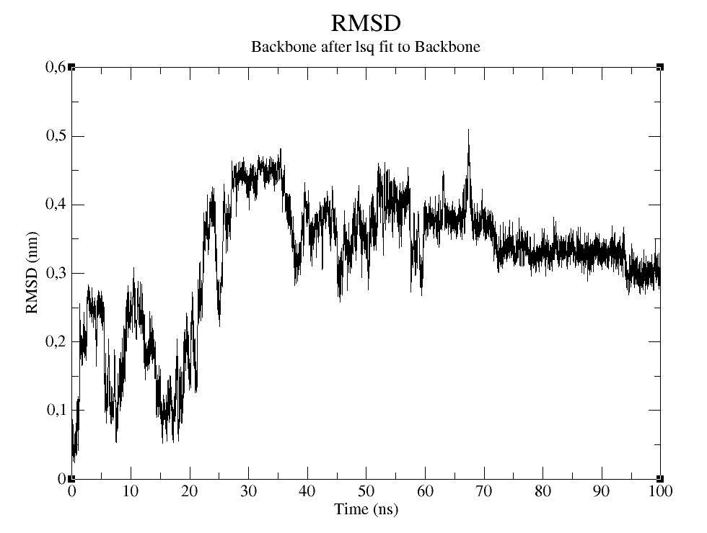 | B  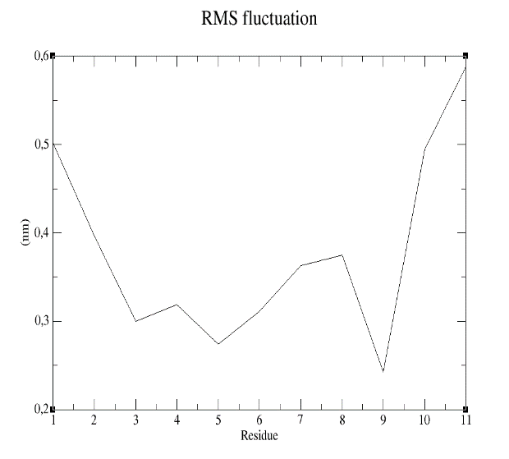
Figure 5. A) The RMSD trajectory of all Cα atoms in of the peptide backbone as function of simulation time in nanoseconds, B) RMSF of all Cα atoms of residues of peptide.

NMR was not previously used to determine the template structure of GA-K4 peptide. However, using the Circular Dichroism (CD) spectroscopic approach, secondary structures of the peptide were investigated (Tsogbadrakh et al., 2017). Using the DSSP technique, the secondary structural constituents of the peptide (Figure 6, Table 1) was investigated. As a result, the found solution is an unstable random coil-structure. As a function of time, the content of random coil, helical, turn, and other conformations in simulations was determined.

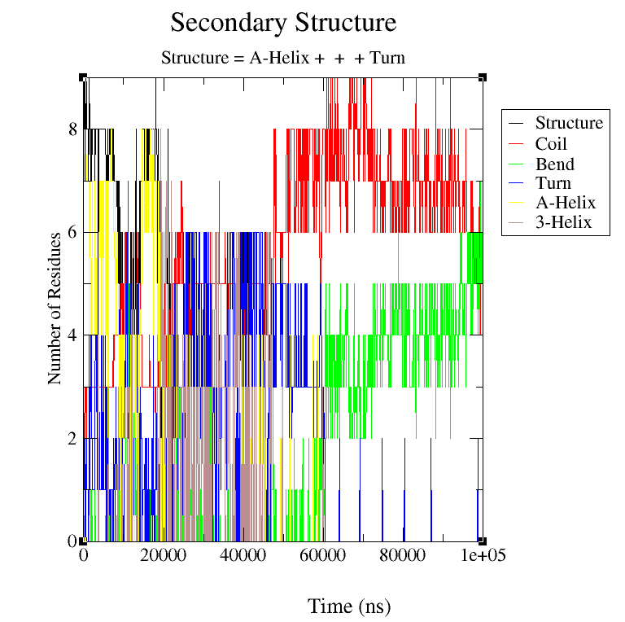
Figure 6: Investigation of the secondary structural constituents of the peptide

Table 1. Comparison of secondary structure of the peptide.
Structure | CD measurement,  % | MD simulation,  %
Coil | 42 | 52
B-Bridge | 0 | 0.5
Bend | 10 | 17
Turn | 24 | 15
α-helix | 14 | 9
5-helix | 0.5 | 0.5
3-helix | 9 | 6

As seen in table 1, the coil structure content is 52%

6. Conclusion
The AMBER ff-03 force field and the TIP3P water model were used to perform a molecular dynamic simulation of the peptide in water. As a result, the peptide's structure was found to be unstable in a water environment. We believe the GA-K4 peptide is a membrane-active peptide, and more research is needed to understand how antimicrobial peptides interact with bacterial mimic membranes (POPG, POPC etc.).

7. Future work
In order to improve the antibacterial action of AMPs as future antibiotics, it is critical to understand their membrane permeability mechanism. Using MD simulation (Gromacs, DL Poly (Kholmurodov, 2010), one can investigate the relationship between the structure of the GA-K4 peptide and its mechanism of lipid interaction, as well as the molecular details of this process. It is envisaged that this research may shed some insight on the AMP-membrane interaction and, as a result, aid in the development of anti-cancer peptides.

Additionally, the concept of MD-simulation learnt in this project will be used in simulating synthetic polymer surfaces and nanoparticles for application in the field of material science and catalysis

8. Acknowledgements
I'd like to express my gratitude to my supervisor, Prof. Dr. Kholmirzo Kholmurodov, for allowing me to participate in a fascinating project and teach an introductory molecular dynamic simulation course. His outstanding explanations and suggestions aided me throughout the entire work.

9. References
- Hancock, R.E. Peptide antibiotics. Lancet, 1997, 349, 418-422.
- WHO. Global Antimicrobial Resistance Surveillance System: Manual for Early Implementation. World Health Organization, 2015.
- Boman, H.G. Peptide antibiotics and their role in innate immunity. Annu. Rev. Immunol., 1995, 13, 61-92.
- Jenssen, H.; Hamill, P.; Hancock, R.E. Peptide antimicrobial agents. Clin. Microbiol. Rev., 2006, 19, 491-511.
- Pistolesi, S.; Pogni, R.; Feix, J.B. Membrane insertion and bilayer perturbation by antimicrobial peptide CM15. Biophys.J., 2007, 93, 1651-1660.
- Ginsburg, I.; Koren, E. Are cationic antimicrobial peptides also “double-edged swords”? Expert Rev. Anti. Infect.Ther., 2008, 6, 453-462.
- Kang, S.J.; Ji, H.Y.; Lee, B.J. Anticancer activity of undecapeptide analogues derived from antimicrobial peptide, brevinin-1EMa. Arch. Pharm. Res., 2012, 35, 791-799.
- Won, H.S.; Kang, S.J.; Choi, W.S.; Lee, B.J. Activity optimization of an undecapeptide analogue derived from a frog-skin antimicrobial peptide. Mol. Cells, 2011, 31, 49-54.
- Cruciani, R.A.; Barker, J.L.; Zasloff, M.; Chen, H.C.; Colamonici, O. Antibiotic magainins exert cytolytic activity against transformed cell lines through channel formation. Proc. Natl. Acad. Sci. USA, 1991, 88, 3792-3796.
- Hoskin, D.W.; Ramamoorthy, A. Studies on anticancer activities of antimicrobial peptides. Biochim. Biophys. Acta, 2008, 1778, 357-375.
- Hui, L.; Leung, K.; Chen, H.M. The combined effects of antibacterial peptide cecropin A and anti-cancer agents on leukemia cells. Anticancer Res., 2002, 22, 2811-2816.
- Brogden, K.A. Antimicrobial peptides: pore formers or metabolic inhibitors in bacteria?. Nat. Rev. Microbiol., 2005, 3, 238-250.
- Kim, S.; Kim, S.S.; Bang, Y.J.; Kim, S.J.; Lee, B.J. In vitro activities of native and designed peptide antibiotics against drug sensitive and resistant tumor cell lines. Peptides, 2003, 24, 945-953.
- Hancock, R.E.; Chapple, D.S. Peptide antibiotics. Antimicrob. Agents Chemother., 1999, 43, 1317-1323.
- Shai, Y.; Oren, Z. From mechanism to de-novo designed diastereomeric cell-selective antimicrobial peptides. Peptides, 2001, 22, 1629-1641.
- Kholmirzo Kholmurodov, Models in Bioscience and Materials Research: Molecular Dynamics and Related Techniques, Nova Science Publishers (N.Y.), ISBN: 978-1-62808-052-0 (2013).
- Bradley P, Misura KMS, Baker D. Toward high-resolution de novo structure prediction for small proteins. Science 2005;309:1868–71.
- Rohl CA, Strauss CEM, Misura KMS, Baker D. Protein structure prediction using Ro-setta. Methods Enzymol 2004, 383:66–93.
- Xu D, Zhang Y. Ab initio protein structure assembly using continuous structurefragments and optimized knowledge-based forcefield. Proteins 2012;80:1715–35.
- K Kholmurodov, M Abasheva, K Yasuoka, Molecular dynamics simulations of valinomycin interactions with potassium and sodium ions in water solvent, Advances in Bioscience and Biotechnology 1 (3), 145-240 (2010)
- Zhang Y. Protein structure prediction: when is it useful? Curr Opin Struct Biol 2009; 19:145–55
- McCammon JA, Gelin BR, Karplus M. Dynamics of folded proteins. Nature 1977; 267:585–90.
- KT Kholmurodov, Computer design for new drugs and materials: Molecular dynamics of nanoscale phenomena, Nova Science Publishers (N.Y.), ISBN: 978-1-53612-082-0, (2017).
- Bock JE, Gavenonis J, Kritzer JA. Getting in shape: controlling peptide bioactivityand bioavailability using conformational constraints. ACS Chem Biol 2013;8:488–99.
- Guex N and Peitsch MC SWISS-MODEL and the Swiss-PdbViewer: An environment for comparative protein modeling. Electrophoresis 1997;18: 2714-2723.
- Laskowski, R.A. PROCHECK: a program to check the stereochemical quality of protein structures. J ApplCryst 1993;26: 283-291
- Kholmurodov Kh.T. Molecular Simulation in Material and Biological Research. Nova Science Publishers (N.Y.), ISBN: 978-1-60741-553-4 (2009).
- Hooft, RWW, Vriend G, Sander, C and Abola EE Errors in protein structures. Nature 1996; 381: 272-272.
- Y. Duan, C. Wu, S. Chowdhury, M.C. Lee, G. Xiong, W.E.I. Zhang, R. Yang, P. Cieplak, R.A.Y. Luo, T. Lee, J. Caldwell, J. Wang, P. Kollman J. Comput. Chem., 24 (2003), pp. 1999-2012
- W.L. Jorgensen, J. Chandrasekhar, J.D. Madura, R.W. Impey, M.L. Klein.J.Chem.Phys., 79 (1983), pp. 926-935
- Kabsch, W.; Sander, C. Biopolymers 1983, 22, 2577– 2637
- Miyamoto, S. & Kollman, P. A. SETTLE: An Analytical Version of the SHAKE and RATTLE Algorithms for Rigid Water Models. J. Comp. Chem. 13, 952–962 (1992).
- Hess, B., Bekker, H. Berendsen, H. J. C. & Fraajie, J. G. E. M. LINCS: A Linear Constraint Solver for Molecular Simulations. J. Comput. Chem. 18, 1463–1472 (1997).
- Essmann, U. et al. A smooth particle mesh Ewald method. J. Chem. Phys. 103, 8577–8592 (1995).
- Tsogbadrakh Mishig-Ochir, Davaadulam Gombosuren, Altanchimeg Jigjid, Badamkhatan Tuguldur, Galbadrakh Chuluunbaatar, Enerelt Urnukhsaikhan, Chinar Pathak and Bong-Jin Lee, Cellular Membrane Composition Requirement by Antimicrobial and Anticancer Peptide GA-K4, Protein & Peptide Letters J, 24, 197-205 (2017)

