JOINT INSTITUTE FOR NUCLEAR RESEARCH
Dzhelepov Laboratory of Nuclear Problems

FINAL REPORT ON THE
INTEREST PROGRAM

Analysis and interactive visualization of neutrino event topologies registered in the OPERA experiment.

Supervisor:

Dr Sergey Dmitrievsky

Student:
Vaibhav Chahar,
IIT Roorkee, India
Participation period:
8th February – 19th March, Wave 3,
Dubna, 2021

1. Abstract
The OPERA experiment was designed to observe the ν_{μ} → ν_{τ} oscillations in appearance mode through the detection of τ leptons produced in a v_{τ} charged current interactions, initially pure ν_{μ} beam was produced at a CERN and detected in the underground Hall C of the Gran Sasso Laboratory. Data samples collected by OPERA were extracted from the official OPERA data repository and published on the Open Data Portal. Every dataset is compressed into a .zip archive which includes .csv files that contain information about registered neutrino events. In the present report, the datasets are extracted from the Open Data Portal, a C++ program is developed for the analysis of features of neutrino topologies from the datasets. Results of the analysis can be interactively displayed in the ROOT data analysis framework and then saved to image files.

2.Introduction
Neutrinos are one of the elementary particles of nature. They have zero charge they are extremely light and can travel almost at speed of light. As they pass through everyday matter hence, they are quite hard to detect. There are three types of neutrinos, called flavours: electron neutrino, muon neutrino and tau neutrino. Neutrinos travel as a mixture of three flavour states known as mass eigenstates. Currently, there are only three known mass eigenstates, they are called v1,v2,v3. This “neutrino mixing” causes neutrinos to oscillate between flavour states as they travel. By neutrino oscillations, all three neutrinos flavours can change into one another. With this, at a particular distance from the source, neutrinos produced in a specific flavour state may be detected as a different flavour state. The appearance of a neutrino flavour different from the original one is the cleanest signature of oscillations.
The OPERA (long baseline) experiment has discovered the first transmutation of ν_{μ} → ν_{τ} along their flight from CERN to the underground Gran Sasso laboratory (Italy) where the OPERA detector is located, by observing ten tau neutrino candidates. OPERA detector was designed to identify τ laptons via topological observation of their decays followed by a kinematical analysis of the observed events. The CNGS (“CERN Neutrinos to Gran Sasso”) beam consists mainly of ν_{μ} neutrinos with a mean energy of about 17 GeV. The high energy of the beam (above the threshold for the τ lepton production) and totally negligible ν_{τ} prompt contamination made the beam suitable for the study of ν_{μ} → ν_{τ} transitions in appearance mode.
The data collected from the OPERA detector is comprised in a .csv files, that are further compressed in a .zip files. With the data we can analyse different neutrinos event topologies for example, in the form of histograms also we can visualize the event topologies of neutrinos interaction in a web browser using the HTML ,CSS and JavaScript graphic libraries.
The present report discusses tasks such as calculation of flight lengths of charmed hadrons, impact parameters of the daughter particle tracks, multiplicities of charged particles and angles of muon tracks.

3. OPERA Experiment
The Oscillation Project with Emulsion-tRacking Apparatus (OPERA) was an instrument used in detecting tau neutrinos from muon neutrino oscillations. This scientific experiment was a collaboration between CERN (Switzerland, France) and Laboratori Nazionali del Gran Sasso (LNGS) in Gran Sasso, Italy. The whole OPERA collaboration included ~ 180 physicists from 28 institutions of 11 countries . The experiment used uses the CERN neutrinos to Gran Sasso(CNGS) neutrino beam.
Accelerated protons from super proton Synchrotron (SPS) at CERN were fired in two pulses at a carbon target to produce pions and kaons. These particles further decay into muons and neutrinos. OPERA was designed to identify the τ neutrino via the topological observation of its decay. This was done by using a hybrid apparatus that combined real-time detection techniques “electronic detectors” and the Emulsion Cloud Chamber (ECC) technique. An ECC detector was made of passive material plates, used as target, alternated with nuclear emulsion films used as tracking devices with sub-micrometric accuracy. The DONUT experiment, which has first observed the ν_{τ} was an application of the ECC technology at a mass scale of 100 kg. The ECC has proven the unique feature of combining a tracker of an extremely high accuracy with the capability of performing kinematical variable measurements.
The ECC technology used in OPERA was of much larger scale. The “brick”, which was a basic unit, was made up of 56 plates of lead (1 mm thick) mixed with nuclear emulsion films (industrially produced) for a total weight of 8.3 kg. 150000 of that much target units were assembled to reach the total mass of 1.25 kton. The bricks were arranged in 62 vertical walls which were transverse to the beam direction arranged with planes of plastic scintillators. The detector was subdivided in two identical units (super modules), each consisting of 31 walls and 31 double layers of scintillator planes followed by a magnetic spectrometer.
The systematic view of the OPERA detector is given on the next page:
a) The first figure shows an overview of the OPERA detector. The yellow arrow on the left shows the beam direction.
b) Side view of the OPERA detector.

Figure a):
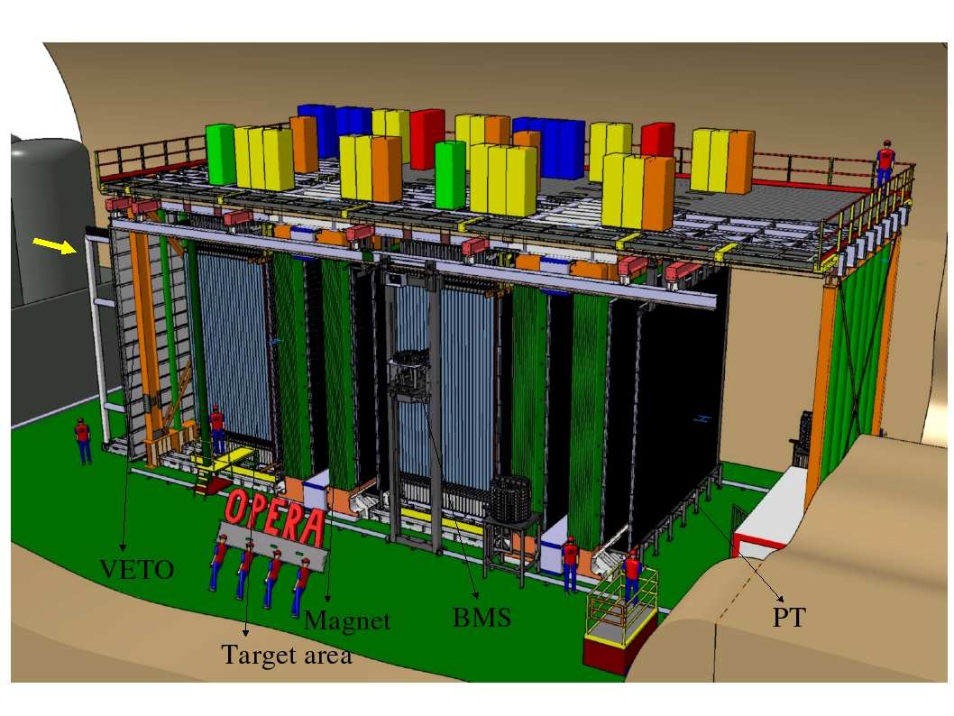
Figure b):
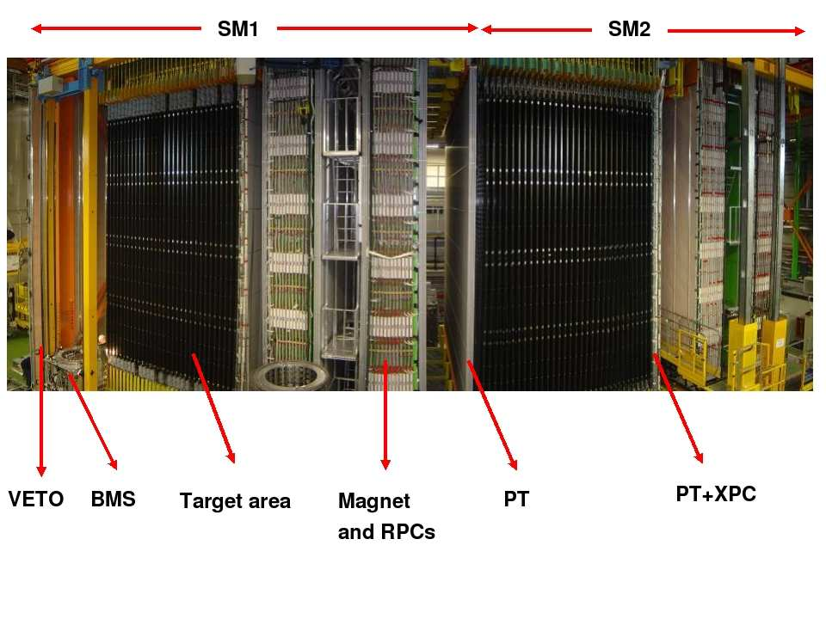

4.CERN Open Data Portal
CERN open data portal is the access point to a range of data produced through the research performed at CERN. It widely spreads the various outputs from various research activities and it includes accompanying software and documentation needed to understand the analyses of the data.
The products of this portal are shared under open licenses and they are issued with a particular DOI(Digital Object Identifier) to make them citeable objects.
Data produced by LHC is divided into four levels:
- Level 1 data provides information on published results like extra figures and tables.
- Level 2 data includes simplified data formats for outreach and analysis training.
- Level 3 data comprises reconstructed collision data and simulated data together with analysis level experiment-specific software.
- Level 4 data covers basic raw data with accompanying reconstruction and simulation software.
CERN Open Data portal focuses on the release of event data from levels 2 and 3. The LHC collaborations may also provide small samples of level 4 data.

This work
This work is divided into three tasks:
Task 1: In this task, emulsion dataset for the neutrino-induced charmed hadron production studies from the CERN Open Data Portal is used. This data set, extracted from OPERA data repository, contains 50 muon neutrino interactions with lead target where a charmed hadron is reconstructed in the final state.
Over a sample of 2925 muon neutrino CC events fully analyzed, only 50 charm decay were observed.
The dataset contains the information of the primary neutrino interaction vertices and secondary vertices produced by charmed hadron decays. It also includes the emulsion tracks produced at both vertices.
C++ program relevant to the Task:
- Reading the TrackLines.csv files
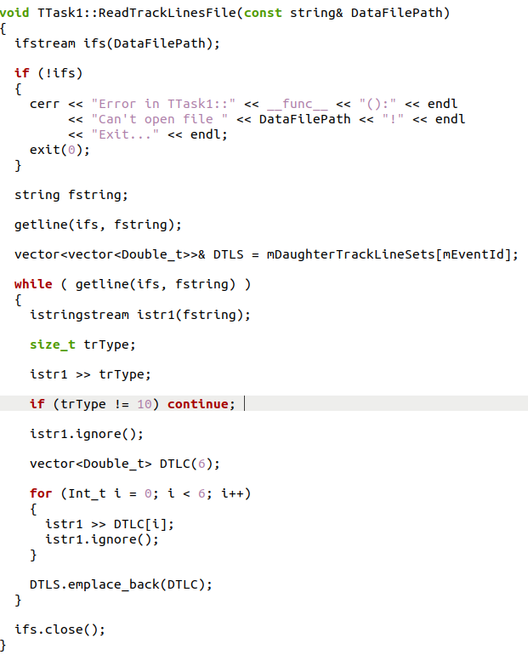

2. Code to calculate distance in 3D space
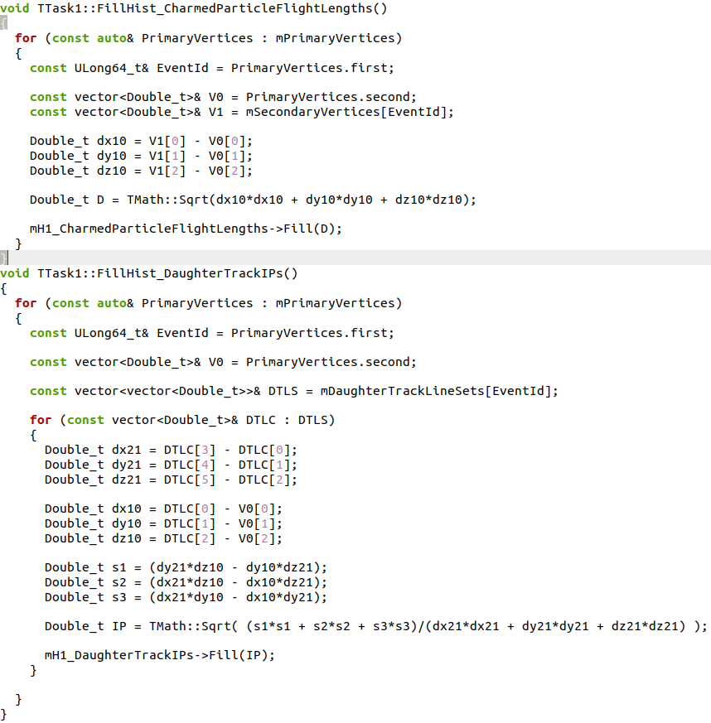

3 . Initializations of Histogram
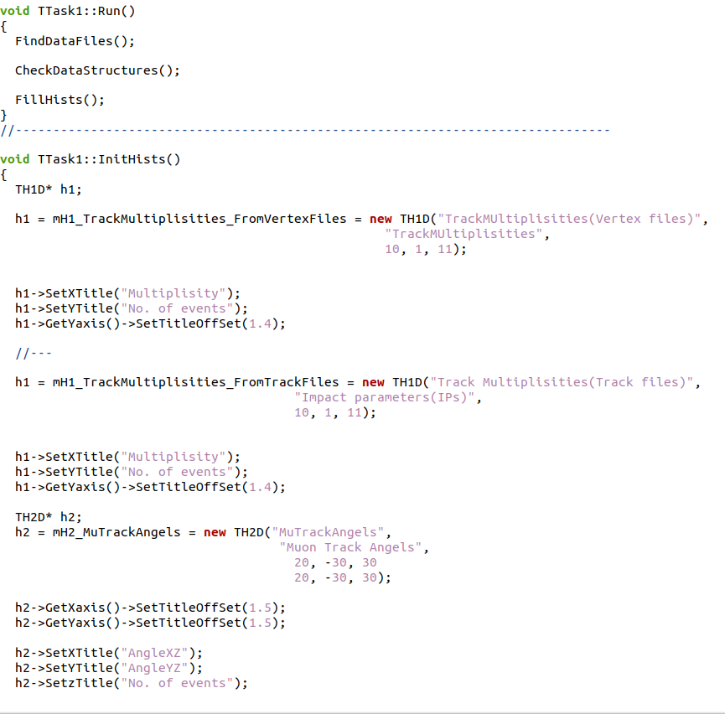

Results:
Flight Length of a charmed hadron is the distance between the primary and the secondary vertices of the neutrino interaction event.
The flight length is shown below:
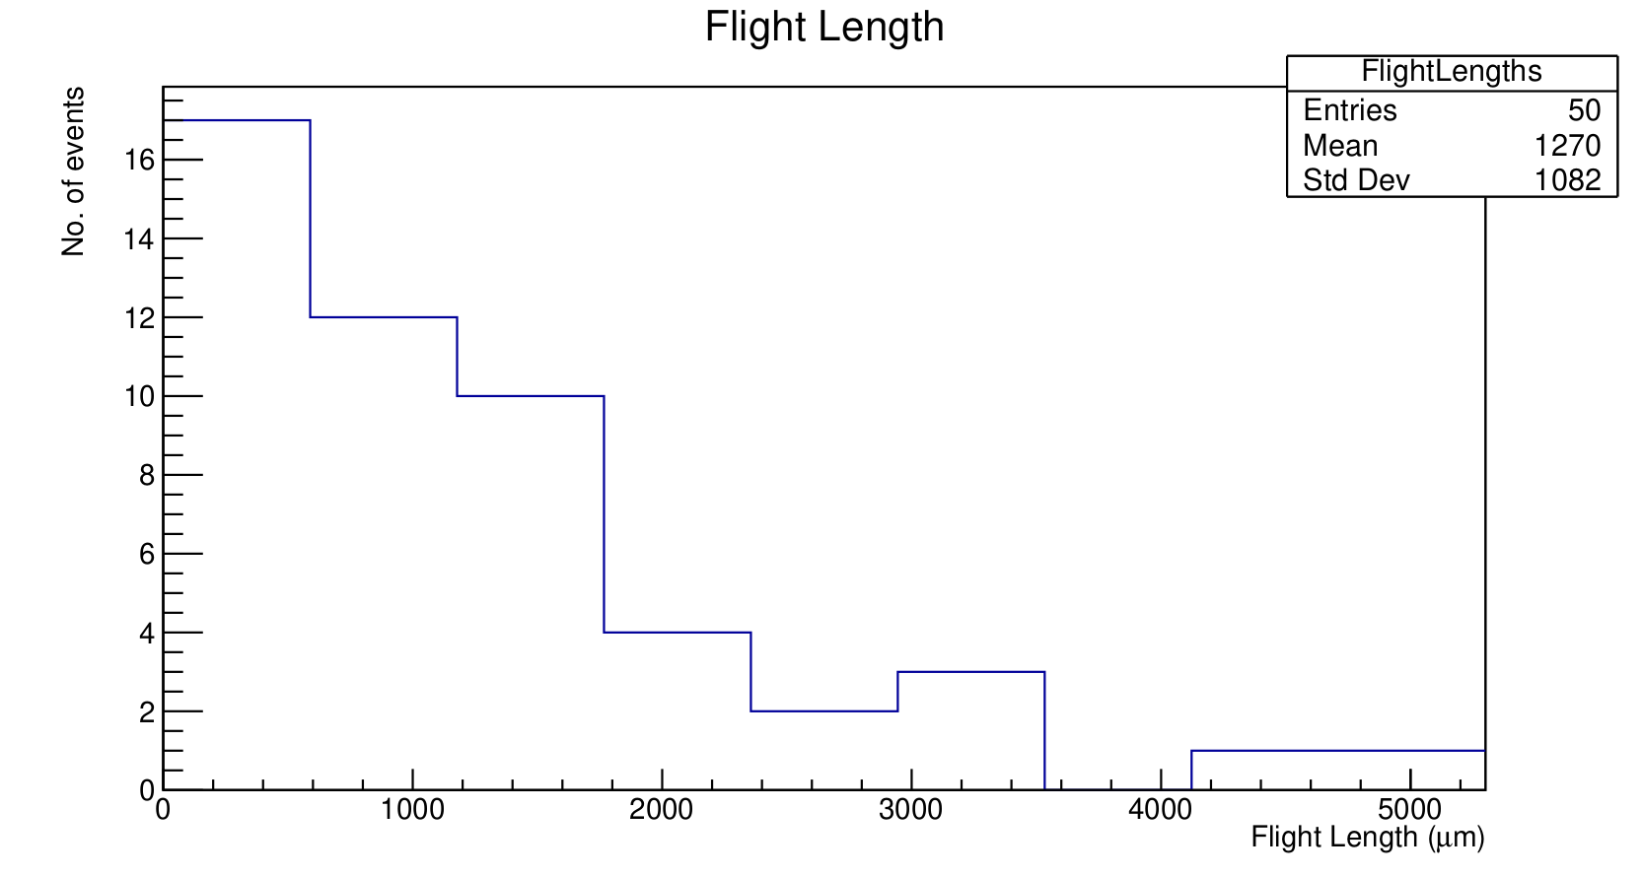
Impact Parameter(IP) is a distance between the daughter particle track and primary neutrino interaction vertex.
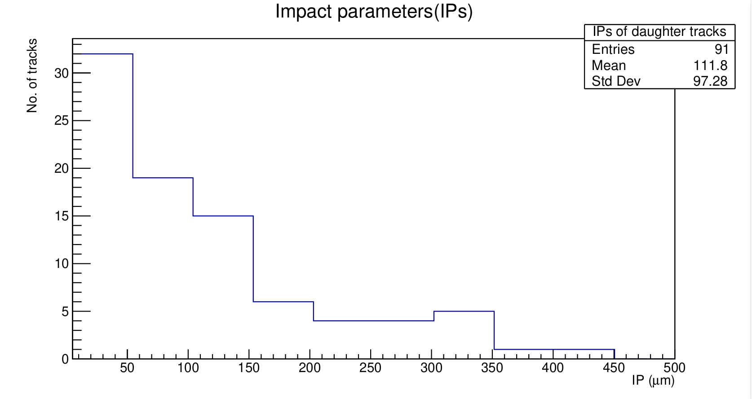

Task 2: In the second task, emulsion dataset for the charged hadron multiplicity studies, extracted from the official OPERA data repository, is used. It contains 817 muon neutrino interactions with the lead target where a muon is reconstructed in the final state.
Events stored in this dataset were selected by requiring that a muon was reconstructed in the final state.
The positions of primary neutrino-lead interaction vertices with the parameters of the secondary charged particle tracks should be read. Using the ROOT, the multiplicities of charged particles and the angle of muon tracks is to be found and saved to histograms.
Codes relevant to the Task:
- Filling of 1D and 2D histograms:
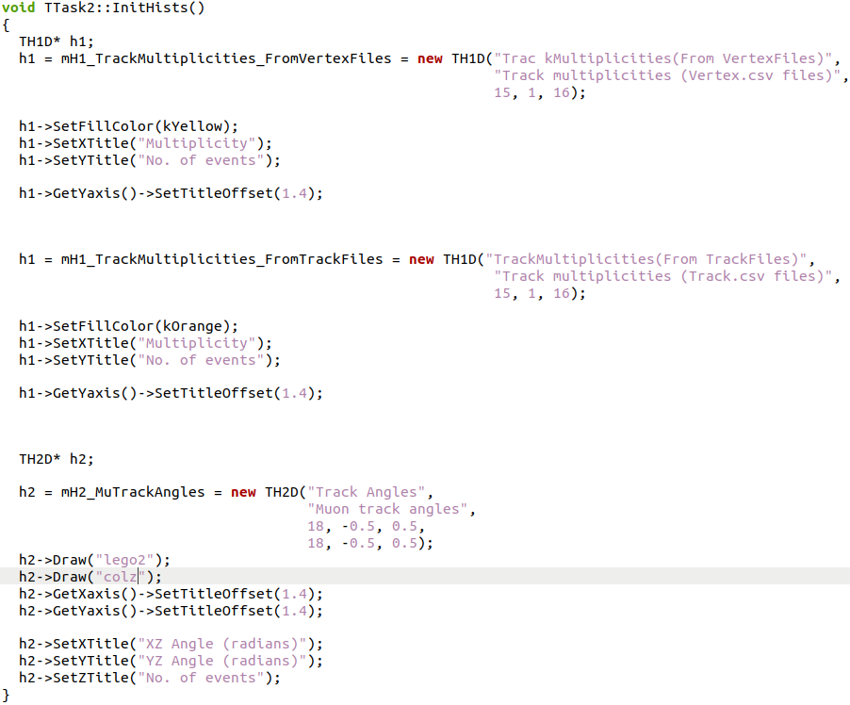

2. Reading the Tracks.csv files:
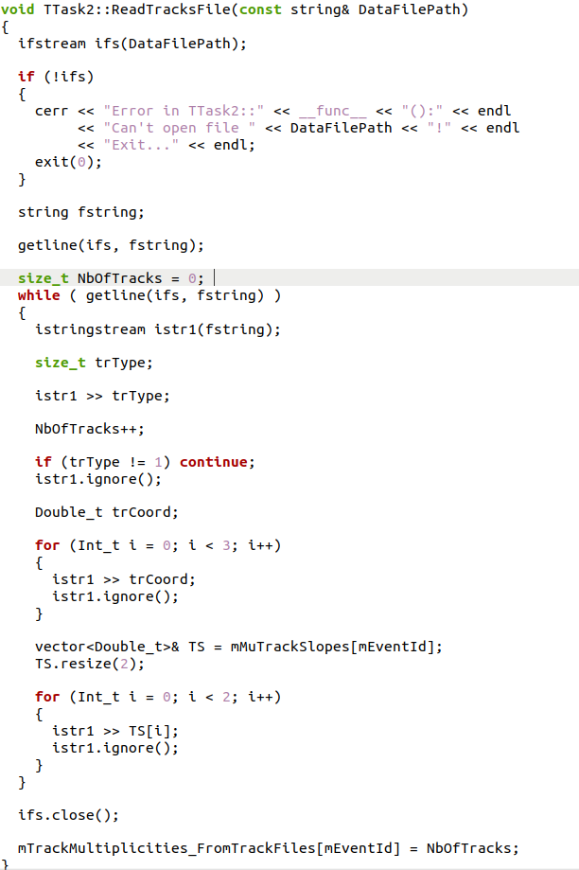
3.

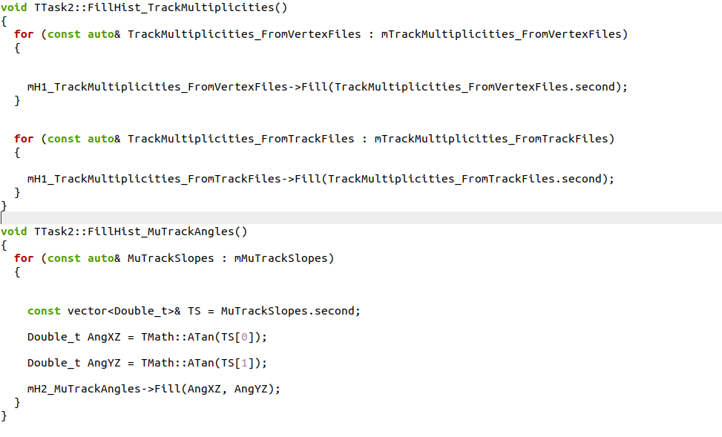
Filling the Histogram:

Results:
Track multiplicities of all produced charged particles(Track.csv files)
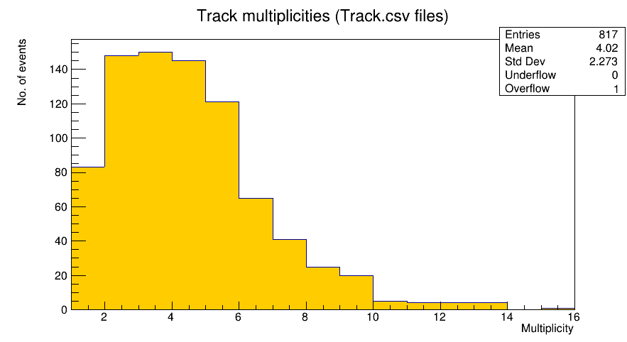
2D histograms for angels of muon tracks:
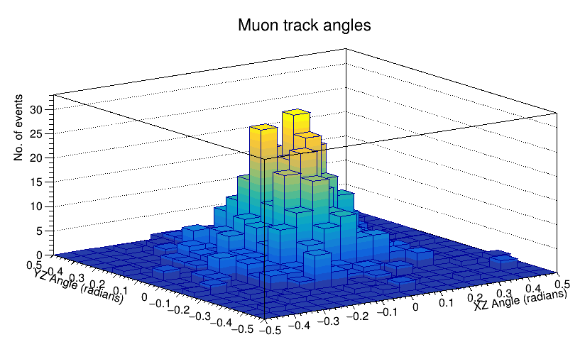

Task 3: In this task, a browser based 3D event display to view tracks and vertices reconstructed in nuclear emulsions of the 10 tau neutrino form the emulsion dataset for the tau neutrino studies from the OPERA Open Data Portal is used.
The observation of the tau neutrino appearance in a muon neutrino is the main goal of the OPERA experiment. This dataset contains information of the neutrino interaction vertices including all the emulsion track produced in the interaction and decay.
C++ code relevant for this task:
Drawing the Vertices
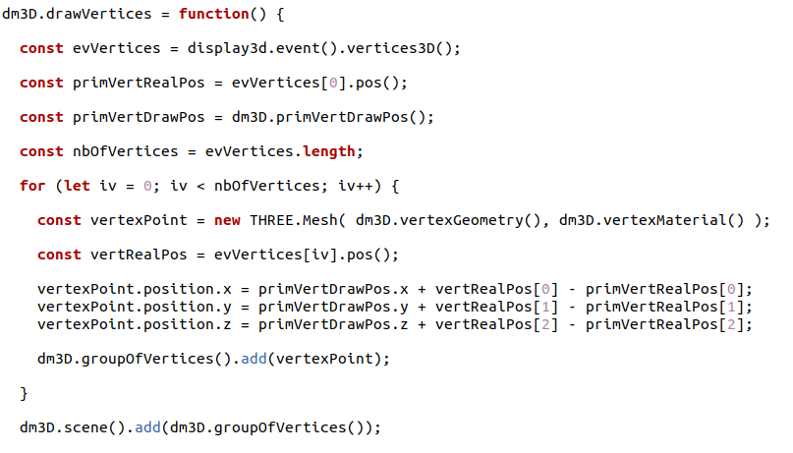
Drawing the Tracks:
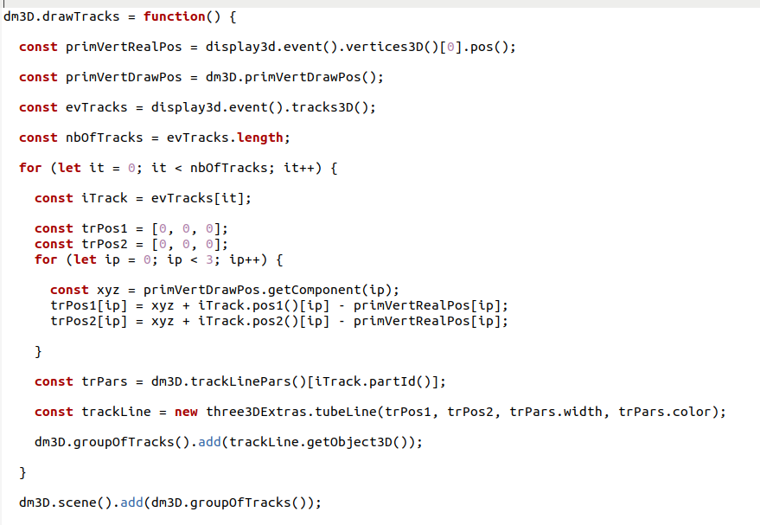

Result:
3D event display of reconstructed tracks and vertices in nuclear emulsion of 10 tau neutrino events.
(side view of display)
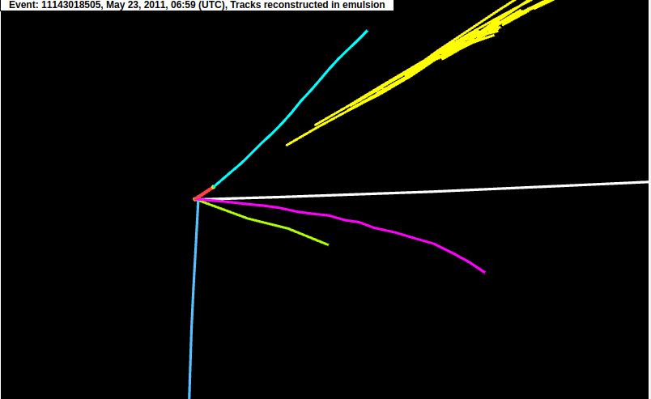
(front view of display)

Conclusion
While doing this report and thoroughly doing all the steps, we now know the working of OPERA neutrino oscillation experiment and CERN Open Data Portal. Working on the task helped to understand better the material about neutrinos, its types and oscillations.
In order to perform the first two tasks the CERN ROOT data analysis framework has been installed and used. C++ programs have been developed:
1) to plot 1D histograms of the flight lengths of charmed hadrons and impact parameters of the daughter particle tracks from the neutrino-induced charmed hadron production dataset;
2) to plot a 1D histogram for multiplicities of charged particles and 2D histogram for the angles of the muon tracks from the muon neutrino dataset.
The obtained histograms have been compared with the ones from the original OPERA papers and found to be in a good agreement with the published results.
In order to visualize interesting “kink” topologies of neutrino interaction events from the OPERA v_{τ}-candidate sample, a simplified version of the OPERA browser based event display has been used and modified. Missing parts of JavaScript code have been inserted in the functions used to draw tracks and vertices reconstructed in the nuclear emulsions. The obtained 3D images of the neutrino events are comparable with the ones available on the Open Data Portal.

Acknowledgements
I tender a sincere gratitude to my scientific project supervisor Dr. Sergey Dmitrievsky for full support in this project for helping in project related codes and help every time. In addition resolving all of our queries through email and Telegram. I would like to thank my project colleagues Athar, Lokesh and Lalitesh to help me with ROOT software and with the programming.

References
- Eur. Phys. J. C (2014) 74:2986
- CERN Open Data Portal
- R Acquafredda et al 2009 JINST 4 P04018

