JOINT INSTITUTE FOR NUCLEAR RESEARCH
Frank Laboratory of Neutron Physics
FINAL REPORT ON THE INTEREST PROGRAMME
3D imaging with neutrons
Supervisor:
Ivan Zel, Ph.D.
Student:
Name, University

Participation period:
February 14 – March 25, Wave 6
Dubna, 2022
Abstract
Neutron tomography is a very important method of obtaining the internal structure of an object using neutrons without destroying the object. This method is used in many industries, in particular: rock research, non-destructive testing of materials and others. Neutrons are particles without charge, due to this property they, can penetrate deep into matter what makes it possible to study the internal structure of different materials and large objects, including metallic ones which are problematique or even impossible to study by other non-destructive methods.
In this work, we studied the structure of two geological samples - Fe-rich quartzites, consisting mainly of iron and quartz using neutron tomography. 3D volumetric images of each sample as a whole and for each phase – iron-rich phase and quartz - were constructed. The linear neutron attenuation coefficient was calculated for three phases presented in the studied samples: quartz, hematite and magnetite. The volume fractions of quartz and iron-rich minerals in each sample were also obtained.
1. Introduction
Neutron radiography is a method of obtaining neutron images of studied objects. Different neutron beam intensity losses while passing through components of the studied sample with different chemical compositions, densities, and thicknesses provide information on the internal structure of the studied materials with spatial resolution on a micrometer level. This method of nondestructive testing is characterized by a deeper penetration into the volume of the studied material when compared to the complementary method of X ray radiography and possesses a number of advantages in investigating objects containing both light (for example, hydrogen and lithium) and heavy elements.
At present, neutron radiography is widely used in material research and studies of products for nuclear technologies, paleontological and geophysical objects, and objects of cultural heritage. It should be noted that much attention is now being paid to unique studies of physical and chemical processes in fuel elements and batteries, processes connected with hydrogen or water penetration into the mass of various materials. The functional elaboration of neutron radiography is neutron tomography. In this method the volume reconstruction of the internal structure of the studied object is performed from the set of separate radiographic projections obtained for different angular positions of the sample with respect to the neutron beam direction.
The basic understanding of neutron tomography begins with the formula:
$I=I_{0}exp⁡(-μx)$,
where $I_{0}$ - initial beam intensity, $μ$ - linear neutron attenuation coefficient, $x$ - the width of the material through which the neutrons pass.
According to this formula, it can be seen that the intensity decreases exponentially when passing through any material. Accordingly, for a mixture of materials, the formula changes:
$I=I_{0}exp⁡(-Σμ_{i}x_{i})$,
where i - the number of the material in the assembly.
The passage of neutrons and the decrease in the intensity through a heterogeneous material is well illustrated in Fig. 1.
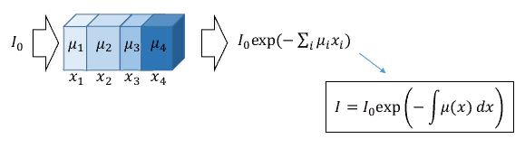
Fig. 1 – The change in the intensity during the passage of neutrons through a variety of materials
2. Materials and Experimental setup
Quality iron ore is the most important raw material for the production of iron and steel. India Steel Vision 2030 projects 300 million tons of steel production, for which 550 million tons of high-grade ore is required. India does not have enough high-grade hematite ore, but possesses abundant resources of low-grade iron ore, such as banded hematite quartzite (BHQ). During conventional mining of hematite ore, there is significant generation of low-grade BHQ ore, which ends up in unused stockpiles at the mine sites because of a lack of suitable beneficiation technology. The iron bands in these ores are of hematite and magnetite, and the silica bands are quartz or reddish jasper with a varying band thickness. The formation of these banded ores is through replacement of silica by iron, by leaching of silica under suitable conditions, or from the precipitation of iron in Earth’s ancient oceans.
The chemical composition of a sample is determined by the content of silicate and ore minerals, as well as the degree of crystallization of the rock. However, a characteristic feature of all ferruginous quartzites (Fig. 2) is the fact that the SiO₂, FeO and Fe₂O₃ together account for up to 90% of the total mass of the rock. The remaining components are present in insignificant proportions (no more than 1-2%).
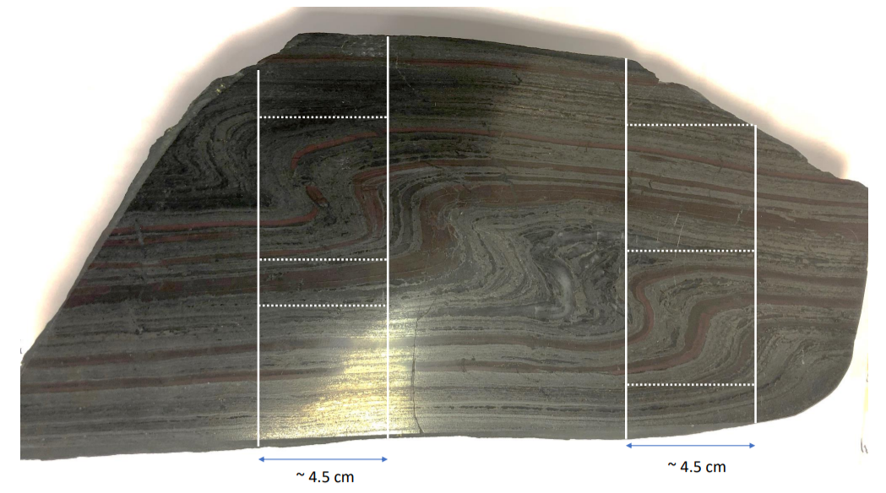
Fig.2 – Parent piece of ferruginous quartzite. Blocks outlined by white lines are the samples studied in this work.
The schematic diagram of basic units of the neutron radiography and tomography facility is shown in Fig. 3.
The neutron beam is formed by a system of collimators consisting of four annular cylindrical inserts from borated polyethylene alternating with steel rings added for rigidity. The inner diameters of the annular collimators increase from 5 cm at the input to 23.7 cm at the output of the collimation system. It is known that the spatial resolution of radiography installations, and therefore the quality of obtained neutron images, depends on the characteristic parameter L/D, which is determined by the ratio of the distance L between the input aperture of the collimation system and the position of the studied sample and the diameter of the input collimator aperture D. The spatial resolution of neutron images is higher, the larger the value of the parameter L/D is. Length L for the new neutron radiography and tomography facility is 10 m, and the diameter of the input collimator hole D is equal to 5 cm, which corresponds to L/D = 200 The design of the collimation system makes it possible to reduce the input aperture diameter to 0.5 cm, which yields L/D = 2000 These values of the characteristic parameter L/D correspond to the values of this parameter for leading neutron radiography facilities at the world science centers. The collimation system is placed in a vacuum casing for reducing intensity losses due to neutron scattering in air.
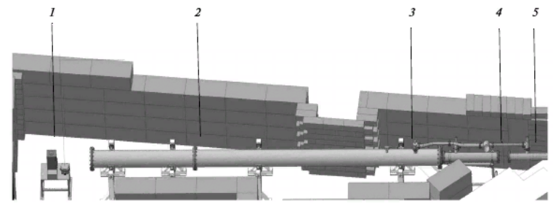
Fig. 3 – 1-Scintillator, 2-Collimator, 3- Vacuum station, 4- Position of the monocrystalline sapphire filter for the neutron beam, 5- inserted tube for collimators
The integral flux of thermal neutrons at the sample position was measured by the activation method with gold foils; it makes $Ф\sim 5.5∙{10}^{6}n/cm^{2}/s$.
A photo of the detector system based on the CCD video camera used in the neutron radiography and tomography facility is also shown in Fig. 4. Neutrons are converted into light photons recorded by the CCD video camera using the 6LiF/ZnS scintillator plate with a thickness of 0.2 mm manufactured by RC TRITEC Ltd. (Switzerland). For protecting the video camera from radiation, the light from the scintillator is reflected by the sweep mirror inclined at an angle of 45° with respect to the axis of the incident neutron beam and then hits the optical system of the video camera. All optical systems of the detector are situated in the shield casing. The technical parameters of the high sensitivity high resolution video camera and its optical system are given in Table 1.
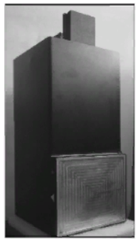
Fig. 4 – Photo of the detector system based on the scintillator and the high sensitivity CCD camera.

Tomography experiments are performed using the system of HUBER goniometers with a minimum rotation angle of 0.02° and the remote control system.
3. Results
3.1. Data pre-processing
With the help of the ImageJ software, the preliminary processing of images was carried out. For each set of images, preliminary processing was performed according to their own algorithm:
- Dark field
File $→$ Import $→$ Image sequence Dark field
Image $→$Adjust $→$ Brightness/Contrast $→$ Auto
Image $→$ Stacks $→$ Z project $→$ Average intensity
Process $→$ Noise $→$ Remove Outliers $→$ Radius = 2, Threshold = 400, Which outliers = Bright
Image $→$ Adjust $→$ Brightness/Contrast $→$ Auto
- Open beam
File $→$ Import → Image sequence Open beam
Image $→$ Adjust $→$ Brightness/Contrast $→$ Auto
Image $→$ Stacks $→$ Z project $→$ Average intensity
Process $→$ Noise $→$ Remove Outliers $→$ Radius = 2, Threshold = 400, Which outliers = Bright
Image $→$ Adjust $→$ Brightness/Contrast $→$ Auto
Projections:
File $→$ Import $→$ Image sequence Projections
Image $→$ Adjust $→$ Brightness/Contrast $→$ Auto
Process $→$ Noise $→$ Remove Outliers $→$ Radius = 2, Threshold = 400, Which outliers = Bright
The output images are shown in Figures 5-7.
Fig.5 – Dark field: (left) before processing, (right) after processing
Fig. 6 – Open beam: (left) before processing, (right) after processing
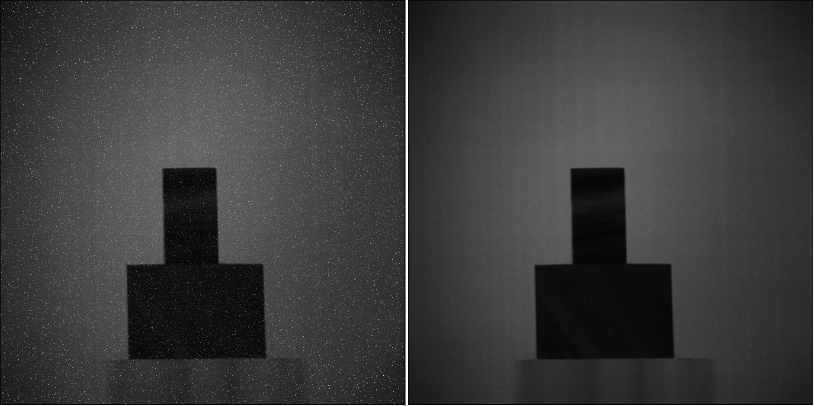
Fig. 7 – Projections: (left) before processing, (right) after processing
After preprocessing the sets of images separately, we processed the images of the Projections package according to the algorithm:
Process $→$ Image calculator $→$ Projections Subtract Dark field
Process $→$ Image calculator $→$ Flat field Subtract Dark field
Process $→$ Image calculator $→$ Projections Divide Flat field (32-bit)

Image $→$ Adjust $→$ Brightness/Contrast $→$ Auto
Process $→$ Math $→$ Reciprocal
Process $→$ Noise $→$ Remove Outliers $→$ Radius = 4, Threshold = 0.7, Which outliers = Dark
Process $→$ Math $→$ Log
Image $→$ Transform $→$ Rotate $→$ 1.25
Process $→$ Math $→$ Min $→$ 0
Subsequently, a sequence of images was saved under the name “tomo”. Figure 8 shows an image of the samples front view (0º).

Fig. 8 – Pre-processing samples (front view)
3.2. Reconstruction
Before the reconstruction, we found the center of rotation with the center of the image and then, using the STP program, we obtained images of samples with the smallest number of ring artifacts, but it was not possible to remove them completely due to the low equipment of computing capabilities.
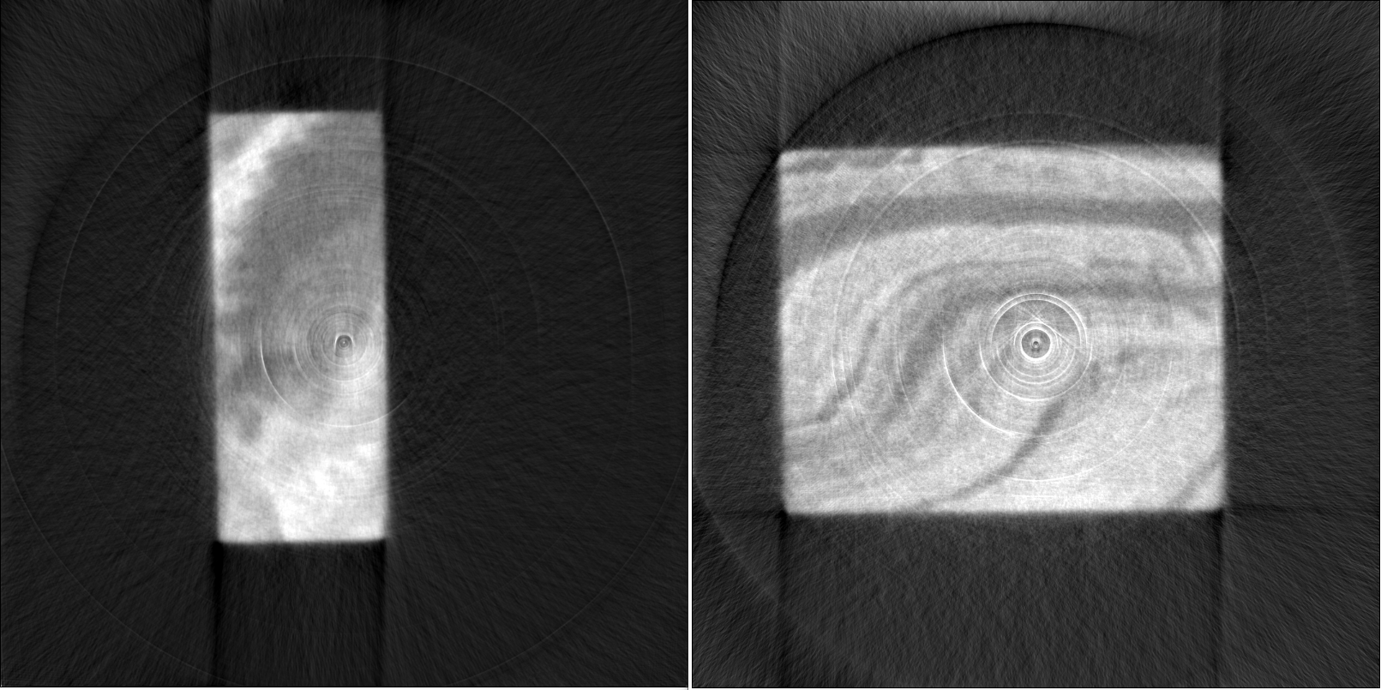
Fig. 9 – Samples after processing in the STP program: (left) 1 sample, (right) 2 sample
After obtaining images of the samples for further reconstruction, masks were obtained for each of the samples according to this algorithm in ImageJ:
Image – Adjust – Threshold – 8 mask
Process – Binary – Options – Do erode with 20 iterations
Save the results in ‘sample_mask’ folder
Crop the original images using sample mask:
Import sample slices and import previously saved mask slices
Process – Math – Divide mask images by 255
Process – Image calculator – Multiply sample slices by mask images
The resulting masks are shown in Figure 10.

Fig. 10 – Masks for samples: (left) for the first, (right) for the second
After applying masks to each sample, images of samples with a more clearly defined phase boundary were obtained.
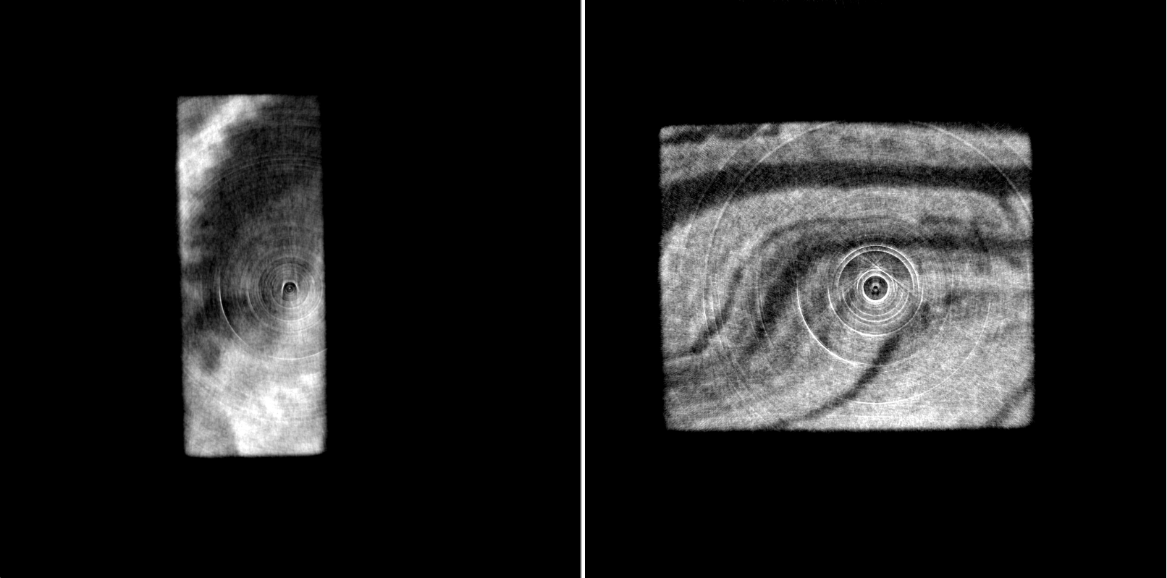
Fig. 11 – Samples after applying masks on them: (right) 1 sample, (left) 2 sample
ImageJ also built 3D images of the samples shown in Figures 12-13.
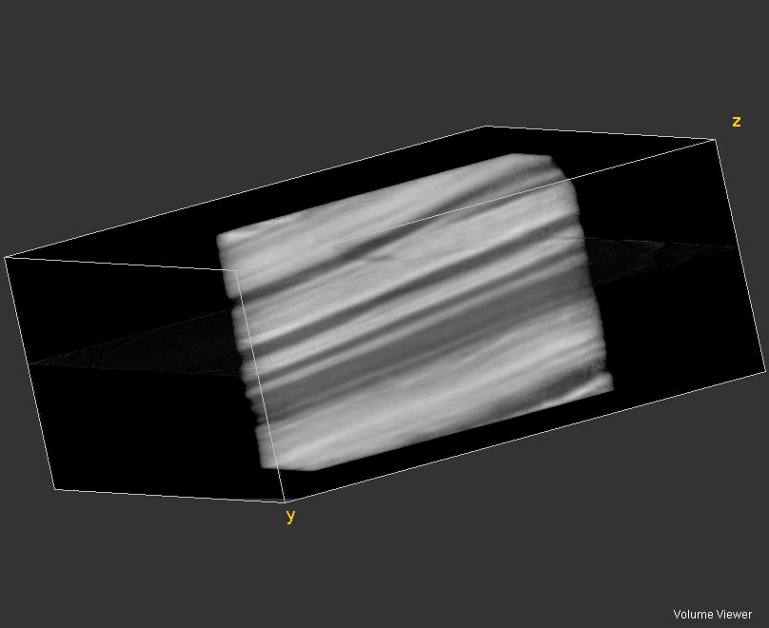
Fig. 12 – 3D reconstruction of 1 sample
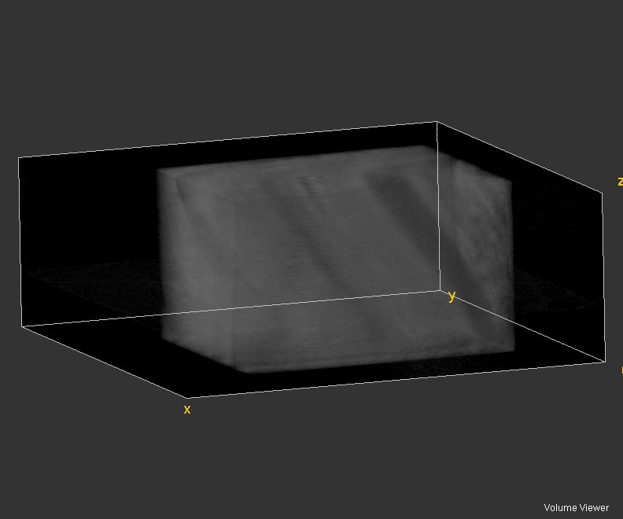
Fig. 13 – 3D reconstruction of 2 sample
For 3 minerals, the neutron attenuation coefficient was calculated using the formula:
$μ_{substance}=\frac{ρ_{substance}}{M_{r_substance}∙1.66∙{10}^{-27} kg}∙\left(\sum_{i-nucleus}{N_{i}σ_{i}}\right)$,
where …, N_{i} – number of atoms in the formula unit, σ_{i} – total microscopic cross-section.
- Quartz
$$μ_{Fe_{2}o_{3}}=\frac{ρ_{SiO_{2}}}{M_{r_SiO_{2}}∙1.66∙{10}^{-27} kg}∙\left(σ_{Si}+2σ_{O}\right)=\frac{2625\frac{kg}{m^{3}}}{\left(28.085+2∙15.999\right)∙1.66∙{10}^{-27} kg}∙\left(2.167+2∙4.232\right){∙10}^{-28}m^{2}=27.98 m^{-1}=0.2798 cm^{-1}$$
- Hematite
$$μ_{Fe_{2}o_{3}}=\frac{ρ_{Fe_{2}o_{3}}}{M_{r_Fe_{2}o_{3}}∙1.66∙{10}^{-27} kg}∙\left(2σ_{Fe}+3σ_{O}\right)=\frac{5300\frac{kg}{m^{3}}}{\left(2∙55.845+3∙15.999\right)∙1.66∙{10}^{-27} kg}∙\left(2∙11.62+3∙4.232\right){∙10}^{-28}m^{2}=71.85 m^{-1}=0.7185 cm^{-1}$$
- Magnetite
$$μ_{Fe_{2}o_{3}}=\frac{ρ_{Fe_{3}o_{4}}}{M_{r_Fe_{3}o_{4}}∙1.66∙{10}^{-27} kg}∙\left(3σ_{Fe}+4σ_{O}\right)=\frac{5150\frac{kg}{m^{3}}}{\left(3∙55.845+4∙15.999\right)∙1.66∙{10}^{-27} kg}∙\left(3∙11.62+4∙4.232\right){∙10}^{-28}m^{2}=69.39 m^{-1}=0.6939 cm^{-1}$$
3.3. Post-processing step (3D data analysis)
After reconstruction, the phases of iron and quartz in the samples were revealed according to the following algorithm:
Analyze – Histogram – 1024 bins – list– plot somewhere – choose threshold level
Image – Adjust – Threshold – apply chosen threshold
Plugins – 3D viewer
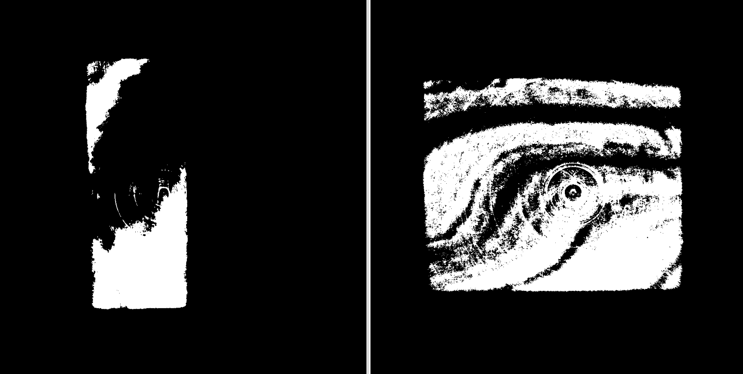
Fig. 14 – Post-processing of samples with isolation of one of the phases: (right) 1 sample, (left) 2 sample
After 3D visualization, three-dimensional images of the phases in each of the samples were obtained. Figures 15-16 show the iron-rich phase, and Figure 17-18 shows the quartz phase.
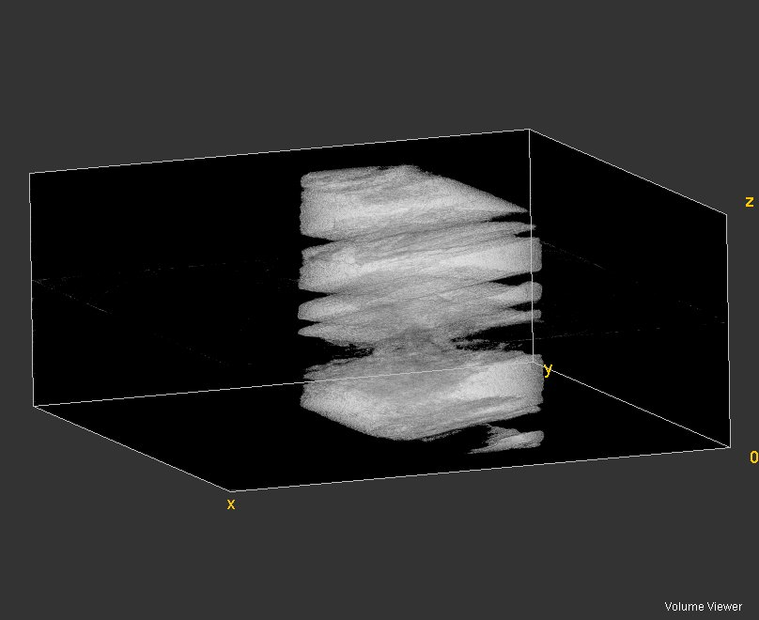
Fig. 15 – 3D reconstruction of the iron phase in 1 sample
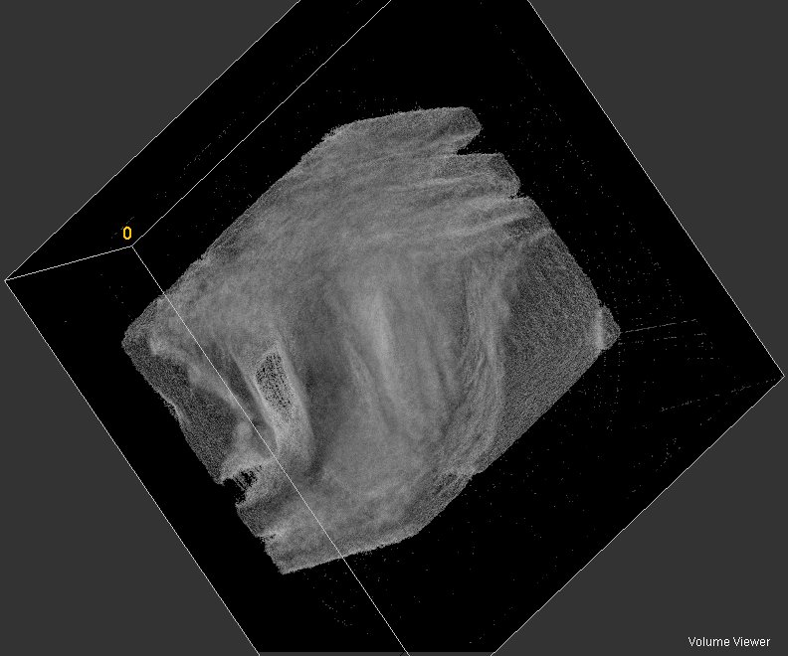
Fig. 16 – 3D reconstruction of the iron phase in 2 sample
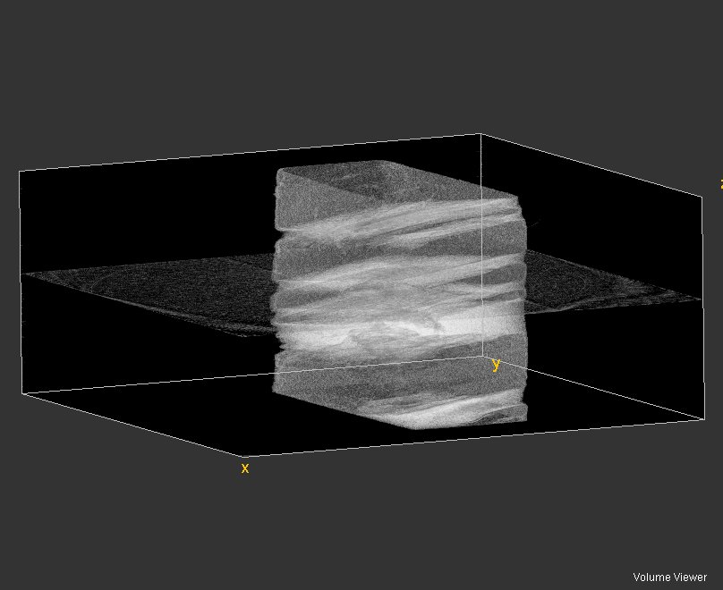
Fig.17 – 3D reconstruction of the quartz phase in 1 sample
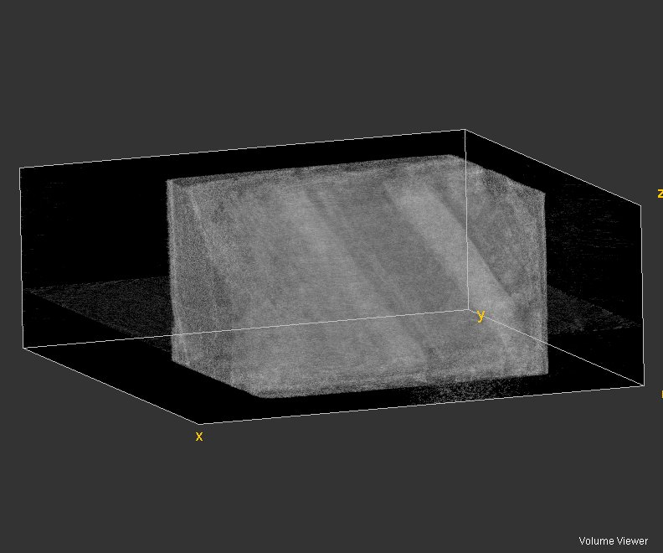
Fig. 18 – 3D reconstruction of the quartz phase in 2 sample
The percentage of iron and quartz in quartzite was calculated for 2 samples:
1 sample
- iron rich phase
$$100\%∙\frac{12671}{18719}=68\%$$
- quartz rich phase
$$100\%-68\%=32\%$$
2 sample
- iron rich phase
$$100\%∙\frac{21987}{35759}=62\%$$
- quartz rich phase
$$100\%-62\%=38\%$$

4. Conclusions
In the course of the work, the structure of two samples consisting mainly of iron and quartz - ferruginous quartzites was studied by neutron tomography method. Three stages of processing of the obtained neutron images were carried out: pre-processing, reconstruction and post-processing.
At the first stage of image processing, three sets of images were pre-processed using ImageJ software: Dark field, Open beam and Projections.
At the second stage, image reconstruction and removal of ring artifacts were performed using STP software. We obtained 3D images of two samples, on which we can see a clear separation of phases. The linear attenuation coefficient was also calculated for three mineral phases presented in studied samples: quartz, hematite and magnetite, the values of which are 0.2798 $cm^{-1}$, 0.7185 $cm^{-1}$ and 0.6939 $cm^{-1}$, respectively.
At last stage, 3D images of phases in each of the samples were obtained using ImageJ software. The percentage of iron and quartz in each sample was calculated: in 1 sample the iron content was 68%, and quartz 32%, in 2 sample the iron content was 62%, quartz 38%. Both samples are rich in iron.
Acknowledgments Both samples are rich in iron
In gratitude, I want to say that I really liked this project. This project develops the skills of processing images obtained from the experiment. Teaches how to work with software such as ImageJ and STP. Especially, I want to express my gratitude to Dr. Ivan Zel, who took this work very seriously: he prepared lecture material, presentations, a lot of literature sources that can be fully studied and throughout the work helped in the development of this project.
References
- D. P. Kozlenko, S. E. Kichanov, E. V. Lukin, A. V. Rutkauskas, A. V. Belushkin, G. D. Bokuchava, and B. N. Savenko / Neutron Radiography and Tomography Facility at IBR 2 Reactor, 2015.
- Veeranjaneyulu Rayapudi, Nikhil Dhawan / Processing of Banded Hematite Quartzite Ore for Recovery of Iron Values, 2020.
- Course of lectures 3D imaging with neutrons / Ivan Zel, 2022.

