JOINT INSTITUTE FOR NUCLEAR RESEARCH
Frank laboratory of Neutron Physics

FINAL REPORT ON THE
INTEREST PROGRAM

INTRODUCTORY COURSE "MD-SIMULATION RESEARCH (FROM ATOMIC FRAGMENTS TO MOLECULAR COMPOUND)"

Supervisor:
Prof. Dr. Kholmirzo Kholmurodov

Student:
Davaadulam Gombosuren,
National University of Mongolia,
Mongolian Academy of Sciences,
Mongolia

Participation period:
May 24 – July 02, Wave 4

Dubna 2021
Contents
- Summary
- Project goals
- Introduction
- Methods
- Results
- Conclusion
- Future work
- Acknowledgements
- Reference

- Summary
Antimicrobial peptides that are short (≥50 amino acids), amphiphilic, cationic are thought to function as an important part of the innate immune system, providing an effective protective machinery against infectious pathogens. In this project, the conformational change of modelled antimicrobial peptide (GA-K4) have been studied in solvent using molecular dynamics (MD) simulations. As a result, MD simulations have been applied to understand the conformation of GA-K4 peptide in future its action mechanism. The results show that the peptide was unstable secondary structure consisting of an uncoiled structure in water phase. In the conclusion, I propose that the GA-K4 peptide is a membrane-active peptide, and further work need to study the interaction antimicrobial peptide and bacterial mimic membrane (POPG, POPC etc.).
- Project goals
The aim of this work was to understand the conformation properties as well as its dynamical stability of the antimicrobial peptide in water environment using the skills and experience gained from this course.
- Introduction
The resistance of conventional antibiotics has been elevated in the past decade (Hancock, 1997). In fact, the World Health Organization (WHO), in the report of 2015, mentions antibiotic resistance as the profound threat to human health (WHO, 2015). The naturally occurring antimicrobial peptides, commonly known as AMPs present a new option (‘nature’s antibiotics’) to fight back against the bacteria (Boman, 1995). The research field of antimicrobial peptides has been thriving for decades. In total, more than 5,000 AMPs have been discovered or synthesized up to date (Zhao et al., 2013). These AMPs display a broad range of activity against microbes, fungi, viruses and bacteria including gram-positive and gram-negative strains (Jenssen et al., 2006; Pistolesi et al., 2007]. They have been shown to be active against some multi-drug resistant microbial strains (Ginsburg et al., 2008; Won et al., 2011; Kang et al., 2012). The AMPs are under study to develop a potential therapeutic agents having potent antimicrobial activity without toxicity against eukaryotic cells, and several antimicrobial peptides are under commercial development (Cruciani et al., 1991; Won et al., 2011; Kang et al., 2012). AMPs have been reported to have anti-cancer effects against multi-drug resistant cancer cells with little toxicity against non-tumor cells (Hoskin et al., 2008). Furthermore studies have shown that AMP possesses synergistic effects when used in combination with conventional chemotherapeutic agents (Kang et al., 2012; Hui et al., 2002). The primary target of antimicrobial peptides are believed to be the bacterial cytoplasmic membrane (Kim et al., 2003; Brogden et al., 2005; Jenssen et al., 2006). The major and important subclass of these AMPs belongs to linear or random-coiled peptides, most commonly carrying a net positive charge, and have a tendency to form amphipathic a-helices upon binding with bacterial membrane (Pistolesi et al., 2007; Kang et al., 2012).
Many AMPs are believed to adopt a non-structured/extended conformation in water environment, (Dathe et al., 1996) while others attain specific configurations due to the presence of intermolecular hydrogen bonds, as for instance β-sheet peptides (Oishi et al., 1997). In both cases, peptides undergo significant conformational changes upon binding to the target bacterial cell. The importance of the secondary structure in the activity of AMPs has been widely studied in order to extract a structure-function relationship.
Previous report showed that the short natural antimicrobial peptide (AMP), Brevinin-1 EMa, formerly known as Gaegurin 5 that was isolated from the skin of Korean frog Rana Rugosa (Park et al., 1994, Won et al., 2008). The peptide has antimicrobial and hemolytic activity, and different derivatives of Brevinin-1 EMa, specially GA-K4, has increased anti-cancer activity (Won et al., 2004; Kang et al., 2012). Additionally it was also reported that the microbicidal activity of Brevinin-1 EMa and its derivatives acts by disintegrating bacterial membranes. Many researchers are known to kill bacteria by selectively disintegrating bacterial membranes. (Shai et al., 1999, Tossi et al., 2000, 2006). Kang et al. examined that synthetic GA-K4 peptide possess synergistic anti-cancer and cytotoxic effect when supplied in combination with doxorubicin, a DNA alkylating agent used extensively in combination chemotherapy in 2011. Combinational effects of doxorubicin and GA-K4 peptide were reported as nine times more effective against kidney tumor cells, and five times more effective against lung cancer cells.
Without suitable template, de novo PSP (template-free modeling) can be used to predict novel protein fold. The most popular and successful ones are usually based on assembly of known structure fragments with potential energy functions from mining know protein structures (such as Rosetta (Bradley et al., 2005; Rohl et al., 2004) and QUARK (Xu et al., 2012)). The predicted peptide models can span a broad range of accuracies and are potentially suitable for different applications (Zhang, 2009).
MD simulations have become an important and pervasive physics-based method to explore the conformational space of peptides and proteins, which can even fold small proteins to their native structures (Kholmurodov, 2009, 2013; McCammon et al., 1977). The availability of user-friendly and reliable software to perform this kind of calculation (e.g. Charmm, NAMD, Amber, Gromacs, Gromos, DL_POLY, etc.) and to visualize and analyse their output (VMD, pymol, gOpenMol, nMoldyn, ...), enable, Therefore, I focused on the conformational dynamics of ab initio structure prediction of peptide using MD simulation for a long time.
- Methods
  - Peptide Structure Prediction (PSP methods)
As the function of a peptides is always related to its unique conformational properties (Bock et al., 2013), accurate peptide structure prediction would contribute significantly to the peptide-based drug design. Many attempts have been made for developing peptide structure prediction, including evaluations of some common PSP methods (Rosetta, I-TASSER) and specific development of PSP methods (PepLook, Pep-Fold). As X-ray crystallographic and NMR study of GA-K4 peptide (sequence:FLKWLFKWAKK) have not been investigated, I predicted the peptide structure using I-Tasser. Manual inspection and manipulation of the model can be performed using molecular graphics software of Swiss-PDB Viewer (Guex et al., 1997).
  - Evaluating stereochemical properties
The main basic requirement for a protein structure is correct stereochemistry. Validation programs check for anomalies, such as phi/psi angle combinations that are placed in disallowed regions, steric collisions, and unfavourable bond lengths and angles. Programs such as PROCHECK (Laskowski, 1993) and WHATCHECK (Hooft et al., 1996) analyse these stereochemical features of the residues in the model and give an evaluation of the overall quality of the structure. Analysis of bond geometry by looking at Ramachandran plots is important in order to highlight unrealistic conformations within the structure. Certain conformations of phi and psi angles are forbidden in protein structures because they result in steric hindrance, or clashes between atoms. A good model will generally have 90% of its residues in the allowable regions of a Ramachandran plot (Laskowski 1993).
  - MD simulation and analysis
The MD simulation were performed under periodic conditions using GROMACS package v2020.04 on Ubuntu 20.04 Linux operating system in an Intel(R) Core(TM) i7 CPU 3.20 GHz. I performed a molecular dynamic simulation for the peptide in water phase using the AMBER ff-03 force field (Duan et al., 2003) and TIP3P water model (Jorgensen et al., 1983). The simulation is convergent in 100 ns. Because the system is required to be neutral for calculations, charges were balanced with sufficient amount of sodium counter ions. To set up the simulation system, peptide was placed in cubic box solvated with water. The LINCS (Hess et al., 1997) algorithm was used to constrain the length of all bonds of peptide. The geometry of water was constrained using SETTLE (Miyamoto et al., 1992). At first the system was energy minimized using the steepest descent method. After energy minimization process, position restraint procedure was performed in association with NVT and NPT ensembles. Equilibration is often conducted in two stages: first, the system is simulated under a canonical ensemble (NVT) in which the number of molecules, volume, and temperature are kept constant. An NVT ensemble was adopted at constant temperature of 300 K with time duration of 100 ps. The integration time-step was of 2 fs and atom positions of the solute were written to file every 1 ps. After stabilization of temperature an isothermal–isobaric ensemble (NPT) was performed. In second phase a constant pressure of 1.0 bar was employed with time duration of 100 ps. NPT ensemble was finished after pressure stabilization. The Particle-Mesh Ewald (PME) method was used to treat the long-range electrostatic interaction and the cut-off method was used to treat the van der Waals interactions, with the cut-off distance of 1.0 nm (Essmann et al., 1995). Secondary structure content was assessed with the DSSP algorithm (Kabsch et al., 1983). MD simulation of peptide-water system are shown using VMD (https://www.ks.uiuc.edu/Research/vmd/).
- Results
A three-dimensional structure of antimicrobial and anti-cancer active GA-K4 peptide was modeled using I-TASSER, Swiss-Pdbviewer tool (see Figure 1). It’s the energy minimization was -58.7 kJ/mol. From first sequences the peptide secondary structure element content was calculated by the DSSP program, which predicted the hydrogen bond energy of secondary structure. As a result the α-helix structural content and the uncoiled structure content were 86.4% and 13.6%, respectively. I validated the structure of the GA-K4 peptide using PROCHECK (Figure 2).
The torsion angles that the atoms of the peptide bond can assume are limited by steric constraints. Φ and Ψ torsion angles determine secondary structure. The rotation around these dihedral angles is basically free, as compared to that around the ω dihedral angles, and is only controlled by the steric repulsions involving the methylene group at the α position, as first noted by Ramachandran (Ramachandran et al., 1968). In 1963, before protein structures at atomic resolution were determined, G. N. Ramachandran established the foundations of the analysis conformations of peptide chains by using simple hard sphere models for the atoms. The so-called Ramachandran maps are 2D representations of the allowed regions of the Φ, Ψ space. In Figure 2, the highlighted regions correspond to allowed local conformations of the amino acid.
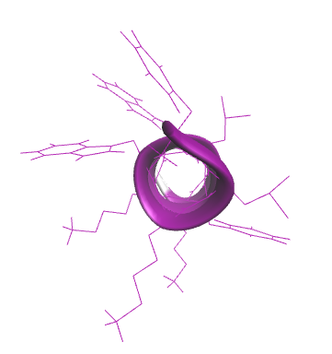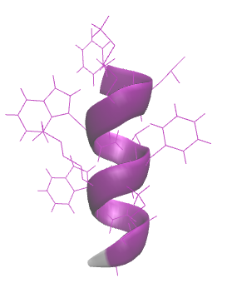
- B.
Figure 1. The snapshot of the three-dimensional structure of GA-K4 peptide by VMD. Helix (purple) and uncoiled (grey) structure of A) from above B) from side.
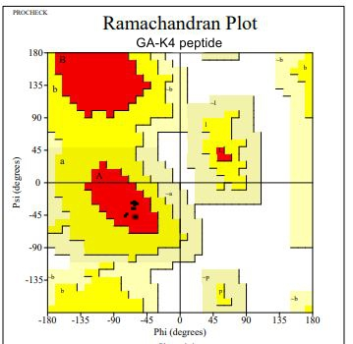
Figure 2. Ramachandran plot. The dotted black regions indicate the sterically allowed Φ and Ψ angles for all residues, excluding Gly and Pro.
The peptide were placed in cubic box containing a pre-equilibrated water molecules and the whole systems were minimized in TIP3P explicit water molecules using AMBER03. After the simulation was initialized with a 100 ps equilibration to stabilize the system and results are shown in Figure 3.
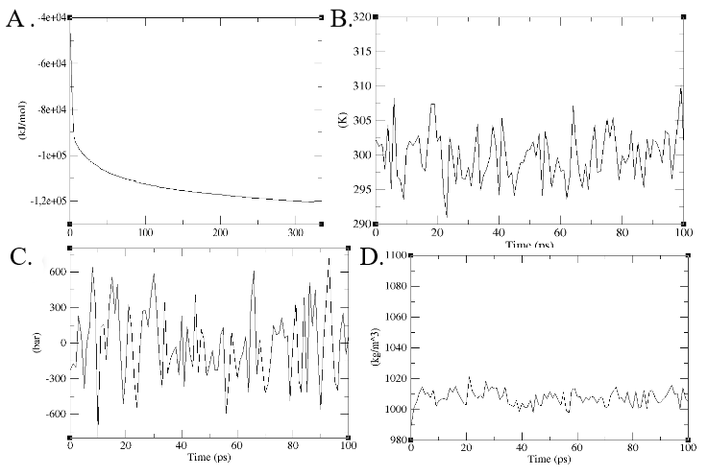
Figure 3. Energy minimization and equilibrium of GA-K4 in water phase
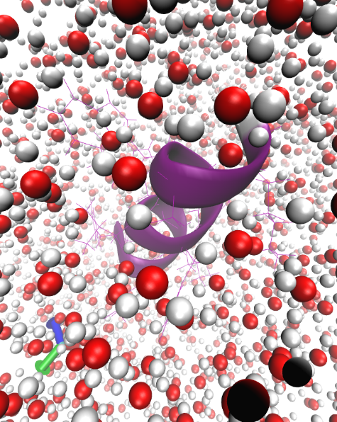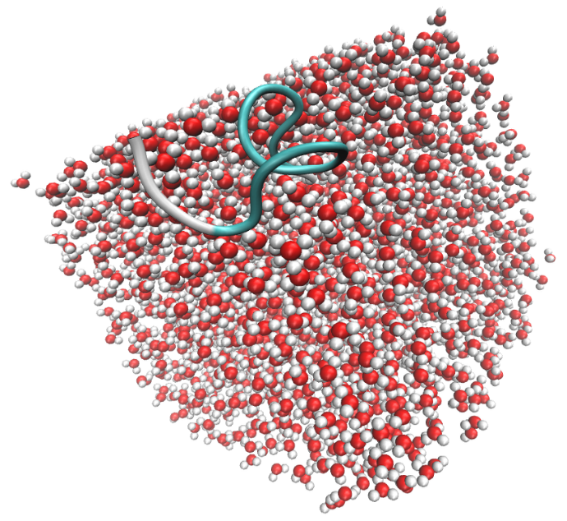
- B.
Figure 5. Snapshots at different times along the simulation of a system composed of water molecules and GA-K4 peptide. The water molecules were represented as bubbles with red (oxygen) and white (hydrogen) color, respectively. The GA-K4 peptide were presented A) helix structure (purple, cartoon), B) disordered structure (grey and tail, cartoon). The position of the peptide at initial stage (0 ns, A) and one of the positions of the peptide after a 100 ns simulation (B) were shown, respectively.
Figure 6 is shown that RMSD for the peptide is stable during the simulation with the system.

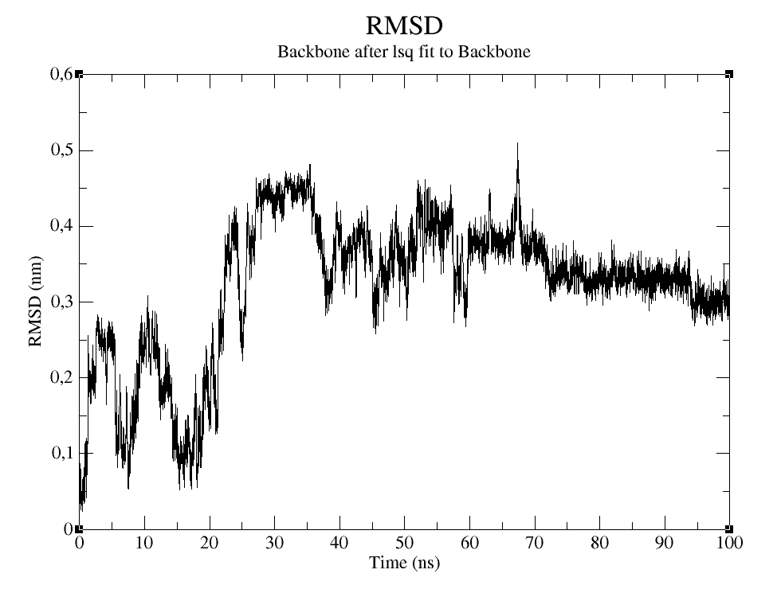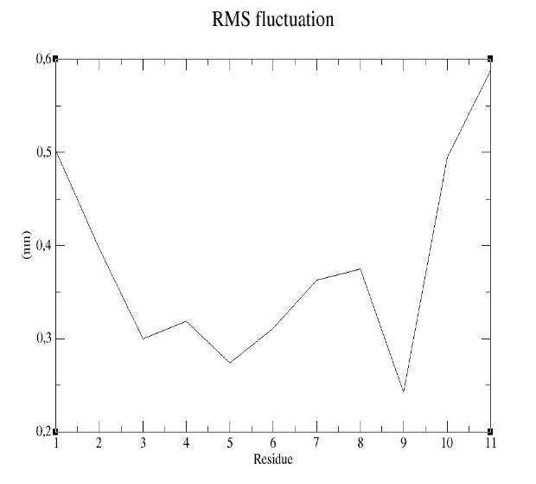
Figure 6. A) The RMSD trajectory of all Cα atoms in of the peptide backbone as function of simulation time in nanoseconds, B. RMSF of all Cα atoms of residues of peptide.
The template structure of GA-K4 peptide was not previously determined using NMR. However, secondary structures of the peptide have studied by Circular Dichroism (CD) spectroscopic method (Tsogbadrakh et al., 2017). Here I am analyzed a various secondary structure elements of the peptide using DSSP algorithm (Figure 7, Table 1). These results are unstable random coil-structure, as found solution. I identified the content of random coil, helical, turn etc… conformations in the simulations as function of time.
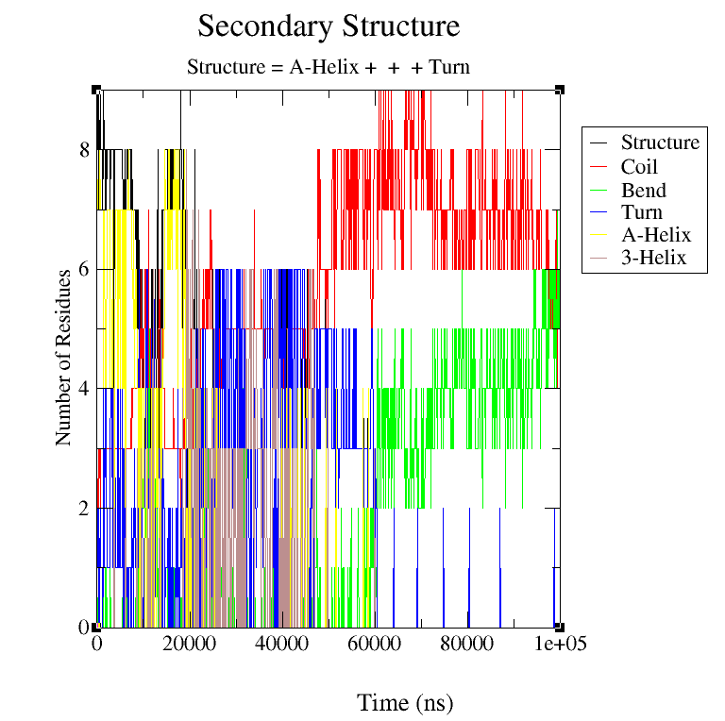
Table 1. Comparison of secondary structure of the peptide.
Structure | CD measurement,  % | MD simulation,  %
Coil | 42 | 52
B-Bridge | 0 | 0.5
Bend | 10 | 17
Turn | 24 | 15
α-helix | 14 | 9
5-helix | 0.5 | 0.5
3-helix | 9 | 6
As seen Table 1, the coil structure content was 52%.
- Conclusion
Molecular dynamic simulation of the peptide in water was performed using the AMBER ff-03 force field and TIP3P water model. As result show that the peptide was unstable structure in water environment. I propose that the GA-K4 peptide is a membrane-active peptide, and further work need to study the interaction antimicrobial peptide and bacterial mimic membrane (POPG, POPC etc.).
- Future work
For the development of AMPs as future antibiotics, it is therefore crucial to understand their mechanism of membrane permeation in order to optimize their antimicrobial activity. I will be study the relationship between the structure of GA-K4 peptide and the mechanism of interaction with lipids, as well as molecular details of this process using MD simulation (Gromacs, DL_Poly (Kholmurodov, 2010) etc…). I hope that our studies will put some light in AMP-membrane interaction, and thus will be useful in designing the anti-cancer peptide agents.
The following objectives of the study will perform:
- To simulate system of interaction POPC and GA-K4 peptide under physiological condition.
- To simulate system of interaction POPG and GA-K4 peptide under physiological condition
- To simulate system of interaction 2:1 POPG:POPC and GA-K4 peptide under physiological condition
- Acknowledgements
I would like to thank supervisor Prof. Dr. Kholmirzo Kholmurodov for giving me the opportunity to be part of a very interesting project, and teaching of introduction molecular dynamic simulation. His explanation and guidance helped me in all the time of work.
- Reference

- Hancock, R.E. Peptide antibiotics. Lancet, 1997, 349, 418-422.
- WHO. Global Antimicrobial Resistance Surveillance System: Manual for Early Implementation. World Health Organization, 2015.
- Boman, H.G. Peptide antibiotics and their role in innate immunity. Annu. Rev. Immunol., 1995, 13, 61-92.
- Jenssen, H.; Hamill, P.; Hancock, R.E. Peptide antimicrobial agents. Clin. Microbiol. Rev., 2006, 19, 491-511.
- Pistolesi, S.; Pogni, R.; Feix, J.B. Membrane insertion and bilayer perturbation by antimicrobial peptide CM15. Biophys.J., 2007, 93, 1651-1660.
- Ginsburg, I.; Koren, E. Are cationic antimicrobial peptides also “double-edged swords”? Expert Rev. Anti. Infect.Ther., 2008, 6, 453-462.
- Kang, S.J.; Ji, H.Y.; Lee, B.J. Anticancer activity of undecapeptide analogues derived from antimicrobial peptide, brevinin-1EMa. Arch. Pharm. Res., 2012, 35, 791-799.
- Won, H.S.; Kang, S.J.; Choi, W.S.; Lee, B.J. Activity optimization of an undecapeptide analogue derived from a frog-skin antimicrobial peptide. Mol. Cells, 2011, 31, 49-54.
- Cruciani, R.A.; Barker, J.L.; Zasloff, M.; Chen, H.C.; Colamonici, O. Antibiotic magainins exert cytolytic activity against transformed cell lines through channel formation. Proc. Natl. Acad. Sci. USA, 1991, 88, 3792-3796.
- Hoskin, D.W.; Ramamoorthy, A. Studies on anticancer activities of antimicrobial peptides. Biochim. Biophys. Acta, 2008, 1778, 357-375.
- Hui, L.; Leung, K.; Chen, H.M. The combined effects of antibacterial peptide cecropin A and anti-cancer agents on leukemia cells. Anticancer Res., 2002, 22, 2811-2816.
- Brogden, K.A. Antimicrobial peptides: pore formers or metabolic inhibitors in bacteria?. Nat. Rev. Microbiol., 2005, 3, 238-250.
- Kim, S.; Kim, S.S.; Bang, Y.J.; Kim, S.J.; Lee, B.J. In vitro activities of native and designed peptide antibiotics against drug sensitive and resistant tumor cell lines. Peptides, 2003, 24, 945-953.
- Hancock, R.E.; Chapple, D.S. Peptide antibiotics. Antimicrob. Agents Chemother., 1999, 43, 1317-1323.
- Shai, Y.; Oren, Z. From mechanism to de-novo designed diastereomeric cell-selective antimicrobial peptides. Peptides, 2001, 22, 1629-1641.
- Kholmirzo Kholmurodov, Models in Bioscience and Materials Research: Molecular Dynamics and Related Techniques, Nova Science Publishers (N.Y.), ISBN: 978-1-62808-052-0 (2013).
- Bradley P, Misura KMS, Baker D. Toward high-resolution de novo structure prediction for small proteins. Science 2005;309:1868–71.
- Rohl CA, Strauss CEM, Misura KMS, Baker D. Protein structure prediction using Ro-setta. Methods Enzymol 2004, 383:66–93.
- Xu D, Zhang Y. Ab initio protein structure assembly using continuous structurefragments and optimized knowledge-based forcefield. Proteins 2012;80:1715–35.
- K Kholmurodov, M Abasheva, K Yasuoka, Molecular dynamics simulations of valinomycin interactions with potassium and sodium ions in water solvent, Advances in Bioscience and Biotechnology 1 (3), 145-240 (2010)
- Zhang Y. Protein structure prediction: when is it useful? Curr Opin Struct Biol 2009; 19:145–55
- McCammon JA, Gelin BR, Karplus M. Dynamics of folded proteins. Nature 1977; 267:585–90.
- KT Kholmurodov, Computer design for new drugs and materials: Molecular dynamics of nanoscale phenomena, Nova Science Publishers (N.Y.), ISBN: 978-1-53612-082-0, (2017).
- Bock JE, Gavenonis J, Kritzer JA. Getting in shape: controlling peptide bioactivityand bioavailability using conformational constraints. ACS Chem Biol 2013;8:488–99.
- Guex N and Peitsch MC SWISS-MODEL and the Swiss-PdbViewer: An environment for comparative protein modeling. Electrophoresis 1997;18: 2714-2723.
- Laskowski, R.A. PROCHECK: a program to check the stereochemical quality of protein structures. J ApplCryst 1993;26: 283-291
- Kholmurodov Kh.T. Molecular Simulation in Material and Biological Research. Nova Science Publishers (N.Y.), ISBN: 978-1-60741-553-4 (2009).
- Hooft, RWW, Vriend G, Sander, C and Abola EE Errors in protein structures. Nature 1996; 381: 272-272.
- Y. Duan, C. Wu, S. Chowdhury, M.C. Lee, G. Xiong, W.E.I. Zhang, R. Yang, P. Cieplak, R.A.Y. Luo, T. Lee, J. Caldwell, J. Wang, P. Kollman J. Comput. Chem., 24 (2003), pp. 1999-2012
- W.L. Jorgensen, J. Chandrasekhar, J.D. Madura, R.W. Impey, M.L. Klein.J.Chem.Phys., 79 (1983), pp. 926-935
- Kabsch, W.; Sander, C. Biopolymers 1983, 22, 2577– 2637
- Miyamoto, S. & Kollman, P. A. SETTLE: An Analytical Version of the SHAKE and RATTLE Algorithms for Rigid Water Models. J. Comp. Chem. 13, 952–962 (1992).
- Hess, B., Bekker, H. Berendsen, H. J. C. & Fraajie, J. G. E. M. LINCS: A Linear Constraint Solver for Molecular Simulations. J. Comput. Chem. 18, 1463–1472 (1997).
- Essmann, U. et al. A smooth particle mesh Ewald method. J. Chem. Phys. 103, 8577–8592 (1995).
- Tsogbadrakh Mishig-Ochir, Davaadulam Gombosuren, Altanchimeg Jigjid, Badamkhatan Tuguldur, Galbadrakh Chuluunbaatar, Enerelt Urnukhsaikhan, Chinar Pathak and Bong-Jin Lee, Cellular Membrane Composition Requirement by Antimicrobial and Anticancer Peptide GA-K4, Protein & Peptide Letters J, 24, 197-205 (2017)

