
JOINT INSTITUTE FOR NUCLEAR RESEARCH
Frank Laboratory of Neutron Physics (FLNP)

FINAL REPORT ON THE
INTEREST PROGRAMME

Interaction of room-temperature neutrons with magnetic vortex in thin films

Supervisor:
Dr. Zhaketov Vladimir
FLNP, JINR, Dubna, Russia

Student:
Lavrenenko Valery, Belarus
Belarussian State University

Participation period:
Oct. 20 – Nov. 30, Wave 13

Dubna, 2025

Contents
Abstract 3
Introduction 3
Toy-model 4
Analytical solution for toy-model 5
Numerical solution of Schrodinger equation 6
Conclusion 10
Acknowledgments 10
References 10

Abstract
During the practice problem of neutron-magnetic vortex interaction was under consideration. Evolution of room-temperature neutrons in external field with special topological property – the swinging axis existence, have been numerically calculated for two cases for longitudinal polarized neutron beam – toy-model of magnitude-constant swinging magnetic field and a skyrmion vortex. In both cases the primary component of neutron beam stayed untwisted, but the second one became a twisted one with $m=1$ as magnetic field was. It has been found, that solution became unstable in such system, if initial particle was far from swinging axis.

Introduction
One of the most topical field of interest of modern physics is study different topological features of any system. These features can be observed both in linear and nonlinear systems. In linear system such topological features refer to superposition of more simple states. In strongly interacting nonlinear system topological structures refer to deep inner symmetries, which can get a classification of some systems and bound with existence of “simple” solutions, which demonstrates clearly defined evolution (topologically protected). Such solutions are called soliton solutions, and can be observed in lots of nonlinear systems. For example, for magnetic systems such solutions are called skyrmions and hophions and were observed experimentally [1-11].
Twisted or vortex states of free particles are simple examples of linear topological structure. These states are Bessel-like like states with well-defined energy, direction of propagation, momentum and angular momentum projections on the propagation direction. Topological property referred to these states is connected with a topological charge – ratio of the phase difference during swinging in transverse plane around propagation direction axis and 2π. In any cases of interaction of such states with non-topological target or in case of decay of such state sum of topological charges of products is equal to initial topological charge. Such state can be great instrument for creation, manipulation and investigation different topological structures in complex nonlinear systems.

Toy-model
Nonrelativistic neutron in the external magnetic field can be described as spinor function $Ψ={\left(ξ η\right)}^{T}$, which satisfies Schrodinger equation:
$iℏ\frac{∂Ψ}{∂t}=-\frac{ℏ^{2}}{2m}∇^{2}Ψ+\left|μ_{n}\right|\underline{σ}∙\underline{B} Ψ.$ (1)
According to the model magnetic field has a constant magnitude and a helical structure around z-axis.
$\underline{B}=B\underline{n}=B{\left(\frac{-y}{\sqrt{x^{2}+y^{2}}}\sin\left(θ_{0}\right),\frac{x}{\sqrt{x^{2}+y^{2}}}\sin\left(θ_{0}\right),\cos\left(θ_{0}\right)\right)}_{\{x,y,z\}}=B{\left(0, \sin\left(θ_{0}\right),\cos\left(θ_{0}\right)\right)}_{\{r,φ,z\}}.$ (2)
It is characterized by two parameters. The first one is a magnitude value and the second one is an angle between magnetic field line and z-axis. Magnetic lines of such type of field are introduced in Figure 1а. This field is a field of magnetic with a vortex placed in a homogeneous external magnetic field. Another type of magnetic structure of our interest is union of parallel magnetic rods with homogeneous magnetization over any rod, but direction of magnetization of different rods is rotated to form a vortex on a macroscopic scale.
Such type of magnetic field differs in principle from field of helimagnetic – another twisted magnetic structure. Figure 2a shows magnetic lines of (2) and figure 2b shows magnetic lines for helimagnetic with the same parameters. Helimagnetic field can be described as a field of layered structure and the external field, orthogonal to layers. Magnetization of any layer is homogeneous, but direction of magnetization of the layer differs from its neighbor one by small angle. In that case all points of one layer are equal, so there could no state with a defined axes be formed.
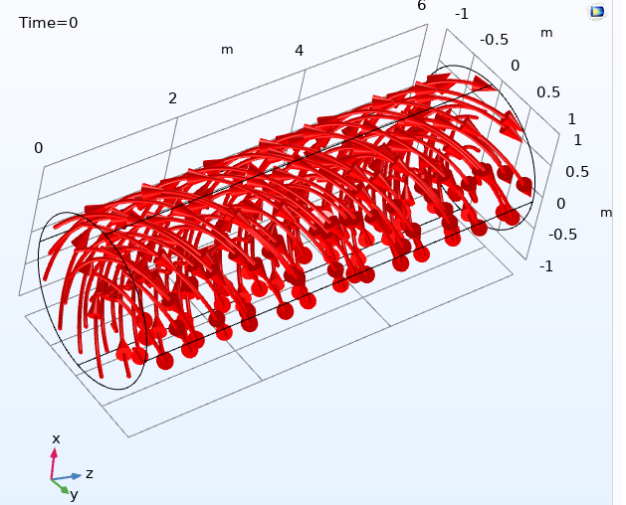 | 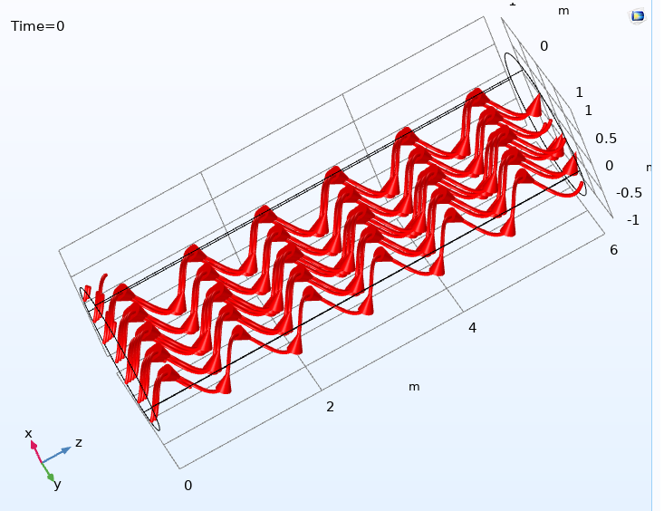
Figure 1. Magnetic field, which is combination of homogeneous external one along z-axis and a) vortex magnetic structure, b) helimagnetic.
Let us rescale energy of a $E_{0}$ value, length of a reduced wave length for an energy value $E_{0}$ in free particle case, wave vector of an inverse of the reduced wave length, time of a reduced period of oscillation of the free particle with the energy value $E_{0}$:
$E=E_{0}ε, r=ƛρ, z=ƛζ, k=1/ƛ κ, t=Tτ.$ (3)
So, equation (1) for the magnetic field of type (2) become more convenient form:
$i\frac{∂}{∂τ}\left(\begin{matrix}ξ \\ η\end{matrix}\right)=-\left(\frac{∂^{2}}{∂ρ^{2}}+\frac{1}{ρ^{2}}\frac{∂^{2}}{∂φ^{2}}+\frac{∂^{2}}{∂z^{2}}\right)\left(\begin{matrix}ξ \\ η\end{matrix}\right)+γ\left(\begin{matrix}\cos\left(θ_{0}\right) & -\sin\left(θ_{0}\right)e^{-iφ} \\ \sin\left(θ_{0}\right)e^{iφ} & -cos\left(θ_{0}\right)\end{matrix}\right)\left(\begin{matrix}ξ \\ η\end{matrix}\right),$ (1’)
where new parameter $γ=\left|μ_{n}\right|B/E_{0}$ have been used.

Analytical solution for toy-model
We will try to solve equation (1’) in the following form:
$\left(\begin{matrix}ξ \\ η\end{matrix}\right)=e^{-iϵτ+iκ_{z}ζ}\sum_{m}{\left(\begin{matrix}C_{m}^{\left(+\right)}\left(ρ\right) \\ C_{m}^{\left(-\right)}\left(ρ\right)\end{matrix}\right)e^{imφ}}.$ (4)
So, equations (1’) for a set of radial functions are the following:
$\left\{\begin{matrix}\left(\frac{∂^{2}}{∂ρ^{2}}-\frac{m^{2}}{ρ^{2}}+\left(ε-κ_{z}^{2}\right)+γ\cos\left(θ_{0}\right)\right)C_{m}^{\left(+\right)}\left(ρ\right)-iγ\sin\left(θ_{0}\right)C_{m+1}^{\left(-\right)}=0, \\ \left(\frac{∂^{2}}{∂ρ^{2}}-\frac{m^{2}}{ρ^{2}}+\left(ε-κ_{z}^{2}\right)-γ\cos\left(θ_{0}\right)\right)C_{m}^{\left(-\right)}\left(ρ\right)+iγ\sin\left(θ_{0}\right)C_{m-1}^{\left(+\right)}=0.\end{matrix}\right.$ (5)
The system is getting unengaged for a case of non-vortex structure of the magnetic field ($θ_{0}=0$), as it should be, for a pair of Bessel-type equations for up and down spinor components. So, in that case if there is no any vortex structure in the initial state, it won’t appear further.
Radial function can be described as a set of polynomials:
$\left(\begin{matrix}C_{m}^{\left(+\right)}\left(ρ\right) \\ C_{m}^{\left(-\right)}\left(ρ\right)\end{matrix}\right)\sim \sum_{k}{\left(\begin{matrix}C_{m,k}^{\left(+\right)} \\ C_{m,k}^{\left(-\right)}\end{matrix}\right)ρ^{k}}.$ (6)
Constants $C_{m,k}^{\left(-\right)}$ is a solution of the following recurrent equation, and $C_{m,k}^{\left(+\right)}$ can be recalculated using $C_{m,k}^{\left(-\right)}$.
$$\left(\left(k-2\right)\left(k-3\right)-{\left(m-1\right)}^{2}\right)\left(k\left(k-1\right)-m^{2}\right)C_{m,k}^{\left(-\right)}+$$
$$+\left(2\left(k-2\right)\left(k-1\right)-\left(\left(ε-κ_{z}^{2}\right)+γ\cos\left(θ_{0}\right)\right)m^{2} - (7)-\left(\left(ε-κ_{z}^{2}\right)-γ\cos\left(θ_{0}\right)\right){\left(m-1\right)}^{2}\right)C_{m,k-2}^{\left(-\right)}+$$
$$+\left({\left(ε-κ_{z}^{2}\right)}^{2}-γ^{2}\right)C_{m,k-4}^{\left(-\right)}=0.$$
Solution of this recurrent equation can be unengaged into odd and even sets, and order of the recursion can be downgraded to the 2-nd order, but cannot be expressed in special functions the author or Wolfram Mathematica can introduce.
The problem of generation of vortex state from non-vortex initial one is a little bit simple. In that case for homogeneous in transverse plane neutron beam with a longitudinal polarization all functions $C_{m}^{\left(+\right)}\left(ρ\right)=0$ for any $m≠0$. So, any equation from (5) led to $C_{m}^{\left(-\right)}\left(ρ\right)=0$ for $m≠1$ and for a pair of equation for the rest functions and polynomial decomposition constants:
$\left\{\begin{matrix}\left(\frac{∂^{2}}{∂ρ^{2}}+\left(ε-κ_{z}^{2}\right)+γ\cos\left(θ_{0}\right)\right)C_{0}^{\left(+\right)}\left(ρ\right)-iγ\sin\left(θ_{0}\right)C_{1}^{\left(-\right)}=0, \\ \left(\frac{∂^{2}}{∂ρ^{2}}-\frac{1}{ρ^{2}}+\left(ε-κ_{z}^{2}\right)-γ\cos\left(θ_{0}\right)\right)C_{1}^{\left(-\right)}\left(ρ\right)+iγ\sin\left(θ_{0}\right)C_{0}^{\left(+\right)}=0.\end{matrix}\right.$ (5’)
$$\left(\left(k-2\right)\left(k-3\right)\right)\left(k\left(k-1\right)-1\right)C_{1,k}^{\left(-\right)}+$$
$$+\left(2\left(k-2\right)\left(k-1\right)-\left(\left(ε-κ_{z}^{2}\right)+γ\cos\left(θ_{0}\right)\right)\right)C_{1,k-2}^{\left(-\right)}+ (7')$$
$$+\left({\left(ε-κ_{z}^{2}\right)}^{2}-γ^{2}\right)C_{1,k-4}^{\left(-\right)}=0.$$
This set of equations have the same problem as a previous one. There are several features of the solution of equations (5’). The first one is that $C_{0}^{\left(+\right)}\left(ρ\right)=const$ does not exist, so non-trivial radial structure will be formed even if the initial state of up component is homogeneous. The second feature is that down component will be in pure vortex state, because only $C_{1}^{\left(-\right)}\left(ρ\right)≠0$.

Numerical solution of Schrodinger equation
Equation (1’) has been solved numerically in COMSOL Multiphysics program for vortex magnetic structure. Module Coefficient form PDE has been used. Geometry of the wave function evolution is a cylinder with a radius is equal to 1 and length is equal to 6. Zero-flux boundary condition have been used for the lateral cylinder surface. A homogeneous in transverse plane with gaussian longitudinal structure pulse with longitudinal polarization has been formed on the left base of the cylinder (up spinor component was a gaussian-type and down one was zero). Figure 2 shows distributions of magnetic field and both magnitudes and arguments of two spinor components for the magnetic field corresponding to $θ_{0}=1 rad$ and $γ=1$. For room-temperature neutrons with energy is in order of $E_{0}=25 мэВ$ magnetic field magnitude $B=0.41 mT$.
 | 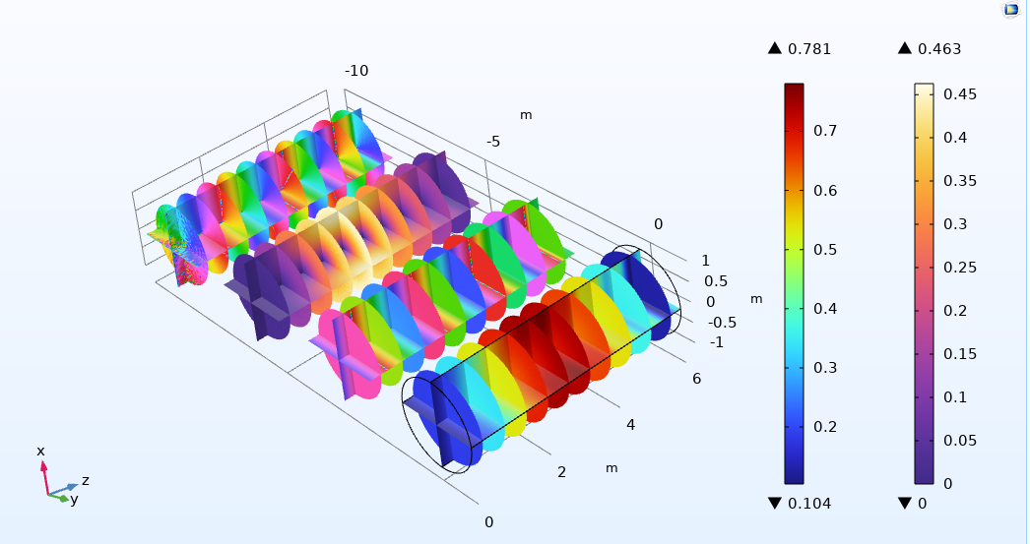
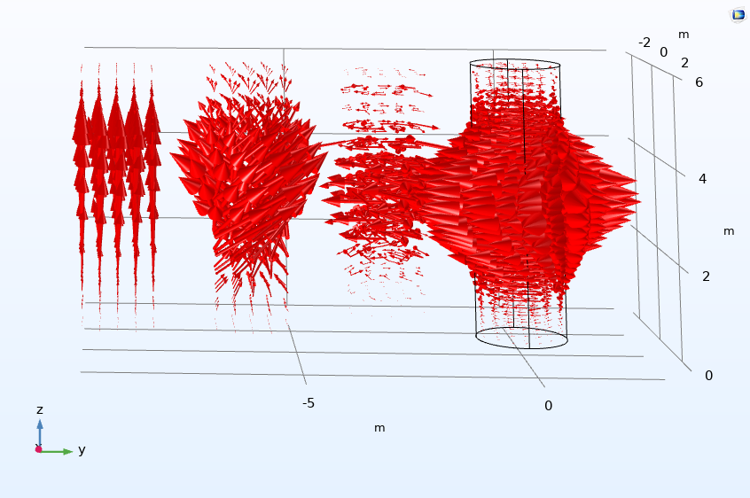 |  | 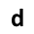  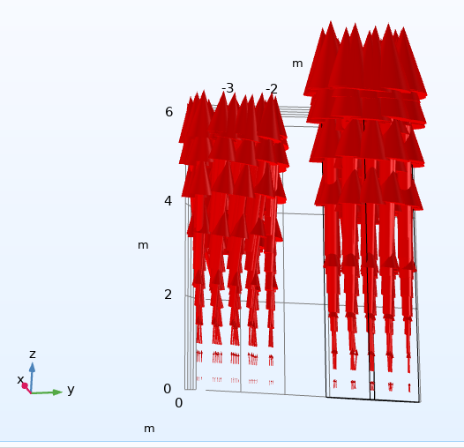
Figure 2. a) magnetic field lines, b) distributions both magnitude and argument of up spinor component (right pair) and down one (left pair), c) from the right to the left: distributions of the angular momentum density of the up comp. (scale x1), down comp. (scale x3), spin density (scale x5) and probability current density, d) probability current density separately for up (left) and down (right) components.
Figure 2b shows that phase for the initial up component is homogeneous in the transverse plane, but for the down one phase changes in the transverse plane according to one swing. The magnitude of the down component is equal to zero on z-axis, which is another one feature of the vortex state. The magnitudes of both components have value of one order. It clearly depends on $θ_{0}$. Spin density distribution has helical structure. Probability current density has the same structure, too, but it is difficult to notice it, because longitudinal phase gradient is much stronger than transverse one.
The following problem was investigated for the sustainability assessment. Initial state was considered a gaussian not only in longitudinal, but in transverse plane, too. The incident point of such beam was set far from the magnetic axis. So, the incident beam was on the boarder of the structure and “do not cross” the magnetic axes. Distributions of magnitudes and phases are shown in Figure 3.
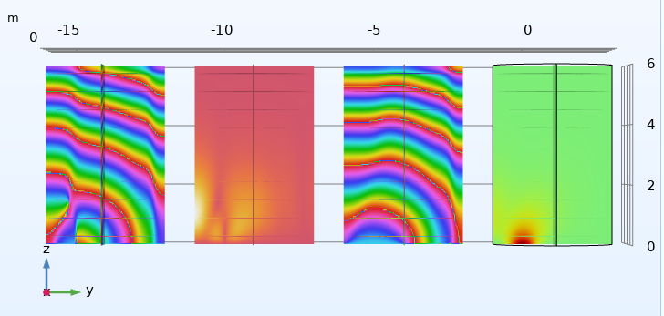
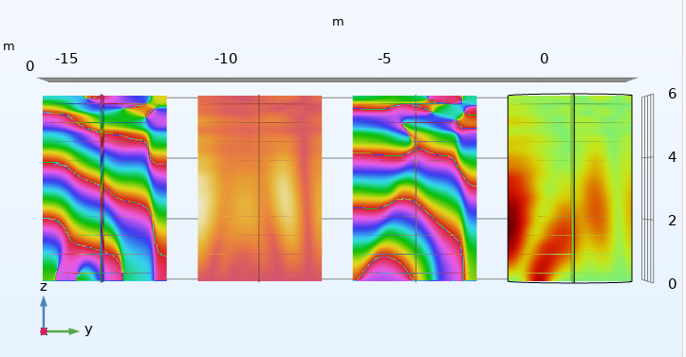
Figure 3. a) distributions both magnitude and argument of up spinor comp. (right pair) and down one (left pair) near the incidence moment, б) the same distributions in further moment.
These distributions shows, that beam is captured by the magnetic axis and starts to swing around as a union without forming special vortex structure. There is a phase shift near the incidence point for down component, but this structure decomposes into several lonely waves very fast. So, for generation stable vortex structure the incoming beam should span a magnetic axis.
Case of strong magnetic field was considered with $θ_{0}=1 rad$ and $γ=200$. In this case very difficult and contrast radial structure has been formed. It requires very detailed mesh and a lot of computing resources. Figure 4 shows distributions for coarse mesh. But even these results get an imagination of existence of vortex structure, its difficult radial structure and stability.
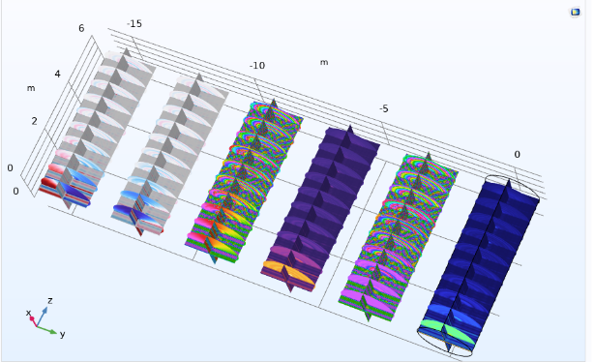
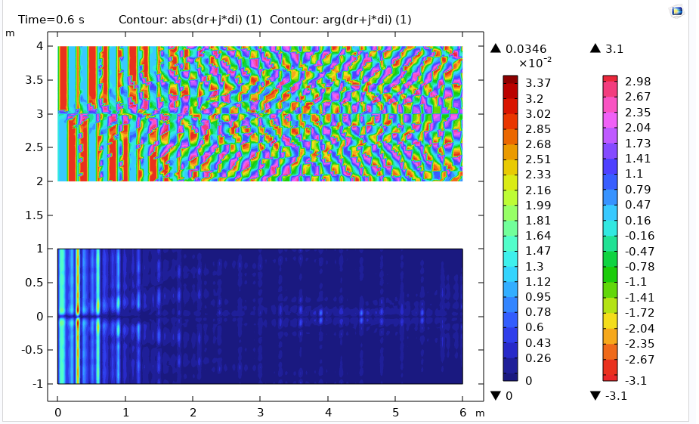 | 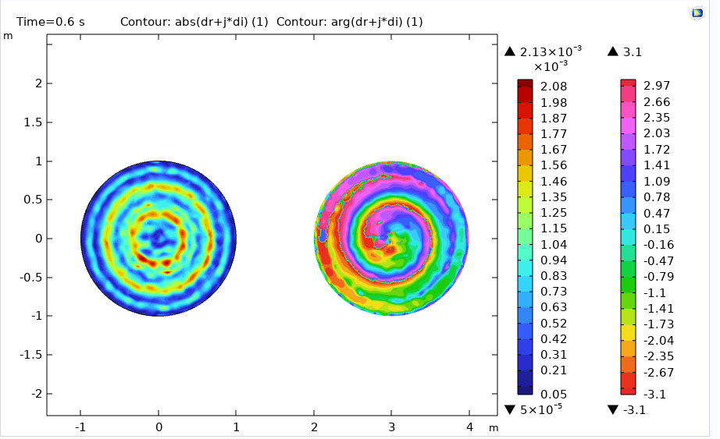
Figure 4. a) distributions both magnitude and argument of up spinor comp. (right pair) and down one (center pair), real and imagine parts of down component (left pair) for a strong magnetic field is about 80 mT.
Another one candidate for the magnetic, which can generate vortex state of neutron, is a skyrmionics lattice. The problem of incidence of transverse homogeneous and gaussian longitudinally state on along long skyrmions. Magnetization field in several sections is introduced on Figure 5a. Vortex radius is about 0.5 and length about 10. Figure 5b shows results of calculation for $θ_{0}=1 rad$ and $γ=10$.
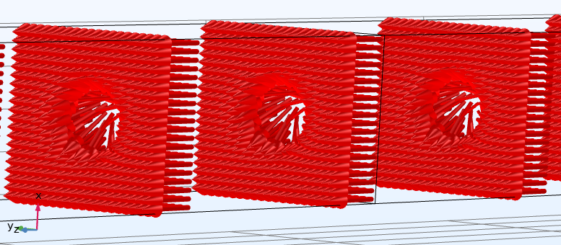 | 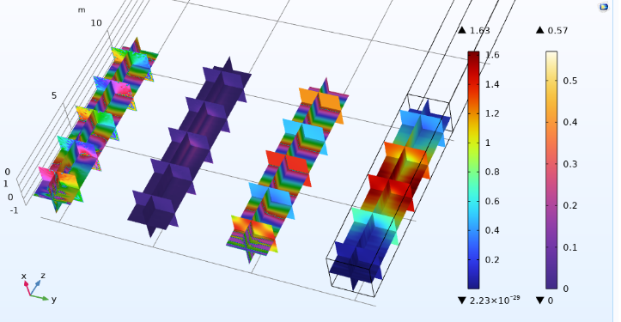
Figure 5. а) magnetization of skyrmion structure, b) distributions both magnitude and argument of up spinor comp. (right pair) and down one (left pair).
Vortex state for down spinor component is forming.

Conclusion
During the practice, the main focus was on elicitation of possibility to convert room-temperature neutrons in twisted neutrons using the magnetic vortex. The simple toy-model of magnitude-constant magnetic field was under analytical and numerical consideration. This model had two parameters – value of neutron-magnetic field interaction energy $γ$ and angle between Oz axis and magnetic field line. Space-energy scaling of model have been used. The main feature of model was the existence of vortex-state component of longitudinally polarized neutron in the magnetic field with sensibly magnitude from tenths to tens of mT.
The problem of sustainability of the vortex beam was revealed, when the incoming particle is far from the magnetic axis. So, it is more preferably to use the structured materials with several parallel magnetic axes except system with along axis. A lot of questions of beam evolution on the boarder of such structure, spatially in incoming and outgoing regions, need to be explored carefully in the further investigation.

Acknowledgments
I would like to express my sincere gratitude to Dr. Zhaketov V. D. for the excellent organization of practice including guidance in material science field and neutron physics. Taking part in INTEREST program was a great possibility to work with him for solving topical problems.
I would like to recognize the assistance and insightful suggestions from Dmitry Tatarskiy.
I would like to express my heartfelt appreciation to organizers of JINR INTERST program. This program is a great chance to work on the frontier of the modern physics and deepen our knowledge in advanced topics.

References
- Y. Tokura, S. Seki, Multiferroics with Spiral Spin Orders// Advanced Materials. 22. – 2010. – 1554-1563. doi: 10.1002/adma.200901961.
- Y. Tokura, S. Seki, N. Nagaosa, Multiferroics of spin origin// Rep. Prog. Phys. 77. – 2014. – 45 PP. doi:10.1088/0034-4885/77/7/076501.
- O.G. Udalov, M.V. Sapozhnikov, E.A. Karashtin, B.A. Gribkov, S.A. Gusev, E.V. Skorohodov, V.V. Rogov, A.Yu. Klimov, A.A. Fraerman, Nonreciprocal light diffraction by a lattice of magnetic vortices// Phys. Rev. B. 86. – 2012. – 4 PP.
- D.A. Tatarskiy, A.N. Orlova, E.V. Skorohodov, I.Yu. Pashenkin, V.L. Mironov, S.A. Gusev, Magnetic vortex states manipulation in overlapping ferromagnetic disks// Journal of Magnetism and Magnetic Materials. 590. – 2024. – 6 PP.
- S. Yakata, M. Miyata, S. Nonoguchi, H. Wada, T. Kimura. Control of vortex chirality in regular polygonal nanomagnets using in-plane magnetic fields// Applied Physics Letters. 97. – 2010. – 3 PP.
- Ch.W. Clark, R. Barankov, M.G. Huber, M. Arif, D.G. Cory, D.A. Pushin, Controlling neutron orbital angular momentum// Nature. Vol. 525. – 2015. – 504-507.
- D. Sarenac, M.E. Henderson, H. Ekinci, Ch.W. Clark, D.G. Cory, L. Debeer-Schmitt, M.G. Huber, C. Kapahi, D.A. Pushin, Experimental Realization of Neutron Helical Waves. arXiv:2205.06263v1.
- X.Z. Yu, Y. Onose, N. Kanazawa, J.H. Park, J.H. Han, Y. Matsui, N. Nagaosa, Y. Tokura, Real-space observation of a two-dimentional skyrmion crystal// Nature. Vol. 465. – 2010. – 901-904. doi:10.1038/nature09124.
- X.Z. Yu, N. Kanazawa, Y. Onose, K. Kimoto, W.Z. Zhang, S. Ishiwata, Y. Matsui, Y. Tokura, Near room-temperature formation of a skyrmion crtstal in thin-films of the helimagnet FeGe// Nature Materials. Vol. 10. – 2011. – 106-109. doi:10.1038/NMAT2916.
- K.Y. Bliokh, I.P. Ivanov, G. Guzzinati, L. Clark, R. Van Boxem, A. Béché, R. Juchtmans, M.A. Alonso, P. Schattschneider, F. Nori, J. Verbeeck, Theory and applications of free-electron vortex states// Phys. Rep. Vol. 690. – 2017. – 70 PP.
- S.M. Lloyd, M. Babiker, G. Thirunavukkarasu, J. Yuan, Electron vortices: Beam with orbital angular momentum// Reviews of Modern Physics. Vol. 89. – 2017. – 44 PP.

