

**JOINT INSTITUTE FOR NUCLEAR REASEARCH**

Veksler and Baldin Laboratory of High Energy Physics

**MINI BEAM-BEAM DETECTOR FOR MPD**

Final Report of INTEREST Program

Wave 10

February 26th – April 24th, 2024

Dubna-Russia

**Submitted by:**

Sebastián Álvarez Gómez

Facultad de Ingeniería Eléctrica-UMSNH

**Supervisor:**

Dr. Ivonne Alicia Maldonado

Veksler and Baldin Laboratory of High Energy Physics

**Contents**

-Abstract…………………………………………………. 3

-Introduction (main problem, background, findings)…….4-6

-Project goals…………………………………………….. 7

-Scope of work and Methods…...………………………...8

-Figures, diagrams or plots………………………………9-11

-Macro’s description………………………………………12-14

-Conclusion References, Acknowledgments…………….15

**Abstract**

Since the beginning of this project we’ve been learning about the Mini Beam—Beam detector, his properties and physics and how to work with this detector. How particles interact with the detector and how this affects the given measurements depending on the type of collision, and we had to estimate the centrality of these collisions. In every task we did, developing software to integrate the MiniBeBe detector into the MPDroot framework. Every step we took was followed by our supervisor Dr. Ivonne Maldonado, who taught us very well.

**INTRODUCTION**

JINR-NICA

The Joint Institute for Nuclear Research (JINR) in Dubna, Moscow Oblast, Russia, is an international research center for nuclear sciences, with 5500 staff members, including 1200 researches holding over Ph.Ds from eighteen countries, Most scientists are scientists of Russia Federation.

NICA (Nuclotron-based Ion Collider fAcility) is a particle collider being constructed by the JINR in Dubna, to perform experiments such as Nuclotron ion beam extracted to a fixed target and colliding beams of ions, ions-protons, polarized protons an deuterons. The projected maximum kinetic energy of the accelerated ions is 4.5GeV per nucleon, and 12.6GeV for protons.

<https://en.wikipedia.org/wiki/Nuclotron-based_Ion_Collider_Facility>

MINI BEAM-BEAM DETECTOR FOR MPD

The MPD experiment that is under construction in the NICA complex at JINR aimed to study the structure of matter under extreme conditions of density and temperature. MPD apparatus consists in several subdetectors (ITS, TPC, TOF, FHCAI, Ecal and FFD)

MAIN PROBLEM

We need to interpret by the right way the function and relationship between the electronic, physics and software, for can modify macros and realize successfully the simulations, and get the required data.

BACKGROUND

Since the early 20th century, scientist have been into atomic nucleus. Experiments such as nuclear fission and the emission of alpha and beta particles laid the groundwork for understanding the atom’s structure. The development of particles accelerators in the 1930s and 1940s allowed scientists to study subatomic particles in great detail. Accelerators like the cyclotron and the synchrotron became essential tools for particle physics research. In the 1930s, exploration began into the physics of heavier atomic nuclei, specifically designed to study the interaction between atomic nuclei at high energies. Before dedicated heavy ion colliders, many valuable information on nuclear collision physics and laid the groundwork in accelerator technology and detectors, enabling the construction of larger and more powerful heavy ion colliders. This advancements in superconductivity, vacuum systems, and particle detection methods such as the MPD at NICA

FINDINGS

Part of our findings are the following:

- Achieving the modification of macros and obtaining particle distributions to better interpret the behavior of particles colliding with each other and consequently with the detectors, as well as the data we obtain from these collisions through the same detectors.

-New perspectives on nuclear physics and particle physics for us, leading to a better understanding of the same.

-Complementing data already

obtained in previous waves to increase accuracy in the understanding of particle physics.

**PROJECT GOALS**

-Explore Matter under Extreme Conditions. Heavy ion colliders as the NICA’s collider allow for the recreation extreme conditions to those present in the early moments of the universe. We could be able to study how matter behaves under these extreme conditions, providing insights into the universe’s evolution and the formation of structures such as quarks, gluons, and hadrons.

-Study quark-gluon plasma, an extremely hot and dense state of matter believed to have existed in the first microseconds after the Big-Bang. Studying QGP (Quark-Gluon Plasma) helps in understanding the phase transition of matter and the fundamental principles of quantum chromodynamics (QCD).

-Explore Nuclear Structure. The heavy ion collider also allow for the investigation of the internal structure of atomic nuclei and how they interact with each other in high-energy collisions. This can provide insights into the strong nuclear force and the subatomic components of nuclei.

-Investigate the creation of new particles, experiments in heavy ion colliders can produce exotic particles and states of matter not found under normal conditions. Studying these new particles and states can provide information about the fundamental forces of nature and help expand our Knowledge of particles physics.

And study universe evolution, by better understanding how matter behaves under extreme conditions, scientists of JINR can gain insights into the evolution of the universe form its early moments to its current state. This can help answer fundamental questions about the formation of galaxies, starts, and another cosmic objects.

**SCOPE OF WORK**

We are developing a device called MiniBeBe that will detect certain triggers for a project called TOF. To understand how the detector will operate, simulations are necessary. Once we have the MiniBeBe built, we proceed with the development of software that will interpret the electronic signals from the detector.

**METHODS**

Through the project, we worked on Linux Ubuntu from our computers, using the MPDroot software and the C++ language through the ubuntu terminal.

We worked by modifying and adding missing data to pre-existing macros to make it more intuitive, as starting a macro from scratch without yet having good knowledge in C++ can be quite difficult and frustrating. However, our supervisor was present to assist us in whatever was necessary. We also conducted through analysis of the macros to better understand them and know what to modify in order to obtain the data correctly and ensure it made sense theoretically. From the outset, we were given a brief course on how to use and install MPDroot, as well as everything necessary for it to function properly, including some examples and theoretical introduction.

Through the project, a significant amount of supporting material and reading was shared with us to gain a better understanding of what we were doing, both

from JINR itself and external sources.

Next, I’m going to show some of the results of the tasks as well as figures of the MPD detector

Here we can see a distribution of energy loss vs z position

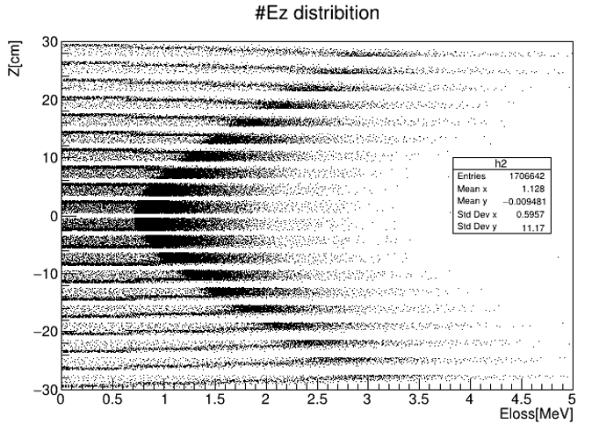

The probability to have at least one hit per event at each ring.

The Trigger efficiency as a function of the primary vertex pions

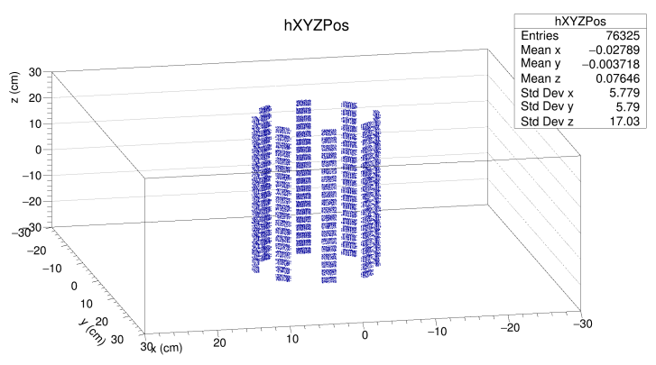 Schematic view of MiniBeBe formed by 8 H-shaped rails.

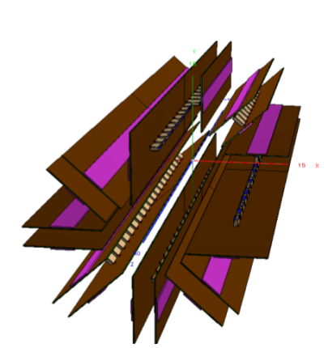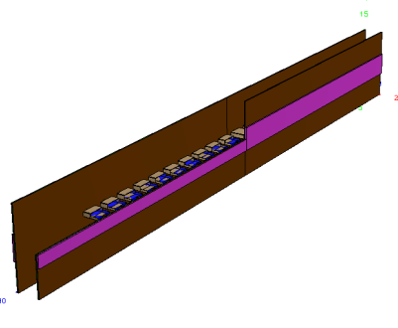

And some of the detector structure

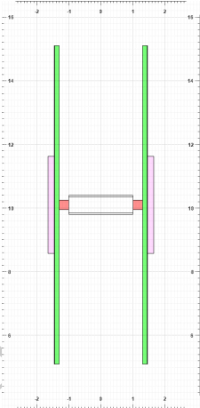Position of the 20 plastic scintillators along the rail

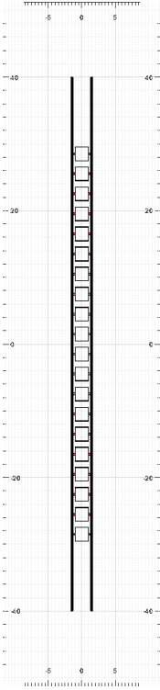

Profile of the H-shaped rail.

In the drawing appears

The SiPMs in red at each

Side of the plastic, and

The H-shaped formed by the

PCB on green and the cooling

Plates in pink

**MACROS DESCRIPTION**

Codes are very large, so I’m going to show you just a little part 😊

runReco.C

It aims to carry out the data reconstruction process obtained from heavy ion collisions in the MPD detector. This involves using information from different sub-detectors within the MPD to determinate the trajectory and energy of the particles.

The code look like this:

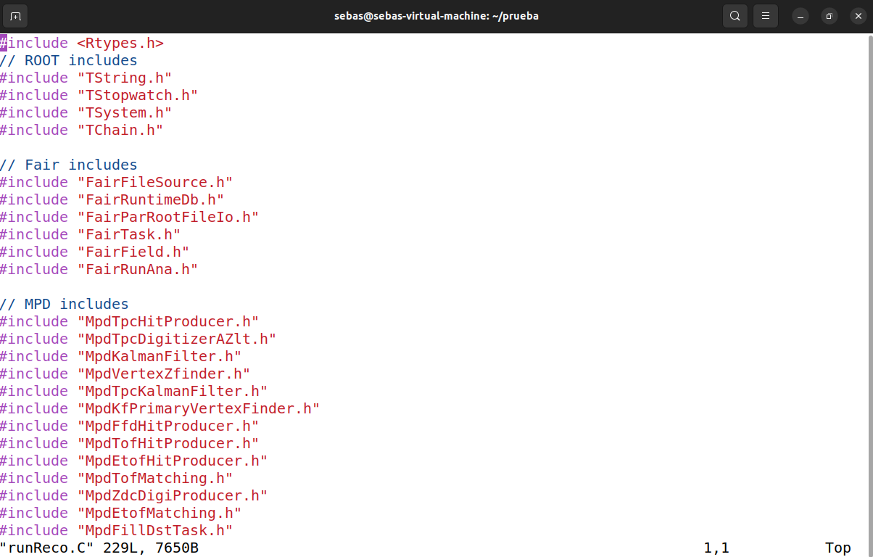

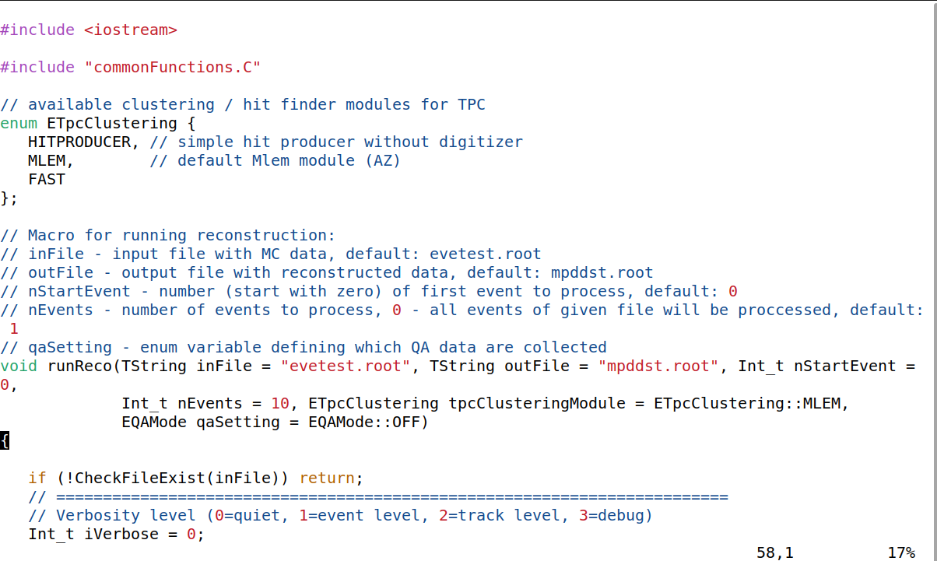

runMC.C

This macro is designed to perform Monte Carlo simulations for the MPD detector. It is used to generate simulated events that mimic the heavy ion collisions occurring in the MPD detector. These Monte Carlo events allow simulating the expected behavior of particles produced by the collisions and their interaction with the detector.

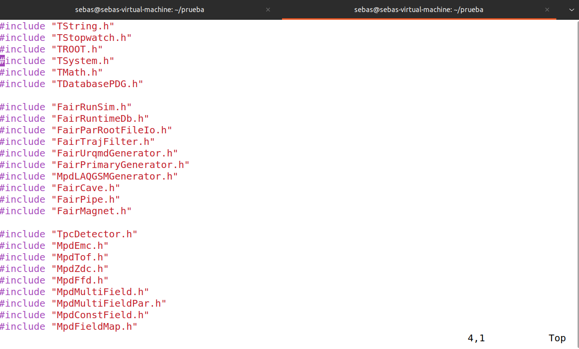

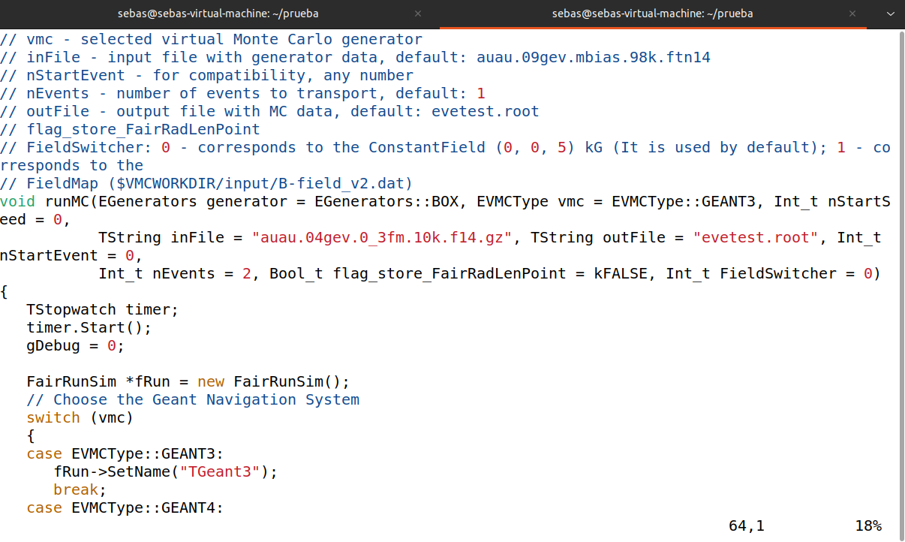

MyreadDST.C

It’s a script for reading and processing DST data files, which includes extracting data from different types of detectors and organizing the information into a data structure suitable for subsequent analysis. Additionally, it could be used to automate repetitive tasks such as reading and processing DST files, thus saving time and effort in data analysis.

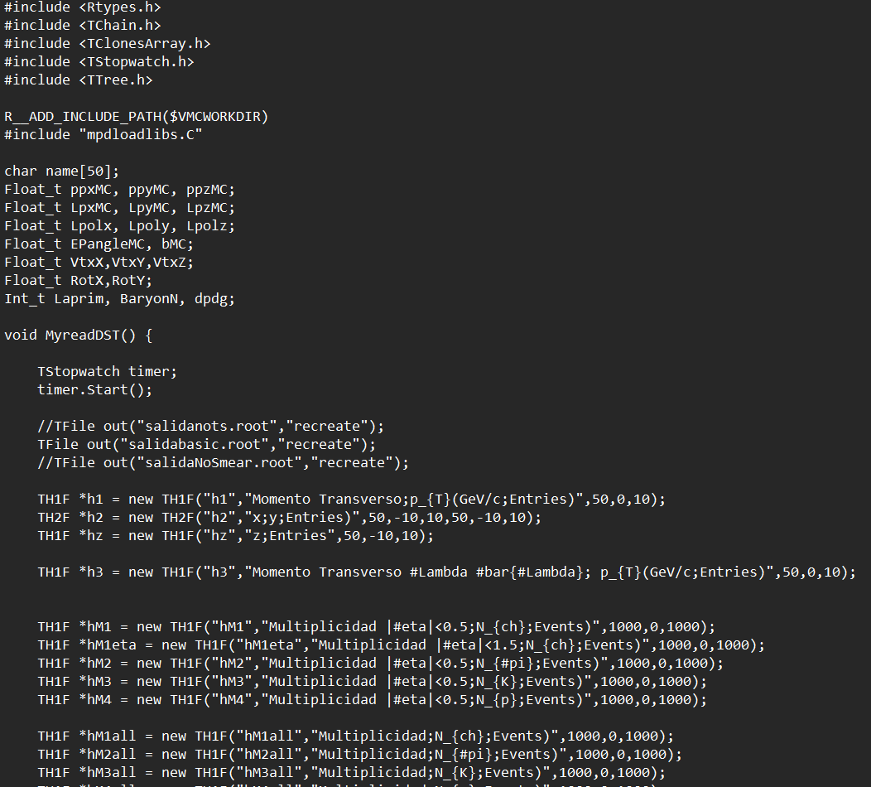

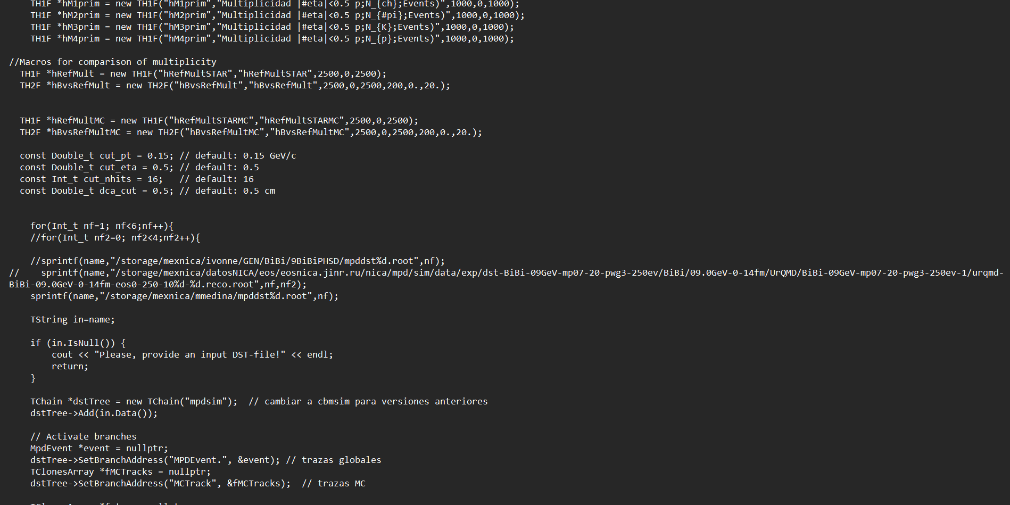

**IN CONCLUSION**

In conclusion, it was a somewhat complex but quite interesting and unforgettable experience. I met good colleagues, and our supervisor was a very patient person and very good at teaching everything seen during the project. I learned things that I never imagined learning as an engineer. It was a very good experience.

**REFERENCES**

MiniBebe_Trigger_Efficiency-3.pdf

<https://es.wikipedia.org/wiki/Instituto_Central_de_Investigaciones_Nucleares>

<https://interest.jinr.ru/index.php?project_id=293>

<https://www.overleaf.com/project/660a5313717a06ecc6769953>

**ACKNOWLEDGMENTS**

I want to thank the JINR and INTEREST teams, but specially Dr. Ivonne Maldonado for her patience and teachings. I also want to express my gratitude to professor Galileo Cristian Tinoco Santillan and Dr. Alfredo Raya Montaño, as it was through them that I learned about the course and gained a lot of knowledge In their Particle Physics course. I am very grateful to everyone for this opportunity. THANK YOU!!!.