

JOINT INSTITUTE FOR NUCLEAR RESEARCH

Veksler and Baldin laboratory of High Energy Physics

**FINAL REPORT ON THE**

**INTEREST PROGRAMME**

*Analysis of hypernuclei in simulated data of the BM@N experiment*

**Supervisor:**

Dr. Sergei Pavlovich Merts

**Student:**

Konstantinova Elizaveta Nicolaevna, Russia, Irkutsk State University

**Participation period:**

26 February – 14 April, Wave 10

Dubna, 2024

1. Introduction

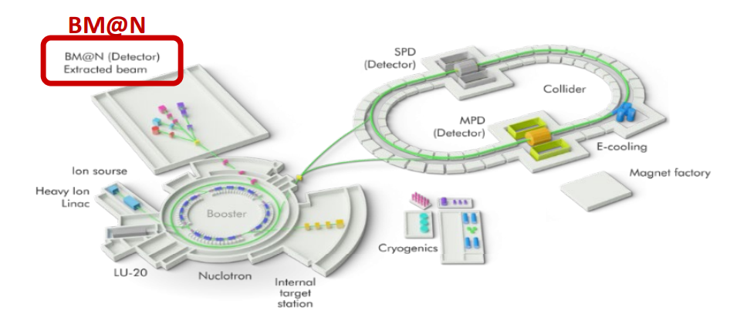

NICA is an accelerator complex under construction at the Joint Institute for Nuclear Research (Dubna) aimed at studying the properties of dense baryonic matter. One of the key components of the initial stage of this complex is the BM@N experiment, which focuses on studying collisions of relativistic ions with a fixed target.

1.1 Hypernucleus

A hypernucleus is similar to a conventional atomic nucleus, but contains in addition to the normal protons and neutrons at least one hyperon. They are a category of baryon particles that carry a non-zero strangeness quantum number, which is conserved by the strong and electromagnetic interactions.

Hypernuclei containing the lightest hyperon, the lambda, are generally bound more tightly than ordinary nuclei, although they can decay under weak forces with an average lifetime of about 200 ps.

The simplest hypernucleus is the hypertriton, which consists of one proton, one neutron, and one lambda hyperon. They could be one of the possible markers of the phase transition from nuclear matter to quark-gluon plasma in the collision of high-energy ions. In this work, the hypertriton decay channel to helium-3 and negative pi meson is studied.

1.2. Aim and objectives

The aim of this work was to reconstruct the hypertriton peak on mass distribution for the simulated data of the BM@N experiment. To achieve this goal, the following tasks were solved:

1. Obtaining basic knowledge about experiments in particle physics in general and about the BM@N experimental setup.

2. Study of the hypernuclei simulation process in the BmnRoot software package.

3. Mastering the skill of extracting basic information about a hypernuclei by its decay products.

1. Practical Part

Firstly, materials about the experimental setup, track reconstruction procedure and hyperon analysis were studied.

2.1. BM@N Setup

The experiment combines high precision measurement of track parameters with time-of-flight information for particle identification and presumes a measurement of the total energy by the hadron calorimeter to analyze the collision centrality. The charged track momentum and multiplicity are measured using a set of silicon detectors (8) and 7 planes of two-coordinate Gaseous Electron Multiplier detectors mounted downstream of the target inside a dipole magnet. The vertical gap between the poles of the analyzing magnet for detector installation is about 1 m. The magnetic field can reach a maximum value of 1 T, which makes it possible to optimize the BM@N geometrical acceptance and resolution on momentum for different processes and energies of the beam. Time-of-flight detectors (11) and (13) are used for hadron and light nuclei identification, while the lead calorimeter (20) is used for measuring collision centrality. External track detectors based on two drift chambers and a strip cathode chamber are used to refine trajectories beyond the magnet.

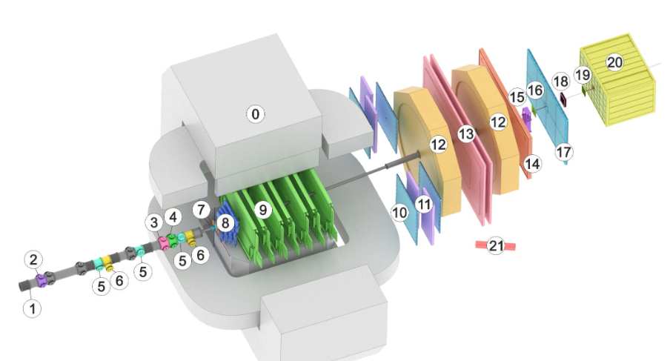

2.2. Data Processing

The BmnRoot software package was used to process and analyze the hypernuclei. It is implemented in the C++ programming language and based on the ROOT framework.

For convenience of data processing, an extension for remote editing of program codes was installed in Visual Studio Code. MobaXterm was used as a program for remote access to the computing cluster of the JINR high energy physics laboratory.

A program code realizing the search for the corresponding particles was written to study the hypertriton decay products.

Then, the possibilities of constructing histograms were studied using basic characteristics such as the index of the parent track and decay products, rapidity, and total momentum as examples. For further reconstruction of events, it is planned to extend the code to output momentum and rapidity distributions.

1. Future Work

After mastering basic skills, the following steps are planned:

 • Modeling standard events of xenon beam interaction with a cesium-iodide target, with hypertritons mixed in.

 • Writing program code to reconstruct the mass spectrum of hypertritons. Processing the obtained data by imposing additional conditions on pairs, considering the invariant mass of this pair, and constructing a mass spectrum.

 • Parameter tuning to maximize the signal and minimize the background.

 • Transition to experimental data.

4. Used literature

* R.K.Barak//“STUDYING THE POSSIBILITY OF HYPERON RECOVERY IN THE BM@N EXPERIMENT”
* M.N.Kapishin//“Studies of Baryonic Matter at the Nuclotron (BM@N)”
* I.D.Kozlov//“Development and optimization of data processing algorithms in the BM@N NICA experiment”