JOINT INSTITUTE FOR NUCLEAR RESEARCH

FINAL REPORT ON THE
INTEREST PROGRAMME

Radiation effects study on advanced materials exposed to electron beams and gamma rays using Raman Spectroscopy

Supervisor:
Dr. Antonio Leyva Fabelo

Student:
Violetta Korsakova
D. Mendeleev University of Chemical Technology of Russia, Moscow, Russia

Participation period:
February 13 – March 26, Wave 8

Dubna, 2023
Abstract
In this project, we have studied the effects of radiation on such advanced material as multiwalled carbon nanotubes (MWCNTs). We looked at how high-frequency gamma radiation (irradiation with photons with energy of 1.25 MeV (⁶⁰Co)) affects the structure of nanotubes, what parameters of this material it changes. We also studied the effect of another type of radiation - high-energy electron irradiation (beam of electrons with an energy of 20 MeV). The results were processed using the "ORIGIN" program. The spectra of nanotubes before and after irradiation were deconvoluted, and, after comparing the results with the literature data, conclusions were made about the effect of the two types of radiation on the promising material. No strong change in the spectra of the samples before and after irradiation was observed, but a more detailed study revealed differences in the intensities of individual Modes. Based on this data it was concluded that the number of structural defects after both types of irradiation decreased.

Introduction
Raman spectroscopy is a spectroscopic method that studies vibrational, rotational, and other low-frequency modes of substances. It is also nondestructive chemical analysis technique, that can provide us detailed information about chemical structure and identity, phase and polymorphism, molecular interactions and crystallinity [1]. Raman spectroscopy is a sensitive method of carbon nanotube characterization. Lately, carbon nanomaterials have been largely studied because of their diverse and promising chemical and physical properties which make them the materials of the future. Studying the various defects present in structures such as MWCNT can give us a broad understanding of what additional properties may appear in such materials. In turn, the impact of gamma radiation on such material can significantly change its structure (cause defects), and hence its properties. Such a changes need careful study and analysis of what new useful or undesirable properties it may lead to.

Material and Methods
Raman spectroscopy is based on the principle of inelastic scattering of light. This means that instead of measuring non-informative elastic (Rayleigh) scattering having the same amount of wavelength as light source has; we therefore measure a very small amount of light (typically 0.0000001%) which is scattered with different wavelengths. The molecule gets a certain amount of energy from the photons by the light source, excited and goes into a virtual energy state, then from this state after a short time the photon emits it and its energy is either lower or higher than the incident photon, thus we can measure the differences and make conclusions about the structure of our material. Once the scattering is done, the sample is in a different vibrational state. The final spectrum is the dependence of intensity from Raman shift (Δω). The Raman shift can be obtained by calculating the following equation: ∆ω=1/λ_{excitement} - 1/λ_{scattering}. There is a selection rule in the Raman spectroscopy that tells us whether a particular molecule can be detected by this method: the vibrations that lead to a change in the polarizability of the molecule are shown. It is known that molecules with a system of conjugated π-bonds have the highest intensity in this method, so aromatic compounds, polyenes, pyridine, pyrrole and porphyrin compounds, and alicyclic hydrocarbons are well detected [1]. Raman spectroscopy is one of the most useful methods for studying nanomaterials. It is a good method for measuring even very small changes in structural morphology of carbon nanomaterials (orientation of C-C bonds), so it is quite useful for its characterization.

Figure 1. Schematic of the backscattering geometry in Raman spectrometer. | Figure 2. Solar TII Raman spectrometer setup.

In this project the Raman measurements were done at room temperature in backscattering geometry [2]. Figure 1 shows a schematic of the Raman spectrometer working in a backscattering geometry regime. Spectrometer model Solar TII, shown in figure 2, was employed applying the following conditions: diffraction grating of 1200 lines/mm, objective 40x (model Olympus-UPlanFL N), and acquisition time 70 s.
Carbon nanomaterials are very useful in a wide range of areas from electronics to the construction industries [3].
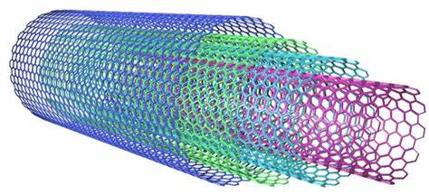
Figure 3. Structure of multi-walled carbon nanotube.
There are many different types of carbon nanostructures, and they are all made up of pure carbon. For instance, Multiwalled carbon nanotubes are made of concentric graphene sheets rolled in a cylindrical form with diameters of tens of nanometers, see figure 3.
They are characterized by the value of the distance between nearest graphene layers of about 0.34 nm, which is close to the distance between adjacent planes of crystalline graphite. It is obvious that such materials might have a lot of defects in its structure. Sometimes it can cause unpleasant effects. Nevertheless, the structures that have defects are preferred in some cases such as: hydrogen storage, enhancement of chemical reaction via preferred sites, welding, and crosslinking. One of the main features of the spectrum by which MWCNT can be characterized by Raman is that there are two peaks which are called D and G bands [4]. The band at 1342 cm^{–1} (D band) is activated by the presence of disorder in the carbon system and the band at 1580 cm^{–1} (G band) is assigned to the in-plane vibration of the C–C bond, it is often used to measure the quality of the nanotubes.
The analysed in this project MWCNT powder samples were commercial and 90% pure.
Gamma radiation is a shortwave electromagnetic radiation (10keV – 10MeV). Gamma rays are emitted by unstable nuclei when they transit from a high-energy state to a lower state (gamma decay). Gamma photons interact with orbital electrons of the atom, the electrons receive kinetic energy from the gamma photons and are knocked out of the orbit. Vacancies are created and are filled by one of the outer electrons, whose transition is accompanied by the emission of characteristics: soft electromagnetic radiation in the x-rays, ultraviolet, or visible regions of the electromagnetic spectrum. Gamma decay typically accompanies other forms of decay, such as alpha or beta decay.
The main modes of interaction of gamma rays with matter are: photoelectric effect, Compton scattering, pair production [5]. The figure 4 shows the domains of these mechanisms according to the energy of the photons and the atomic number of the material.
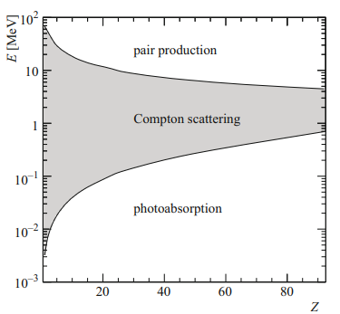 | 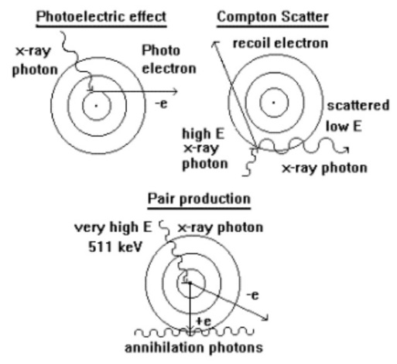
Figure 4. Three major types of photon interaction with matter. The curves demarcate the regions where each effect is dominant. | Figure 5. Schematic representation of the three main interaction mechanisms of gamma radiation with matter.
Compton scattering occurs with the highest probability on the least bound or free electrons. This process is regarded as elastic scattering of a gamma quantum on an electron. A photon of at least 1.02 MeV or the equivalent of two electron masses can create an electron positron pair. In empty space, momentum and energy cannot be conserved. Near the nucleus, the process is possible since the nucleus can carry some momentum and energy. The photoelectric effect dominates at low-energies of gamma rays. In the photoelectric effect, a photon undergoes an interaction with an electron that is bound in an atom. The incident photon disappears in this interaction, and the atom ejects an energetic photoelectron from one of its bound shells. The aforementioned mechanisms are schematically shown in the figure 5.
It is known that when irradiation interact with the MWCNT there is a possibility of formation of different defects like point defects, e.g. vacancy and interstitial defects, strains, atoms, pentagon-heptagon pairs, pentagon-octagon-pentagon pairs etc. Such defects can be very useful in certain areas where a modified and improved material is needed [6].
Figure 6. Radiotherapy chamber similar to the one used in the experiment.
Irradiation facilities. Irradiation with photons of 1.25 MeV (⁶⁰Co) was performed in a therapeutic gamma chamber РОКУЕМ available at the Medical Complex of the DLNP at the Joint Institute for Nuclear Research (JINR). The dose power of the chamber is 148.47 Gy/h. The total exposure dose of the irradiated samples was 23.4 kGy.
The photo in figure 6 shows the equipment used, and the exposure to radiation was done by rotating the head so that the window was directed upwards and the samples were placed directly on top of it. The irradiation time was selected so that the samples received the relevant exposure dose.
Electron irradiation was performed on the JINR LINAC-800 linear accelerator. Its general scheme is presented in figure 7. The picture in figure 8 presents a panoramic view of the accelerator.
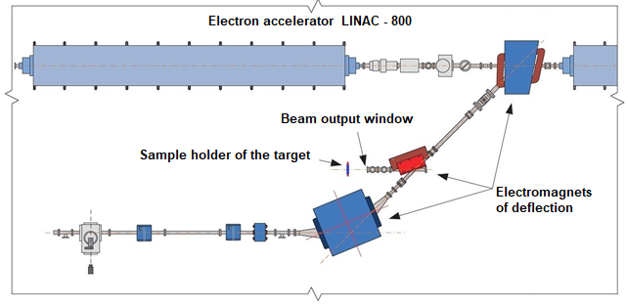 | 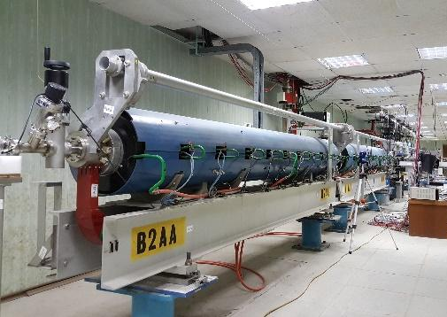
Figure 7. Overview of the LINAC-800 accelerator and the 20 MeV irradiation station. | Figure 8. Panoramic view of the LINAC-800 linear accelerator.
The samples were placed directly in front of the electron output Ti window. The parameters of the beam are energy 20 MeV, current 10 mA, frequency 10 Hz, and pulse duration 1.5 μs. The fluence in the sample was 4.38x10¹⁸ e⁻ cm⁻².
Mathematical processing. The post-processing of the spectra was performed using the software package ORIGIN. The data obtained from the measurements was normalized and used to plot the spectra. They were plotted on the same graph so the differences that appear after the irradiation can be seen more clearly. Each spectrum underwent the process of deconvolution, to find every peak and its intensity. “Deconvolution” is a process of decomposing peaks that overlap with each other, thus extracting information about the “hidden peak”. The Raman spectrum was deconvoluted using the Lorentz fitting function [7].

Results and discussion
After superimposing two spectras (the spectrum of the sample before and after irradiation with two different sources: gamma rays and electrons) in figures 9 and 10 a quick look shows that the spectra do not significantly different from each other by the position of the main peaks. But already at this primary consideration a difference in the intensities of the peaks is noticeable. This difference indicates that some structural modifications took place after the irradiation of the material. The deconvolution procedure applied to these spectra can give more information about the processes involved.
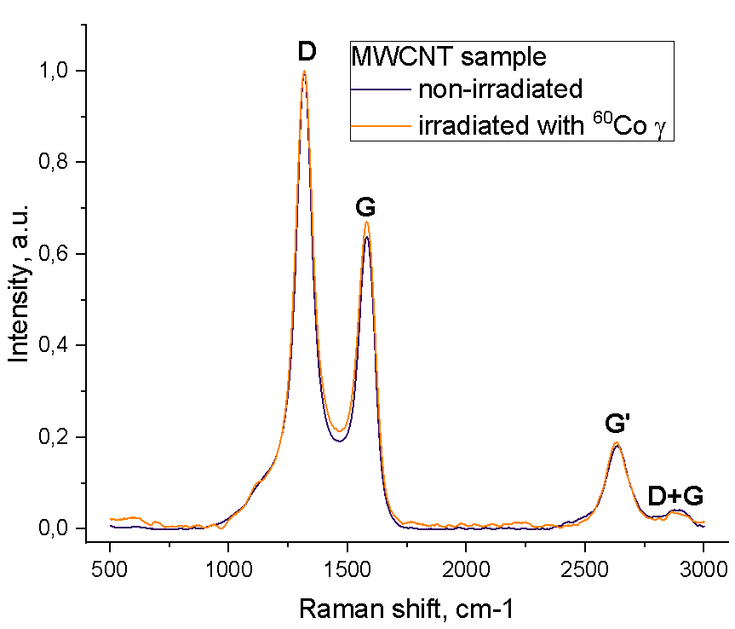 | 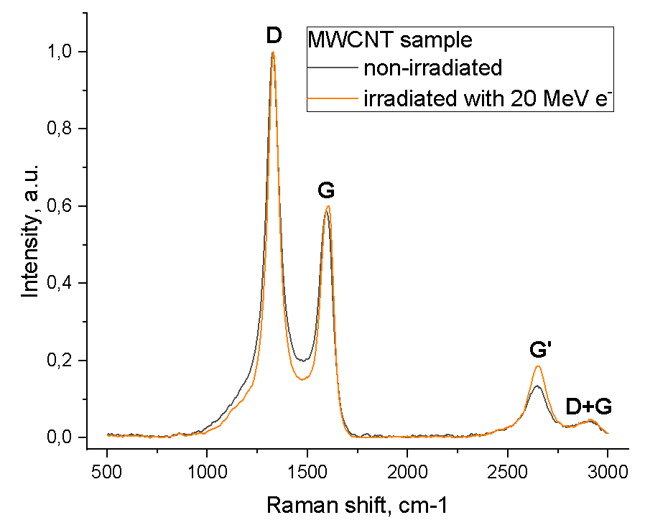
Figure 9. Raman spectras of MWCNT sample before and after gamma rays exposure. Each peak is identified with the most probable mode it represents. | Figure 10. Raman spectras of MWCNT sample before and after electron exposure (20 MeV). Each peak is identified with the most probable mode it represents.
The deconvoluted spectra are presented in figures 11a, 11b, 11c and 11d, while the different parameters extracted from them and that characterize each fitted peak or modes appear in tables 1 and 2.
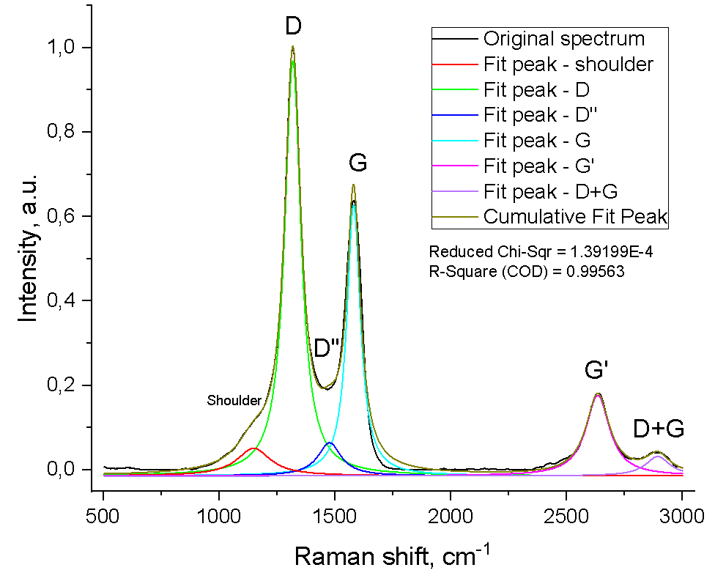 | 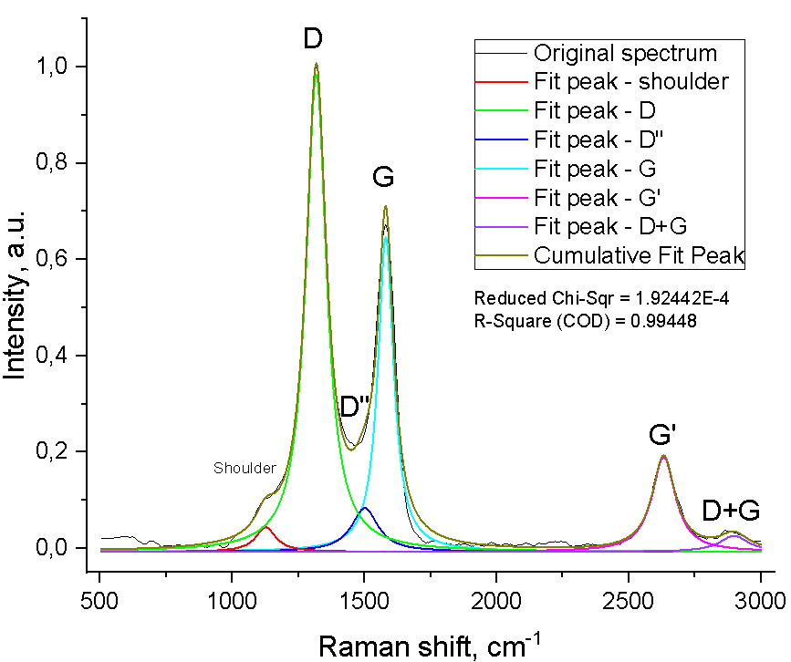
Figure 11a. Deconvolution of Raman spectra of MWCNT before gamma rays exposure. | Figure 11b. Deconvolution of Raman spectra of MWCNT after gamma rays exposure.
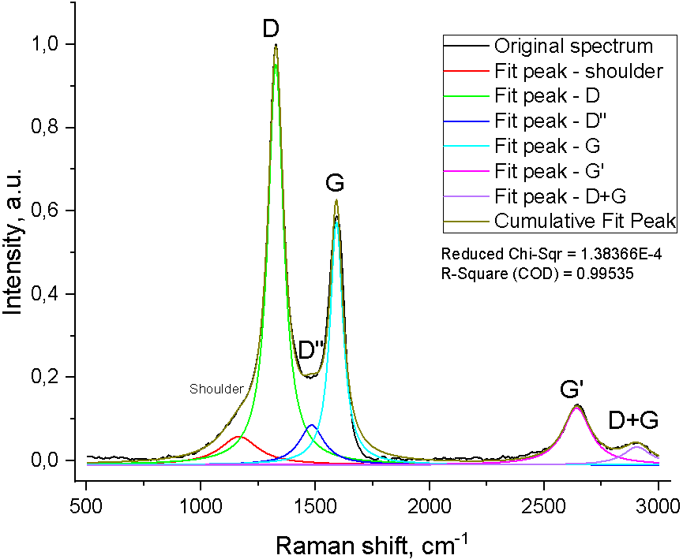 | 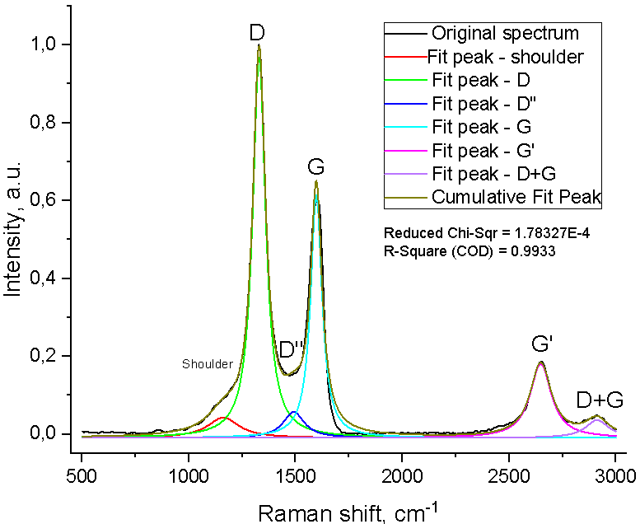
Figure 11c. Deconvolution of Raman spectra of MWCNT before electron exposure. | Figure 11d. Deconvolution of Raman spectra of MWCNT after electron exposure.
Table 1. Raman shifts of the analyzed spectra main modes.
Raman shift [cm⁻¹] | Gamma irradiation |  | Electron irradiation
 | Pristine sample | Irradiated sample | Pristine sample | Irradiated sample
D mode | 1318.027 | 1318.027 | 1328.021 | 1328.8
G mode | 1580.374 | 1580.374 | 1591.58 | 1597.72
D^{II} mode | 1477.02 | 1501.94 | 1483.26 | 1492.61
G^{I} mode | 2633.07 | 2632.263 | 2642.258 | 2647.25465
D+G mode | 2891.52 | 2896.58 | 2904.17 | 2911.75

Table 2. Intensities of the analyzed spectra main modes.
Intensity [a.u.] | Gamma irradiation |  | Electron irradiation
 | Pristine sample | Irradiated sample | Pristine sample | Irradiated sample
D mode | 0.96811 | 0.98345 | 0.95137 | 0.96814
G mode | 0.62791 | 0.64592 | 0.57335 | 0.61416
D^{II} mode | 0.06434 | 0.08393 | 0.08576 | 0.05709
G^{I} mode | 0.17643 | 0.18905 | 0.12688 | 0.18052
D+G mode | 0.03174 | 0.02630 | 0.03326 | 0.03646
ID/IG | 1.541797391 | 1.522557 | 1.659318 | 1.576364

The D mode presents in sp² carbon samples which contains pores, impurities, or other defects in the graphitic structure (defect dependent). In principle, the larger the number of defects, the higher the D band intensity [7]. Thus, we can say that, both after gamma irradiation and after electron irradiation, the number of defects in the structure of the MWCNT increased (as we see from the increased intensity of the D mode). The G mode occurs due to the tangential vibrational motion of sp² carbon atoms. The G peak does not disperse in graphite itself or glassy carbon. It only disperses in more disordered carbon, where the dispersion is proportional to the degree of disorder. The G peak dispersion separates the materials into two types. In materials with only sp² rings, the G peak dispersion saturates at a maximum of 1600 cm⁻¹. In contrast, in those materials also containing sp² chains the G peak rises past 1600 cm⁻¹ and can reach 1690 cm⁻¹ [8]. Therefore, our material before and after irradiation contains only sp² rings.
The ratio of the intensities of D and G bands is a good indicator of the quality of bulk samples [9], it characterizes the degree of graphitization of carbon materials, which allows us to determine the level of disorder of the CNT samples [10]. As shown in Figures 11a, 11b, 11c, 11d and in Table 2, the ratio of the intensities of D and G bands in all cases is more than 1 (approximately 1,5): the D band is more intense than the G band, which reveals the presence of structural defects in the carbon nanotubes. In the table 2, it can be seen that after irradiation, this ratio decreased, albeit insignificantly, indicating a decrease in structural defects of the multilayer nanotubes.
Also, we see an increase in the intensity of the Mode G^{I} in both cases after irradiation. It is used to evaluate the quality of the nanotube material structure, and also it can well characterize the crystallinity of the material, therefore, the decrease in its intensity after irradiation indicates a decrease in the number of defects [10, 11]. For electron irradiation (exposure of the target to 20 MeV electrons), this phenomenon is more pronounced.
The intensity of the G^{I} mode is closely related to the number of tube layers, which makes it frequently used for that determination [12]. From our experiments, we see that both types of irradiations contribute not only to some improvement in the quality of the of the multilayer material, but also to its exfoliation, more actively in the case of irradiation with electrons.
Finally, the deconvolution of the spectra, in addition to providing reliable information on the intensity and shift of each of the modes that could be identified with the naked eye and analyzed above, also revealed two peaks that had not been identified.
They are the D^{II} mode which is a band that is associated with amorphous 𝑠𝑝2-bonded forms of carbon, and a "low frequency shoulder" whose origin has not been clearly identified. Probably the shoulder has its origin in double resonance process, because its Raman shift (~1200 cm⁻¹) is a point on phonon dispersion [7].

Conclusions
Using the spectroscopic method called Raman spectroscopy for advanced material analysis, we studied the effect of different types of irradiations (gamma (1.25 MeV (⁶⁰Co)) and electron (20 MeV)) on the structure of MWCNT. A detailed study of the obtained spectra was carried out using deconvolution. Six constituent peaks were identified: shoulder, D, D^{II}, G, G^{I}, G+D. After analyzing their parameters such as shift and intensity and comparing the obtained data with the literature, we made appropriate conclusions. Study of the spectra revealed that the ratio of the intensities of D and G modes before and after irradiation decreased in both cases, which indicates, in particular, that there are fewer structural defects in the material after irradiation. However, an increase in the intensity of the D mode indicates an increase of such defects as pores and impurities after irradiation. We also found out some peculiarities of the behaviour of the intensity of the G^{I} mode responsible for the graphitization of the material and the number of nanotube layers. After electron exposure there is greater exfoliation of material than after gamma rays.

Acknowledgements
I would like to thank INTEREST for the organization of this project, for the opportunity to gain new knowledge and experience. I also thank my supervisor Antonio Leyva for his help and support in the realization of the project.

References
[1] Bîru E. I., Iovu H. Graphene Nanocomposites Studied by Raman Spectroscopy. Raman Spectroscopy. 2018; DOI:10.5772/intechopen.73487
[2] Bokobza L., Zhang J. Raman spectroscopic characterization of multiwall carbon nanotubes and of composites. Express Polymer Letters, 6(7), 601–608. 2012. DOI:10.3144/expresspolymlett.2012.63
[3] Moraes M. B., Cividanes L., Thim G. Synthesis of Graphene Oxide and Functionalized CNT Nanocomposites Based on Epoxy Resin. Journal of Aerospace Technology and Management, 10. 2018. DOI:10.5028/jatm.v10.944
[4] Joe Hodkiewicz, Thermo Fisher Scientific, Madison, WI, USA. Characterizing Carbon Materials with Raman Spectroscopy. Thermo Fisher Scientific Inc. Paper. Application Note: 51901
[5] Hans Bichsel, Heinrich Schindler. Chapter 2 The Interaction of Radiation with Matter. Particle Physics Reference Library. 5-44. 2020. DOI:10.1007/978-3-030-35318-6_2
[6] Sreekanth P. S. R., Acharyya K., Talukdar I., Kanagaraj, S. Studies on Structural Defects on 60 Co Irradiated Multi Walled Carbon Nanotubes. Procedia Materials Science, 6, 1967–1975. 2014. DOI:10.1016/j.mspro.2014.07.231
[7] Antunes E. F., Lobo A. O., Cora, E. J., Trava-Airoldi V. J., Martin, A. A. & Veríssimo C. Comparative study of first- and second-order Raman spectra of MWCNT at visible and infrared laser excitation. Carbon, 44(11), 2202-2211. 2006. DOI:10.1016/j.carbon.2006.03.003
[9] Ferrari A. C. & Robertson J. Resonant Raman spectroscopy of disordered, amorphous, and diamondlike carbon. Physical Review B, 64(7). 075414(13). 2001. DOI:10.1103/physrevb.64.075414
[10] Costa S., Borowiak-Palen E., Kruszyńska M., Bachmatiuk A., Kaleńczuk R. J. Characterization of carbon nanotubes by Raman spectroscopy. Materials Science-Poland, 26(2). 433-441. 2008. DOI:10.1016/j.mseb.2005.02.046
[11] DiLeo R. A., Landi B. J., and Raffaelle R. P. Purity assessment of multiwalled carbon nanotubes by Raman spectroscopy. Journal of Applied Physics, 101(6). 064307(5). 2007. DOI:10.1063/1.2712152
[12] Dervishi E., Li Z., Watanabe F., et al. Thermally controlled synthesis of single-wall carbon nanotubes with selective diameters. J. Mater. Chem. 19. 3004-3012. 2009. DOI:10.1039/b822469b
[13] Gayathri S., Jayabal P., Kottaisamy M., and Ramakrishnan V. Synthesis of few layer graphene by direct exfoliation of graphite and a Raman spectroscopic study. AIP Advances. 4(2). 027116(12). 2014. DOI:10.1063/1.4866595

