

**JOINT INSTITUTE FOR NUCLEAR RESEARCH**

Flerov Laboratory of Nuclear Reactions

**FINAL REPORT ON THE**

**INTEREST PROGRAMME**

Optimization of the solid ISOL method for volatile reaction products of heavy ion beam reactions

**Supervisor:**

Mr. Viacheslav Vedeneev

**Student:**

Ritesh Reddy Seri, India

ICT Mumbai – IOC campus

**Participation period:**

November 02 – December 07, Wave 2

**Dubna, 2020**

**Abstract:**

Physicist’s in 1940’s was able to produce new and unstable heavy elements. The curiosity of researchers hasn’t stopped with the discoveries and production of new superheavy elements it led to concepts like “**Island of Stability**” and “**Sea of Instability**”. For identification and measurements of the physical properties of superheavy elements such as decay energy and modes, mass and half-lives, the **MASHA** (Mass Analyzer of Super Heavy Atoms) mass spectrometer was designed. The MASHA setup uses solid **ISOL** (Isotope Separation On-Line) method. The experiments are being carried out at MASHA facility, **FLNR**, **JINR**.

**Introduction:**

The most efficacious method of separation where the superheavy isotopes are separated from original beam in order to determine their masses i.e., The Isotope On-line separation method. ISOL system is done through many steps: production, thermalization, ionization, extraction, mass separation, cooling, charge-state breeding, and acceleration. The ISOL techniques rely on the availability of the radioactive species produced in a target and thermalized in a catcher consisting of solid, liquid or gas material. Often the target and catcher are one and the same system. The isotopes are subsequently extracted from the catcher material and ionized in an ion source. After extraction from the ion source the species are mass analysed using a dipole magnet and subsequently accelerated to the required energy. The ultimate aim for ISOL systems is the production of beams of exotic nuclei that are abundant, pure, of good ion optical quality and variable in energy essentially from rest to intermediate energy. The whole production sequence must possess the following properties:

* **High Production Rate**

The production cross-section of a particular reaction is energy dependent. Accelerators have to be used that can deliver the highest beam intensities and target systems have to be developed that can cope with the power deposition of the primary beam and of the secondary reaction products.

* **Efficient**

The production rate of the very exotic nuclei will always be marginal. Therefore, any manipulation of the reaction products – e.g., ionization, purification, acceleration, transport to the detection system – has to be very efficient, otherwise one loses the few precious nuclei.

* **Fast**

As one is dealing with short-lived exotic nuclei, the losses due to radioactive decay between the moment of production and the arrival at the experimental set-up should be kept to a minimum.

* **Selective**

In the nuclear reaction process the unwanted – in general more stable – nuclei are produced much more abundantly. Furthermore, ISOL systems often produce beams of isotopes from the target material itself or from other components of the target-ion source system. Thus, the separation process should distinguish between the wanted and unwanted species in an effective way.

**MASHA:**

Mass Analyzer for Super Heavy Atoms (MASHA) is a set up that used for the separation of the super heavy elements using a combination of the ISOL method and the classic magnetic mass analysis method. It is designed for the determination of the masses of super heavy elements as reaction products. This separator allows to measure on-line the mass-to-charge ratios of superheavy element isotopes with simultaneous detection of their alpha-decays and spontaneous fission. Both a fast-on-line separation of the nuclides with half-lives from 0.6 to 30s and a high separation efficiency needed for reactions with low cross sections (< 5 pb) are of importance in these measurements. MASHA was constructed at one of the beam outs of U-400M cyclotron in FLNR, JINR, Dubna, Russia.



The main parts of MASHA are:

**Target box & hot catcher**:

The recoil nuclei, flying out of the target, are implanted into a catcher heated to a temperature Theat ~1800-2000k. The target is a rotating one represents the wheel with sectors, assembled into 6 cassettes, with 2 sectors each. The thickness of the target is determined by the range of the recoil nuclei in the working layer, it depends on the kinetic energy of the heavy atom produced from the fusion reaction.

The idea to use a rotating target instead of stationary target is better efficiency and heat distribution.

The material of hot catcher is flexible thermally expanded graphite which have the porous polygraphene structure with porosity of 75%, that has density of 1 g/cm3, thickness of 0.6 mm, and it is shaped as a 30 mm diameter disk. Also, its operating temperature is 1800~2000 K and its delivery time of nuclides to the ion source (ECR) (the separation time determined with the beam interruption method [3]) is 1.8±0.3 s.

**Ion source:**

Atoms diffused from the heated catcher are injected into the ion source. We use ion source of the ECR type that operates at high frequency of 2.45 GHz. When the atoms reach the ECR they ionized to the charge Q=+1, then there is three electrode

Electrostatic lens that accelerate the ions accelerate the ions up to 38 keV. And the ion beam formed is then separated by the magneto-optical mass-to-charge ratio analyser.

The ion beam formed is separated by the magneto-optical mass-to-charge ratio analyser. Obtained for noble gases, the ionization efficiency is about 90%.

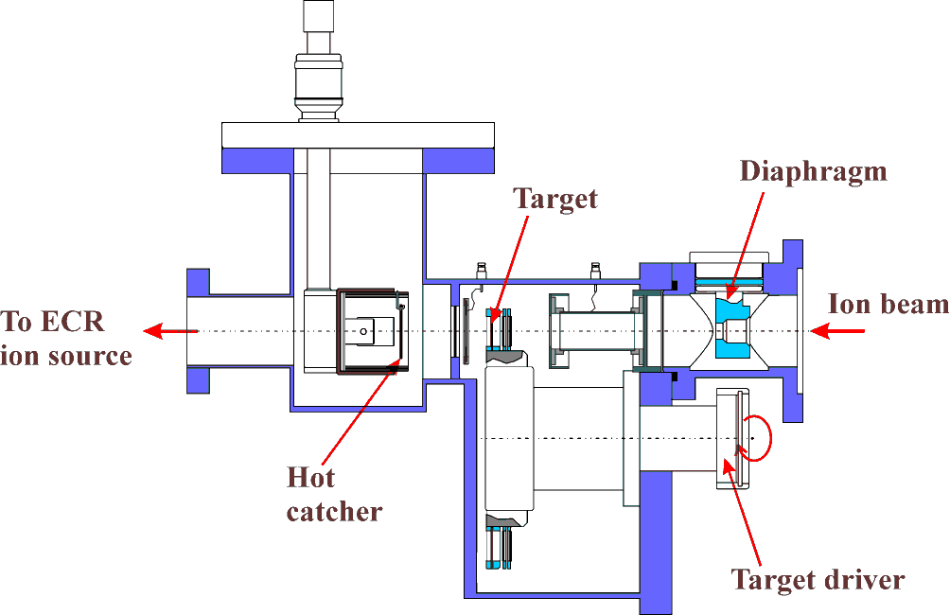

**The mass separator:**

Mass separator in this set up is a magnetic-optical analyser. The separation of ions depends on their magnetic rigidity in a permanent magnetic field. The determination of the mass of super heavy atoms is done with accuracy of Δm=0.25-0.30 e.m.u.

**DAQ in the focal plane:**

In the focal plane of the magnetic analyser detectors are placed, which register the position and decay of the separated atom. The well-type position sensitive strip construction of detector with a focal, side and lateral crystals make it possible to register and determine the masses and decay energies both of evaporation residues and of their daughter decay products with a bigger geometric efficiency.

The registration of the atoms in the focal plane of the separator requires exclusion of the alpha-particle background from the decay of target-like nuclei, especially from the

decay products of light isotopes of actinide elements (Th and U), produced in deep-inelastic collisions or quasi-fission. These nuclei are some 40-60 e.m.u. away from the mass of the superheavy atom and can be separated already at the intermediate focal plane.

**Task Outcome:**

Given task was to take data from of products of three different reactions: (40Ar+148Sm 188-xnHg+xn),

(40Ar+166Er 206-xnRn+xn) and

(48Ca+242Pu 21xRn). Draw their histograms and analyse the peaks of their alpha energy radiation and their daughter nuclei, then draw their heat maps.

1. 40Ar+148Sm 188-xnHg+xn

The above fusion reaction yields mercury isotopes with different mass numbers (180,181,182,183,184,185)

**Hg 180:** 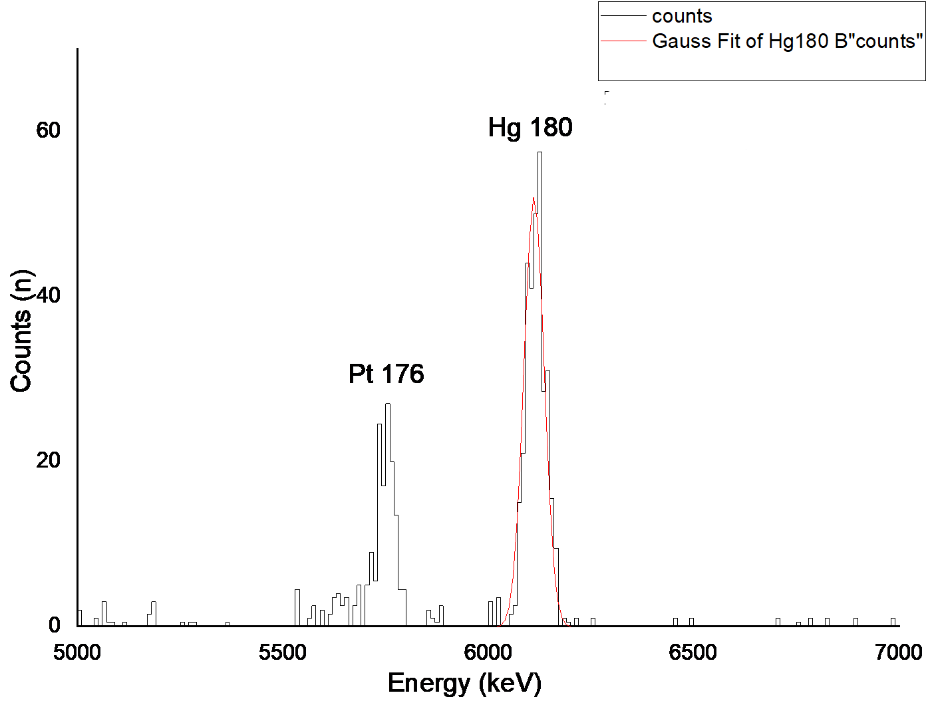

**Hg 181:**

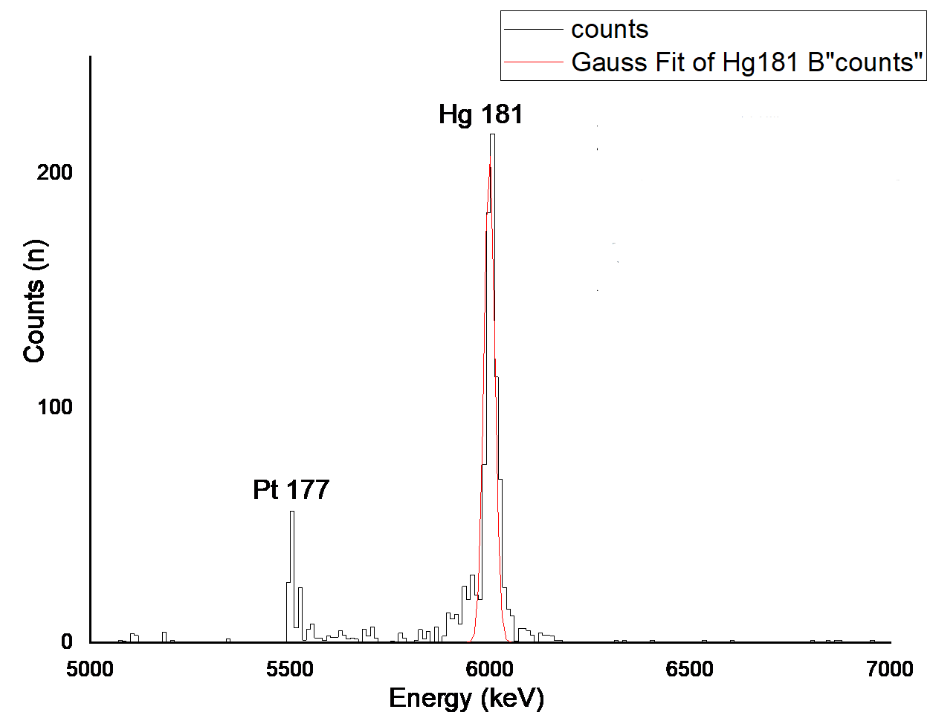

**Hg 182:** 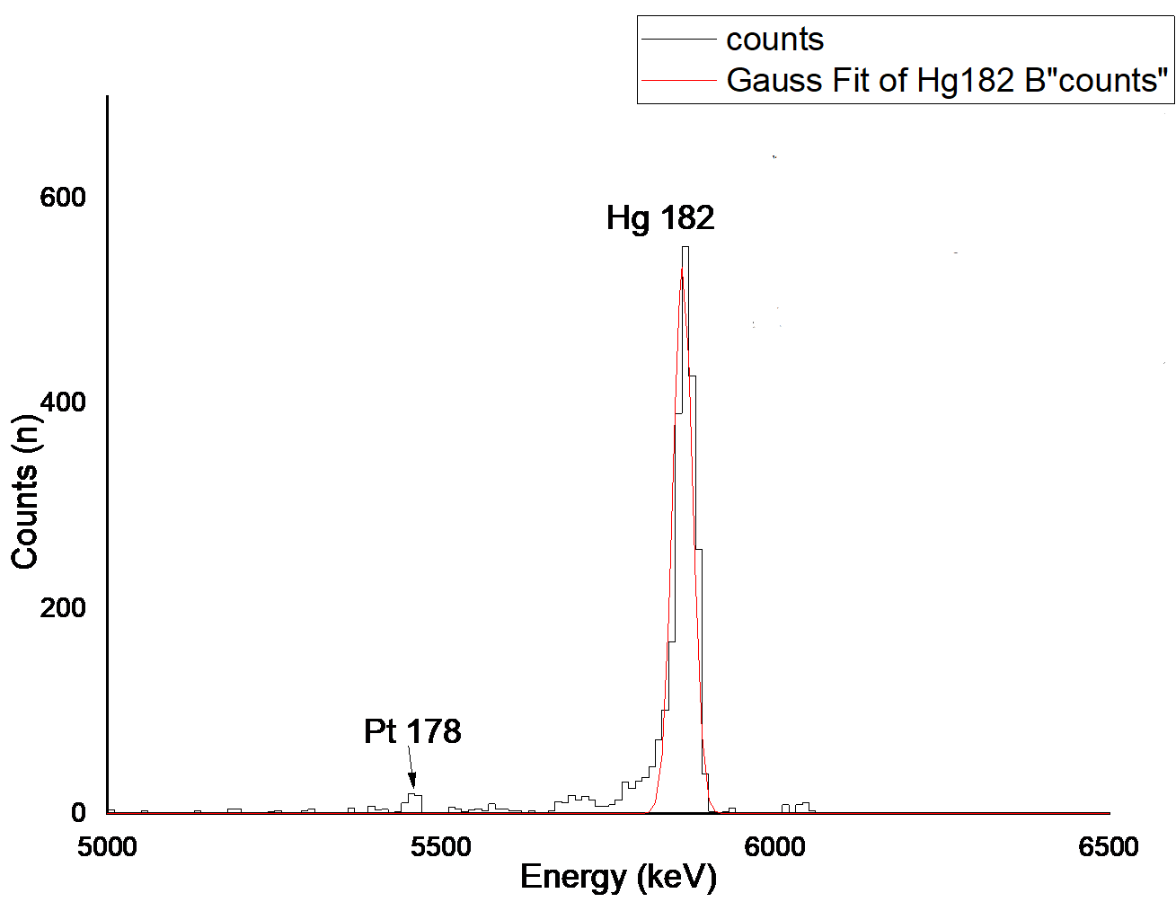

**Hg 183: 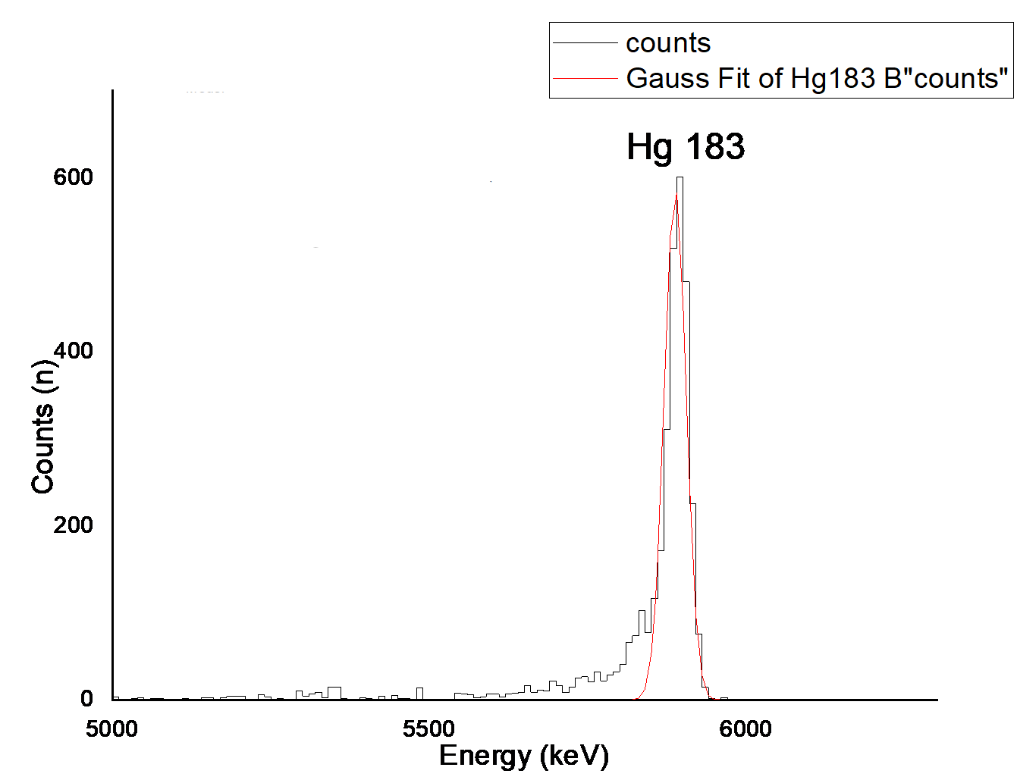Hg 184:** 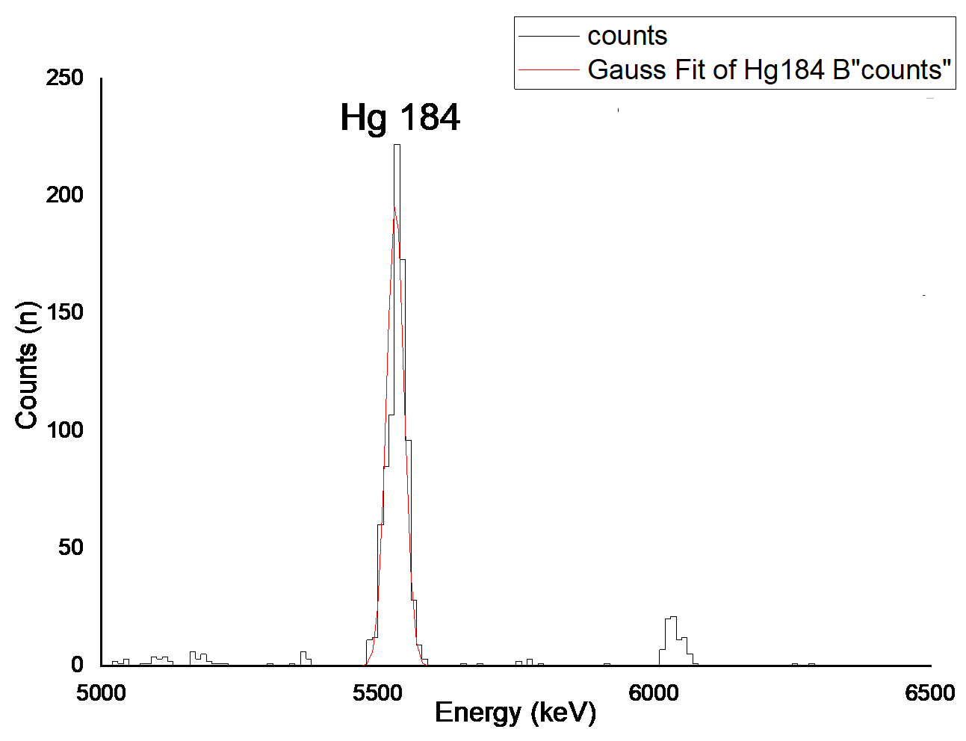

**Hg 185:** 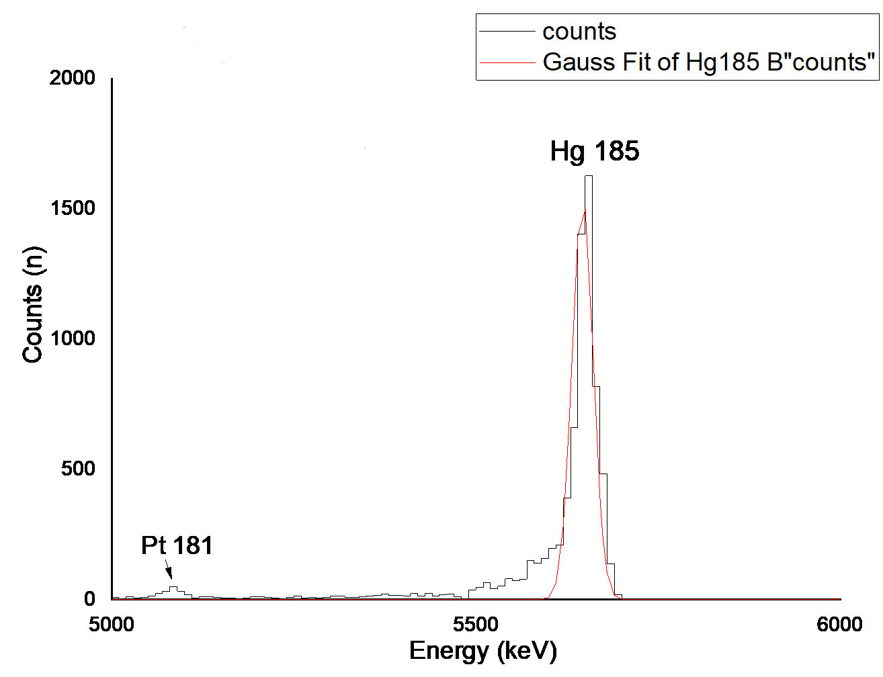

**The heat map for mercury isotopes:**

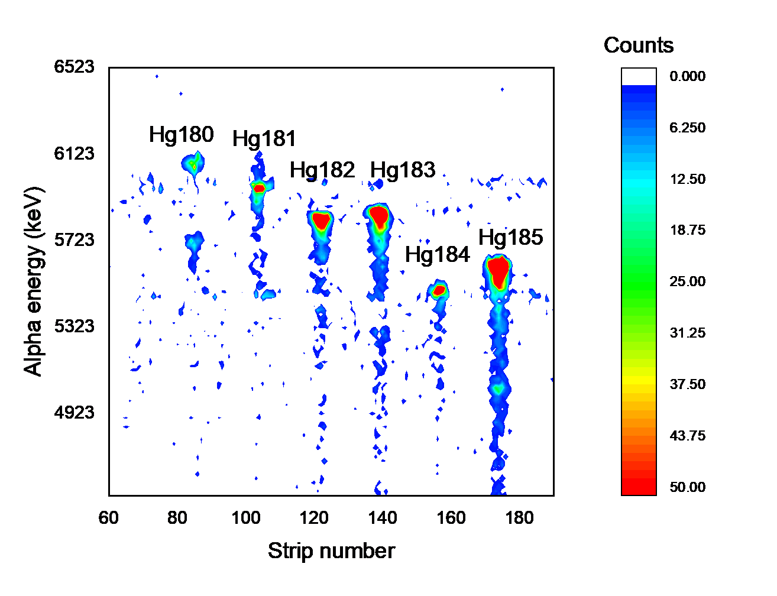

1. 40Ar+166Er 206-xnRn+xn

The above reaction yields Radon isotopes with different mass numbers (201,202,203,204,205)

**Rn 201:**

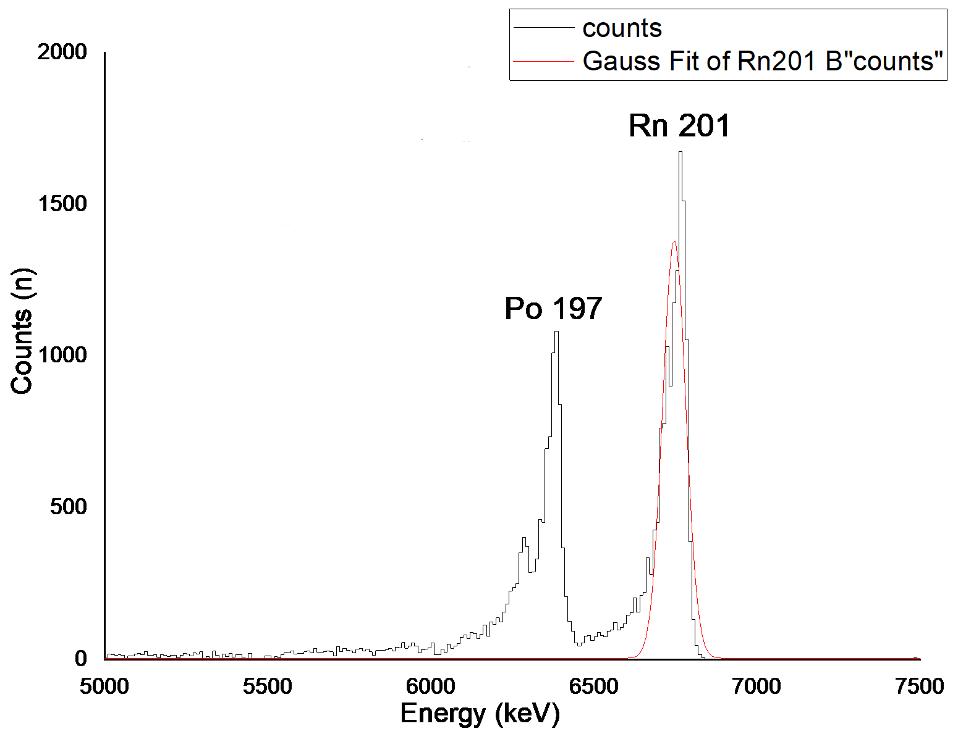

**Rn 202:**

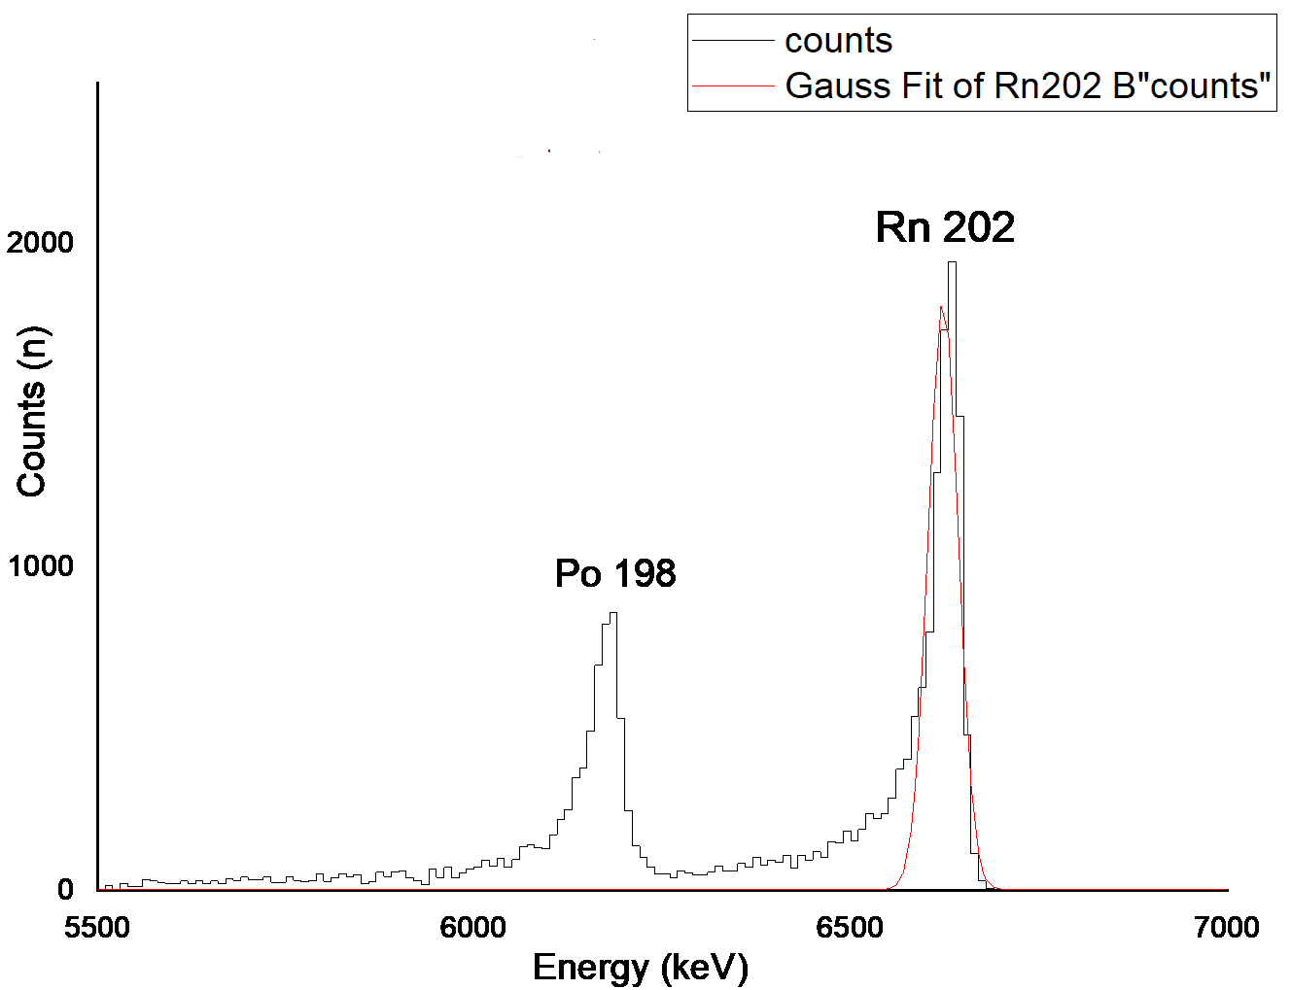

**Rn 203:**

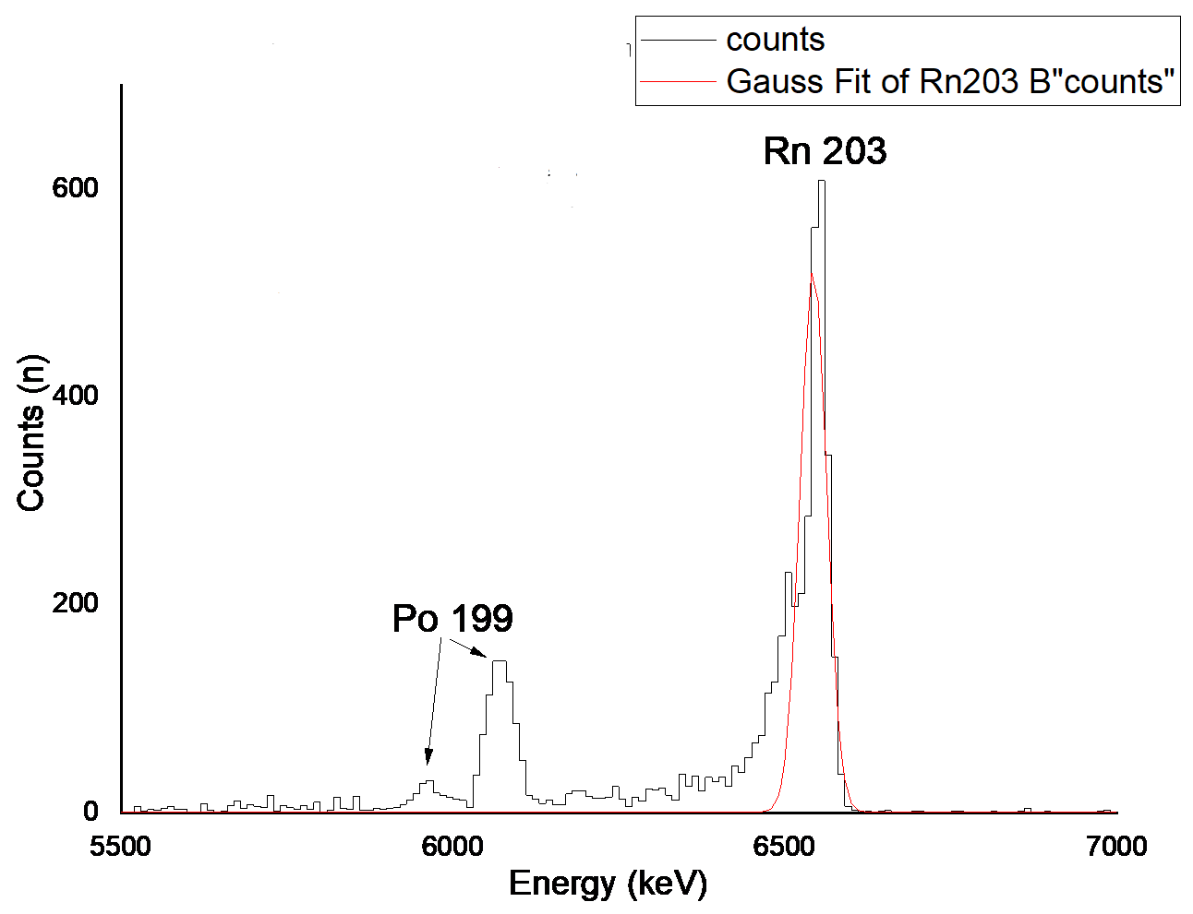

**Rn 204:**

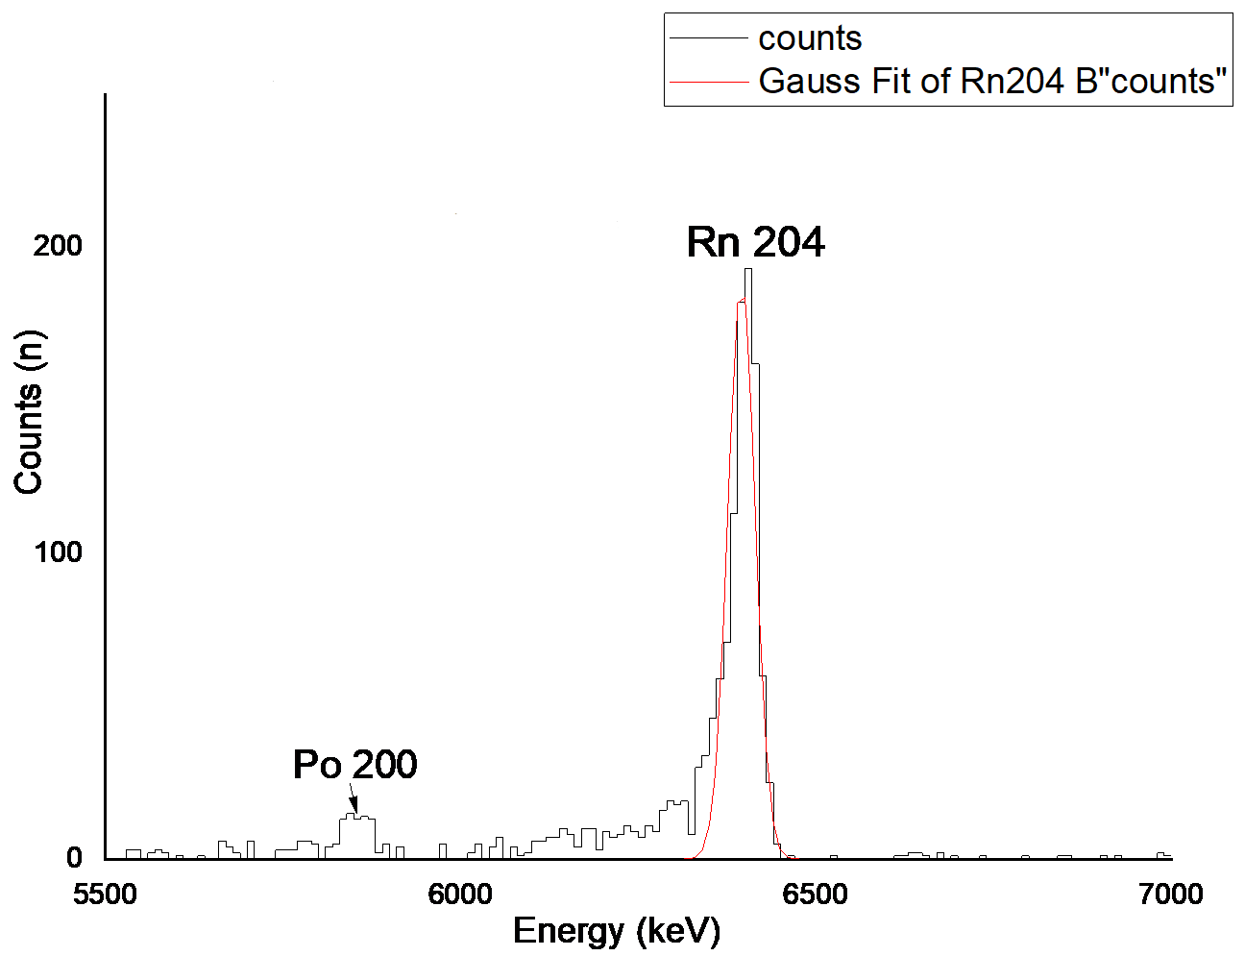

**Rn 205:**

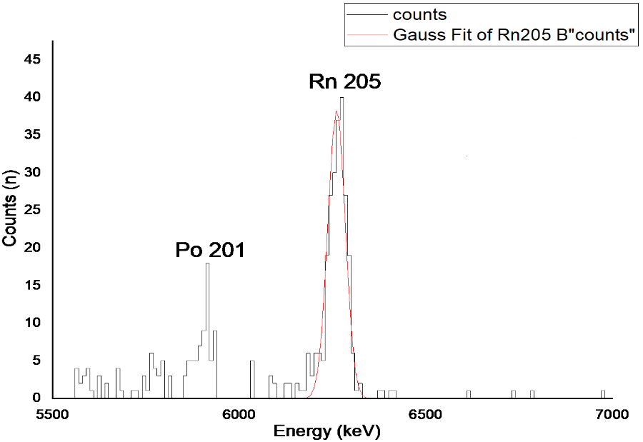

**The heat map for radon isotopes:**

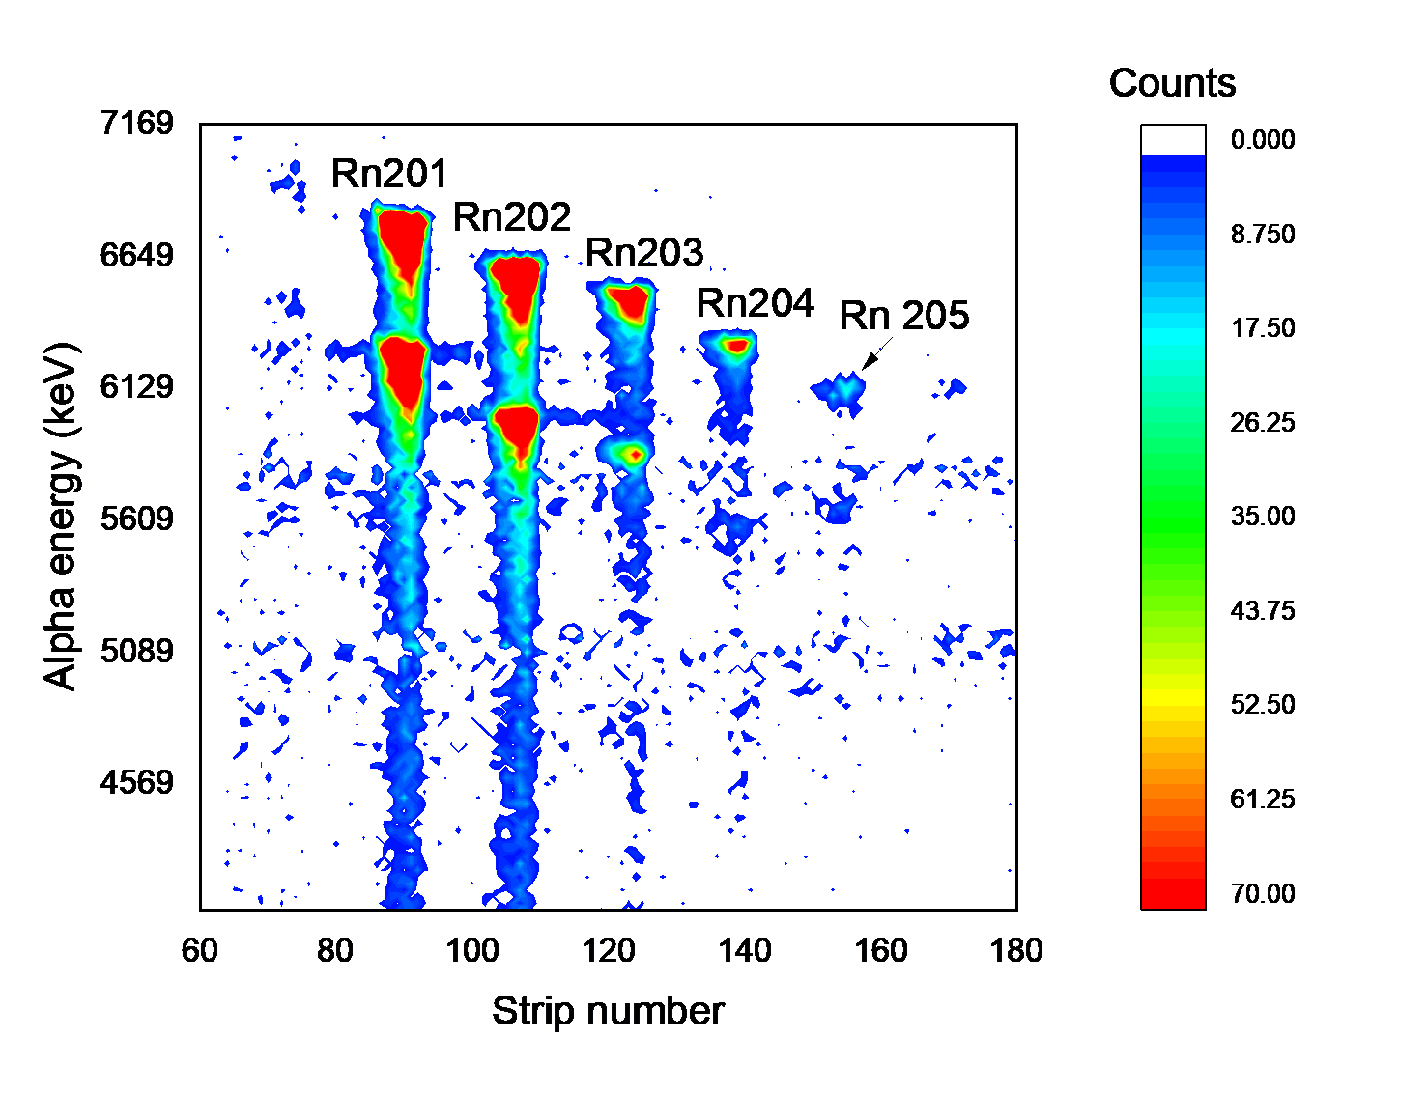

1. 48Ca+242Pu 21xRn

The above reaction yields different isotopes of Radon with mass numbers (212, 218 and 219)

**Rn 212:**

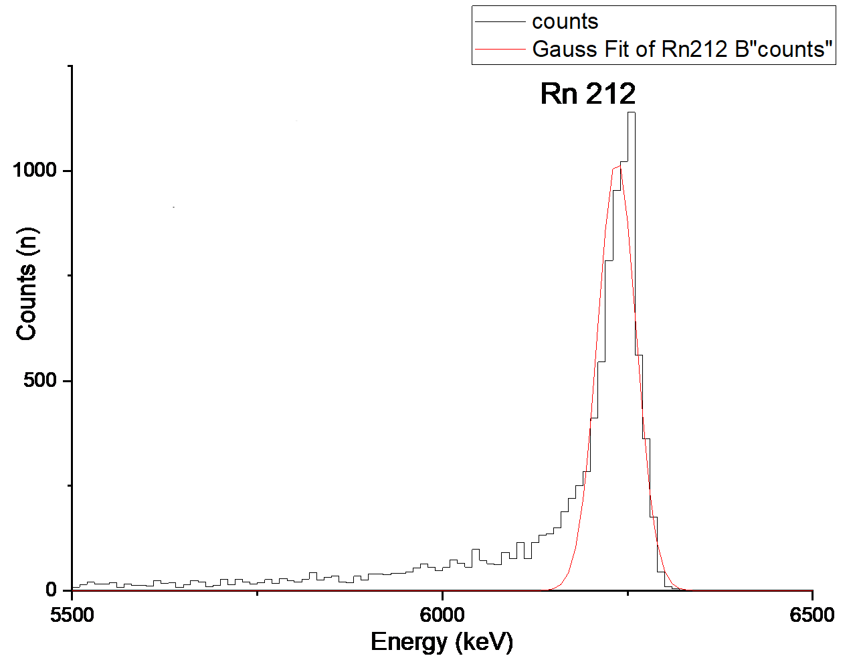

**Rn 218:**

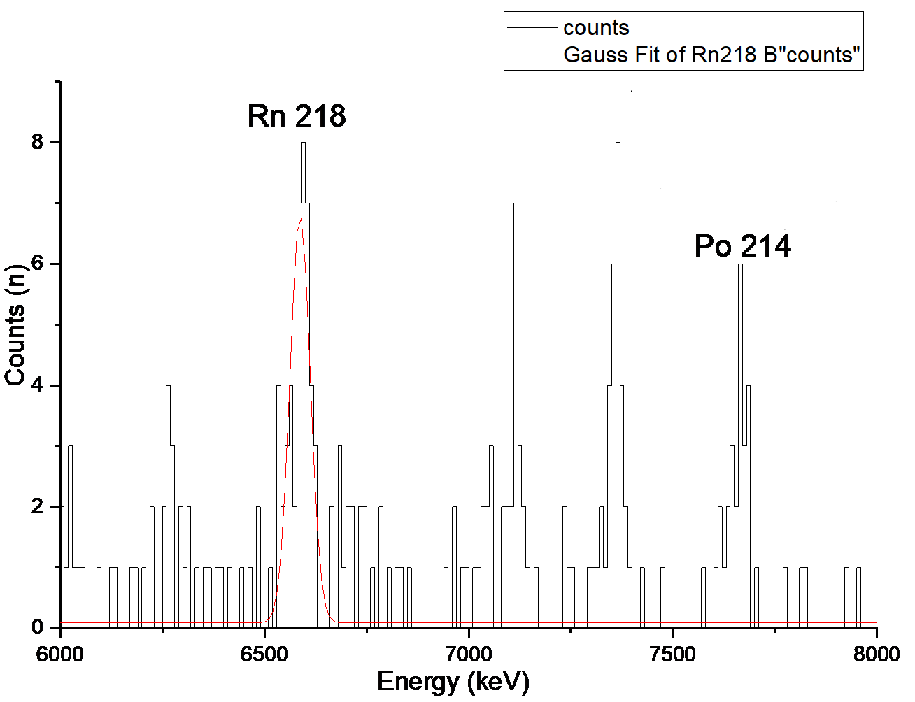

**Rn 219:**

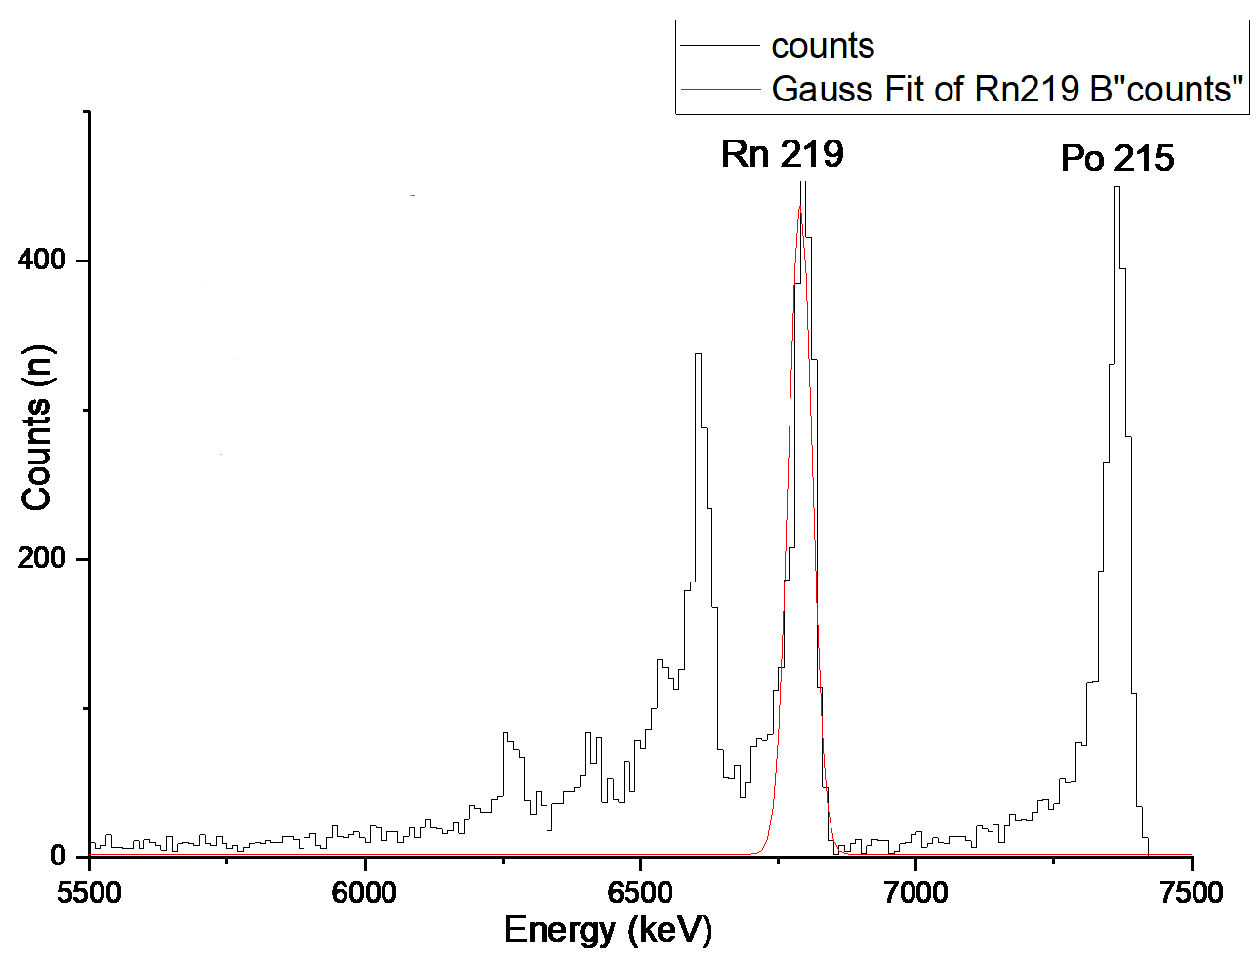

**The heat map for radon isotopes:**

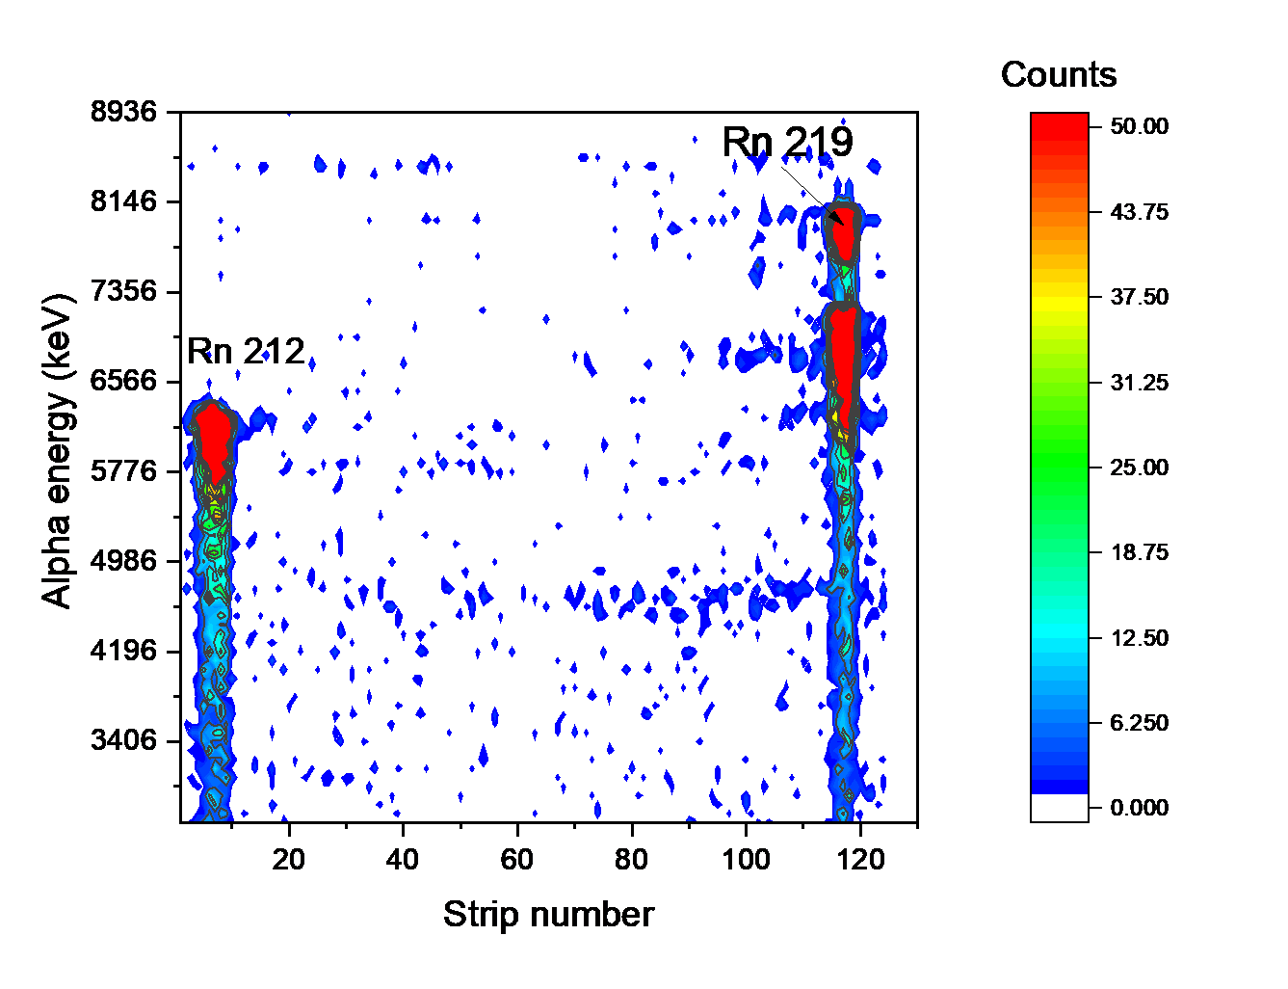

**Conclusion**

Detailed study of superheavy elements helps us to know more about the mechanism of the nuclear reactions and the existence of the “Island of the Stability” which is a predicted set of [isotopes of](https://en.wikipedia.org/wiki/Isotope) [superheavy elements that](https://en.wikipedia.org/wiki/Superheavy_element) may have considerably longer [half-lives than](https://en.wikipedia.org/wiki/Half-lives) known isotopes of these elements.

The Isotope On-Line separation method is used to produce quality beam of nuclei and can be followed by post acceleration, these methods transport the nuclei of interest away from their place of production, where a large background from nuclear reactions is present, to a well-shielded experimental set-up, where the nuclear properties can be explored. Moreover, it makes possible the mass-analysis of new born nuclei by cooling them. Apart from creating low- background conditions for the experiment, the transport serves at the same time to purify the beam and to prepare it in the necessary conditions with respect to energy, time and ion optical properties for the experiments. MASHA set up uses these methods in separating the atoms, it is continuously improved to get better efficiency and to measure more data about the atoms.

Experiments with improving ISOL method, construction and materials are continuing at Masha facility. Already it was performed a divided in space solid catcher. This construction eliminates the heat load on the catcher material thus performing the separation efficiency stability.

In addition, using new nanomaterials based on carbon seems to be righteous idea. Graphene foil and carbon nanotube paper sheet performs good results in a test experiments showed great separation efficiency stability and decreasing of separation time, which opens a big perspective to the short-lived isotopes analysis.

**Acknowledgment**

Unto Almighty for his grace, I give all praise and adoration, for having favoured and given me strength to pursue this path.

My sincere thanks and gratitude to my supervisor Mr. Viacheslav Vedeneev for letting me work under his guidance and I would like to thank him for the time he spent for us.

I’m highly indebted towards INTEREST team for their effort to organize and JINR for making the INTEREST Program happen this year.

**References**

* C. Moskowitz, "Superheavy Element 117 Points to Fabled "Island of Stability" on Periodic Table," *Scientific American,* 2014.
* P. V. Duppen, "Isotope Separation On line and Post Acceleration," *Springer-Verlag* *Berlin Heidelberg,* pp. 37-77, 2006.
* A.M. Rodin, A.V. Belozerov, E.V. Chernysheva et al., "Separation efficiency of MASHA facility for short-lived mercury isotopes," *Hyperfine interact,* vol. 227, pp. 209-221, 2014.
* V. Yu. Vedeneev1 · A. M. Rodin1 · L. Krupa1,3 · A. V. Belozerov1 ·..., "The current status of the MASHA setup," *Springer International Publishing Switzerland,* 2017.
* Y. T. Oganessian, "On-Line Mass Separator of SuperHeavy Atoms," *Nuclear Instrument and Methods A,* pp. 33-46, 2002.