JOINT INSTITUTE FOR NUCLEAR RESEARCH

FINAL REPORT ON THE
INTEREST PROGRAMME

Crystallographic texture analysis from synchrotron and neutron diffraction data

Supervisor:
Dr. RomanVasin

Student:
Pavel Shuitcev, Tula State University, Russia

Participation period:
Feb 14 – Mar 25, Wave 6

Dubna, 2022

Abstract:

Many materials, such as rocks, ceramics, metals and alloys are polycrystals. Crystallographic preferred orientation, or crystallographic texture, is formed by different processes and defines anisotropic physical properties of polycrystalline materials. This project was focused on study the basics of crystallographic texture analysis using synchrotron and neutron diffraction data of real samples. The main aim of this project is to learn crystallographic texture research methods and sophisticated data analysis routines. In order to achieve these goals, a combination of orientation distribution function (ODF) calculation methods with a Rietveld method was performed. Specifically, the MAUD software was applied to determine the texture of the samples.

Key words: Texture analysis, Orientation Distribution Function, Rietveld refinement.

Introduction:

In material science, crystallographic texture is an important microstructural parameter, which directly determines the anisotropy degree of most physical properties of a polycrystalline material at the macro scale. Crystallographic texture is the preferred orientation of the crystallites within a polycrystalline material, or, in other words, the non-uniform distribution of crystallographic orientations. The degree of texturization is dependent on the volume percentage of crystals having the preferred orientation.
Texture describes the orientation of crystallites of phases that compose a material relative to sample coordinates with a three-dimensional statistical orientation distribution function (ODF), which is formed and changed by plastic deformation, sedimentation, crystallization, recrystallization, structural phase transitions [1]. The texture induces anisotropy of physical and mechanical properties of the material, so the texture is not only important for mechanical properties, they are also essential for crystal structure refinements and volume fraction estimates of aggregates with preferred orientation.
X-ray, electron, and neutron diffraction, EBSD etc. techniques are used to determine crystallographic preferred orientations in materials. Compared with laboratory X-ray diffraction and electron back-scatted diffraction, high-energy synchrotron X-ray diffraction with large area detectors enables the probing of a large of crystalline orientations in individual exposures, offering the advantages of fast texture measurements [2-4]. For quantitative texture analysis with high-energy synchrotron diffraction, an ODF of textured materials is usually determined on the basis of polar pattern measurements collected as Debye-Scherrer diffraction images at different sample orientations. In such cases, Rietveld texture analysis as a method for quantitative analysis is gaining increasing researchers’ attention, and have proved to be a very powerful tool in combination with texture analysis routines.
Neutron diffraction probes crystallographic texture in large sample volumes, therefore enabling studies of coarse-grained samples, or materials with texture gradients; usually multidetector setups or position sensitive detectors are used [1,5,6].
This project was focused on study the basics of crystallographic texture analysis by MAUD software using synchrotron and neutron diffraction data. A combination of ODF calculation methods with a Rietveld method was performed, specifically, we apply the MAUD software to determine the texture of the samples, as well as other relevant parameters.

1. Introduction to the MAUD program

In order to achieve finale goal, first of all, it is necessary to master the skills of working in the MAUD software. It is most convenient to master the Rietveld method using the example of X-ray diffractograms. To obtain the most reliable crystallographic data during refinement, it is necessary to determine the instrumental parameters through standard sample of powder Si. Fig. 1 shows Rietveld refined Si X-ray diffractograms.

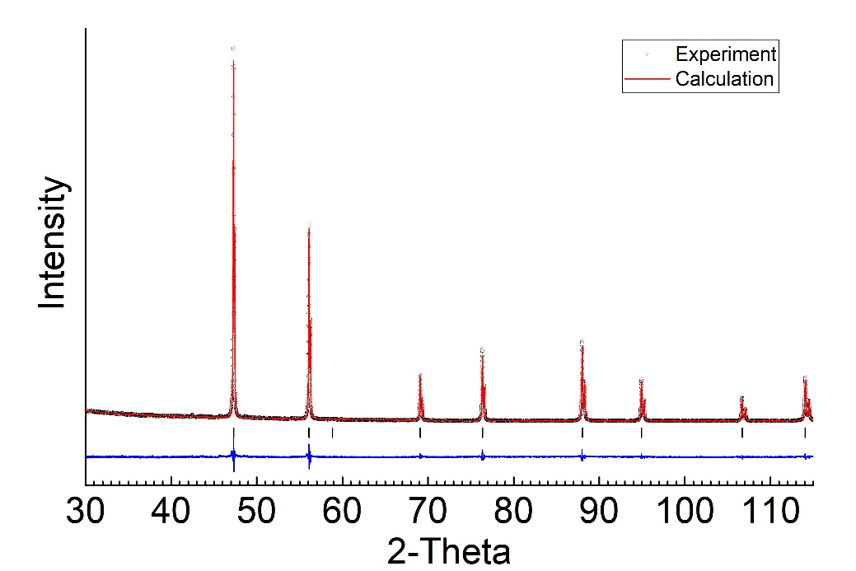
Fig. 1. Rietveld refinement of Si standard using MAUD software

Next step is applying Rietveld refinement for real alloy. Ni₅₀Ti₃₀Hf₂₀high temperature shape memory alloy was chosen. The alloy was prepared by arc-melting using high purity titanium, nickel and hafnium in a water-cooled copper crucible under an argon atmosphere. Before the melting of the ingot, a pure Ti button was melted and used as an oxygen-getter. The ingot was re-melted eight times, being flipped over after each melting step to ensure homogeneity in composition. After melting, the ingot was sealed in a quartz tube under vacuum and homogenized at 900 °C for 6 h and solution-treated by water-quenching.
Microstructural and chemical analyses of solution-treated Ni₅₀Ti₃₀Hf₂₀ alloy were carried out on a JEOL JXA-8230 electron probe micro-analyzer (EPMA) equipped with wave-length dispersive X-ray spectrometers (WDS).
Back-scattered electron (BSE) image of the solution-treated Ni₅₀Ti₃₀Hf₂₀ alloy is shown in Fig. 2(a). The matrix of alloy has a homogeneous structure with the dark and bright light inclusions of irregular shape with an average size ofless than 1 µm. The dark and bright inclusions were identified as (Ti,Hf)₂Ni/(Ti,Hf)₄Ni₂O_{x} and HfO₂ phase, respectively [7, 8]. The volume fractions of dark and bright light particles were estimated to be 0.37%±0.02% and 0.10%±0.01%, respectively. The chemical composition of the solution-treated alloy is summarized in Table 1. The EPMA analysis was taken in ten random points of sample. The results showed a gain of ~0.7 at.%Ti, a loss of ~0.8 at.% Hf and good compliance of Ni compared to the nominal compositions. In addition, a small amount of ~0.09 at.% Zr is also present in the matrix. The chemical composition of inclusions could not be reliably determined due to their small size.

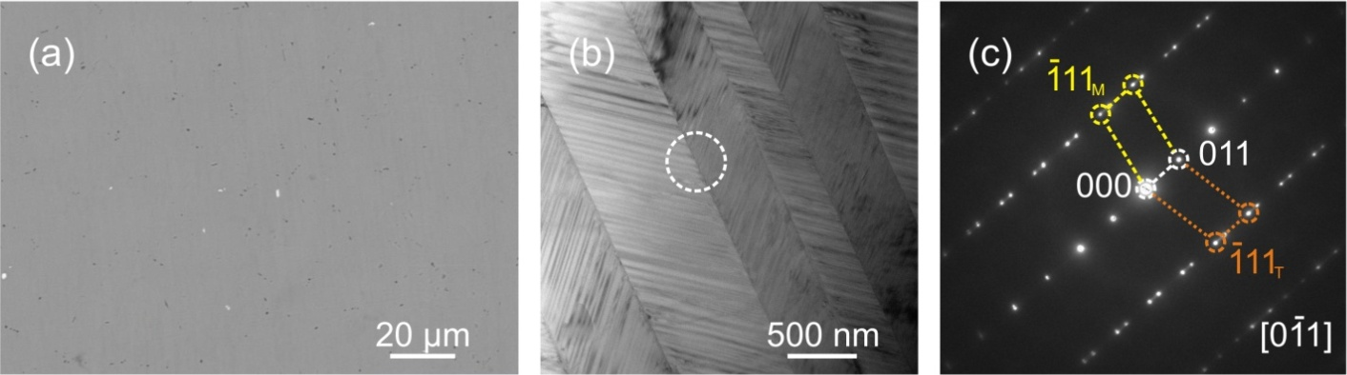
Fig. 2. BSE (a) and TEM bright-field (b) images of the solution-treated Ni₅₀Ti₃₀Hf₂₀ and the SAED patterns (c) taken from the interface of the variant of (b) marked by circle.

Table 1 Composition (at.%) of the Ni₅₀Ti₃₀Hf₂₀ alloy in solution-treated state measured by EPMA. ± indicates the standard deviation from a total of 10 measurements.
Composition | Ni | Ti | Hf | Zr
Nominal | 50 | 30 | 20 | -
Measured | 50.01±0.11 | 30.71±0.10 | 19.18±0.12 | 0.09±0.03

The microstructure of Ni₅₀Ti₃₀Hf₂₀ alloy is illustrated in Fig. 2(b). The martensite variants are characterized by the lath-like morphology. The boundaries of martensite variants are straight and well-defined with a high density of inner twins. The martensite variants are related to the (011) type I twin. This is confirmed by the selected area electron diffraction (SAED) patterns shown in Fig. 2(c), which was taken from the circled interface of martensitic variants of Fig. 2(b). The above results are well consistent with the previous works of NiTiHf alloys [9, 10].

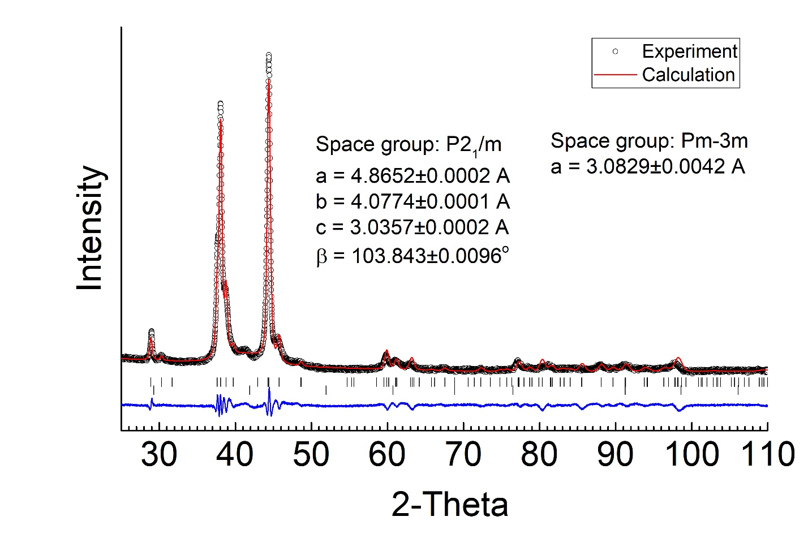
Fig. 3. Rietveld refinement of Ni₅₀Ti₃₀Hf₂₀ alloy using MAUD software

Fig. 3 shows Rietveld refinement of Ni₅₀Ti₃₀Hf₂₀ alloy. It is clearly seen that monoclinic martensite is determined during refinement, while cubic austenite most likely contributes only 1 intensive diffraction peak at 2θ ≈ 42°.

2. Nickel coin sample

Analysis of the synchrotron diffraction data from polycrystalline samples is more complex.
The schematic of the usual setup is shown in Fig.4. For this example, a coin sample, which is a Cu-Ni alloy, was used [2]. High-energy X-ray beam with short wavelength (0.10798 Å) was used, and the distance between detector and sample was about 1850 mm.

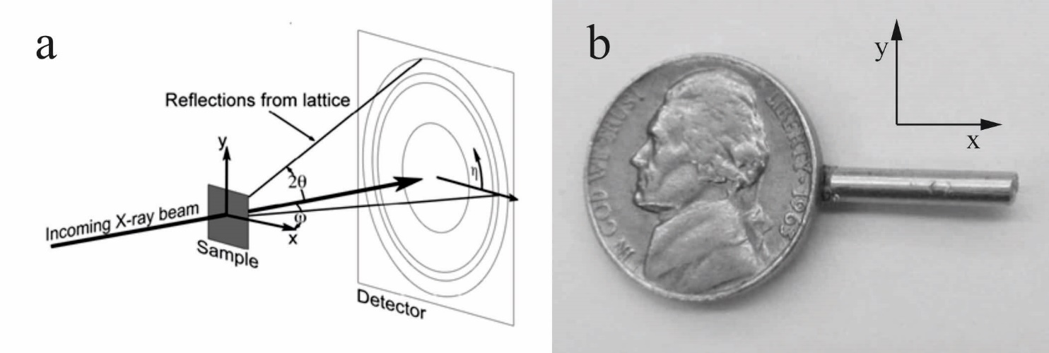
Fig.4. (a): Geometry of synchrotron diffraction texture experiment; (b): Sample for a hard X-ray diffraction experiment: Nickel coin mounted on a pin.

Ⅰ: Instrumental Calibration
In order to obtain the most reliable crystallographic data during refinement, it is necessary to determine the instrumental parameters, such as exact sample-to-detector distance, detector center, tilt, etс. Also, the line broadening analysis requires as a prerequisite to separate the peak broadening due to the sample microstructure (e.g., crystallite size and micro-strain) from the broadening arising from the instrument. The refinement strategy for the microstructure characteristics of the sample in MAUD features a clear separation between the instrument line broadening model and the line broadening model related to the sample [2]. So, using standard sample (usually powdered LaB₆ or CeO₂) to do the instrumental broadening determination is essential.
For the calibration, CeO₂ diffraction image (Fig. 5(a)) was integrated in MAUD software in 5° azimuthal steps, and 72 diffraction patterns were simultaneously processed.

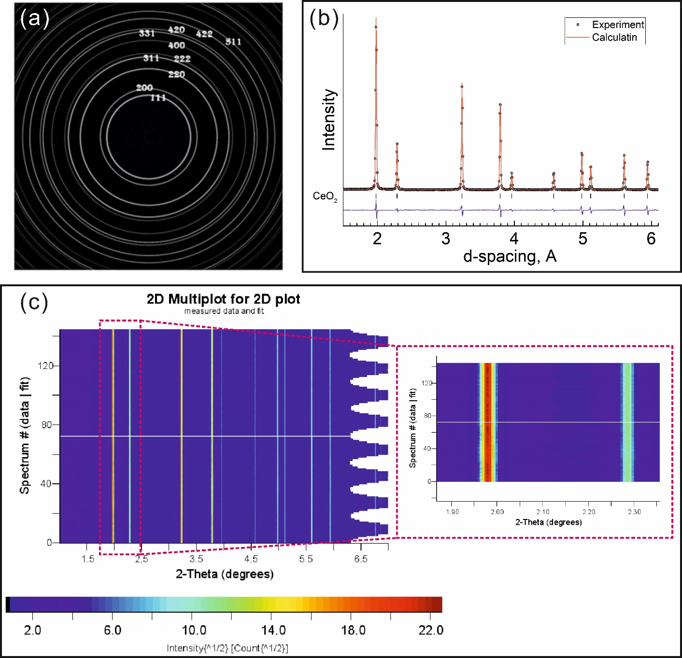
Fig. 5. Diffraction image with Debye rings (a)and Rietveld refinement (b) of CeO₂ standard using MAUD software and 2D-Intensity plots of experimental (bottom) and simulated (top) diffraction pattern with respect to integrated azimuthal angle in steps of 5° from 0° to 360° (c).Insert of (c) is theenlarge area near (111) and (200) peaks

Rietveld refinement allows to achieve good agreement in position, width and intensity between the calculated and experimental patterns (Fig. 5(b) and (c)). This indicates that the result is convincing. The refined sample-to-detector distance was estimated to be 1850.602±0.002 mm.

Ⅱ：Texture analysis for the Nickel-coin
To perform a texture analysis, we need a sufficient amount of data in order to measure a representative number of grains in different orientations with desired angular resolution in the orientation space. We need to cover the large part of orientation space to ensure the validity of the results.

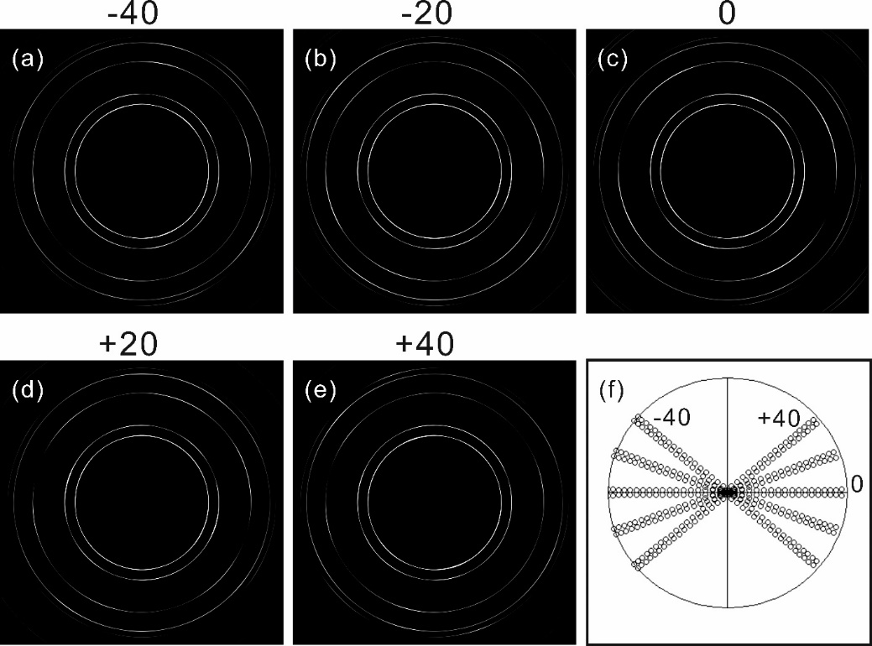
Fig. 6. A series of diffraction image with Debye rings of Cu-Ni coin with Phi = -40 (a), -20 (b), 0 (c), +20 (d), +40 (e) and pole figure coverage with the sample rotated to different positions (f).

Fig. 6(a)-(e) shows a diffraction images of “nickel” coin collected at Phi angles of -40°, -20°, 0°, +20°, +40°. Debye rings corresponds to the reflections of hkl lattice planes. The azimuthal variations of X-ray intensity immediately indicate lattice preferred orientation. Debye rings are smooth, indicating excellent grain statistics, which is a prerequisite for a quantitative texture analysis. Fig. 6(f) shows a pole figure coverage, which corresponds to the 5 diffraction images of Fig. 6(a)-(e) integrated with 5° intervals.

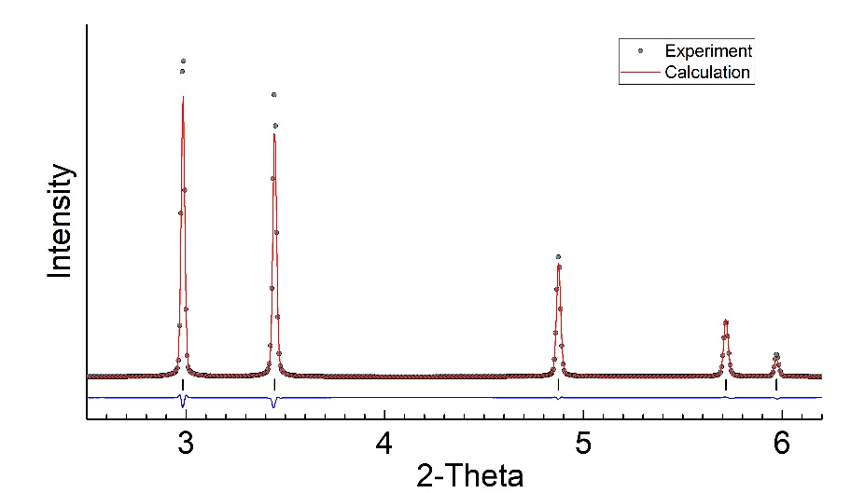
Fig. 7. The Rietveld refinement of Cu-Ni coin using MAUD software.

Rietveld refinement with the MAUD software was applied in order to analyze the diffraction patterns. Here, incident intensity, backgrounds, unit cell parameter, microstructure parameters (crystallite size and r.m.s. micro-strain in isotropic approximation), and isotropic thermal factors were refined. Texture was refined using a discrete E-WIMV algorithm.
The FCC crystal structure was considered for Cu-Ni alloy. The unit cell parameter refined to a=3.59079(1) Å. Fig. 7 shows the results of the refinement.

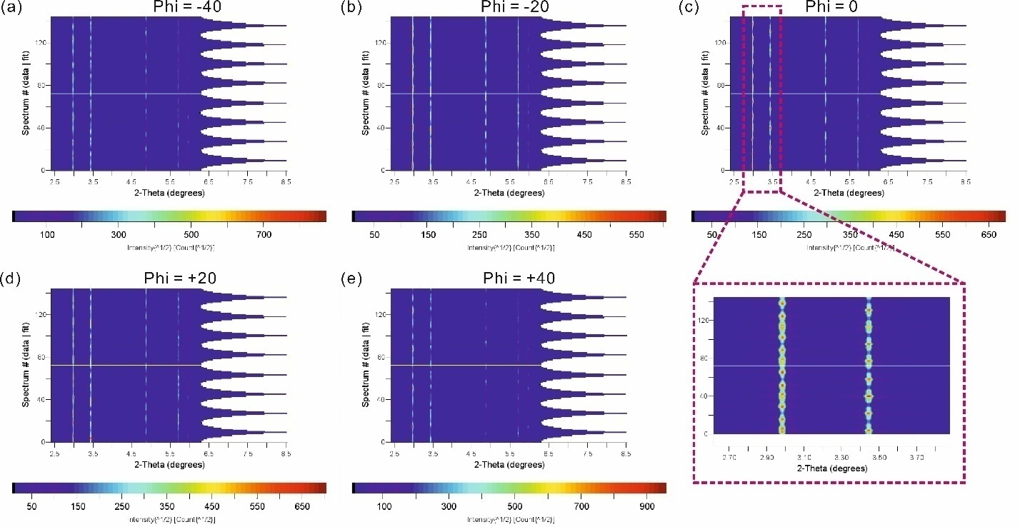
Fig. 8. 2D-Intensity plots of experimental (bottom) and simulated (top) diffraction patterns of Cu-Ni coin with respect to integrated azimuthal angle in steps of 5° from 0° to 360° with Phi = -40° (a), -20° (b), 0° (c), +20° (d), +40° (e). Insert of (c) is the enlarge area near (111) and (200) peaks

Fig. 8 shows the experimental and fitted 2D-plots of the diffraction pattern at different Phi angles and simulated diffraction patterns matches well with the experimentally observed patterns of Cu-Ni coin.
Fig. 9 represents pole figures of experimental data of Cu-Ni coin in comparison with pole figures plotted using MAUD software coverage 5 images with 10°, 5° and 3° cell size in the orientation space.
The texture indicates recrystallization process in the rolled metal sheet.

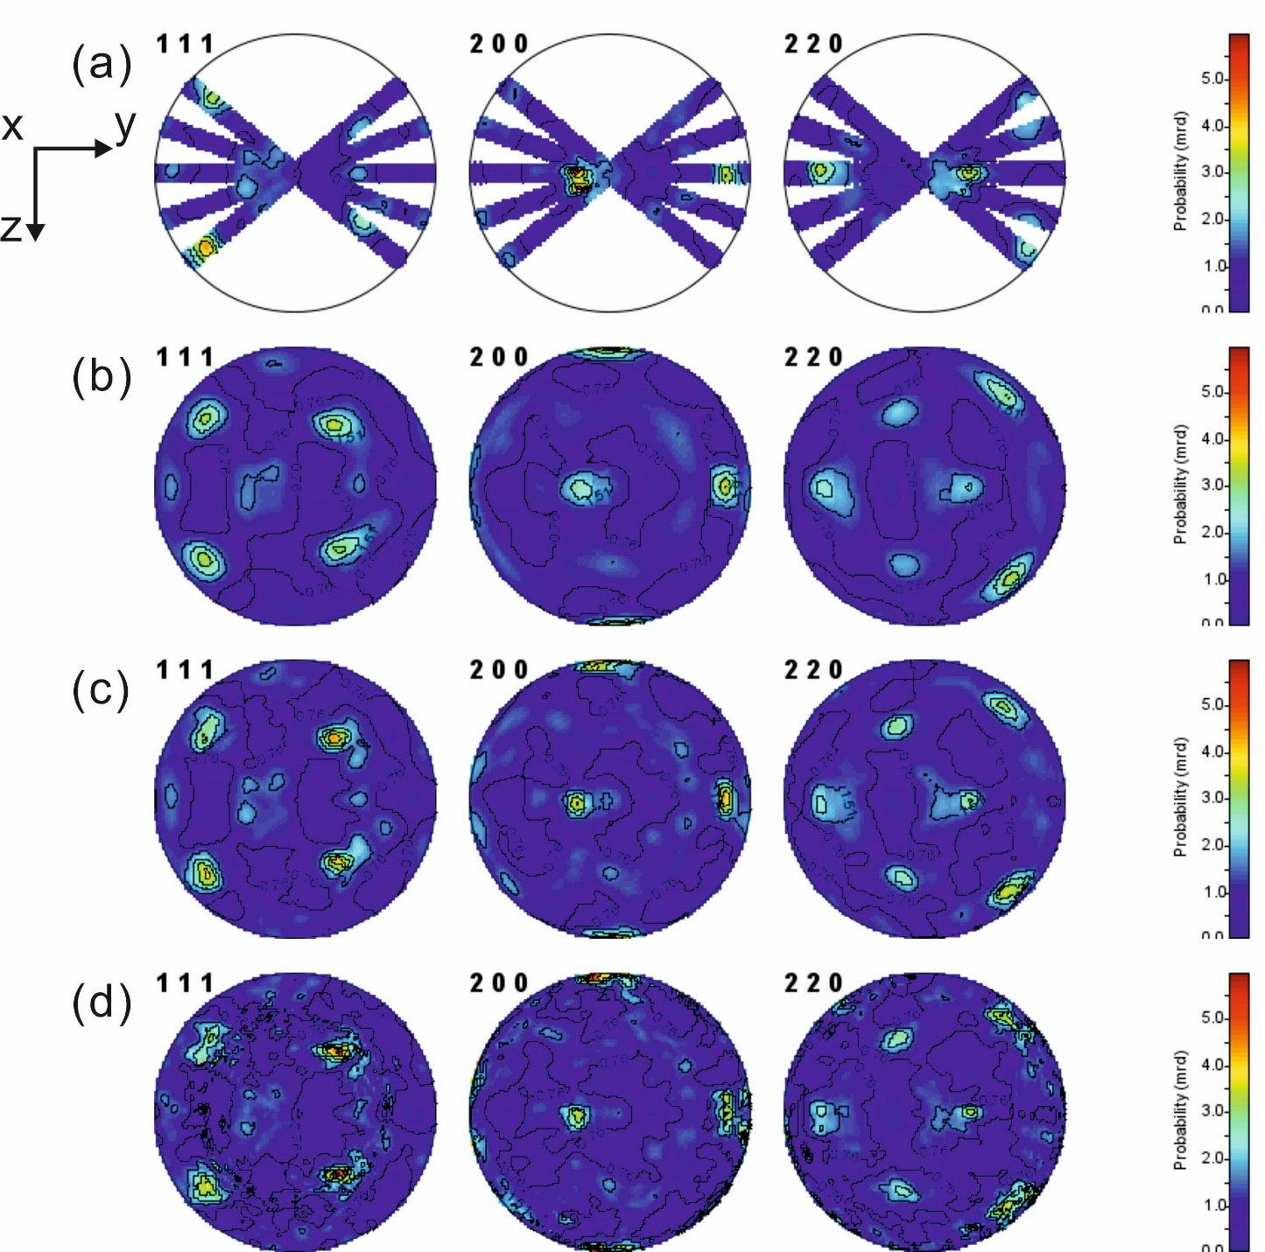
Fig. 9. Pole figures of experimental pole figure data with 5 diffraction images (a) in comparison with pole figures recalculated from the ODF computed using MAUD software and E-WIMV with 10° (b), 5° (c) and 3° (d) cell size in the orientation space. Equal area projections, linear scale. Sample coordinate system (cf. Fig. 4) is also shown.

3. Cu-Fe composite example

Neutron diffraction texture analysis is a powerful tool in studies preferred orientations in bulk samples with linear dimensions of ~ several cm. Here the studied example is a sample of deformed Cu-Fe composite measured at SKAT diffractometer [6]. This is a time-of-flight instrument, which for the input in MAUD requires a specific .prm configuration file. Here we use a premade configuration.
Cu-Fe composite consists of two phases, FCC copper and BCC iron. In addition to incident intensity and backgrounds of every diffraction spectrum, phase volume fractions, unit cell parameters, microstructure parameters (crystallite size and r.m.s. micro-strain in isotropic approximation), and isotropic thermal factors were refined for both copper and iron. Texture was refined using a discrete E-WIMV algorithm with 5° cell size in the orientation space.

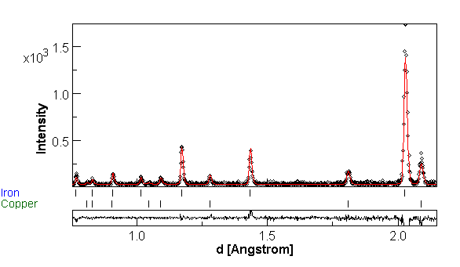
Fig. 10. Diffraction spectrum of Cu-Fe composite from SKAT detector A, first sample position
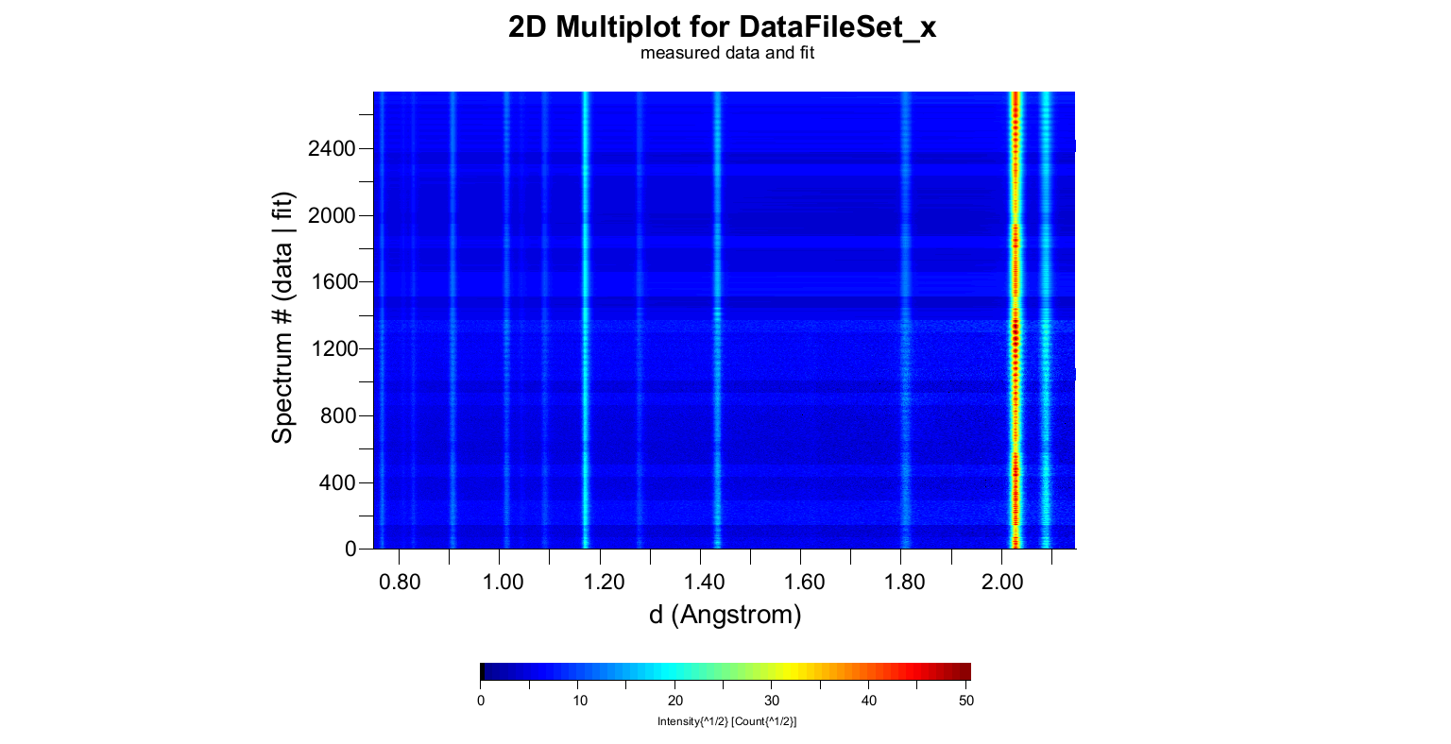
Fig. 11. 2D-Intensity plots of experimental (1368 bottom) and simulated (1368 top) diffraction patterns of deformed Cu-Fe composite
Cu-Fe composite consists of two phases, FCC copper and BCC iron. In addition to incident intensity and backgrounds of every diffraction spectrum, phase volume fractions, unit cell parameters, microstructure parameters (crystallite size and r.m.s. micro-strain in isotropic approximation), and isotropic thermal factors were refined for both copper and iron. Texture was refined using a discrete E-WIMV algorithm with 5° cell size in the orientation space. There is a perfect correspondence of experimental diffraction data and the model (Fig. 10, 11).
Recalculated pole figures are shown in Figures 12 and 13. The texture is weak, but a regular preferred orientation is observed revealing horizontal direction of main applied compressive stress. Pole figures of copper and iron follow Kurdyumov-Sachs orientation relationship.
Volume fraction of copper is determined to be 27.9 (1) Vol.%, unit cell parameter is 3.6149 (1) Å, volume fraction of iron is 72.1 (1) Vol.%, and unit cell parameter is 2.8662 (1) Å. Coherent scattering domains sizes are larger than 0.1 µm.
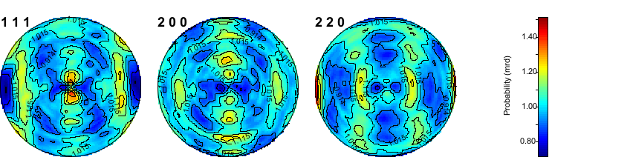
Fig. 12. Pole figures of copper in deformed Cu-Fe composite. Equal area projections, linear scale.
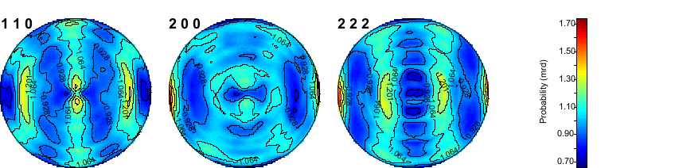
Fig. 13. Pole figures of iron in deformed Cu-Fe composite. Equal area projections, linear scale.

Conclusion
- Application of Rietveld texture analysis to high-energy synchrotron X-ray and time-of-flight neutron diffraction data is a powerful tool to study crystallographic preferred orientations in bulk materials.
- A combination of ODF calculation methods with a Rietveld method is a good solution for some cases allowing extracting additional information from diffraction pattern, such as: unit cell parameters, phase composition, residual stresses, etc.

Acknowledgements
I would like to thank my supervisor Dr. Roman Vasin for his expertise, and Joint Institute for Nuclear Resarch for providing the opportunity to learn at online courses.

Reference:
[1] H.-R. Wenk, L. Lutterotti, S.C. Vogel, Powder Diffraction 25 (2010) 283-296.
[2] L. Lutterotti, R.N. Vasin, H.-R. Wenk, Powder Diffraction 29 (2014) 76-84.
[3] K.-D. Liss, A. Bartels, A. Schreyer, H. Clemens, Textures Microstruct. 35 (2003) 219-252.
[4] M.Y. Xie, N. Baimpas, C. Reinhard, A.M. Korsunsky, J Appl Phys 114 (2013) 163502.
[5] H. Simons, J.E. Daniels, A.J. Studer, M. Hoffman, J Electroceramics 32 (2014) 283-291.
[6] R. Keppler, K. Ullemeyer, J.H. Behrmann, M. Stipp, J Appl Crystallogr 47 (2014) 1520-1534.
[7] Y. Tong, F. Chen, B. Tian, L. Li, Y. Zheng, Materials Letters 63 (2009) 1869-1871.
[8] T. Umale, D. Salas, B. Tomes, R. Arroyave, I. Karaman, Scripta Mater 161 (2019) 78-83.
[9] H.E. Karaca, S.M. Saghaian, G. Ded, H. Tobe, B. Basaran, H.J. Maier, R.D. Noebe, Y.I. Chumlyakov, Acta Materialia 61 (2013) 7422-7431.
[10] R. Santamarta, R. Arroyave, J. Pons, A. Evirgen, I. Karaman, H.E. Karaca, R.D. Noebe, Acta Materialia 61 (2013) 6191-6206.

