

Production and spectroscopic investigation of

new neutron-rich isotopes near the neutron

N=126 shell closure using the multi-nucleon

transfer reactions

By

**Roman Leva**

Department of applied physics, Mechanics and Machinery university after Vladimir Dahl, Lugansk city

**Supervisor**

**Mr Viacheslav Vedeneev**

Flerov Laboratory of Nuclear Reactions,Dubna, Russia

Wave 5 Final Report

Joint Institute For Nuclear Research, Dubna, Russia

October 28, 2021

Contents

1 Introduction . . . . . . . . . . . . . . . . . . . . . . . . . . . . . . . . . . . . . . . 4

2 Experimental Setup . . . . . . . . . . . . . . . . . . . . . . . . . . . . . . . . .5

2.1 MASHA Setup . . . . . . . . . . . . . . . . . . . . . . . . . . . . . . . . . . . . 5

2.2 Ion Source . . . . . . . . . . . . . . . . . . . . . . . . . . . . . . . . . . . . . . 5

2.3 Target Assembly and Hot Catcher . . . . . . . . . . . . . . . . . . . 6

2.4 Detection and Control System . . . . . . . . . . . . . . . . . . . . . . 7

2.4 Experimental Technique . . . . . . . . . . . . . . . . . . . . . . . . . . . 7

3 Result and Discussion . . . . . . . . . . . . . . . . . . . . . . . . . . . . . . 8

3.1 Reaction 40Ar+148 Sm . . . . . . . . . . . . . . . . . . . . . . . . . . . . 8

3.2 Reaction 40Ar+166 Er . . . . . . . . . . . . . . . . . . . . . . . . . . . . 11

3.3 Reaction 48Ca+242 Pu . . . . . . . . . . . . . . . . . . . . . . . . . . . . 13

Conclusions. . . . . . . . . . . . . . . . . . . . . . . . . . . . . . . . . . . . . . . . 15

Acknowledgments . . . . . . . . . . . . . . . . . . . . . . . . . . . . . . . . . . 15

Bibliography . . . . . . . . . . . . . . . . . . . . . . . . . . . . . . . . . . . . . . .. 15

**Abstract**

The MASHA mass spectrometer designed for identifying super-heavy elements by their masses is described. The separation efficiency has been measured in the autonomous mode using four calibrated leak ages of noble gases. The total separation efficiency of the mass spectrometer with a hot catcher and an ion source based on the electron cyclotron resonance has been determined using the *40Ar* beam. Test experiments have been carried out, in which α-active *Hg* isotopes produced in complete fusion reaction *40Ar + 144Sm →184 – xnHg + xn*, have been detected in the focal plane of the mass spectrometer. The separation time and efficiency have been determined for short lived *Hg* isotopes

1. Introduction

The study of super-heavy nuclei is one of the most important studies in nuclear physics. This involves precise measuring of energy, mass, α-decay schemes and spontaneous fission with using statistics analysis methods.

The Mass Analyser of Super Heavy Atoms (MASHA) is used as one of the beam from U-400M cyclotron that based in Flerov Laboratory of Nuclear Reactions (FLNR) at Joint Institute for Nuclear Research (JINR), Dubna, Russia.

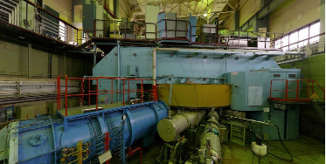

*Figure 1.1: cyclotron U-400*

In this work, we studied the products of the reactions:

*Ar40 + Sm148 → Hg188-xn + xn*

*Ar40 + Er166 → Rn206-xn + xn*

*Ca48 + Pu242 → Rn219 –xn*

The masses of new nuclides must be measured online, directly in the course of their synthesis on accelerated heavy ion beams similarly to the well-known ISOL method.

For this in the U-400M cyclotron a stream of Ar40 or Ca48 atoms accelerated to 284 MeV were created than, the stream is used to bomb the targets of *Sm148, Er166 and Pu242.* The decay products were slowed down in a hot trap, from where they diffused into the ECR ion source, in which they were ionized to a charge state of +1. Then they got into the detector.

2. Experimental Setup

**2.1 MASHA Setup**

The setup, the layout of which is shown in Figure 2.1, consists of the target assembly with a hot catcher; an ion source based on the electron cyclotron resonance (ECR); a magneto-optical analyzer (a mass spectrometer).

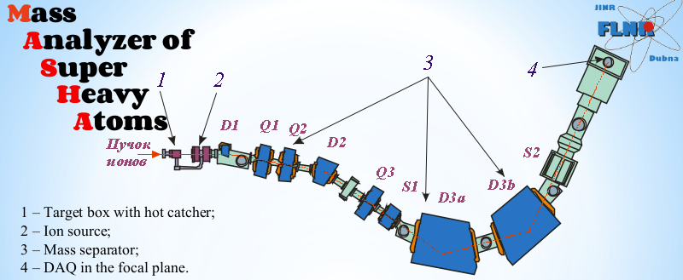

*Figure 2.1: MASHA setup: (D1, D2, D3a, D3b) dipole magnets, (Q1, Q2, Q3) quadrupole lenses, and (S1, S2) sixtupole lenses. The detection system is in focal plane of the separator 4*

**2.2 Ion Source**

An ion source based on the ECR (the ECR source) with a 2.45GHz frequency of its microwave oscillator is used for ionizing atoms of nuclear reaction products.

In the ECR, atoms are ionized to charge state Q = +1, accelerated with the aid of the three electrode system, and gathered into a beam, which is thereafter separated by the magneto-optical system of the mass spectrometer. The ECR source helps to obtain ion currents consisting of almost 100% of singly ionized atoms.

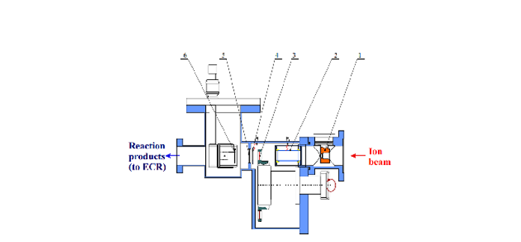

*Figure 2.2: Target-hot catcher system. 1-diaphragm; 2-pick-up sensor; 3-target on the wheel; 4-electron emission beam monitor; 5-separatin foil; 6-hot catcher*

**2.2 Target Assembly and Hot Catcher**

The hot catcher is a part of the target assembly shown in Figure 2.2. Prior to hitting the target, the primary beam of heavy ions passes through the diagnostic system composed of a split type aperture of the electrostatic induction sensor and a Faraday cup. The split aperture is divided into four sectors each of which measures the fraction of the beam current that does not fall into the hole of the aperture. This system allows control of the beam position relative to the ion guide. The Faraday cup is fixed in place on the rotary vacuum tight feedthrough at a distance of 70 mm in front of the target. Behind the diagnostic system, there is a stationary target fixed in place between two grids, which are cooled with water. Nuclear reaction products escape from the target, pass through the separating foil, and are stopped in the graphite absorber. In the form of atoms, the products diffuse from the graphite absorber to the vacuum volume of the hot catcher and, moving over the pipeline, reach the ECR source.

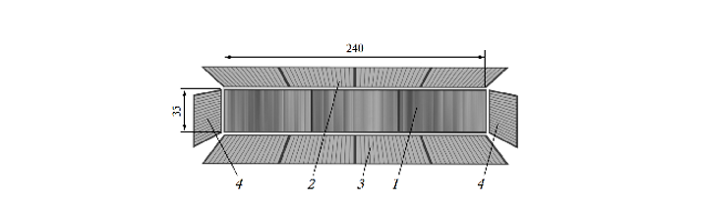

*Figure 2.3: 1-frontal 192 strips; 2-top 64 strips; 3-bottom 64 strips; 4-side 16 strips*

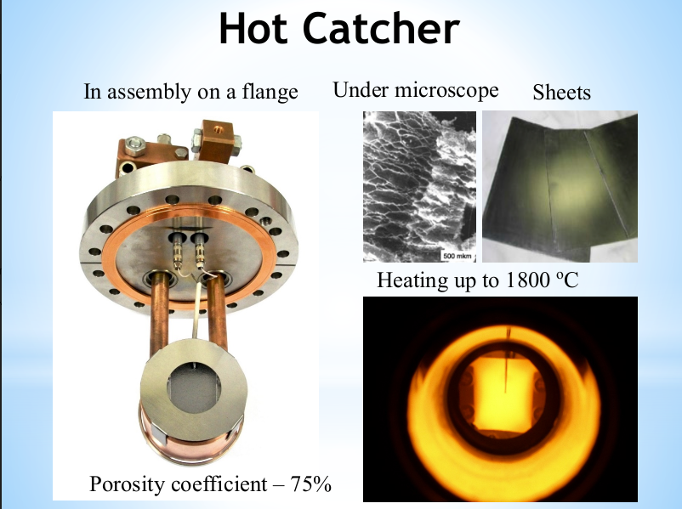

*Figure 2.4: Hot catcher*

**2.3 Detection and Control System**

To detect decays of nuclear reaction products, a well-type silicon detector is mounted in the focus plane of the mass spectrometer. The 192 strips make up the plane of the frontal detector component, which is positioned normal to the beam direction. Each of the side detectors is divided into 64 and 16 strips. The detectors have a conventional operating bias of 40V and a 30keV energy resolution for particles from a Ra226 source. The detector assembly’s stated design allows it to detect no less than 90% of particles emitted in a single nuclear decay at the detector’s frontal section. Each strip of the silicon detector’s signals is read out separately. The application displays one-dimensional energy spectra for each strip as well as two-dimensional spectra for each crystal’s energy dependency on strip number.

**2.4 Experimental Technique**

MASHA was constructed at one of the beam outs of U - 400M cyclotron in order to conduct online measurements of the physical properties of super-heavy elements. The target was bombarded by beam of Ca48 with energy Ebeam = 7,3 MeV / n.

Atoms diffuse from the graphite volume and, move along the vacuum pipe and reach the ECR ion source discharge chamber where they are ionized. Faraday cup allows beam intensity control or target protection by periodically interrupting the beam. The separation efficiency and time were measured for Hg isotopes due to their similarity with element Z = 112 and Z = 114. A radioactive isotopes were obtained in the fusion reaction. A decay energy of the fusion products was measured as a function of the strip number.

3. Result and Discussion

In this chapter we will represent and analyze the results of the nuclear reactions taken from MASHA.

**3.1 Reaction 40Ar + 148 Sm**

It is noticeable in Table 3.1, that the experimental and theoretical results are very close, and this indicates the accuracy of the mass analyzer MASHA. The magnetic system and detector have excellent resolution, distinguishing the various isotopes both in mass and energy.

|  |  |  |  |
| --- | --- | --- | --- |
| **Isotope** | **T ½, s** | **E experiment, keV** | **E theory, keV** |
| Hg180 | 2.58 | 6111 | 6119 |
| Hg181 | 10.83 | 5997 | 6006 |
| Hg182 | 9.4 | 5861 | 5867 |
| Hg183 | 30.9 | 5887 | 5904 |
| Hg184 | 49.1 | 5531 | 5535 |
| Hg185 | 82.8 | 5646 | 5653 |
| Pt176 | 6.3 | 5746 | 5753 |
| Pt177 | 11 | 5497 | 5517 |
|  |  |  |  |

*Table 3.1: comparison between experimental and theoretical energy of the nuclei.*

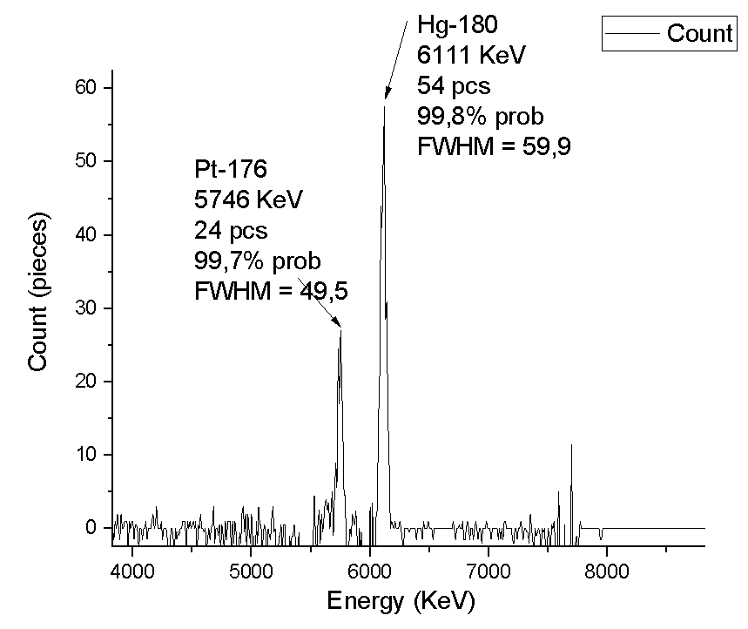 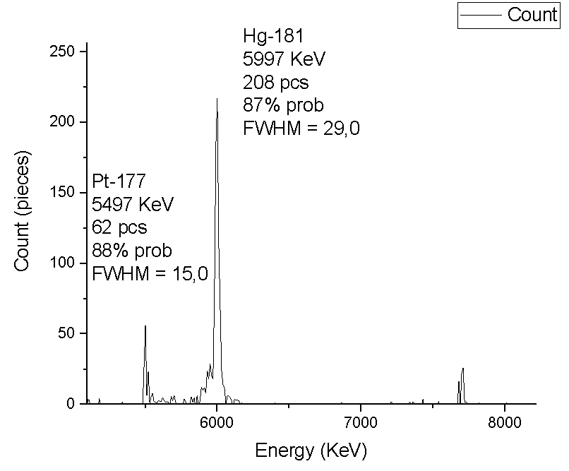

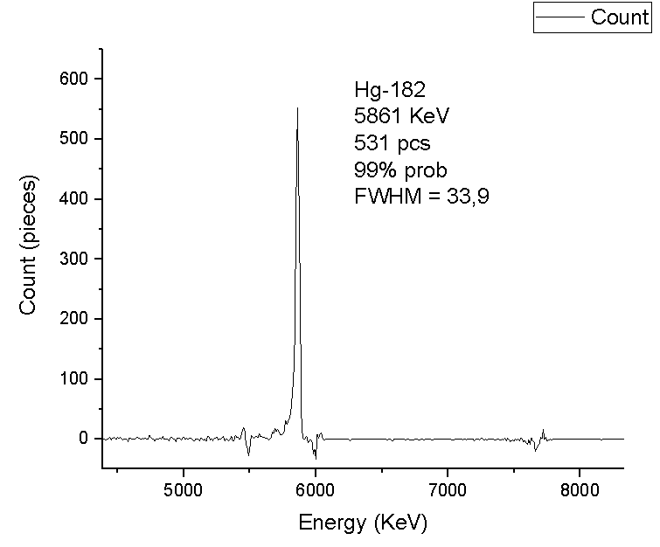 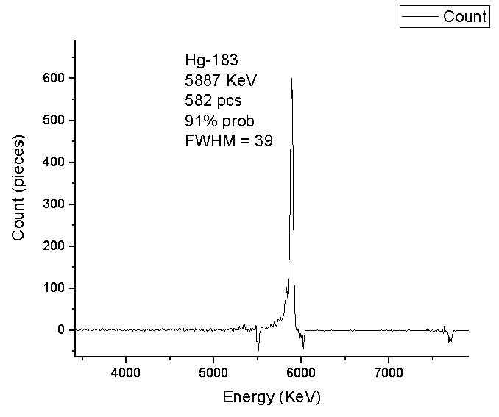

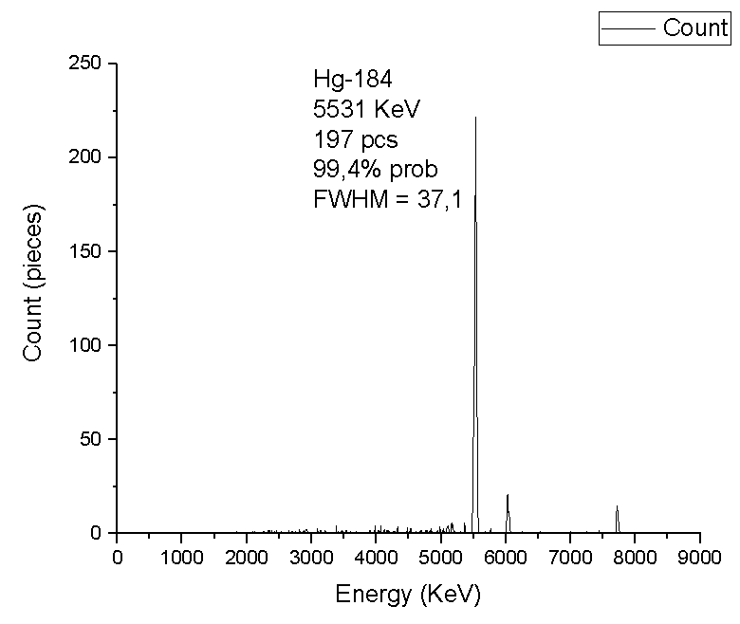 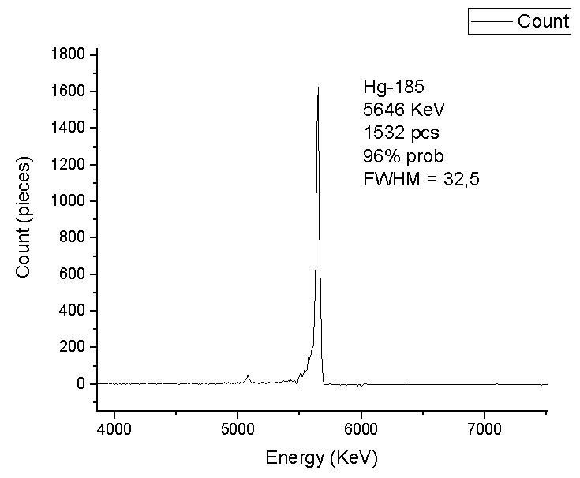

*Figure 3.1*

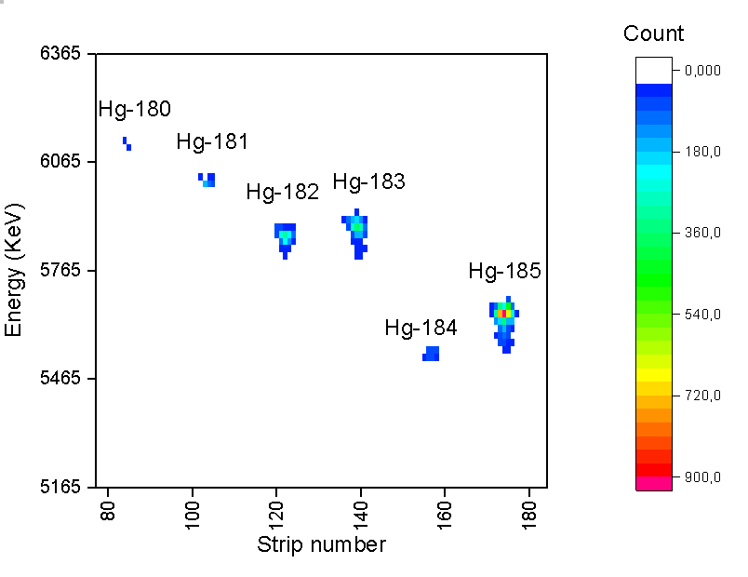

*Heat map3.1*

**3.2 Reaction 40Ar+166 Er**

In below the peaks are clearly shown whether they are Rn or Po nuclei. The decays which we can extract are:

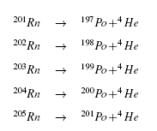

|  |  |  |  |
| --- | --- | --- | --- |
| **Isotope** | **T ½, s** | **E exp, keV** | **E theor, keV** |
| Rn201 | 7.1 | 6747 | 6725 |
| Rn202 | 10 | 6623 | 6639 |
| Rn203 | 28 | 6544 | 6549 |
| Rn204 | 74.4 | 6395 | 6419 |
| Rn205 | 170 | 6260 | 6262 |
| Po197 | 25.8 | 6370 | 6383 |
| Po198 | 106.2 | 6168 | 6182 |
| Po199 | 250.2 | 6066 | 6059 |
| At205 | 1572 | 5910 | 5902 |

*Table 3.2: comparison between experimental and theoretical energy of the nuclei.*

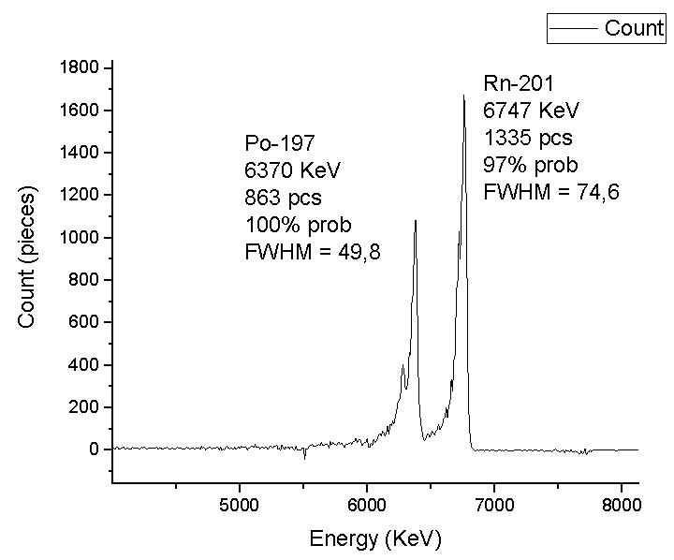 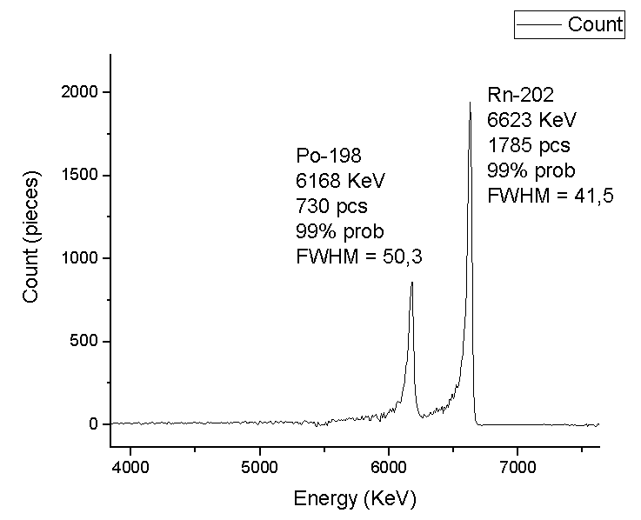

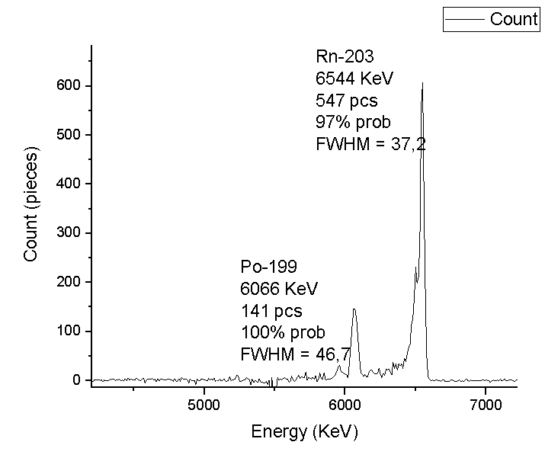 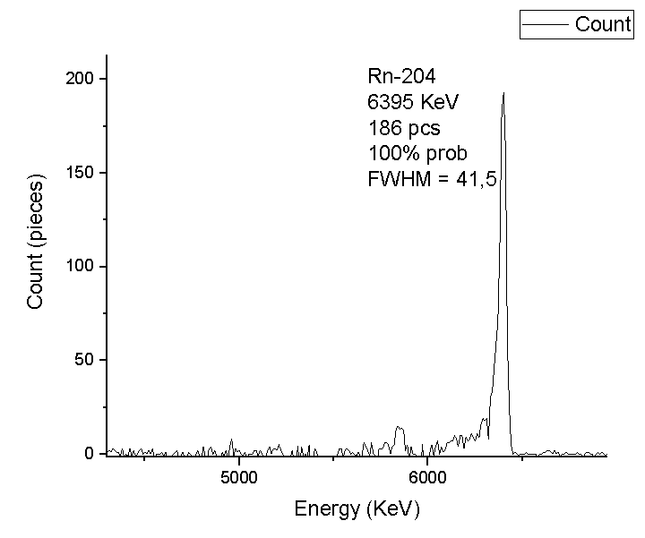

*Figure 3.2*

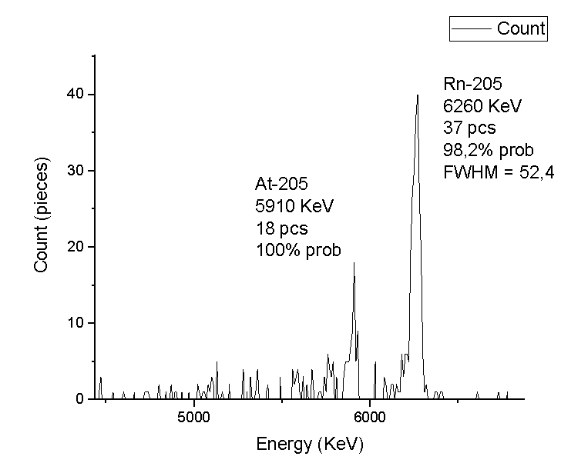

*Figure 3.2*

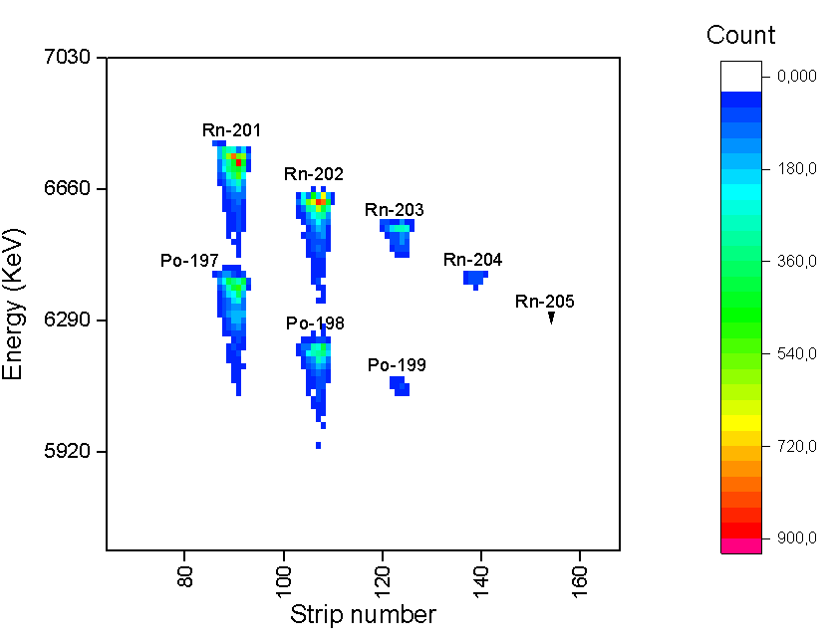

*Heat map 3.2*

**3.3 Reaction 48Ca+242 Pu**

|  |  |  |  |
| --- | --- | --- | --- |
| **Isotope** | **T ½, s** | **E exp, keV** | **E theor, keV** |
| **Rn212** | **1434** | **6250** | **6264** |
| **Rn218** | **0.00035** | **7110** | **7129** |
| **Rn219** | **3.96** | **6790/6400** | **6819/6425** |
| **Rn222** | **36.17** | **6590** | **6559** |
| **Po210** | **138 days** | **5280** | **5304** |
| **Po214** | **0.000163** | **7660** | **7686** |
| **Po215** | **0.0001781** | **7360** | **7386** |
| **Bi210** | **5 days** | **4120** | **4100** |
| **Bi211** | **128.4** | **6600/6260** | **6622/6250** |

***Figure 3.3***

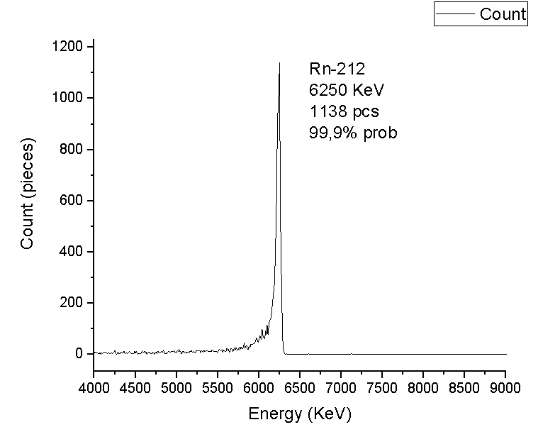 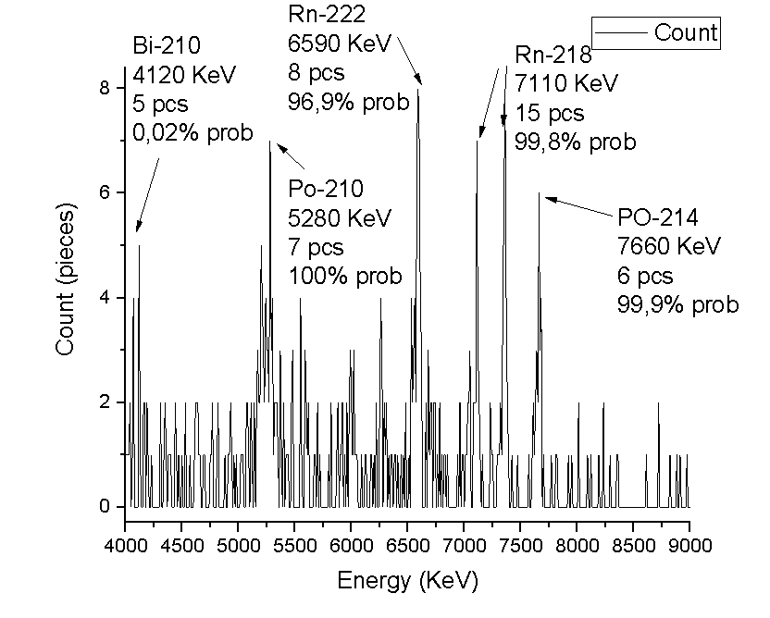

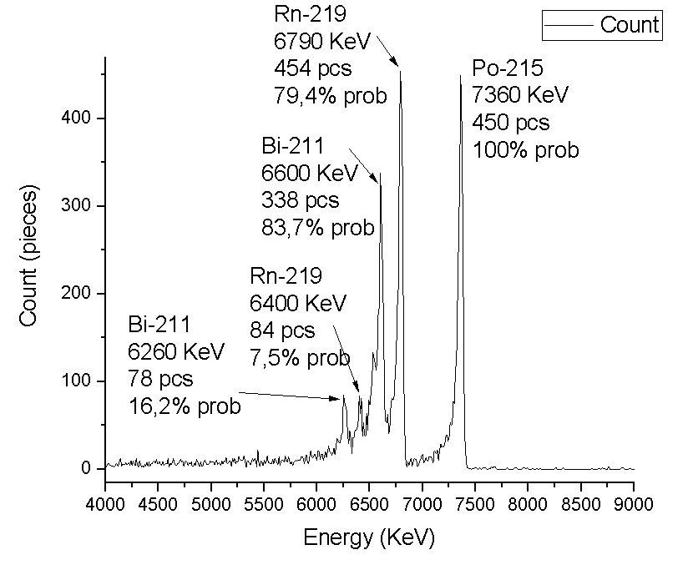

*Figure 3.3*

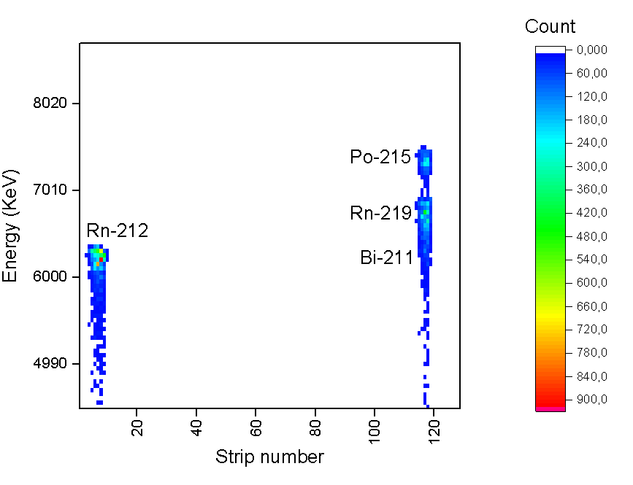

*Heat map 3.3*

Due to the short lifetime of radon isotopes with mass numbers 213-217

MASHA was unable to identify these isotopes. What can be clearly seen on

heat map of this reaction. These isotopes decay on the way to the detector without reaching it. The main delay occurs in a hot trap, from where the nuclei diffuse into the ECR ion source [4].

Conclusions

The existence of the "Island of the Stability," which is a predicted group of isotopes of super-heavy elements that may have far longer half-lives than known isotopes of these elements, is revealed by a detailed examination of super-heavy elements. During the experiment, the energy spectra of the alpha decay were measured at the focal plane using the silicon detection system. By analyzing interaction data, we were able to identify the nuclei of mercury and radon and compare their experimental results with the theoretical results that have been studied. The comparison showed closeness in the experimental and theoretical results for mercury nuclei, but in the case of

radon nuclei, there was a clear difference between the results.

Acknowledgments

I would like to thank Joint Institute for Nuclear Research for this great opportunity, which is based on mixing with real projects and dealing with them to gain experience!!

Bibliography

[1] S. N. Dmitriev, Y. T. Oganessyan, V. K. Utyonkov, S. V. Shishkin, A. V. Yeremin, Y. V. Lobanov, Y. S.

Tsyganov, V. I. Chepygin, E. A. Sokol, G. K. Vostokin, et al., “Chemical identification of dubnium as a

decay product of element 115 produced in the reaction 48ca+ 243am,” Mendeleev Communications, vol. 15,

no. 1, pp. 1–4, 2005.

[2] R. Eichler, N. Aksenov, A. Belozerov, G. Bozhikov, V. Chepigin, S. Dmitriev, R. Dressler, H. Gäggeler,

V. Gorshkov, F. Haenssler, et al., “Chemical characterization of element 112,” Nature, vol. 447, no. 7140,

pp. 72–75, 2007.

[3] V. Y. Vedeneev, A. Rodin, L. Krupa, A. Belozerov, E. Chernysheva, S. Dmitriev, A. Gulyaev, A. Gulyaeva,

D. Kamas, J. Kliman, et al., “The current status of the masha setup,” Hyperfine Interactions, vol. 238, no. 1,

p. 19, 2017.

[4] A. Rodin, A. Belozerov, D. Vanin, V. Y. Vedeneyev, A. Gulyaev, A. Gulyaeva, S. Dmitriev, M. Itkis, J. Kliman,

N. Kondratiev, et al., “Masha separator on the heavy ion beam for determining masses and nuclear

physical properties of isotopes of heavy and superheavy elements,” Instruments and Experimental Techniques,

vol. 57, no. 4, pp. 386–393, 2014.